Supplementary Material

A. Gap filling in climate record for Syferkuil
In total, from 01-October-2015 to 30-September-2017, we found 212 missing days for solar radiation, for maximum temperature 212 days, minimum temperature 212 days, and 222 days for rain. As no data was available from another weather station close to the experimental site, we used the on-station climate records from that site, dating back to 2008. For this period we downloaded the NASA data as described in the main text. A simple regression model was fitted for solar radiation (see supplementary material: Figure S1), as well as minimum (Figure S2) and maximum temperatures (Figure S3). For rainfall, we checked whether we can estimate a rain day from the NASA data (Figure S4). The days of rain that equalled zero were excluded and the model fitted for the rain days > 0. For rainfall, we used a simple rule: if the NASA rainfall equals zero, then we set the predicted rainfall to zero; if the NASA rainfall was above zero then we used the derived model to fill the gap for the specific day in question (Figure S5). The following models were used to predict the gaps for the period between October-2015 to September-2017.
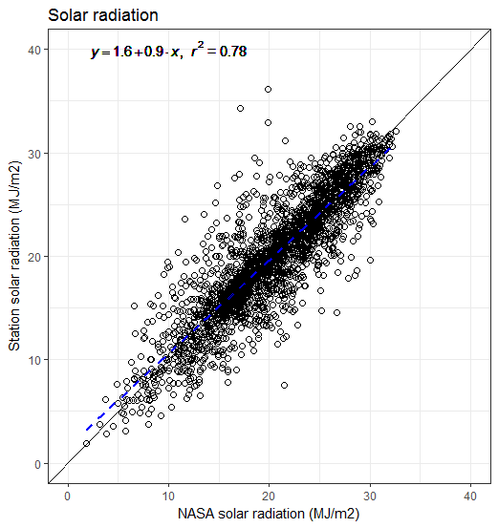
Figure S1: Measured solar radiation in Syferkuil plotted against solar radiation derived from the NASA.

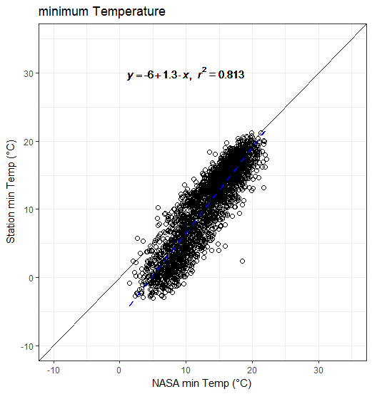
Figure S2: Measured minimum temperature in Syferkuil plotted against minimum temperature derived from the NASA.

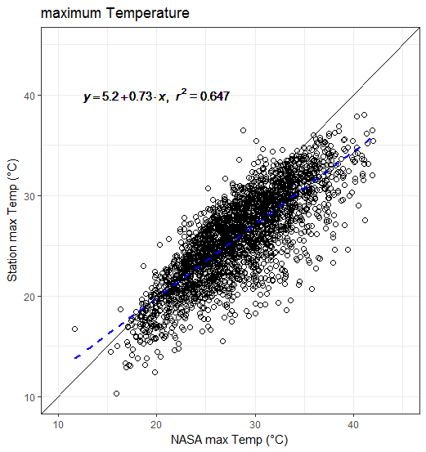
Figure S3: Measured maximum temperature in Syferkuil plotted against maximum temperature derived from the NASA.

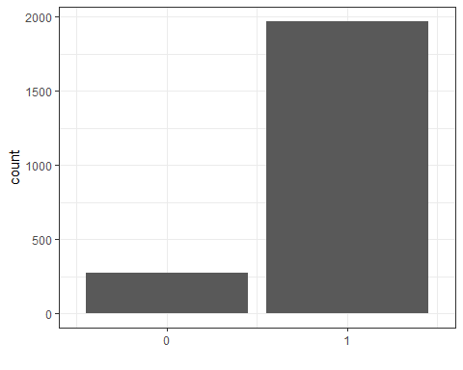
Figure S4: The number of times the NASA prediction was correct, whether it was a rain day or not (represented by the bar 1) and where it was not correct (represented by the bar 0) for the period 2008-2017. Days where considered only where observed and NASA data was available.

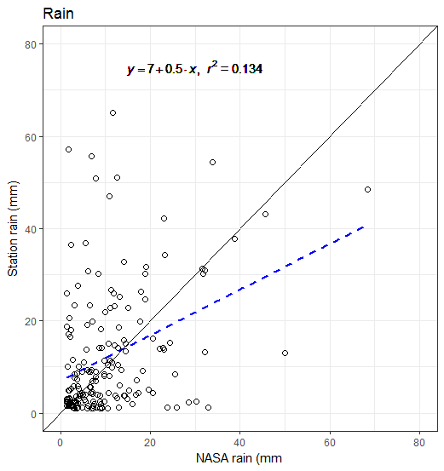
Figure S5: Measured rainfall in Syferkuil plotted against rain derived from the NASA. Only rain days defined by more than 1 mm per day were considered.

B. Additional field data results
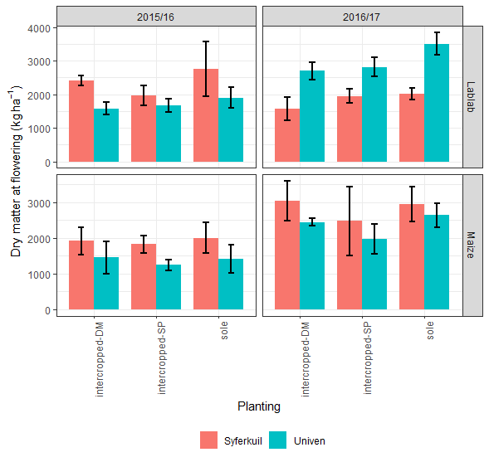
Figure S6: Dry matter at flowering as affected by season, site and planting management. Sole is the crop planted as a monocrop, intercropped-DM is lablab planted 28 days after maize, and intercropped-SP is maize and lablab planted on the same day.

