Supplementary Material Figure S1

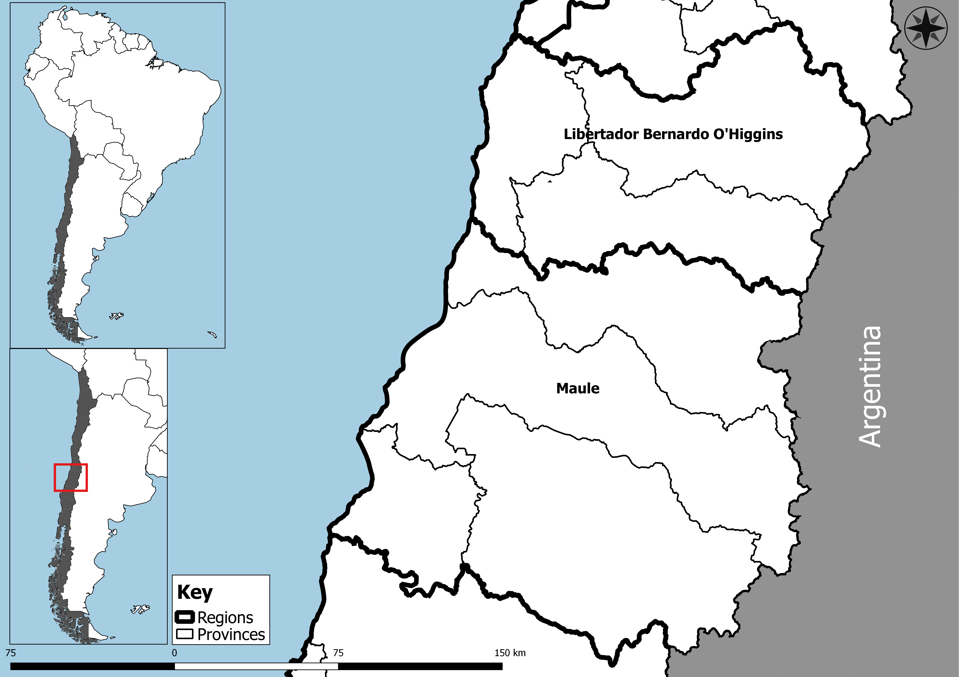

Supplementary Material Table S1: Innovative behaviour scale
Statement |  | Strongly disagree | Disagree | Moderately disagree | Agree | Strongly agree
 |  | 1 | 2 | 3 | 4 | 5
1 | My curiosity has allowed me to generate new ideas in orchard management (GI1).
2 | I pay attention to everyday experiences; these have allowed me to develop new ideas (GI2).
3 | I often have new ideas when I see the development of management in the orchard (GI3).
4 | I get new ideas to improve the productivity of the orchard when I look at the national or international environment (GI4).
5 | Every time I have a new idea in mind, I don't rest until I implement it (GI5).
6 | I am attentive to improving process efficiency through of the incorporation of new ideas (GI6)
7 | I have developed new ideas with the help of my colleagues and acquaintances (NW7)
8 | I encourage the development of new ideas in other farmers, to achieve quality fruit and efficiency in productivity (NW8)
9 | I encourage the development of new ideas in others (NW9)
10 | I trust farm workers to suggest new ideas that help improve productivity (AIW10).
11 | I seek people with proactive features to assist and support the implementation of new ideas (AIW11)
12 | My work group has initiative and is proactive when I implement a new idea (AIW12).
13 | In the company, I encourage workers to cooperate and develop new ideas (AIW13)
14 | I encourage workers to develop their skills when I work on a new idea (AIW14).
15 | I recognize that workers have been an important pillar in the success of the new ideas that have been implemented (AIW15).
GI: Generation and implementation of new ideas, NW: Networking, AIW: Ability to involve workforce.

