Table S1: Example of survey on farmers’ experiences with dry direct seeding in wet season 2016
.
District: | Date:
Village: | Time:
Farmer: | Survey number:
Interviewer: | Survey checked by:

Parcel information
Household size: | Farm area (ha):
Rice area usually grown (ha):  Wet season  Dry season | Land type:  [ ] low [ ] middle [ ] upper
Soil texture:  [ ] sandy [ ] loamy [ ] clay [ ] others (specify) | Soil fertility:  [ ] very fertile [ ] fertile [ ] unfertile
Do you have access to irrigation?  [ ] Yes [ ] No | If yes, what is the irrigation source?
Rice shortage (months): | % income from rice sales:
Number of livestock owned: | % income from livestock sales:
Number of family members working off-farm: | % income from off-farm employment:
Number of seasons experience with DDS?

Yield and productivity of rice in wet season 2015
 | Direct seeding | Other establishment method
Variety
Seed source
Area of rice (m²)
Land type (lower, middle, upper)
Date sown
Date transplanted
Date harvested
Grain yield (kg)
Fertiliser applied – type & quantity
Water management practices
Weed management practices
Problems encountered (e.g. lodging, weeds, pest, disease)
Weather pattern (i.e. late onset rains, mid-season drought etc)

Labour
ຈໍານວນພົນໃນຄອບຄົວທັງໝົດ/Number of people in your household | ຈໍານວນຜູ້ຢູ່ອາໄສໃນຄອບຄົວປະຈຸບັນ/How many members currently living here?
ໃນລະດູຝົນ, ແຮງງານຕົ້ນຕໍສຳລັບເຮັດການຜະລິດກະສິກຳມີຈັກຄົນ/How many full time farm workers WS? | ໃນລະດູແລ້ງ, ແຮງງານຕົ້ນຕໍສຳລັບເຮັດການຜະລິດກະສິກຳມີຈັກຄົນ/ How many part time farm workers WS?
ວຽກສັກເຂົ້າໄຮ່ ທ່ານໄດ້ໃຊ້ແຣງງານຄອບຄົວເອງ, ຈ້າງແຮງງານຫລືແລກປ່ຽນແຮງງານ/For planting, what type of labour do you use  ແຮງງານຄອບຄົວ/Family labour  ແລກປ່ຽນແຮງງານ/Exchange labour  ຈ້າງແຮງງານເຮັດໃຫ້/Hire labour (cost LAK/day?) | ວຽກເສຍຫຍ້າໄຮ່ ທ່ານໄດ້ໃຊ້ແຣງງານຄອບຄົວເອງ, ຈ້າງແຮງງານຫລືແລກປ່ຽນແຮງງານ/For weeding, what type of labour do you use?  ແຮງງານຄອບຄົວ/Family labour  ແລກປ່ຽນແຮງງານ/Exchange labour  ຈ້າງແຮງງານເຮັດໃຫ້/Hire labour (cost LAK/day?)

ວຽກເກັບກ່ຽວ, ຮູດເຂົ້າໄຮ່ ທ່ານໄດ້ໃຊ້ແຣງງານຄອບຄົວເອງ, ຈ້າງແຮງງານຫລືແລກປ່ຽນແຮງງານ/For harvesting, what type of labour do you use?

ແຮງງານຄອບຄົວ/Family labour

ແລກປ່ຽນແຮງງານ/Exchange labour

ຈ້າງແຮງງານເຮັດໃຫ້/Hire labour (cost LAK/day?)
ຄົນໃນຄອບຄົວຂອງທ່ານມີໃຜໄດ້ໄປຈ້າງເຮັດວຽກກະສິກຳ ແລະ ຈ້າງວຽກນອກກະສິກຳບໍ່ ຫຼື ເຣັດວຽກນອກກະສິກຳຂອງຕົນເອງ?/Do any members of your household work off-farm or non-farm work?  ມີ/Yes ບໍ່ມີ/No  ຜູ້ໄປຈ້າງເຮັດວຽກກະສິກຳ ແລະ ບໍ່ແມ່ນກະສິກຳ ຫຼື ເຮັດວຽກຂອງຕົນເອງທີ່ບໍ່ກ່ຽວກະສິກຳ ນັ້ນແມ່ນເຣັດຫຍັງ?/What do they do during this period? ___________________________ | ວຽກທີ່ຄົນໃນຄອບຄົວທ່ານໄປນັ້ນເຮັດນັ້ນແມ່ນຢູ່ໃນຊ່ວງລະດູໃດ?/Which season do they work in this activity?  ລະດູຝົນ/Wet-season  ລະດູແລ້ງ/Dry-season  ໝົດປີເລີຍ/All year

ຄ່າຈ້າງແຮງງານກະສິກຳມື້ລະເທົ່າໃດ?/What is the daily wage rate when working off-farm?

_____________ກີບ/ມື້-kip/day
ຄອບຄົວທ່ານໄດ້ມີພີ່ນ້ອງ, ລູກຫຼານຝາກເງິນມາໃຫ້ບໍ່?/Do you receive remittances from members living elsewhere?  ມີ/Yes ບໍ່ມີ/No | ປີກາຍໄດ້ຮັບເງິນຝາກມາໃຫ້ເທົ່າໃດ?/Remittances received each last year  __________________

Labour requirements in wet season 2016
No. Labour days | Direct seeding | Other establishment method | Other establishment method
Prepare nursery
Transplanting
Weeding
Harvest

If you have saved labour:
Which family members now have more time?
What do they do with this free time?

Machinery access and use
Where did you get information about the direct seeding technique?

Who were the most important people in helping you to decide to use direct seeding?
Name: | Relationship to you:
Where did you source the machine (i.e. purchase, hire contractor, use group seeder etc)?
If purchased, did you have access to more than one type of machine?
If purchased, did you borrow money to buy the seeder? From where? Is the process to borrow money difficult?
Did you need to adapt anything to make using the machine easier?
Can you suggest modifications that need to be made to the machine based on your experience?
Do you plan to use the direct seeder again next year? Why/why not?

Impact of adoption
Did you experience change(s) in your household or farm after using the direct seeder? What is the magnitude of this change?
Variable for impact | Changes  (+)-yes, increased  (- )-yes, decreased  (0)-no change | Amount of change (%)
Yield (kg)
Area planted (ha)
Income from rice (LAK)
Income from other crop (LAK)
Number of months without food
Incidence of pests and diseases
Incidence of weeds
Amount of production inputs used
Cost of production (LAK)
Rice for home consumption (kg)

Thank you for your time

Table S2: Monthly rainfall (mm) in 2015 and 2016 relative to long-term means (mm) for Savannakhet and Champassak Provinces in Lao PDR. M, missing.
 |  | Jan | Feb | Mar | Apr | May | Jun | Jul | Aug | Sep | Oct | Nov | Dec | Total
Savannakhet | 2015 | 0 | 26 | 6 | 8 | 50 | 82 | 303 | 184 | 143 | 83 | 2 | 0 | 886
 | 2016 | 13 | 0 | 4 | 16 | 119 | 151 | 152 | 26 | 189 | 64 | 23 | 1 | 757
 | Mean | 4 | 17 | 32 | 91 | 168 | 263 | 219 | 343 | 219 | 87 | 7 | 2 | 1452
Champassak | 2015 | 0 | 3 | 16 | 107 | 105 | 185 | 301 | 409 | 267 | 77 | 31 | 0 | 1501
 | 2016 | 63 | 5 | 0 | 19 | 180 | 283 | 421 | 285 | 591 | 244 | M | 37 | 2128
 | Mean | 2 | 16 | 25 | 75 | 245 | 324 | 434 | 468 | 309 | 116 | 30 | 2 | 2044

Table S3. Experiment 2: Percent variation associated with sources of variance for dry weight (DM) of weeds and rice and their combined canopy cover at 21, 36 and 51 days; and grain yield, total DM and harvest index of rice at maturity. Values are percentages for sources of variation from the full factorial analysis from Table 4.

Variation |  | Weed DM | (kg ha⁻¹) |  | Rice DM | (kg ha⁻¹) |  | Canopy | (%) |  | Maturity | (Mg ha⁻¹)
Source | dF | 21 days | 36 days | 51 days | 21 days | 36 days | 51 days | 21 days | 36 days | 51 days | Grain yield | Total DM | HI (%)
District | 3 | 6.0 | 5.6 | 5.1 | 48.4 | 53.8 | 63.0 | 38.2 | 23.4 | 49.6 | 23.8 | 22.4 | 16.4
Weed | 2 | 4.3 | 33.2 | 58.2 | 0.4 | 2.4 | 7.7 | 22.4 | 5.3 | 6.6 | 23.7 | 21.9 | 0.2
Fertilizer | 2 | 7.8 | 5.9 | 6.7 | 14.5 | 9.3 | 10.3 | 3.6 | 4.0 | 6.7 | 12.1 | 7.6 | 1.3
DxW | 6 | 14.1 | 18.3 | 11.1 | 2.5 | 4.0 | 5.5 | 2.1 | 27.1 | 4.4 | 5.6 | 10.4 | 20.5
DxF | 6 | 40.7 | 13.6 | 6.9 | 20.7 | 17.3 | 5.3 | 14.8 | 17.1 | 13.6 | 15.6 | 18.8 | 33.7
WxF | 4 | 10.5 | 3.8 | 2.1 | 3.9 | 4.8 | 2.5 | 7.6 | 4.2 | 11.0 | 1.2 | 2.8 | 5.9
DxWxF | 12 | 16.6 | 19.6 | 9.9 | 9.6 | 8.4 | 5.7 | 11.3 | 18.9 | 8.1 | 18.0 | 16.1 | 22.0

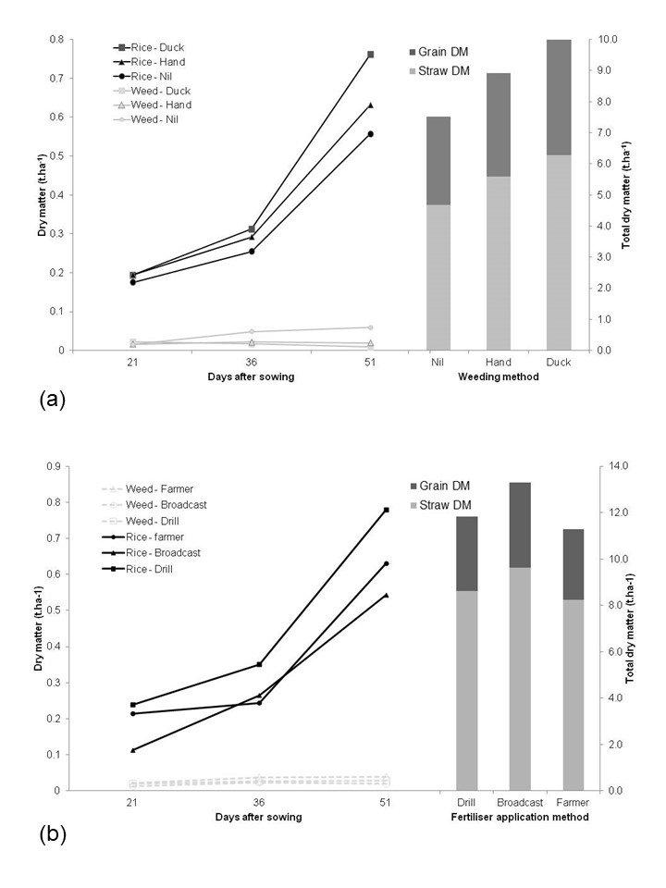

Supplementary Material Figure Captions:

Fig. S1. Mean dry matter production (kg ha⁻¹) of rice and weeds at 21, 36 and 51 days after emergence (DAE) in (a) 3 weed control treatments (Unweeded, Hand-weeded, Ducklings) and in (b) 3 fertilizer treatments (Drilled, Broadcast, Farmer Practice) at 4 locations in southern Lao PDR in 2016. At maturity, the total dry matter production and the grain yield (shaded) of each weeding method (a) or fertilizer treatment (b) are presented as histograms. Note the different scales for 0-51 days and at maturity. At 21, 36 and 51 days, l.s.d. for dry matter of weeds was 13.0, 16.4 and 14.7 (a) and 12.3, 17.8 and 15.6 (b), and for dry matter of rice was 102, 98 and 153 (a) and 123, 133 and 262 (b), respectively (P < 0.05). At maturity, l.s.d. of total dry matter and grain yield were 1470 and 550 (a) and 1680 and 600 (b), respectively (P < 0.05). In a, Duckling = square, Hand-weeded = triangle and Unweeded = circle. In b, Drill = square, Broadcast = triangle and Farmer Practice = circle. Rice is shaded symbols and unbroken lines; weed is open symbols and dotted lines. In the DM histograms, grain DM is shaded, and straw DM is not.

