Table S1: Effect of establishment methods on total weed density (plants m⁻²) at 30 and 60 days after sowing (DAS) in weedy plots
30 DAS
2013 | E. colona | L. chinensis | D. sanguinalis | C. difformis | Fimbristylis miliacea | S. zeylanica | Ludwigia octovalvis | Total
Row seeding | 15 | 10 | 8 | 6 | 4 | 3 | 3 | 49
Broadcasting | 21 | 13 | 7 | 8 | 6 | 4 | 3 | 62
Spot seeding | 14 | 8 | 7 | 5 | 4 | 5 | 4 | 47
Total | 50 | 31 | 22 | 19 | 14 | 12 | 10 | 158
2014 | E. colona | L. chinensis | D. sanguinalis | C. difformis | Fimbristylis miliacea | S. zeylanica | Ludwigia octovalvis | Total
Row seeding | 13 | 7 | 9 | 8 | 5 | 3 | 2 | 47
Broadcasting | 20 | 9 | 8 | 6 | 5 | 3 | 3 | 54
Spot seeding | 11 | 7 | 7 | 6 | 6 | 3 | 3 | 43
Total | 44 | 23 | 24 | 20 | 16 | 9 | 8 | 144
60 DAS
2013 | E. colona | L. chinensis | D. sanguinalis | C. iria | C. difformis | Fimbristylis miliacea | S. zeylanica | L. octovalvis | Cleome viscosa | Euphorbia hirta | Physalis minima | Eclipta prostrata | Phyllanthus niruri | Scoparia dulcis | Total
Row seeding | 17 | 22 | 5 | 2 | 11 | 9 | 7 | 4 | 1 | 1 | 1 | 1 | 1 | 1 | 83
Broadcasting | 20 | 28 | 6 | 4 | 12 | 7 | 8 | 5 | 1 | 1 | 1 | 1 | 0 | 0 | 94
Spot seeding | 12 | 17 | 2 | 4 | 12 | 10 | 7 | 4 | 2 | 0 | 1 | 1 | 0 | 0 | 72
Total | 49 | 67 | 13 | 10 | 35 | 26 | 22 | 13 | 4 | 2 | 3 | 3 | 1 | 1
2014 | E. colona | L. chinensis | D. sanguinalis | C. iria | C. difformis | Fimbristylis miliacea | S. zeylanica | L. octovalvis | Cleome viscosa | Euphorbia hirta | Physalis minima | Eclipta prostrata | Phyllanthus niruri | Scoparia dulcis | Total
Row seeding | 14 | 22 | 8 | 3 | 12 | 9 | 6 | 3 | 1 | 1 | 1 | 1 | 0 | 1 | 82
Broadcasting | 18 | 23 | 5 | 5 | 14 | 8 | 8 | 2 | 1 | 1 | 0 | 0 | 1 | 0 | 86
Spot seeding | 10 | 13 | 3 | 4 | 9 | 8 | 7 | 3 | 2 | 1 | 1 | 1 | 0 | 0 | 62
Total | 42 | 58 | 16 | 12 | 35 | 25 | 21 | 8 | 4 | 3 | 2 | 2 | 1 | 1

Table S2: Weed distribution of major weeds (E. colona, L. chinensis and D. Sanguinalis) as influenced by herbicides
2013 | 30 DAS |  |  |  | 60 DAS
 | BPS | AZM | FCS | Weedy | BPS | AZM | FCS | Weedy
E. colona | 12 | 5 | 19 | 60 | 13 | 12 | 33 | 38
L. chinensis | 7 | 3 | 6 | 15 | 37 | 11 | 31 | 58
D. sanguinalis | 7 | 2 | 18 | 28 | 14 | 14 | 21 | 33
2014 | 30 DAS |  |  |  | 60 DAS
 | BPS | AZM | FCS | Weedy | BPS | AZM | FCS | Weedy
E. colona | 12 | 6 | 15 | 54 | 11 | 10 | 28 | 28
L. chinensis | 4 | 4 | 7 | 12 | 30 | 10 | 28 | 54
D. sanguinalis | 5 | 1 | 14 | 25 | 13 | 11 | 20 | 34

Table S3: Direct and indirect contribution of panicle m⁻², grains panicle⁻¹, crop biomass, weed dry matter, weed control efficiency and weed index to rice grain yield as partitioned by path analysis during 2013 and 2014
2013 | Panicle m⁻² | Grains panicle⁻¹ | Crop biomass | Weed dry matter | Weed control efficiency | Weed Index | Grain yield
Panicle m⁻² | (0.0386) | 0.1035 | 0.2541 | 0.0241 | -0.0210 | 0.1215 | 0.5204
Grains panicle⁻¹ | 0.0190 | (0.2106) | 0.2715 | 0.0182 | -0.0380 | 0.1602 | 0.6420
Crop biomass | 0.0229 | 0.1335 | (0.4284) | 0.0277 | -0.0490 | 0.1608 | 0.7244
Weed dry matter | -0.0230 | -0.0950 | -0.2940 | (-0.0400) | 0.0581 | -0.1990 | -0.5930
Weed control efficiency | 0.0109 | 0.1047 | 0.2767 | 0.031 | (-0.0760) | 0.2028 | 0.5504
Weed Index | -0.0120 | -0.0870 | -0.1780 | -0.0210 | 0.0397 | (-0.3860) | -0.6450
2014 | Panicle m⁻² | Grains panicle⁻¹ | Crop biomass | Weed dry matter | Weed control efficiency | Weed Index | Grain yield
Panicle m⁻² | (0.0745) | 0.036 | 0.1564 | 0.8726 | -0.6830 | 0.2284 | 0.6854
Grains panicle⁻¹ | 0.0420 | (0.0639) | 0.0959 | 0.6322 | -0.4170 | 0.2271 | 0.6436
Crop biomass | 0.0507 | 0.0267 | (0.2297) | 0.9549 | -0.8260 | 0.2290 | 0.6651
Weed dry matter | -0.0500 | -0.031 | -0.1670 | (-1.3100) | 1.183 | -0.2700 | -0.6440
Weed control efficiency | 0.0407 | 0.0213 | 0.1518 | 1.24 | (-1.2500) | 0.2628 | 0.4666
Weed Index | -0.0320 | -0.0270 | -0.0980 | -0.6570 | 0.6114 | (-0.5370) | -0.7400

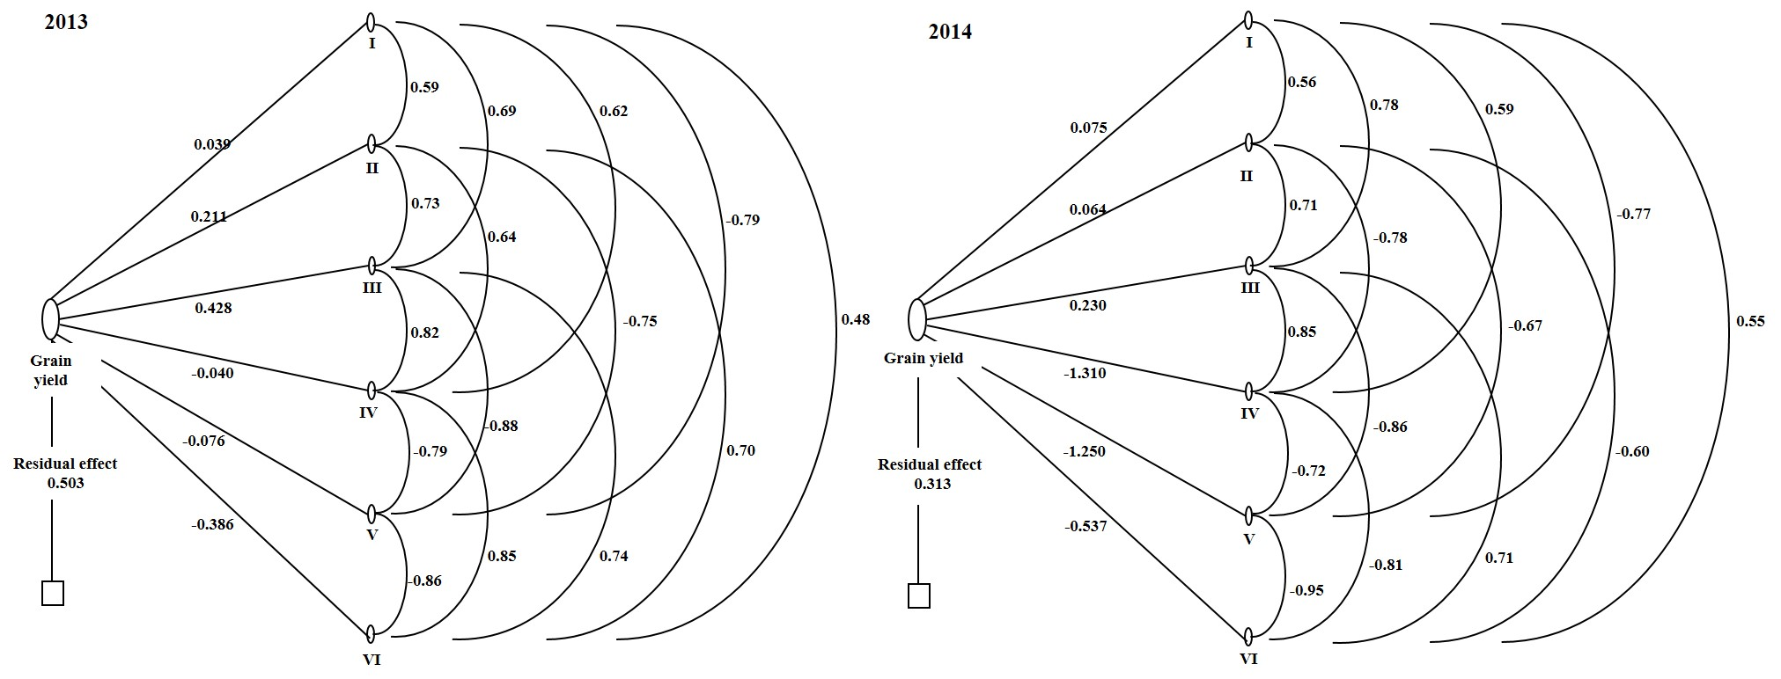
Figure S1. Path diagram for grain yield; I: panicle m⁻², II: grains panicle⁻¹, III: crop biomass, IV: weed dry matter, V: weed control efficiency and VI: weed index during 2013 and 2014

