Figure S1. Topographic map of Timor-Leste. The exclave of Oecusse is shown in bottom right-hand corner.
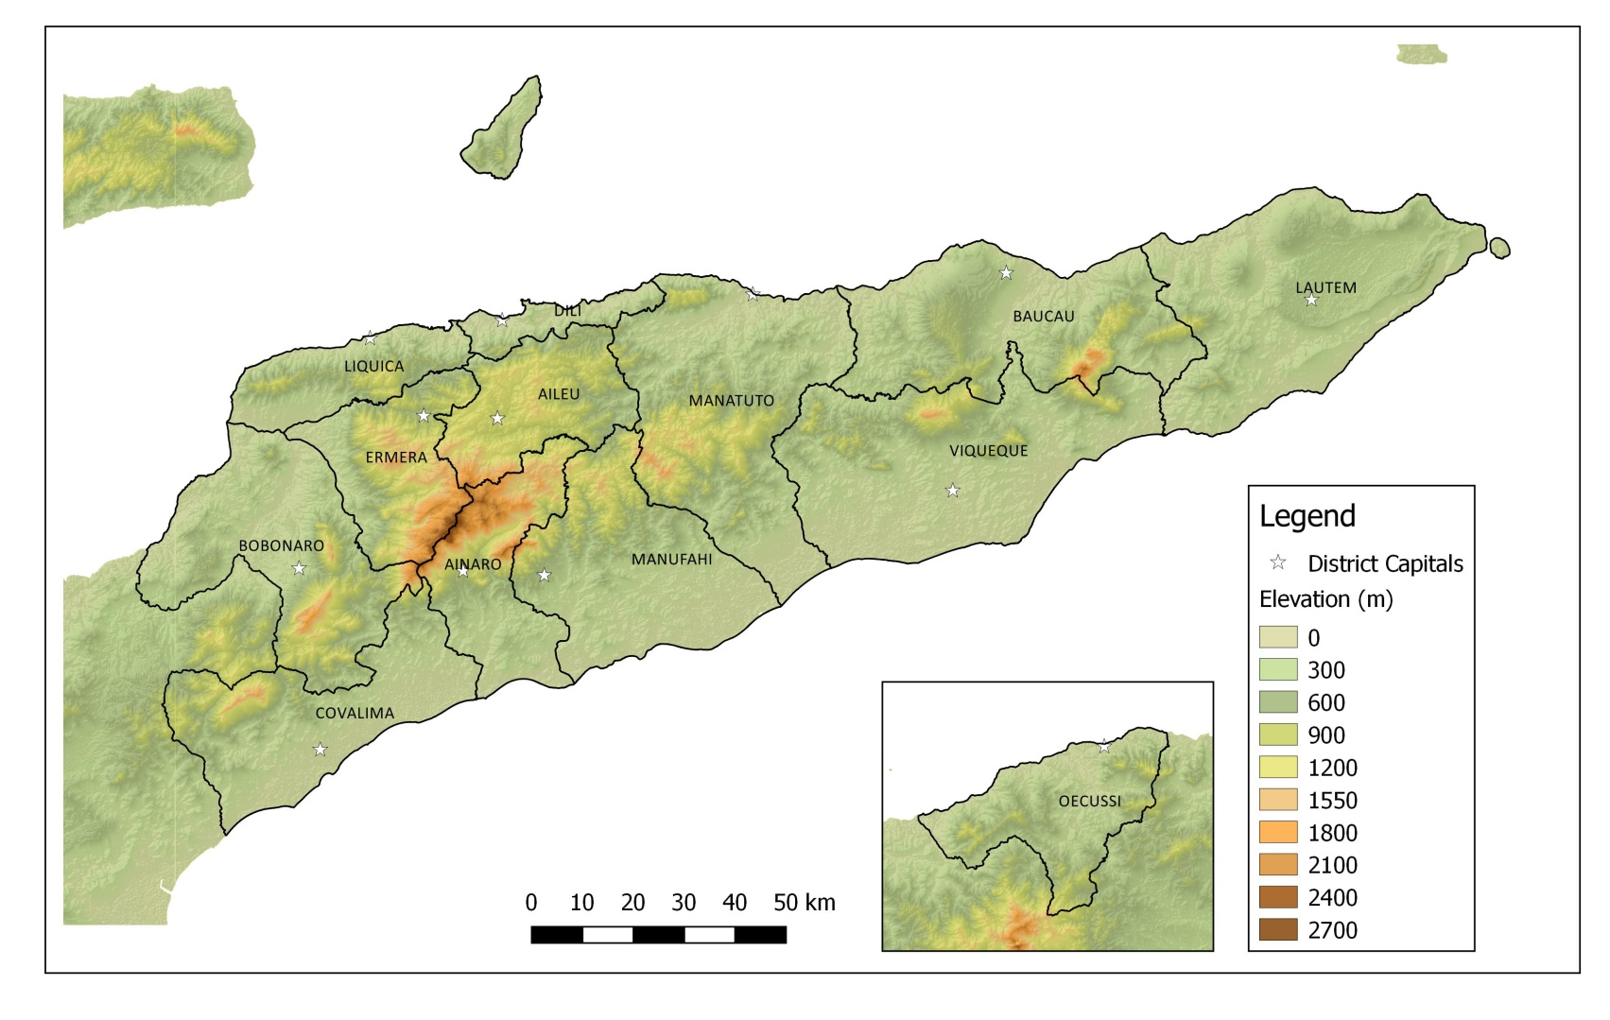

Figure S2. Map of average total annual rainfall in Timor-Leste based on WorldClim data base (Hijmans et al., 2005).
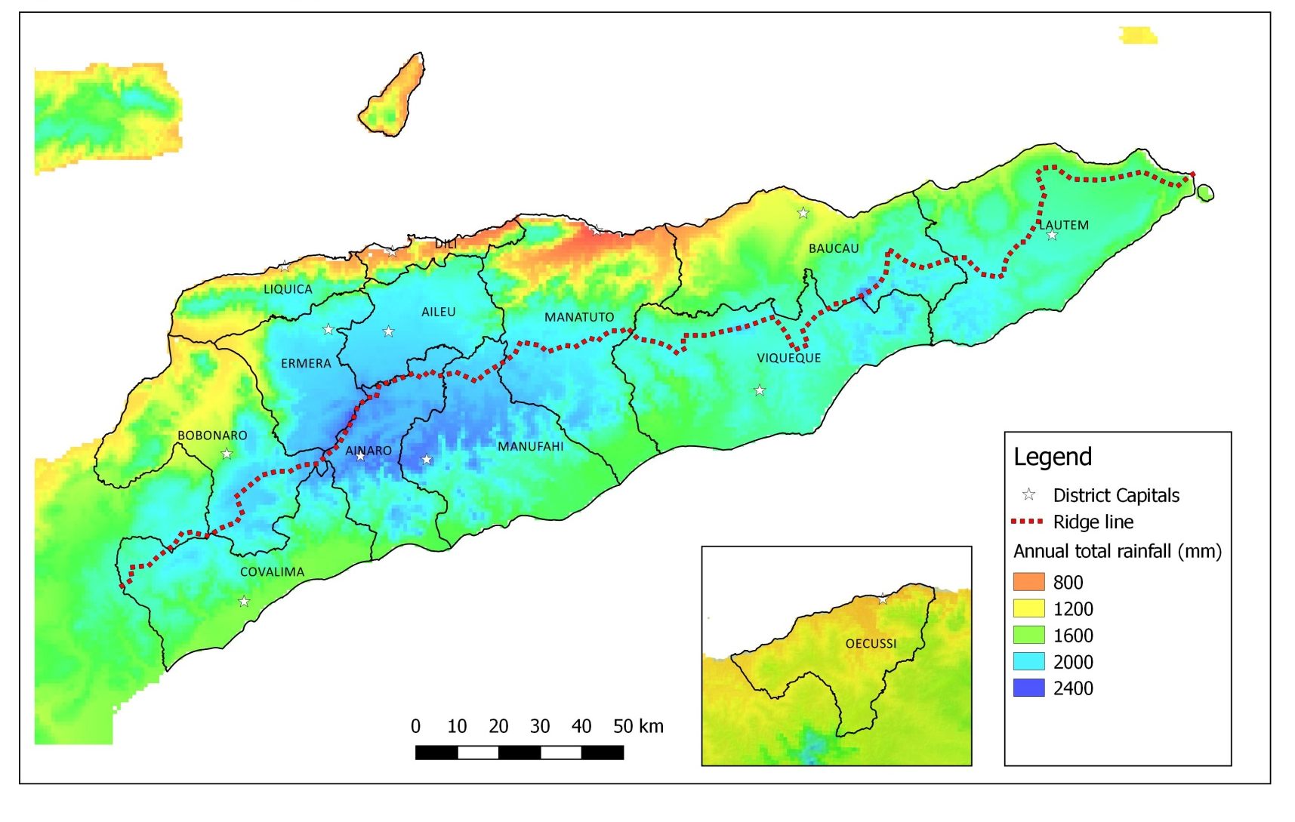
Figure S3. Map of villages of Timor-Leste coloured based by percent households planting maize.
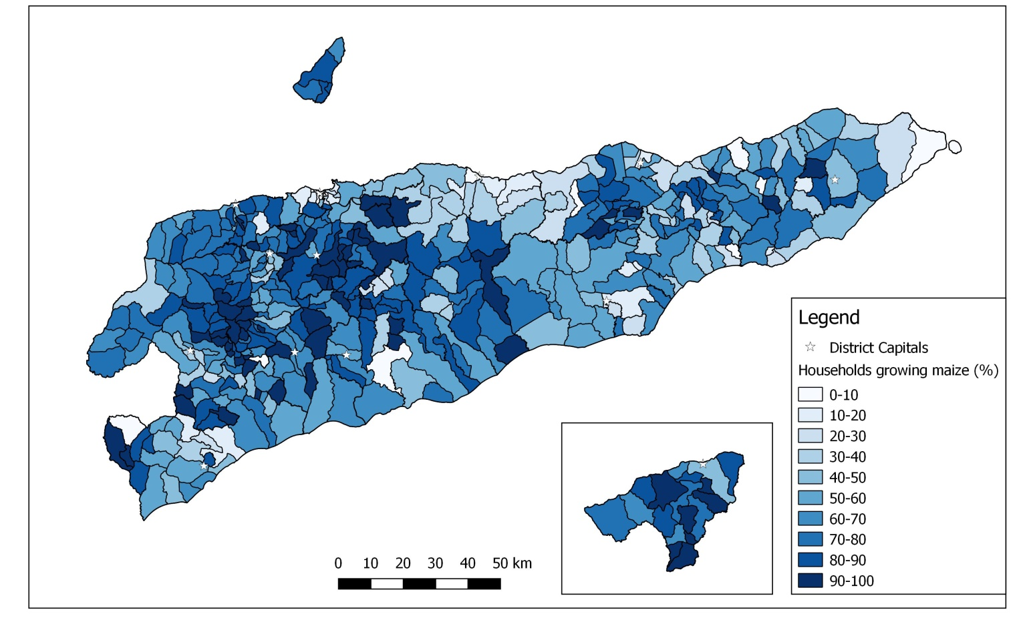

Figure S4. Map of villages of Timor-Leste coloured based by percent households planting cassava.
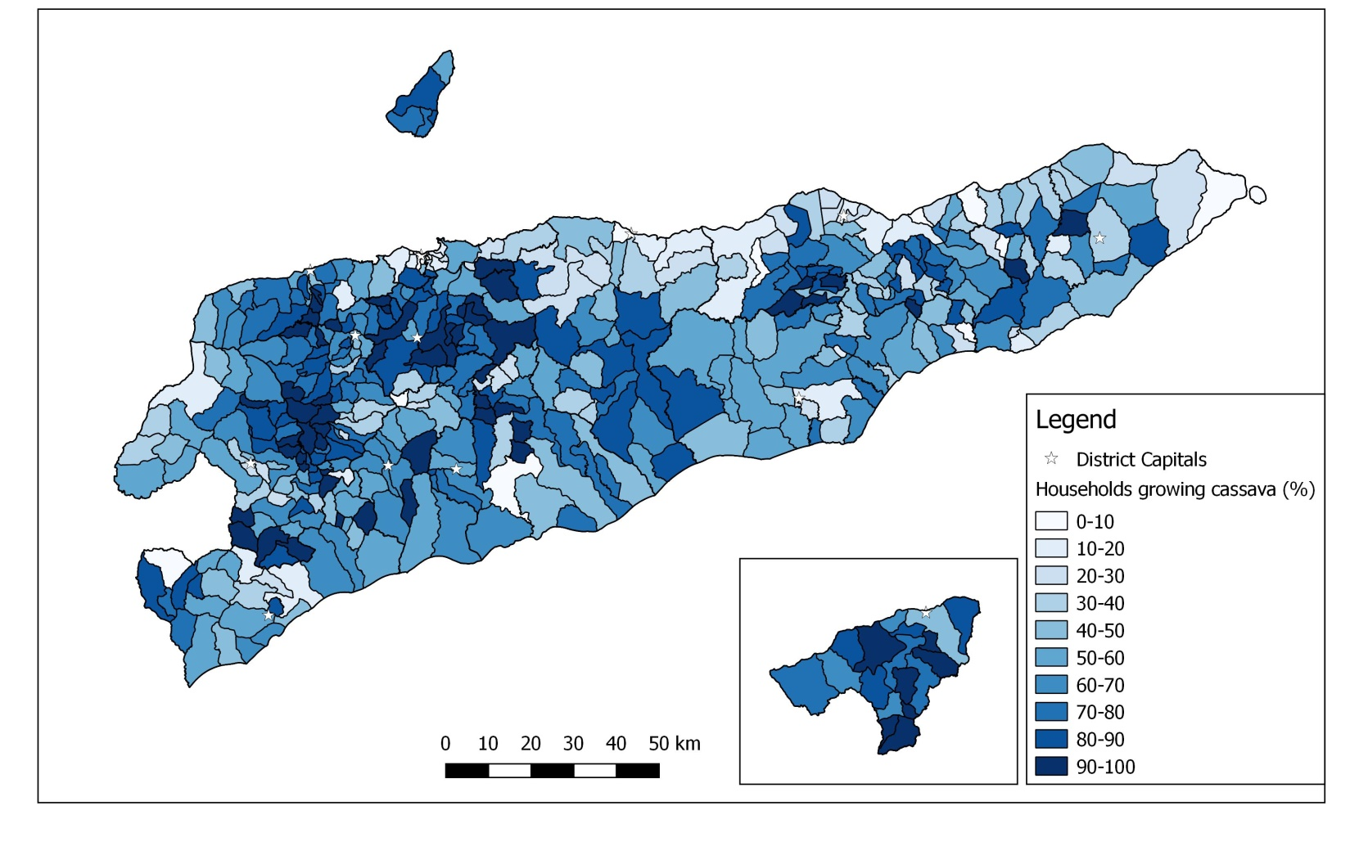

Figure S5. Map of villages of Timor-Leste coloured based by percent households planting coffee.

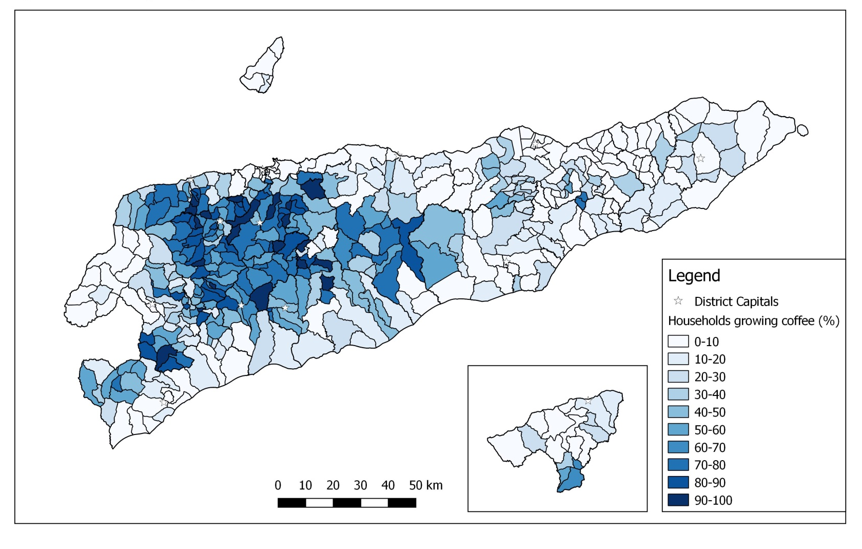

Figure S6. Map of villages of Timor-Leste coloured based by percent households planting rice.

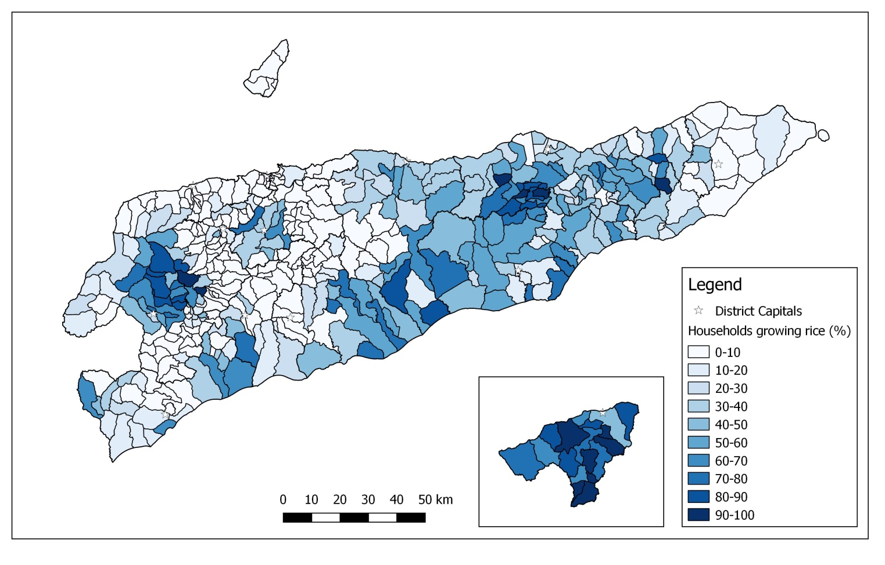

Figure S7. Map of villages of Timor-Leste coloured based by percent households raising sheep.

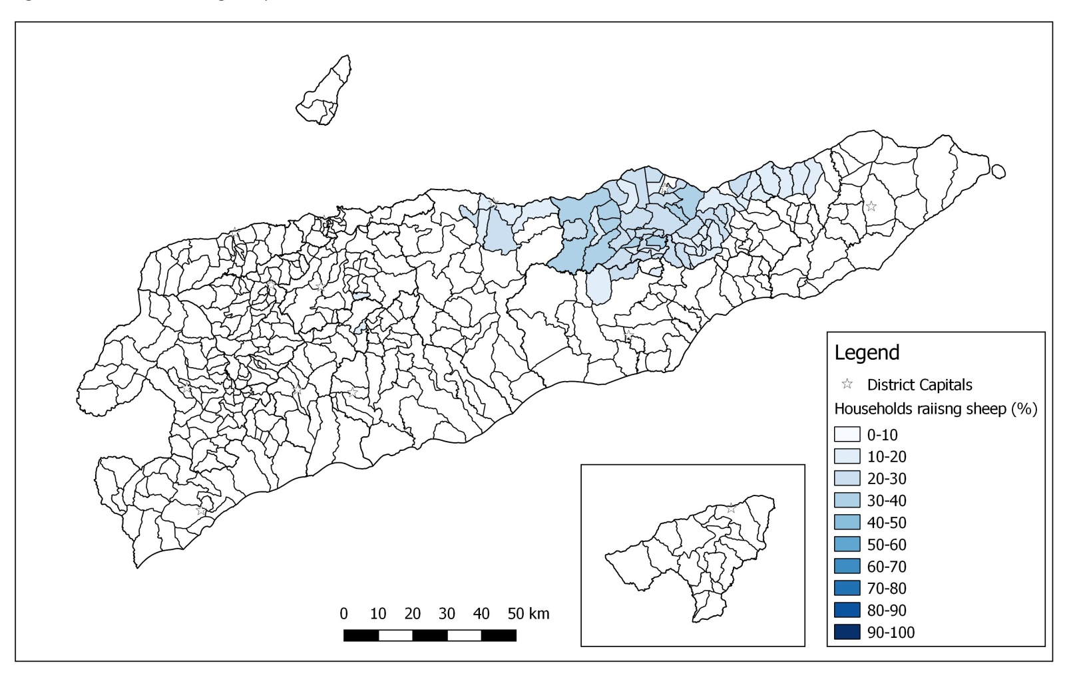

Figure S8. Map of villages of Timor-Leste coloured based by percent households raising goats.

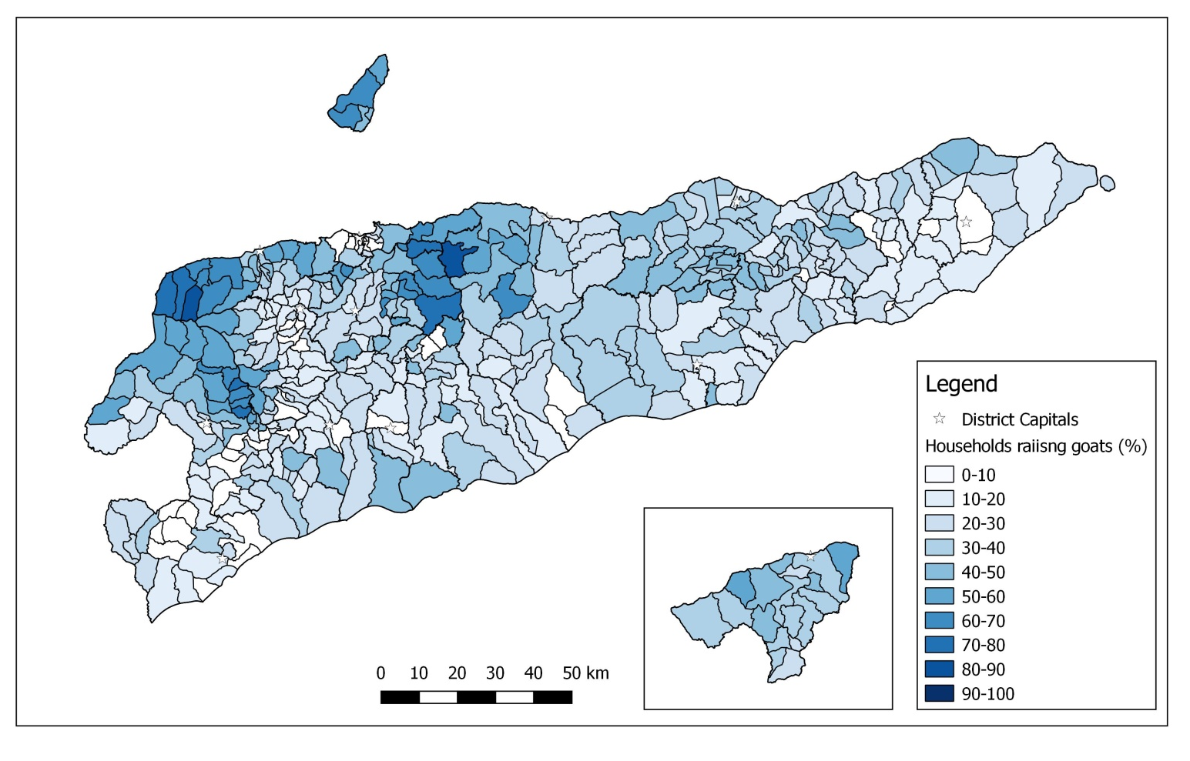

Figure S9. Map of villages of Timor-Leste coloured based by percent households raising cattle.

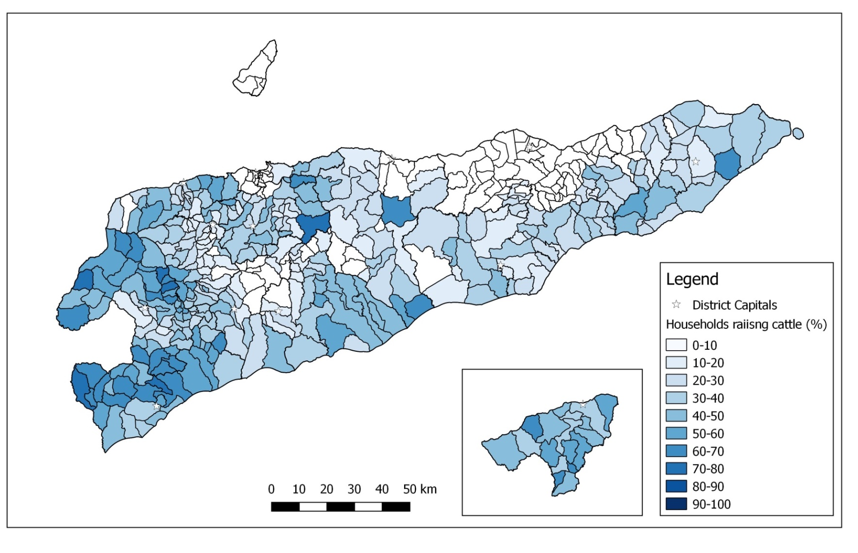

Figure S10. Map of villages of Timor-Leste coloured based by percent households raising buffalo.

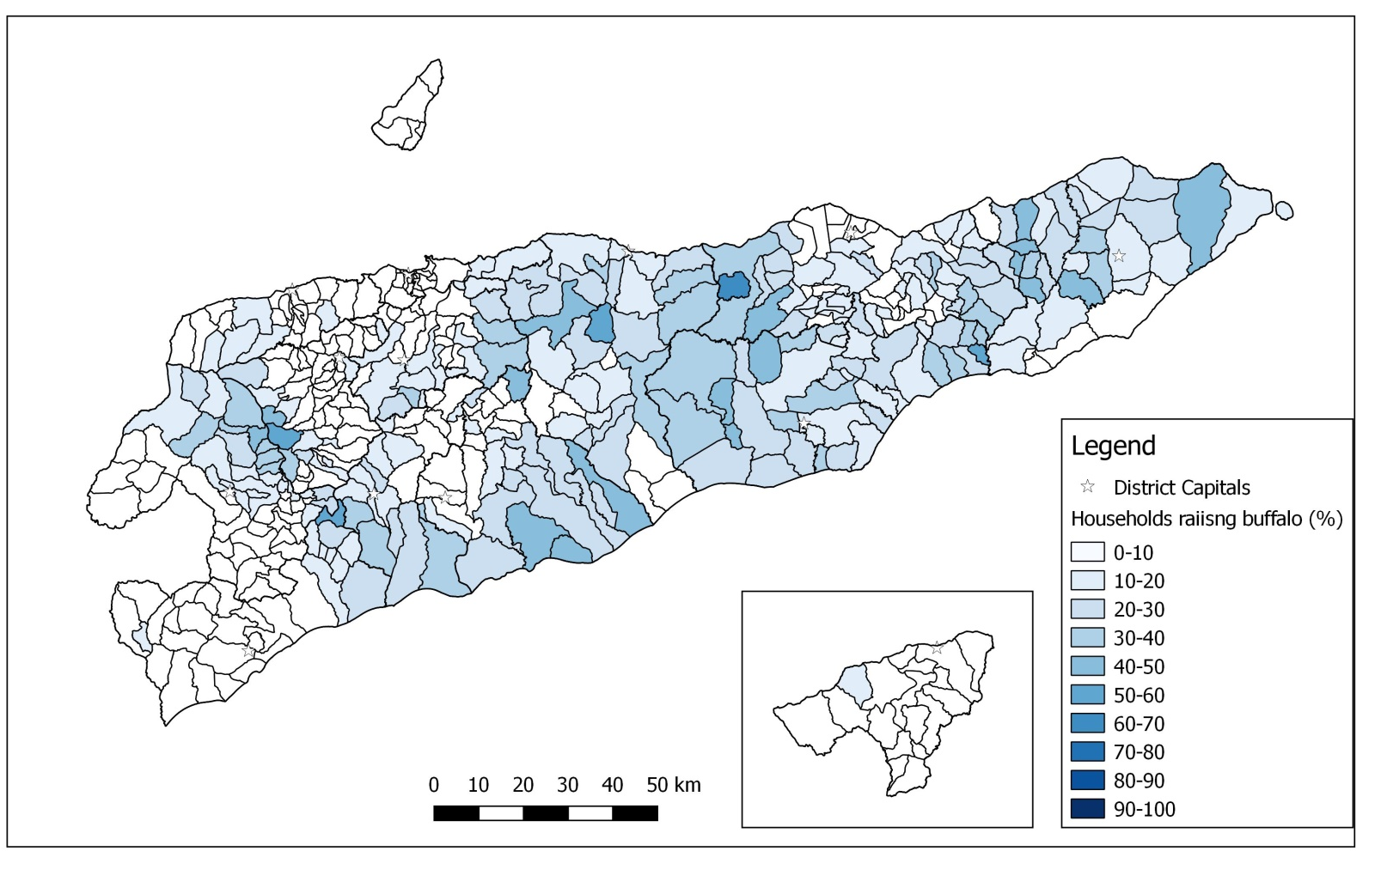

Figure S11. Map of livelihood systems of Timor-Leste with village boundaries.

Table S1. Output matrix showing the number of villages in each of the eleven groups based on cluster analysis and the seven zone typology.

Cluster analysis output (11 livelihoods) | Each of the seven zones
 | North coast irrigated | Mid altitude irrigated | South coast irrigated | Mid altitude uplands | High altitude uplands | Northern rainfed | Southern rainfed
Rice buffalo cows: Low diversity | 2 | 8 | 29 | 16 | 4 | 13 | 12
Rice and upland cropping : Low animal diversity | 2 | 4 | 30 | 16
Rice High diversity | 3 | 5 | 9 |  |  | 2 | 5
Goats coconut non-rice |  |  |  | 1 | 1 | 8
Coffee non rice : V low animals |  |  |  | 8 | 24
Coffee non rice low diversity |  |  | 1 | 50 | 12 | 6 | 9
Coffee and coconuts High diversity |  |  |  | 2 | 1
Coffee low diversity |  |  |  | 6 | 11 | 6 | 1
Cow low diversity |  | 2 | 7 |  |  | 17 | 21
Sheep and buffalo low diversity | 4 | 1 | 6 |  |  | 9
Non specialized : Low diversity | 1 |  | 3 |  | 1 | 17 | 18

Table S2. Characteristics are elevation (m above sea level, asl), annual rainfall total (mm), population density, adult literacy rate (%), percent births delivered by trained assistant, access to electricity (%), percent of female headed households, improved water supply (%), net school enrolment rate (%), sex ratio, distance (km) by road to the district capital, distance (km) by road to national capital, Dili, and a village asset index (ADB, 2013).
Livelihood zone | Annual Rain (mm) | Elevation (m) | Adult Literacy rate (%) | Births delivered by trained assistant (%) | Population density (people km⁻²) | Households with mains electricity connenction (%) | Female headed households (%) | Households with improved Sanitation (%) | Households with improved water (%) | Net primary school enrolment rate (%) | Sex ratio | Asset Index ¹ | Distance to national capital (km) | Distance to district capital (km)
1. North coast irrigated areas | 1242 | 400 | 45 | 31 | 62 | 34 | 19 | 32 | 57 | 62 | 104 | 0.63 | 218 | 18
2. Mid altitude irrigated areas | 1616 | 413 | 42 | 22 | 72 | 17 | 1 8 | 20 | 50 | 68 | 101 | -2.57 | 170 | 31
3. South coast irrigated areas | 1715 | 145 | 55 | 31 | 65 | 22 | 14 | 22 | 47 | 71 | 105 | -1.12 | 197 | 51
4. Mid elevation uplands | 1938 | 754 | 43 | 17 | 121 | 12 | 15 | 28 | 58 | 65 | 102 | -1.57 | 116 | 36
5. High elevation uplands | 2147 | 1418 | 40 | 14 | 131 | 10 | 16 | 18 | 51 | 63 | 102 | -1.67 | 89 | 40
6. North rain-fed areas | 1549 | 467 | 48 | 24 | 85 | 21 | 19 | 31 | 62 | 69 | 101 | 0.51 | 101 | 33
7. South rain-fed areas | 18677 | 316 | 50 | 23 | 60 | 21 | 17 | 24 | 61 | 77 | 100 | -1.77 | 200 | 35
F prob. | <0.001 | <0.001 | <0.001 | <0.001 | <0.001 | 0.006 | <0.001 | 0.009 | 0.045 |  | 0.229 | 0.003 | <0.001 | 0.028
L.S.D. (P<0.05) | 15 | 124 | 6.3 | 7.9 | 39 | 11 | 2.8 | 10 | 13 | 6.2 | ns | 2.1 | 27 | 12
¹ Asset index is based from the ADB (2013) score. Mean value is zero cross the country, with district means ranging from -2 to 3.

