Supplementary material

Table S1. Pearson correlations among soil and plant nutrient concentrations and ratios. Significant correlations are highlighted in bold type (n=84).

|  |  |  |  |  |  |  |
| --- | --- | --- | --- | --- | --- | --- |
| Variable | DOC | Available-N concentration | Available-P concentration | DOC:available-N ratio | DOC:available-P ratio | Available-N:available-P ratio |
| Foliar C concentration | 0.062 | **0.485\*\*** | **0.238\*** | -0.164 | **-0.211\*** | **0.399\*\*** |
| Foliar N concentration | **-0.217\*** | **0.545\*\*** | **0.823\*\*** | **-0.511\*\*** | **-0.515\*\*** | **0.197\*** |
| Foliar P concentration | **0.638\*\*** | **-0.490\*\*** | **-0.243\*** | **0.768\*\*** | **0.325\*\*** | **-0.485\*\*** |
| Foliar C:N ratio | 0.061 | **-0.500\*\*** | **-0.698\*\*** | **0.320\*\*** | **0.421\*\*** | **-0.181\*** |
| Foliar C:P ratio | **-0.741\*\*** | **0.609\*\*** | **0.424\*\*** | **-0.836\*\*** | **-0.542\*\*** | **0.498\*\*** |
| Foliar N:P ratio | **-0.602\*\*** | **0.643\*\*** | **0.765\*\*** | **-0.782\*\*** | **-0.616\*\*** | **0.305\*\*** |
| Stem C concentration | **0.246\*** | **0.311\*\*** | 0.007 | 0.081 | -0.106 | **0.292\*\*** |
| Stem N concentration | **-0.374\*\*** | **0.670\*\*** | **0.813\*\*** | **-0.620\*\*** | **-0.624\*\*** | **0.328\*\*** |
| Stem P concentration | **0.645\*\*** | **-0.592\*\*** | **-0.301\*\*** | **847\*\*** | **0.446\*\*** | **-0.552\*\*** |
| Stem C:N ratio | 0.116 | **-0.552\*\*** | **-0.688\*\*** | **0.353\*\*** | **0.543\*\*** | **-0.213\*** |
| Stem C:P ratio | **-0.609\*\*** | **0.708\*\*** | **0.289\*\*** | **-0.809\*\*** | **-0.555\*\*** | **0.657\*\*** |
| Stem N:P ratio | **-0.554\*\*** | **0.791\*\*** | **0.605\*\*** | **-0.790\*\*** | **-0.636\*\*** | **0.577\*\*** |
| Root C concentration | **0.482\*\*** | -0.109 | **-0.565\*\*** | **0.448\*\*** | **0.365\*\*** | 0.091 |
| Root N concentration | **-0.557\*\*** | **0.712\*\*** | **0.573\*\*** | **-0.670\*\*** | **-0.622\*\*** | **0.492\*\*** |
| Root P concentration | **0.549\*\*** | **-0.736\*\*** | **-0.540\*\*** | **0.746\*\*** | **0.635\*\*** | **-0.510\*\*** |
| Root C:N ratio | **0.458\*\*** | **-0.600\*\*** | **-0.599\*\*** | **0.616\*\*** | **0.606\*\*** | **-0.364\*\*** |
| Root C:P ratio | **-0.516\*\*** | **0.767\*\*** | **0.349\*\*** | **-0.622\*\*** | **-0.523\*\*** | **0.616\*\*** |
| Root N:P ratio | **-0.581\*\*** | **0.755\*\*** | **0.433\*\*** | **-0.634\*\*** | **-0.553\*\*** | **0.568\*\*** |

*, significant correlation at *P*<0.05; **, significant correlation at *P*<0.01.

DOC = Soil dissolved organic carbon

**Table S2**. Test statistics for squared Mahalanobis distances among treatments with different levels of steel slag amendment with soil Ca, Si, K, Mg, N, and P availabilities; DOC and MBC concentrations; the ratios of DOC:available N, DOC:available P, and available N:available P; foliar, stem, and root N, P, and C concentrations and C:N, C:P, and N:P concentration ratios; foliar, stem, root, and total biomasses; and rice yield as variables.

|  |  |  |  |
| --- | --- | --- | --- |
| Mg steel slag ha-1 | Mg steel slag ha-1 | | |
| 2 | 4 | 8 |
| 0 | SM= 102  *F*=19.5  *P*<0.0001 | SM = 327  *F*=62.4  *P*<0.0001 | SM = 663  *F*=126  *P*<0.0001 |
| 2 |  | SM = 127  *F*=24.3  *P*<0.0001 | SM = 102  *F*=380  *P*<0.0001 |
| 4 |  | | SM = 102  *F*=113  *P*<0.0001 |

SM=Squared Mahalanobis distances.

**Table S3**. Main effects of the variables in the GDA analysis. Statistics (Wilks’ λ and *P*) of the discriminant functional analysis among treatments with soil Ca, Si, K, Mg, N, and P availabilities; DOC and MBC concentrations; the ratios of DOC:available N, DOC:available P, and available N:available P; foliar, stem, and root N, P, and C concentrations and C:N, C:P, and N:P concentration ratios; foliar, stem, root, and total biomasses; and rice yield as variables. Significant effects of a variable in the model are highlighted in bold type (*P*<0.05).

|  |  |  |
| --- | --- | --- |
| Independent variable | Wilks’ λ | *P* |
| MBC concentration | 0.646 | **<0.0001** |
| DOC concentration | 0.830 | **0.028** |
| Available-N concentration | 0.816 | **0.019** |
| Available-P concentration | 0.832 | **0.034** |
| Available-K concentration | 0.962 | 0.60 |
| Available-Si concentration | 0.631 | **<0.0001** |
| Available-Ca concentration | 0.595 | **<0.0001** |
| Available-Mg concentration | 0.451 | **<0.0001** |
| DOC:available-N ratio | 0.594 | **<0.0001** |
| DOC:available-P ratio | 0.525 | **<0.0001** |
| Available-N:available-P ratio | 0.851 | **0.050** |
| Foliar C concentration | 0.656 | **0.00014** |
| Foliar N concentration | 0.826 | **0.026** |
| Foliar P concentration | 0.765 | **0.0046** |
| Stem C concentration | 0.718 | **0.0011** |
| Stem N concentration | 0.867 | 0.074 |
| Stem P concentration | 0.973 | 0.73 |
| Root C concentration | 0.682 | **0.00034** |
| Root N concentration | 0.875 | 0.091 |
| Root P concentration | 0.791 | **0.0098** |
| Foliar C:N ratio | 0.946 | 0.44 |
| Foliar C:P ratio | 0.769 | **0.0052** |
| Foliar N:P ratio | 0.737 | **0.0020** |
| Stem C:N ratio | 0.681 | **0.00033** |
| Stem C:P ratio | 0.851 | **0.049** |
| Stem N:P ratio | 0.891 | 0.13 |
| Root C:N ratio | 0.949 | 0.47 |
| Root C:P ratio | 0.828 | **0.027** |
| Root N:P ratio | 0.852 | 0.051 |
| Rice yield | 0.180 | **<0.0001** |
| Shoot biomass | 0.775 | **0.0062** |
| Root biomass | 0.654 | **0.00013** |
| Total biomass | 0.356 | **<0.0001** |

**Figure legends**

Figure S1.The location of the study area and sampling sites (▲) in Fujian Province, southeastern China.

Figure S2. Concentrations of MBC (A), DOC (B), available N (C), available P (D), available K (E), available Si (F), available Ca (G), and available Mg (H) during the growing season in the soils of the control and various treatments of steel slag application. Different letters indicate significant differences between treatments (*P*<0.05).

Figure S3. Ratios of soil DOC:available N (A), soil DOC:available P (B), and soil available N:available P (C) during the growing season in the soils of control and the various treatments of steel slag application. Different letters indicate significant differences between treatments (*P*<0.05).

Figure S4. Concentrations of foliar C (A), foliar N (B), foliar P (C), stem C (D), stem N (E), stem P (F), root C (G), root N (H), and root P (I) during the growing season in control and the various treatments of steel slag application. Different letters indicate significant differences between treatments (*P*<0.05).

Figure S5. Foliar C:N (A), foliar C:P (B), foliar N:P (C), stem C:N (D), stem C:P (E), stem N:P (F), root C:N (G), root C:P (H), and root N:P (I) ratios during the growing season in the plant organs from control and the various treatments of steel slag application. Different letters indicate significant differences between treatments (*P*<0.05).

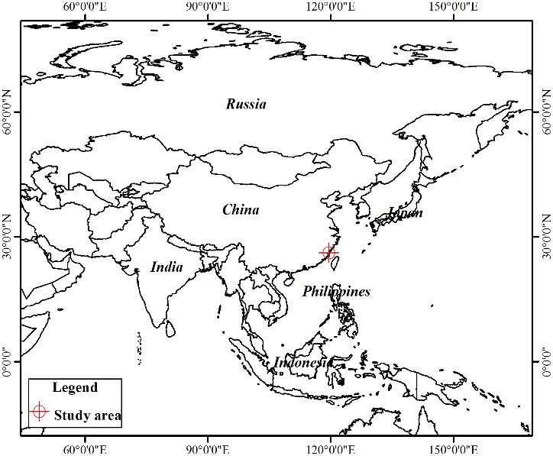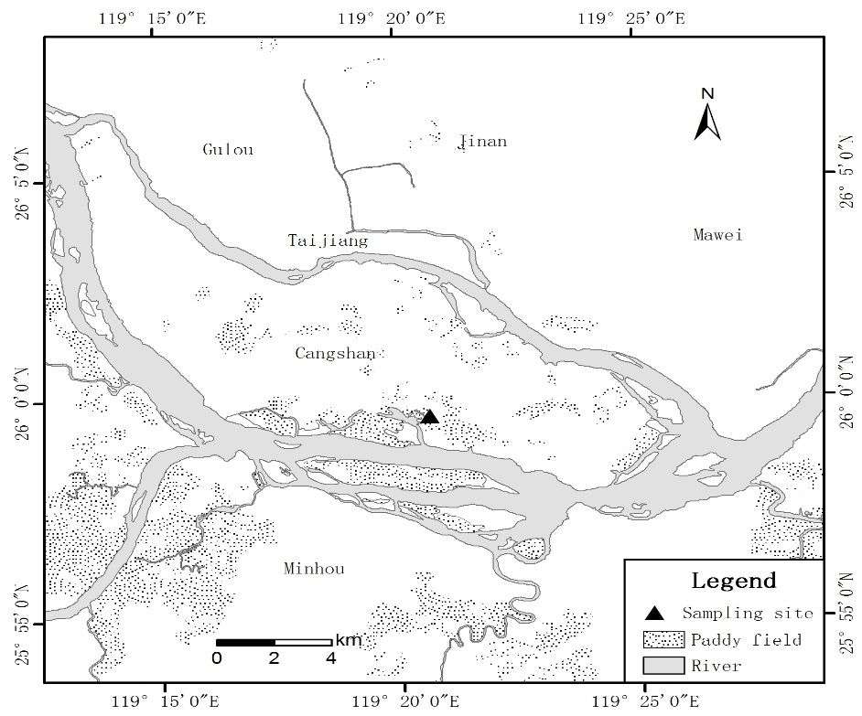

Figure S1



Figure S2







Figure S3

   

 

Figure S4

 

 

  

Figure S5