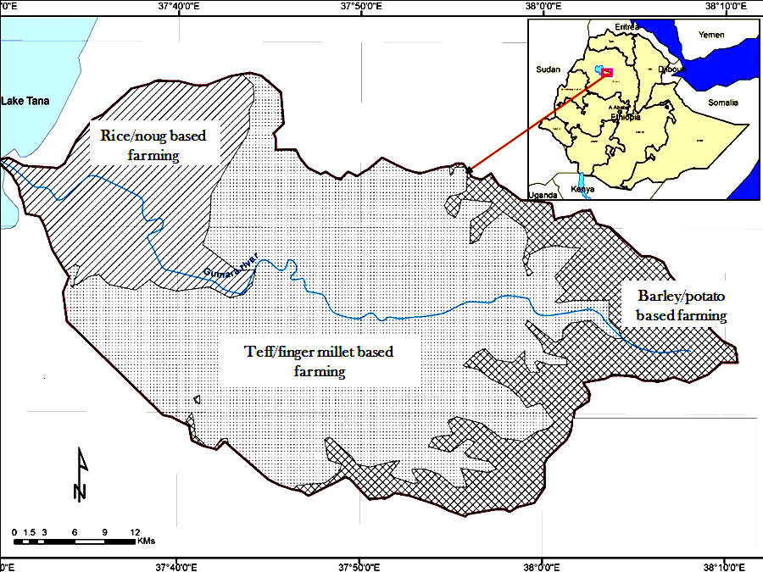

Figure S1. Gumera watershed with its prevailing mixed farming systems.

