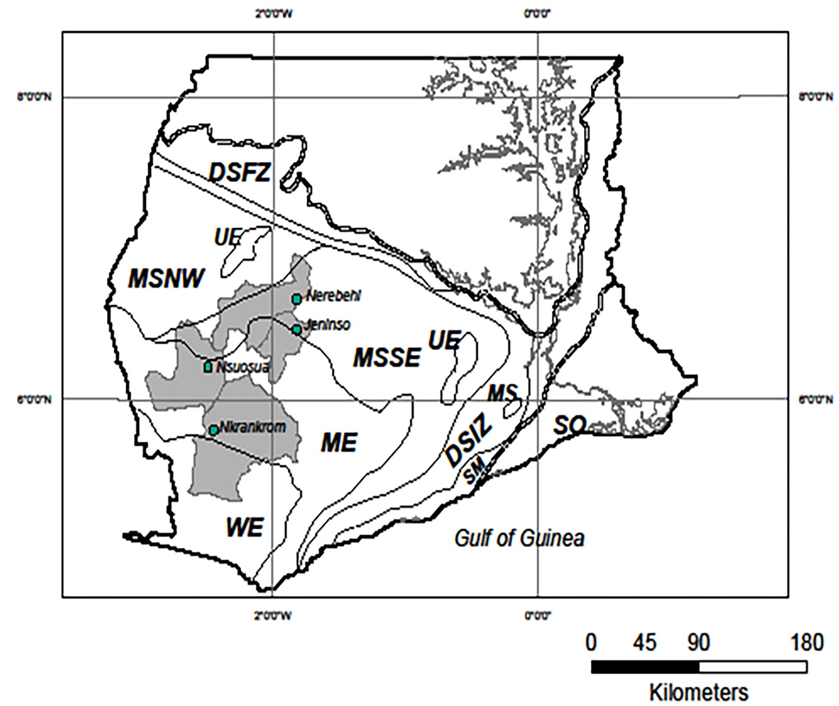
Figure S1: Map of Southern Ghana showing four shaded districts consisting of the study sites (•). Forest type boundaries are shown by broken line (-----). Forest-type abbreviations: WE=Wet Evergreen; UE=Upland Evergreen; ME=Moist Evergreen; MSSE=Moist Semi-deciduous; NW=Northwest subtype; SE=Southeast subtype; DS= Dry Semi-deciduous; FZ=Fire Zone subtype; IZ=Inner Zone subtype; SM=Southern Marginal [adapted from Asare and Ræbild (2016)]

