Supporting Information

Influence of Zirconia on sintering behavior and mechanical properties of Reaction Sintered Mullite-based Composite Ceramics
Zhenying Liu ^{1,} ^{2, 3*}, Nan Xie ¹, Shouwu Huang¹, Hanxin Zhang ¹,
Chongmei Wu ¹, Kai Cui ¹, Yin Liu ^{1,} ^{2, 3*}, Hongzheng Zhu ¹, Jinbo Zhu ^{1, 2} and Changguo Xue ¹
¹ School of Materials Science and Engineering, Anhui University of Science and Technology, Huainan 232001, Anhui, China
² State Key Laboratory of Mining Response and Disaster Prevention and Control in Deep Coal Mines, Anhui University of Science and Technology, Huainan 232001, Anhui, China
³ Anhui International Joint Research Center for Nano Carbon-based Materials and Environmental Health, Anhui University of Science and Technology, Huainan 232001, Anhui, China

*Corresponding authors: zyliu@aust.edu.cn (Zhenying Liu)
Experimental
Raw materials
Kaolin (Anhui Jinyan Kaolin Technology Co. Ltd., China) and alumina (Al₂O₃, analytical pure, Xilong Scientific Co. Ltd., China) powders were used as the starting materials. Zirconia (ZrO₂, purity >99%, Tianjin Fuchen Chemical Reagent Factory, china) was used as an additives, magnesium oxide (MgO, purity >99.9%, Sinopharm Chemical Reagent Co. Ltd., China) was used as a sintering aid. The XRD pattern of the kaolin is presented in Fig. S1 (a). The main crystalline phases of kaolin are kaolinite (Al₄(OH)₈(Si₄O₁₀), PDF # 78-2109) and quartz (SiO₂, PDF # 82-511). Fig. S1 (b) shows the particle size distribution (frequency and cumulative distribution) of kaolin. Obviously, the particle size distribution of kaolin presents a three-peak distribution (peaks located at 0.17, 2.15 and 16.72 μm), which resulted possibly from the soft agglomeration of primary particles. The average particle size was 11.2μm.
Fig. S1. (a) XRD pattern and (b) particle size distribution of kaolin.
Composite ceramics preparation
Firstly, the starting materials are mixed for 1 h in a planetary ball mill according to the proportion shown in Table S1. Then, adding the polyvinyl alcohol solution (5 wt.%) for granulation. The granulated mixtures were compressed into the required green body (cylindrical samples: Φ: 15 x5 mm, rectangular samples: 40 x 40 x 5 mm) under 20 MPa uniaxial pressure. Finally, after being dried at 100 °C for 24 h, the samples were heat treated in muffle furnace at 1450 °C, 1500 °C, 1520 °C, 1540 °C, and 1560 °C for 3 h with a 5 ℃/min heating rate. The sintered samples are designed as AZS0, AZS3, AZS6, AZS9, AZS12, corresponding to the ZrO₂ contents of 0, 3, 6, 9, 12 wt.% shown in Table S1.
Table S1: The formulated compositions of AZS samples (wt. %).
Sample no. | Content
 | Kaolin | Al₂O₃ | ZrO₂ | Sintering aid (MgO)
AZS0 | 46 | 54 | 0 | 2
AZS3 | 46 | 54 | 3 | 2
AZS6 | 46 | 54 | 6 | 2
AZS9 | 46 | 54 | 9 | 2
AZS12 | 46 | 54 | 12 | 2
characterization
The bulk density and apparent porosity of the sintered samples were measured by the Archimedes method. The formula to calculate the results is given as follow (1) and (2)：
(1)
(2)
In the formula, D_{ρ} represents the bulk density of the samples (g/cm³), P represents the porosity of the samples (%), ρ represents the density of water (g/cm³), M₁ represents the mass of the samples after drying (g), M₂ represents the mass of the samples in water (g), and M₃ represents the mass of the samples with free bubbles on the surface (g).
The flexural strength of the samples was measured by ceramic bending strength tester (WDW-50, Kaiqiangli, China) according to Fig. S2. Five polished strip samples were tested to obtain an average value. The span and loading speed were 30 mm and 0.5 mm/min, respectively. The specific calculation formula is shown in (3)：
(3)
where σ is the flexural strength (MPa), F is the maximum load (N), $\text{L}$ is the length, and a and b are the width and height of the samples, respectively.
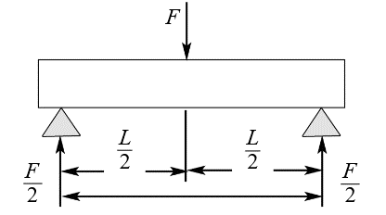
Fig. S2. Schematic diagram of mechanical properties experiment
The single-edge notch beam method (SENB) was used to measure the fracture toughness of the samples. The span and loading speed were 30mm and 0.5mm/min, respectively. The specific calculation formula is shown in (4) and (5)：
(4)
(5)
Where K_{IC} is the fracture toughness (MPa·m^{1/2}), L is the mold span, c is the crack depth (c=b/2, mm). The other symbols and meanings are the same as those in the flexural strength formula.

The experimental data
Table S2: The calculation data of sintering performance of samples.
Sample no. |  | 1450 ℃ | 1500 ℃ | 1520 ℃ | 1540 ℃ | 1560 ℃
AZS0 | Bulk density (g/cm³) | 2.30 | 2.36 | 2.31 | 2.28 | 2.43
 | Apparent porosity (%) | 24.15% | 21.56% | 24.54% | 28.42% | 20.62%
AZS3 | Bulk density (g/cm³) | 2.29 | 2.44 | 2.39 | 2.35 | 2.60
 | Apparent porosity (%) | 25.29% | 19.10% | 22.18% | 23.40% | 13.69%
AZS6 | Bulk density (g/cm³) | 2.39 | 2.59 | 2.56 | 2.42 | 2.72
 | Apparent porosity (%) | 22.32% | 12.45% | 17.27% | 22.95% | 10.01%
AZS9 | Bulk density (g/cm³) | 2.41 | 2.55 | 2.46 | 2.42 | 2.62
 | Apparent porosity (%) | 23.15% | 17.10% | 19.87% | 24.10% | 16.48%
AZS12 | Bulk density (g/cm³) | 2.41 | 2.58 | 2.47 | 2.48 | 2.72
 | Apparent porosity (%) | 23.68% | 17.72% | 21.93% | 22.59% | 12.17%

Table S3: The calculation data of flexural strength of samples.
Sample no. |  | Flexural strength (MPa) |  |  | Mean value |  | Standard deviation
AZS0 | 1500 ℃ | 52.68 | 58.11 | 60.79 | 57.19 | 4.13
 | 1560 ℃ | 63.71 | 66.70 | 67.11 | 65.84 | 1.86
AZS3 | 1500 ℃ | 57.53 | 64.19 | 58.80 | 60.17 | 3.54
 | 1560 ℃ | 82.98 | 76.42 | 70.76 | 76.72 | 6.11
AZS6 | 1500 ℃ | 70.04 | 77.38 | 78.10 | 75.17 | 4.46
 | 1560 ℃ | 87.56 | 82.74 | 82.02 | 84.11 | 3.01
AZS9 | 1500 ℃ | 72.87 | 64.99 | 67.01 | 68.29 | 4.09
 | 1560 ℃ | 74.68 | 83.52 | 75.50 | 77.90 | 4.89
AZS12 | 1500 ℃ | 80.71 | 85.42 | 80.66 | 82.26 | 2.73
 | 1560 ℃ | 98.55 | 88.89 | 87.51 | 91.65 | 6.01

Table S4: The calculation data of fracture toughness of samples.
Sample no. |  | fracture toughness (MPa·m^{1/2}) |  |  | Mean value |  | Standard deviation
AZS0 | 1560 ℃ | 1.83 | 1.67 | 1.72 | 1.74 | 0.08
AZS3 | 1560 ℃ | 1.98 | 1.82 | 1.93 | 1.91 | 0.08
AZS6 | 1560 ℃ | 2.28 | 2.06 | 2.14 | 2.16 | 0.11
AZS9 | 1560 ℃ | 1.99 | 1.92 | 2.06 | 1.99 | 0.07
AZS12 | 1560 ℃ | 2.54 | 2.45 | 2.42 | 2.47 | 0.06

Appearance image of the sample
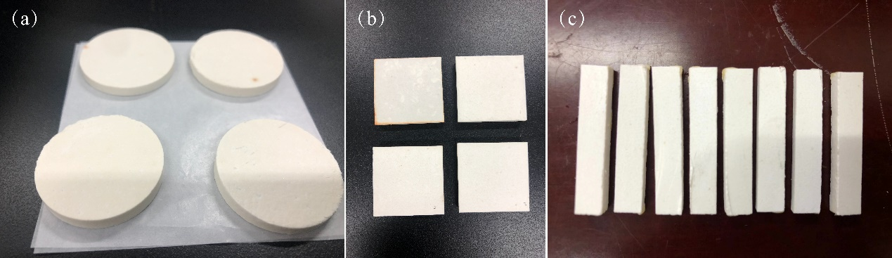
Fig. S3. The samples of after sintering: (a) used for measuring sintering properties, (b) used for measuring mechanical properties, (c) is cut sample of (b).

