Study on the adsorption mechanisms of NH₃, H₂S, and SO₂ on sepiolite via molecular dynamics simulations
Ji Zhou^{1,2}, Zuozhang Wang², Ana C. S. Alcântara^{3∗}, Yanhuai Ding^{1,2∗}
¹College of Civil and Environmental Engineering, Hunan University of Science and Engineering, Yongzhou, 425199, China
²Institute of Rheological Mechanics, Xiangtan University, 411105, Xiangtan, Hunan, China
³Department of Chemistry, Universidade Federal do Maranhão, 65080-805 São Luís - MA, Brazil
Corresponding author: yhding@xtu.edu.cn
Figures:
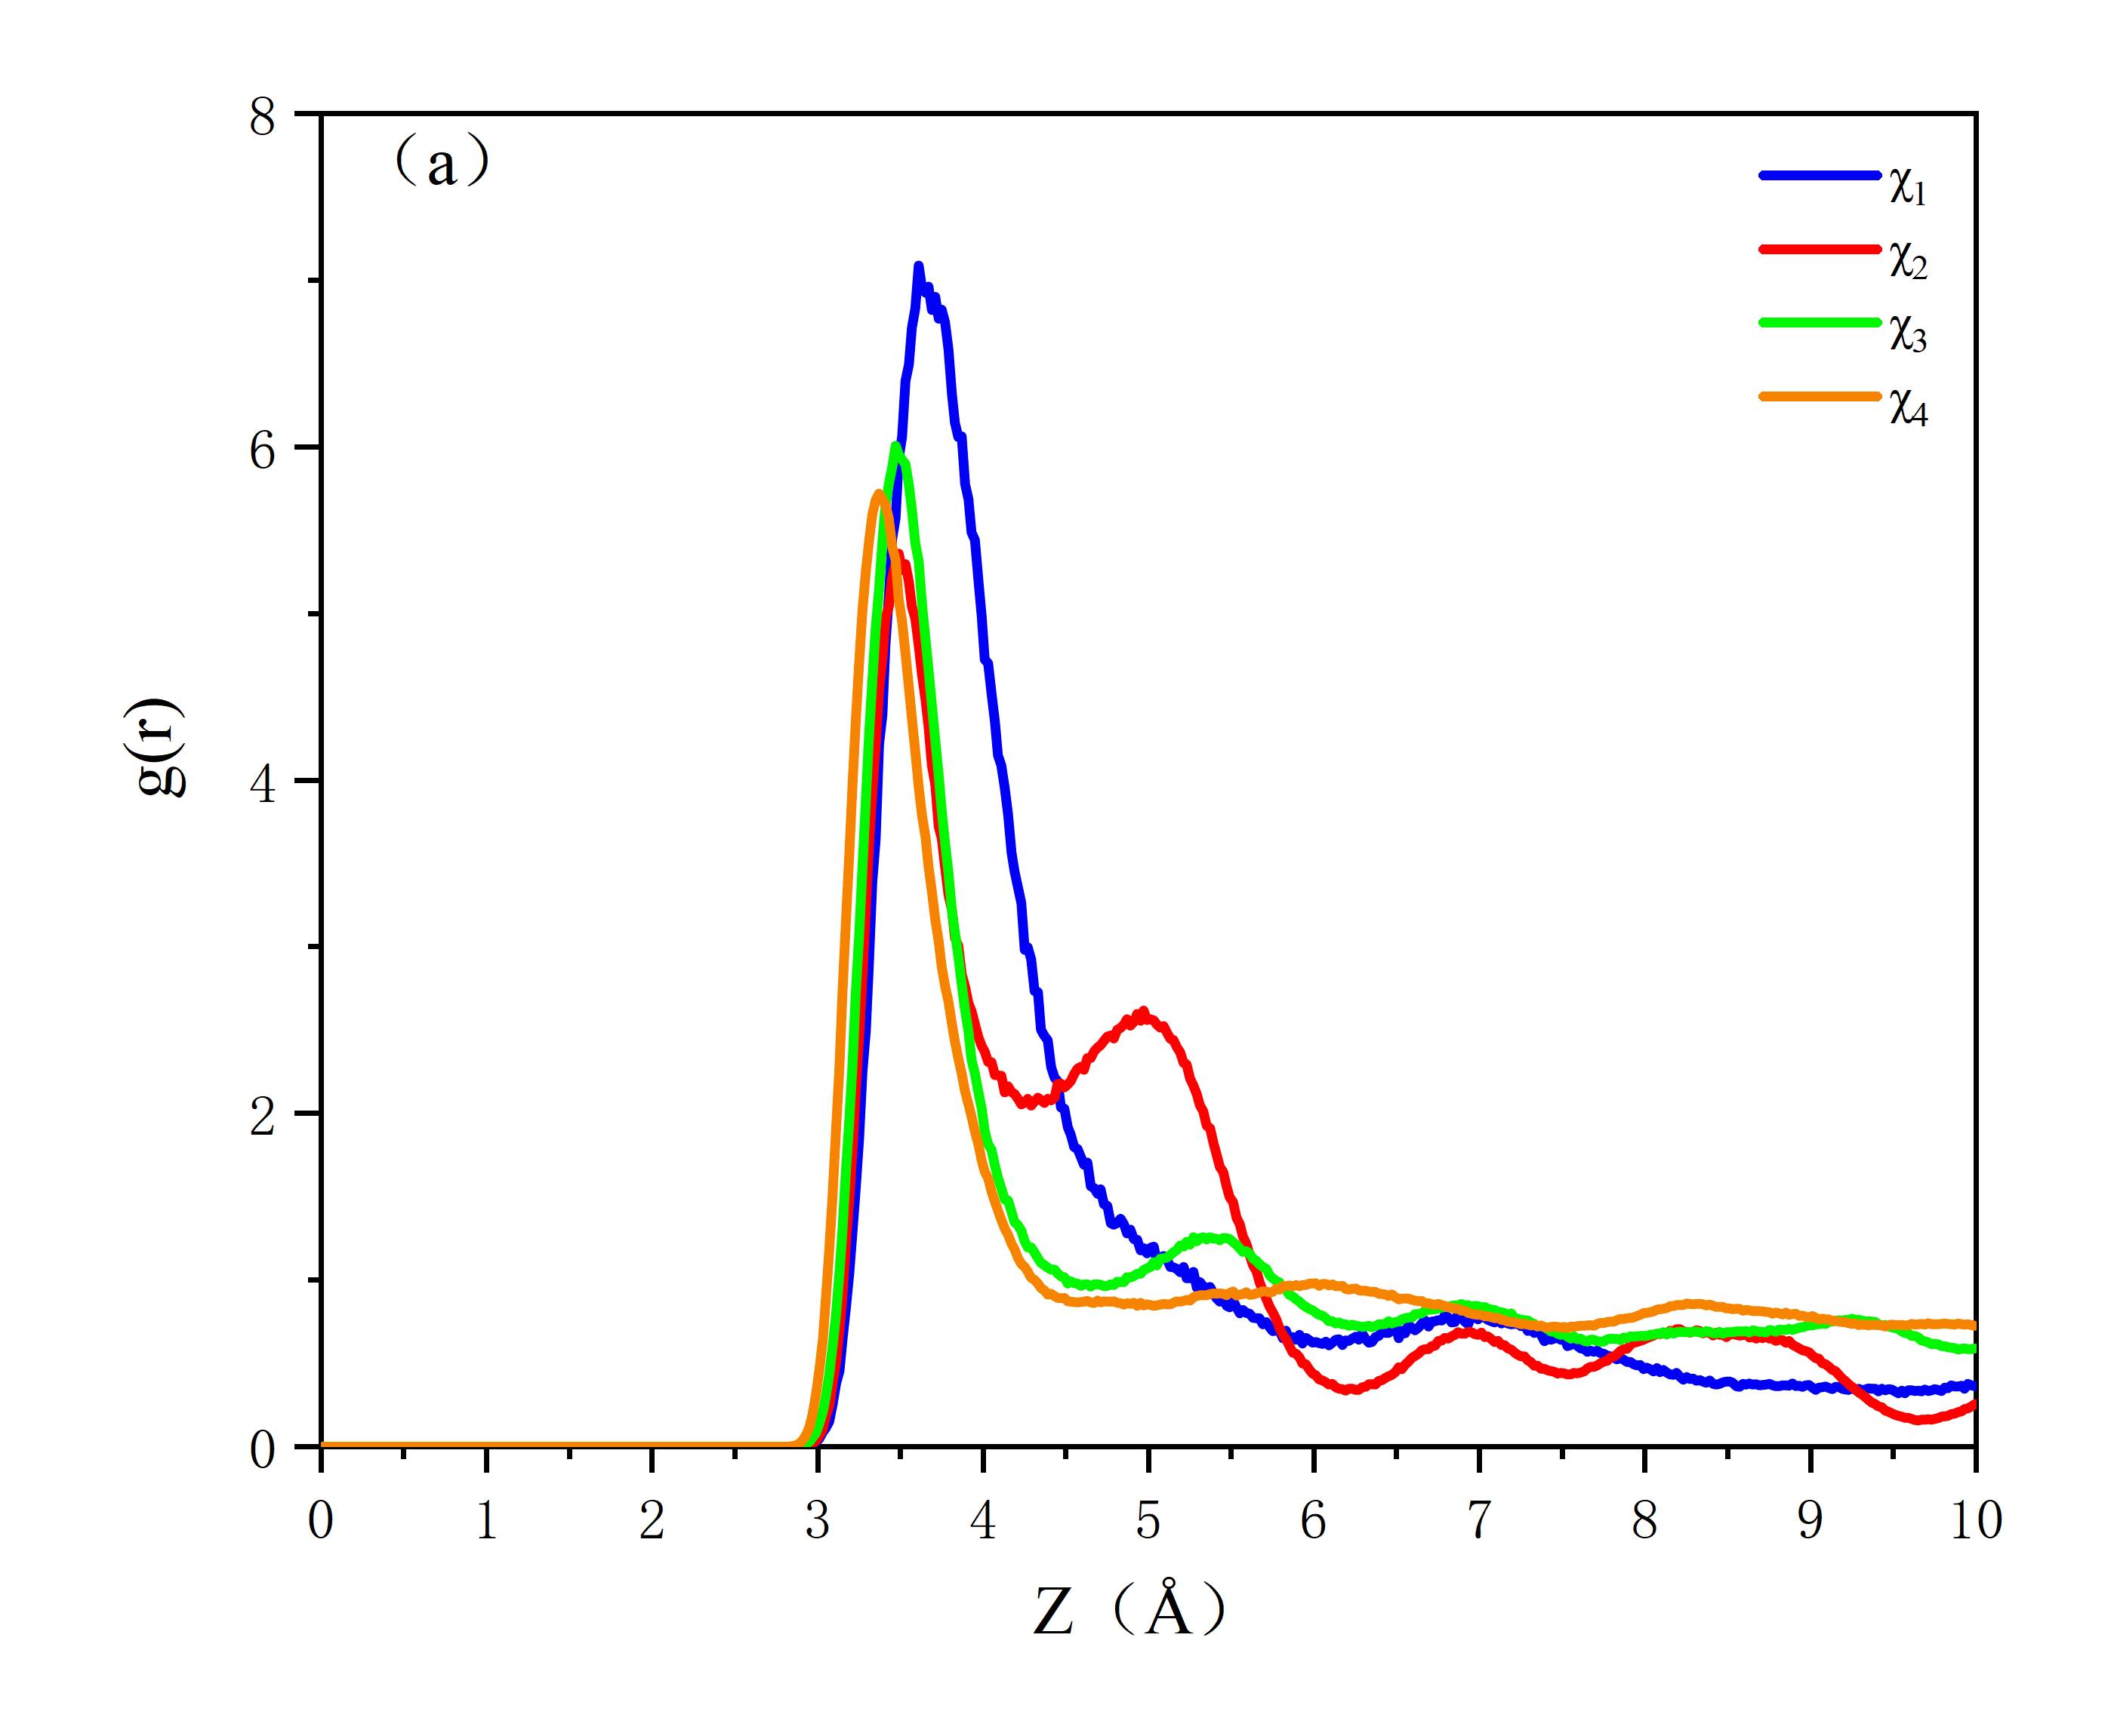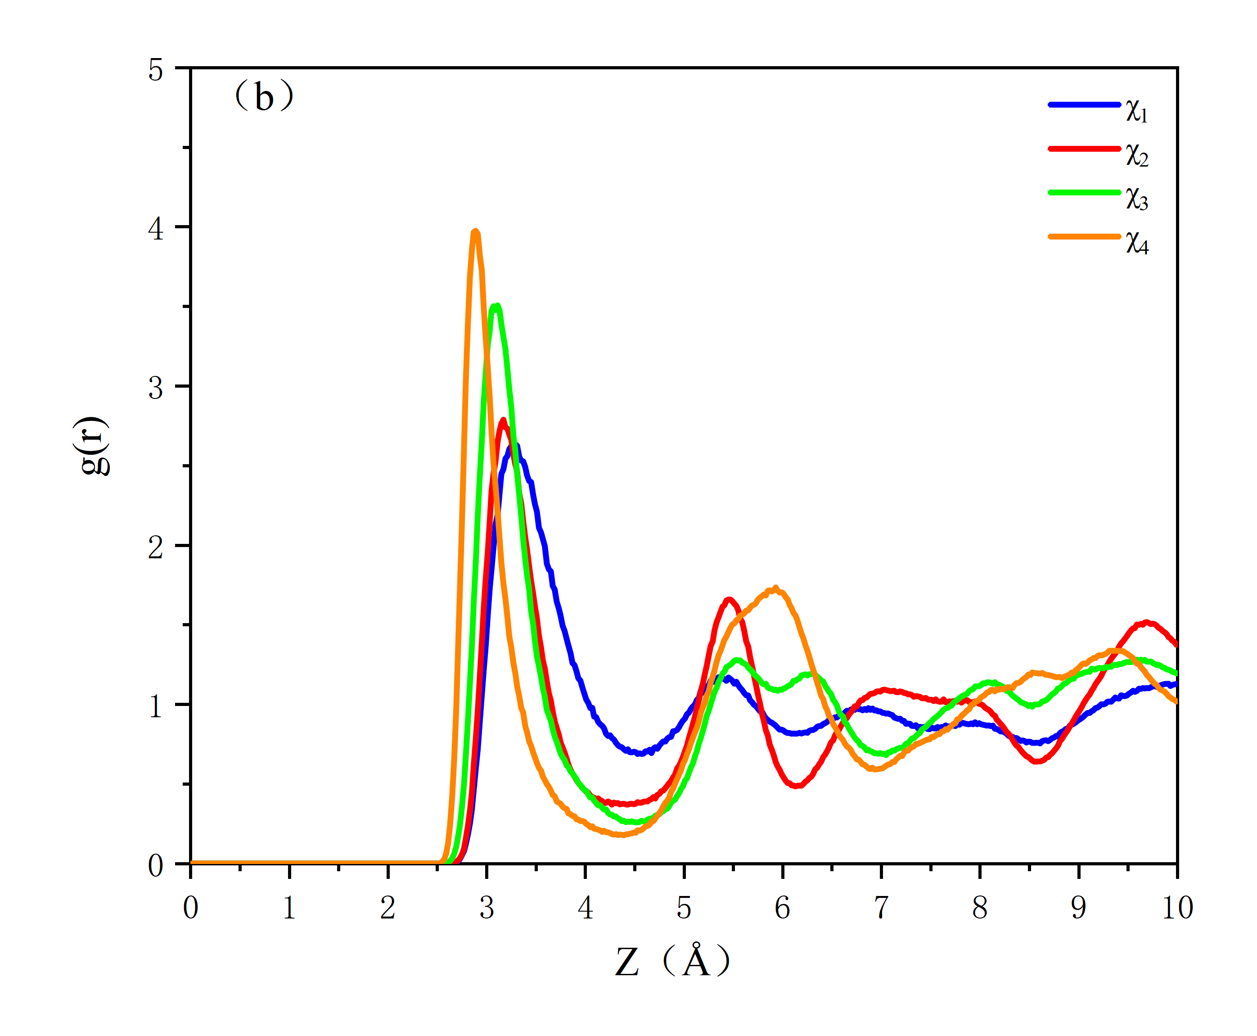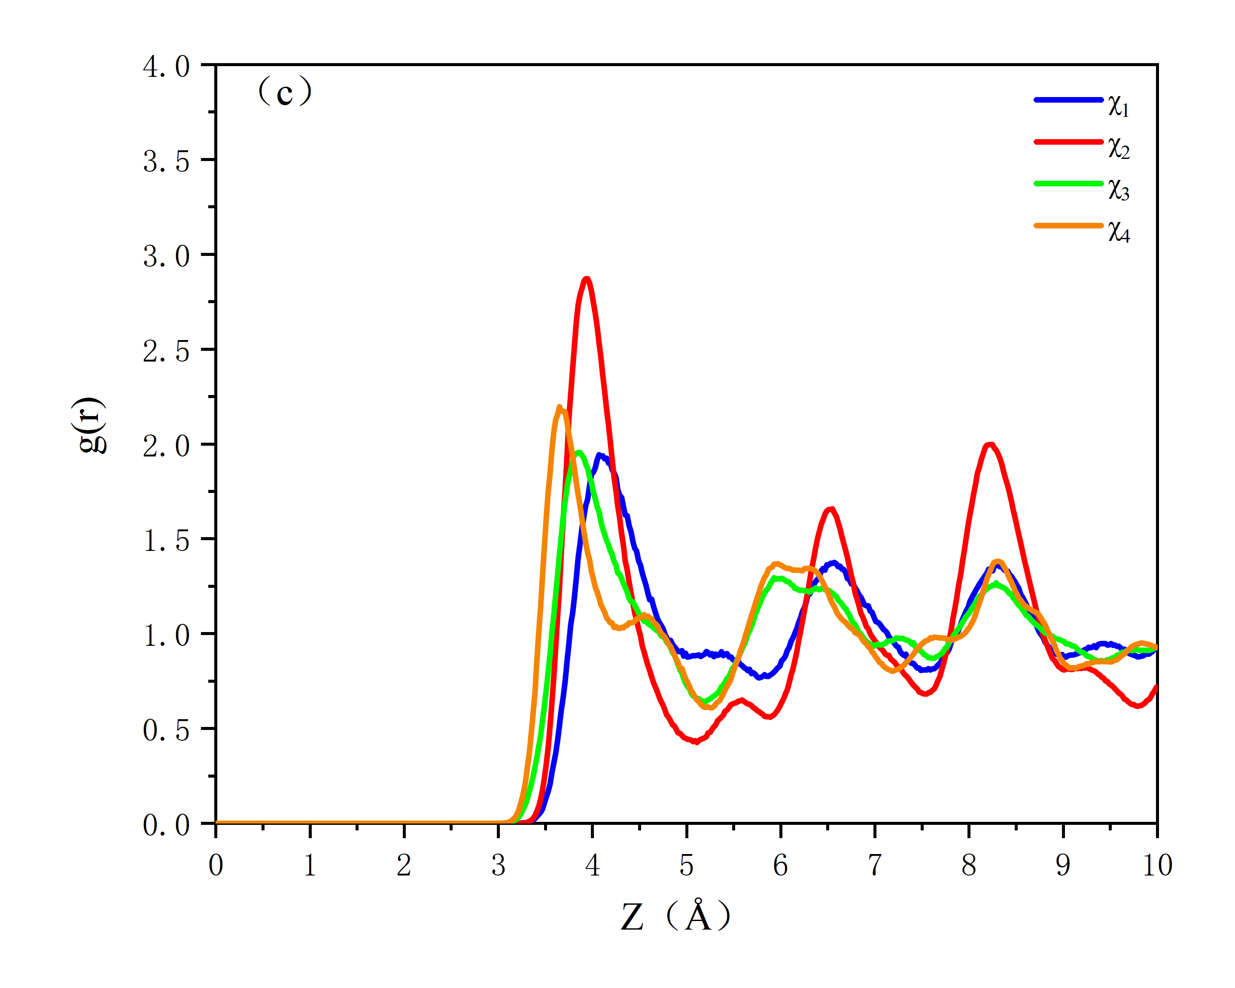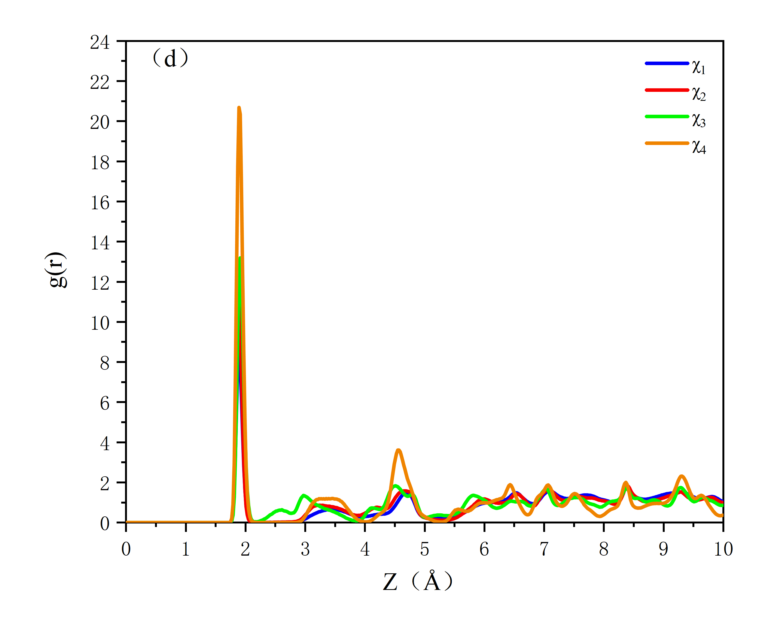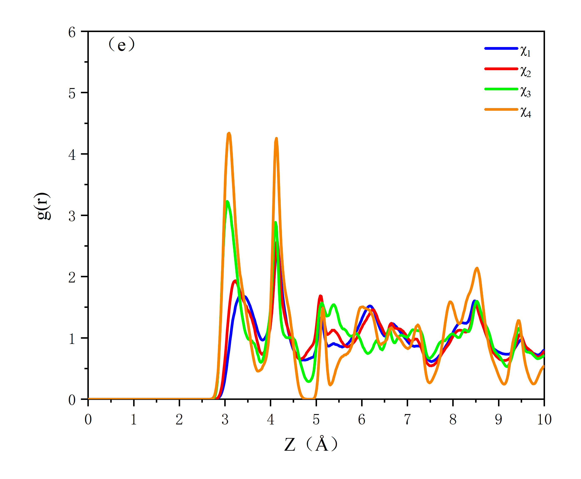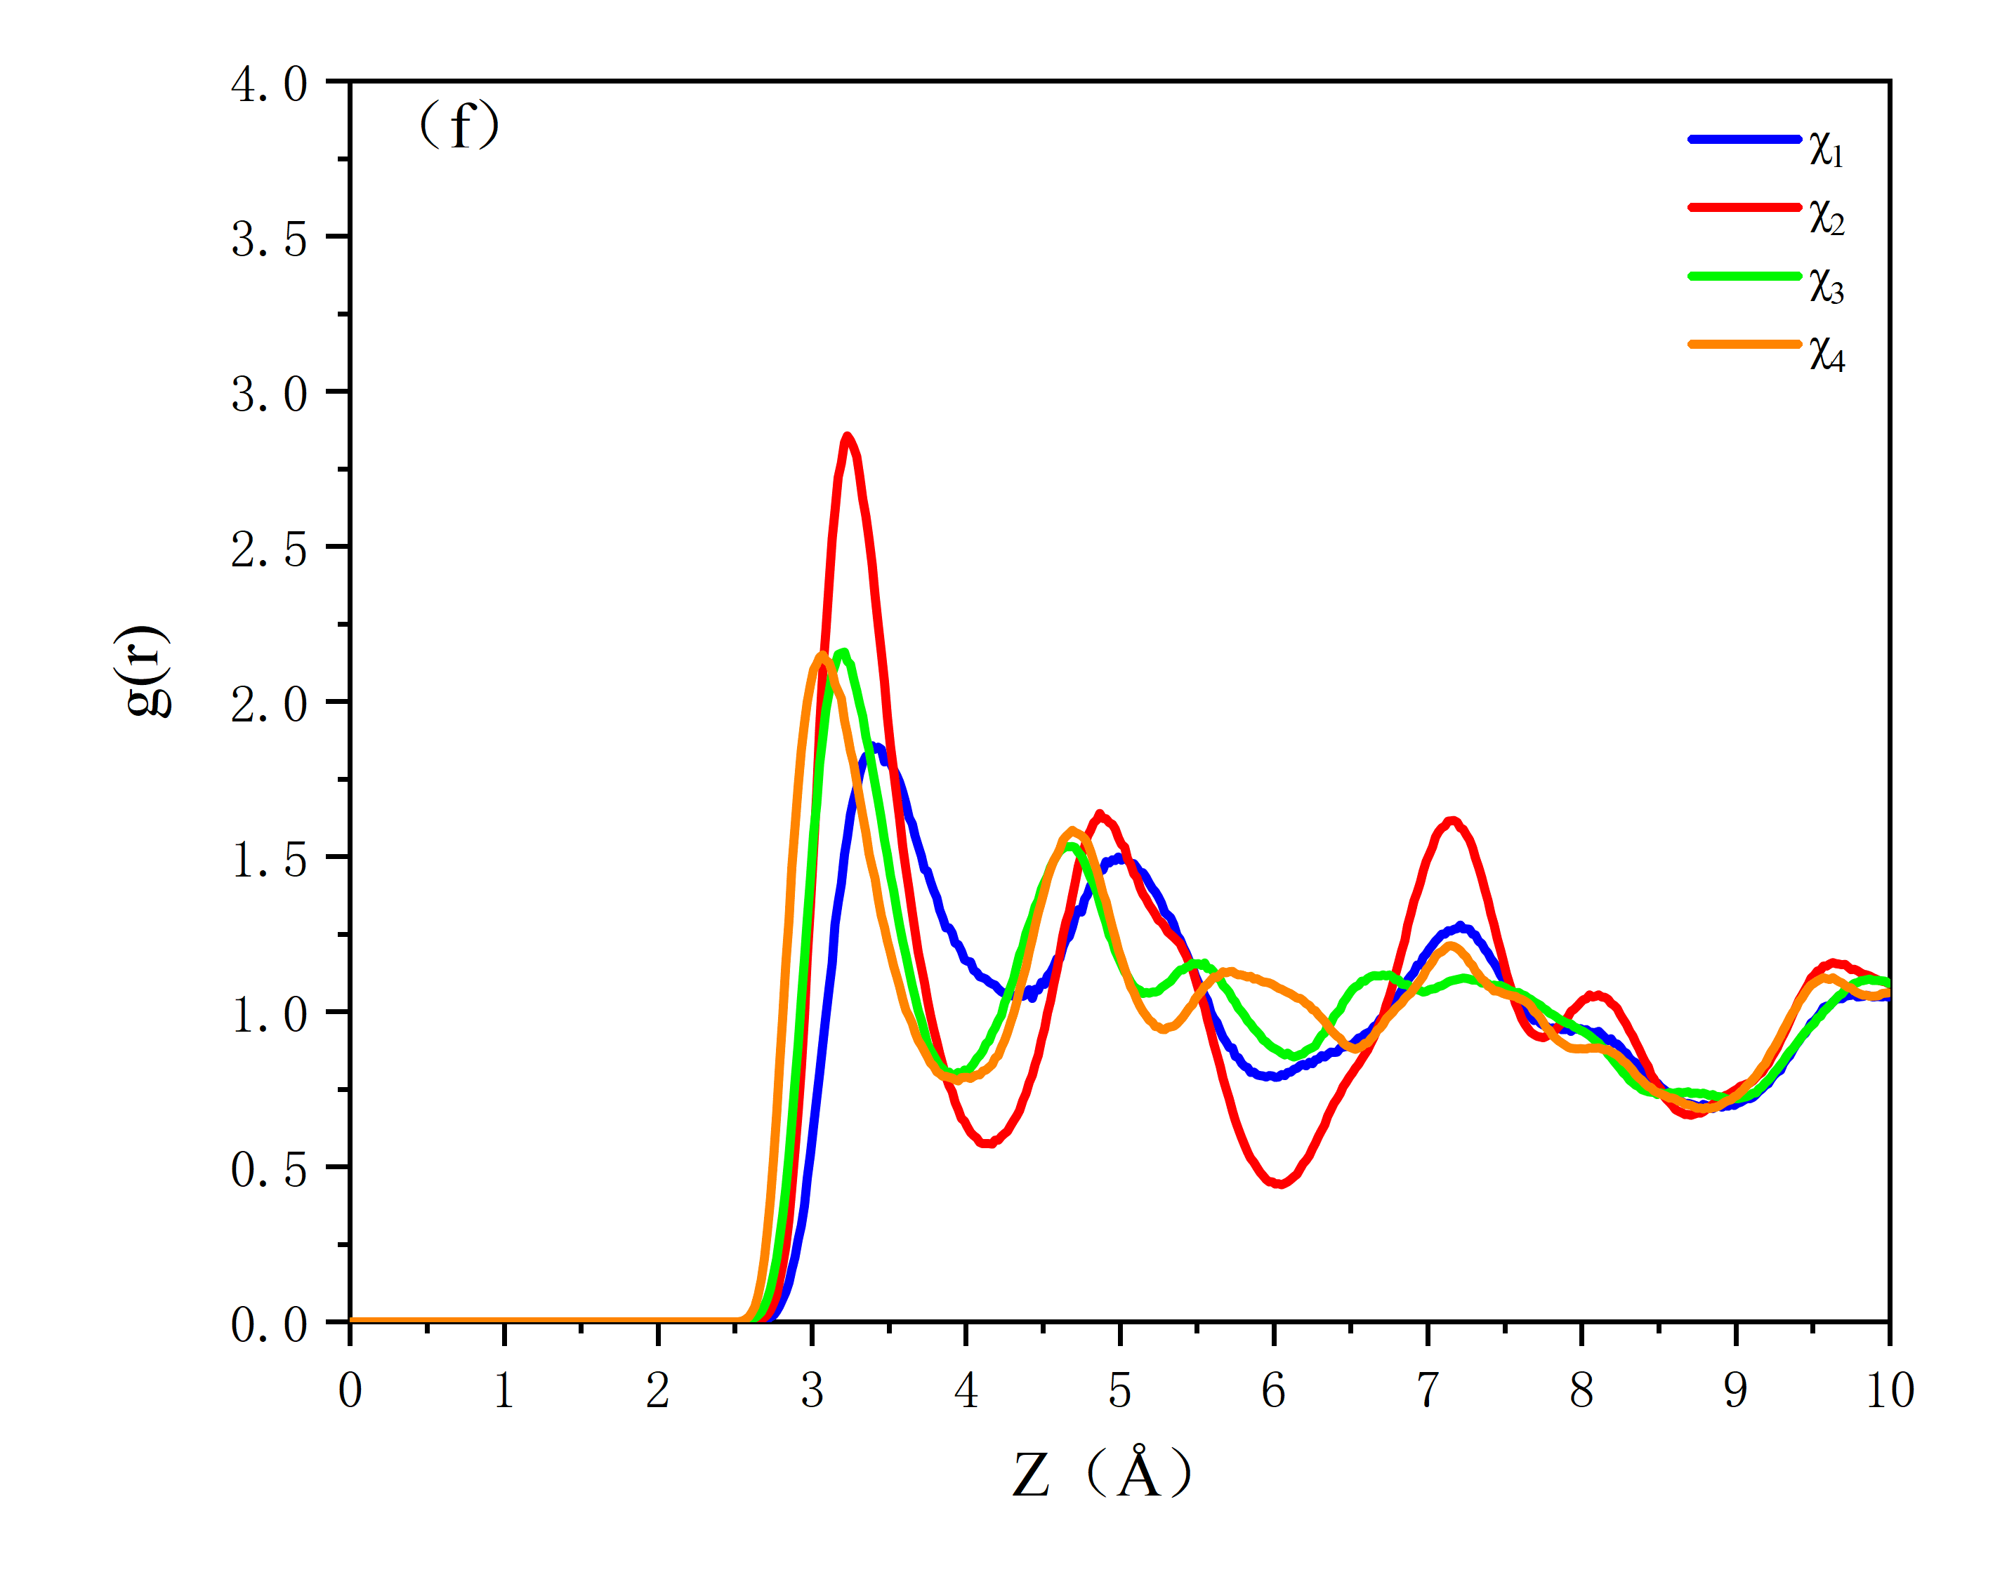
Fig.s1 RDF patterns of H₂S adsorption with different values of χ_{i}. (a) S-S; (b) S-O_{w}; (c) S-Si; (d) Mg-O_{w}; (e) Si-O_{w}; (f) S-O_{s}. S: S atom in H₂S; O_{w}: O atom in zeolitic water molecule; Si: Si atom in sepiolite; Mg: Mg atom in sepiolite; Os: O atom in structural water molecule.
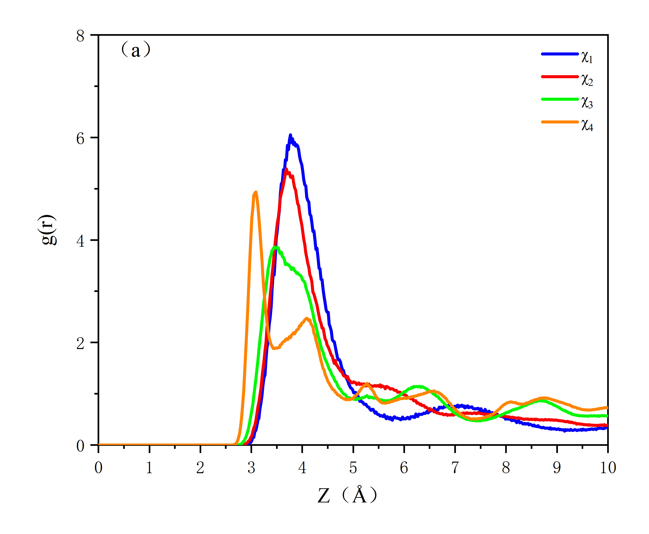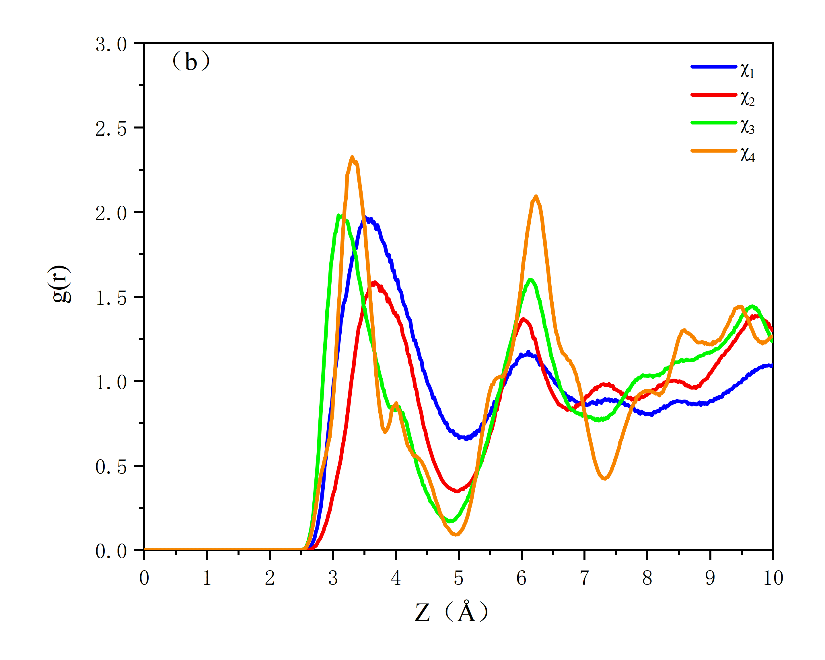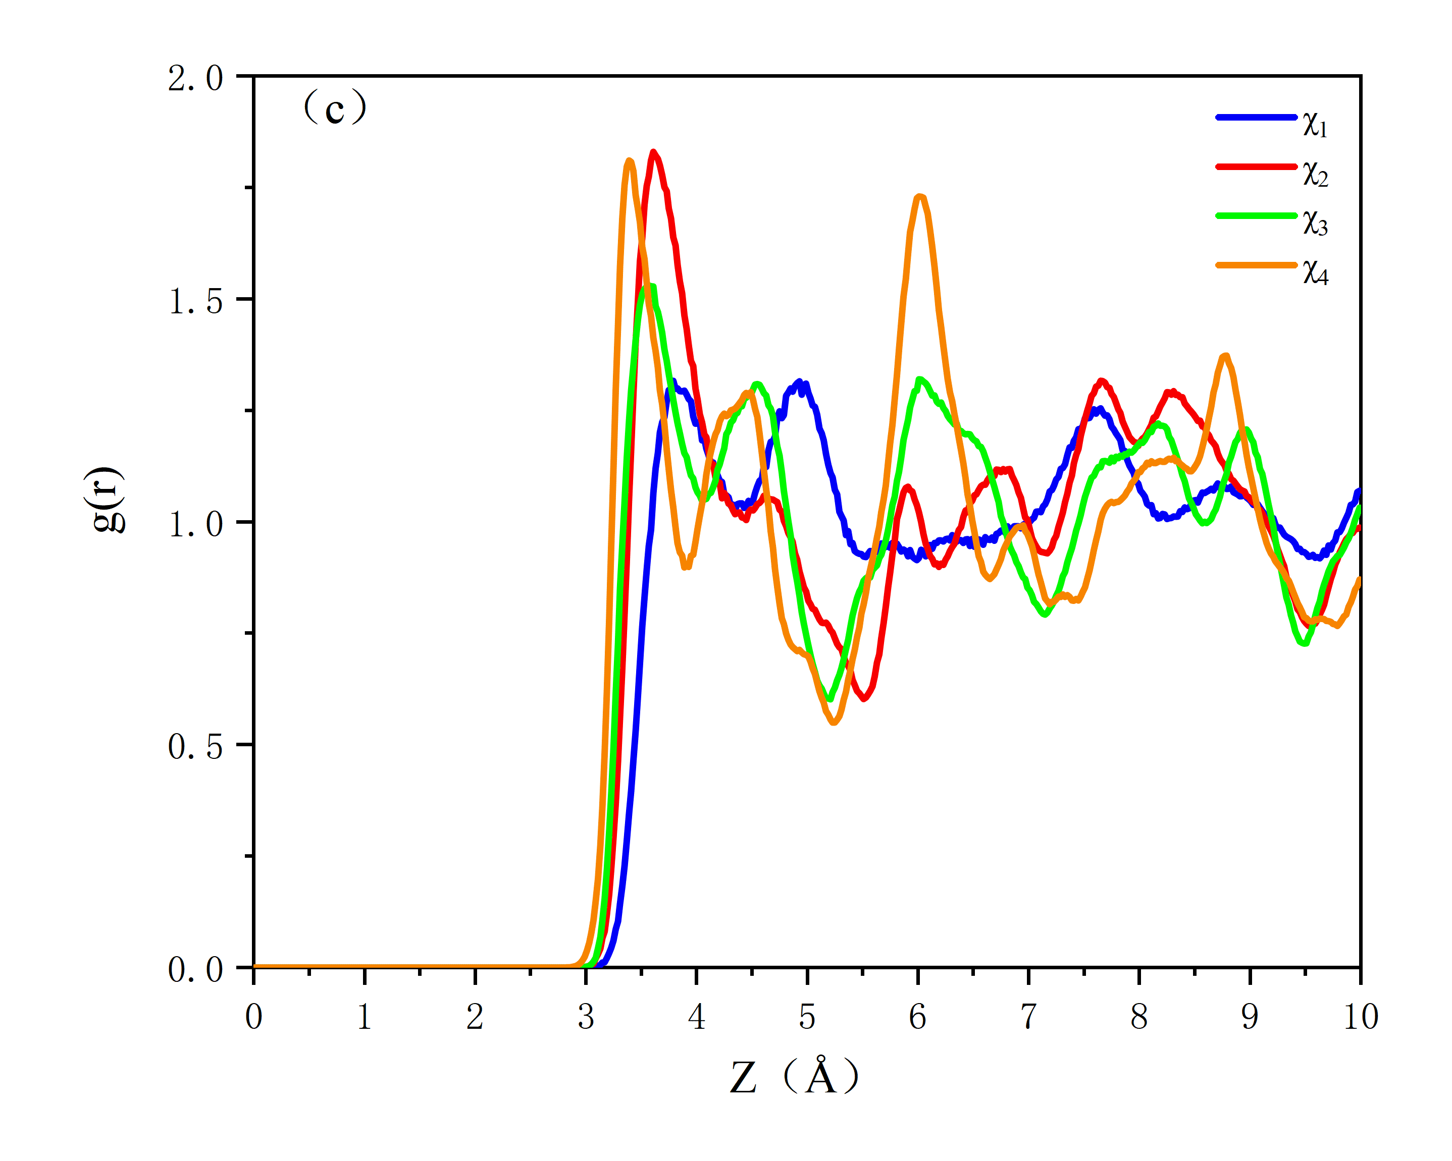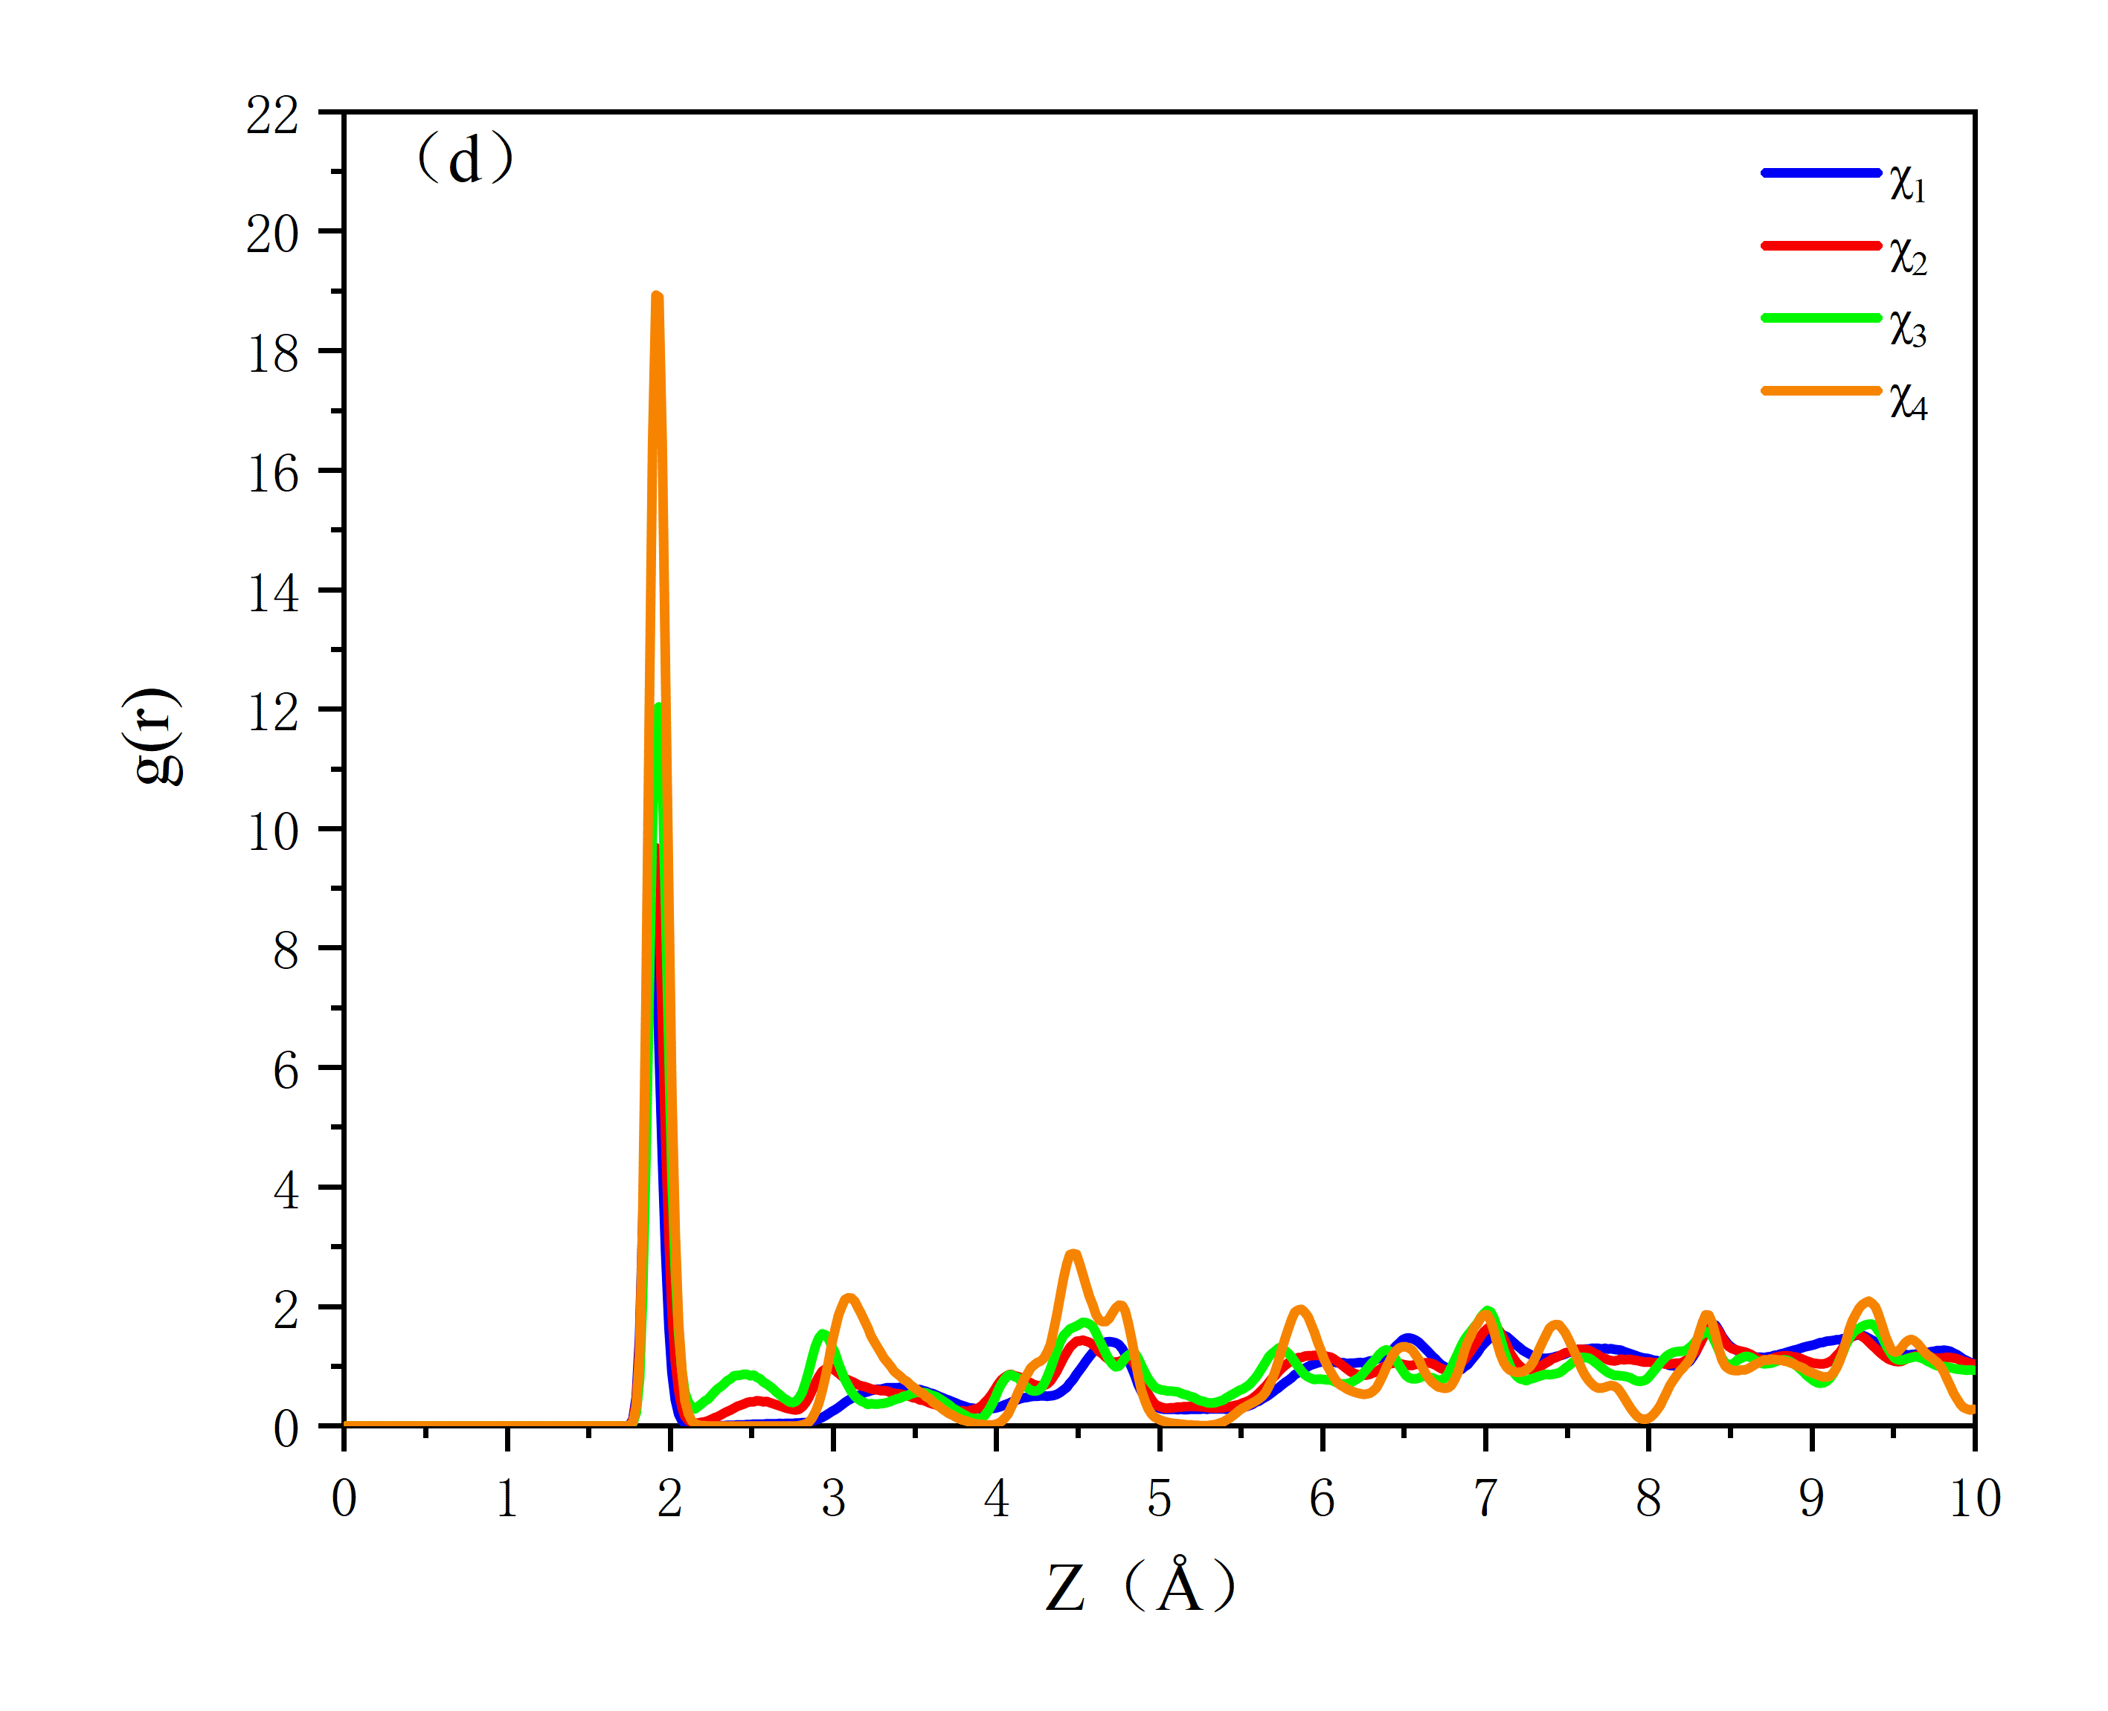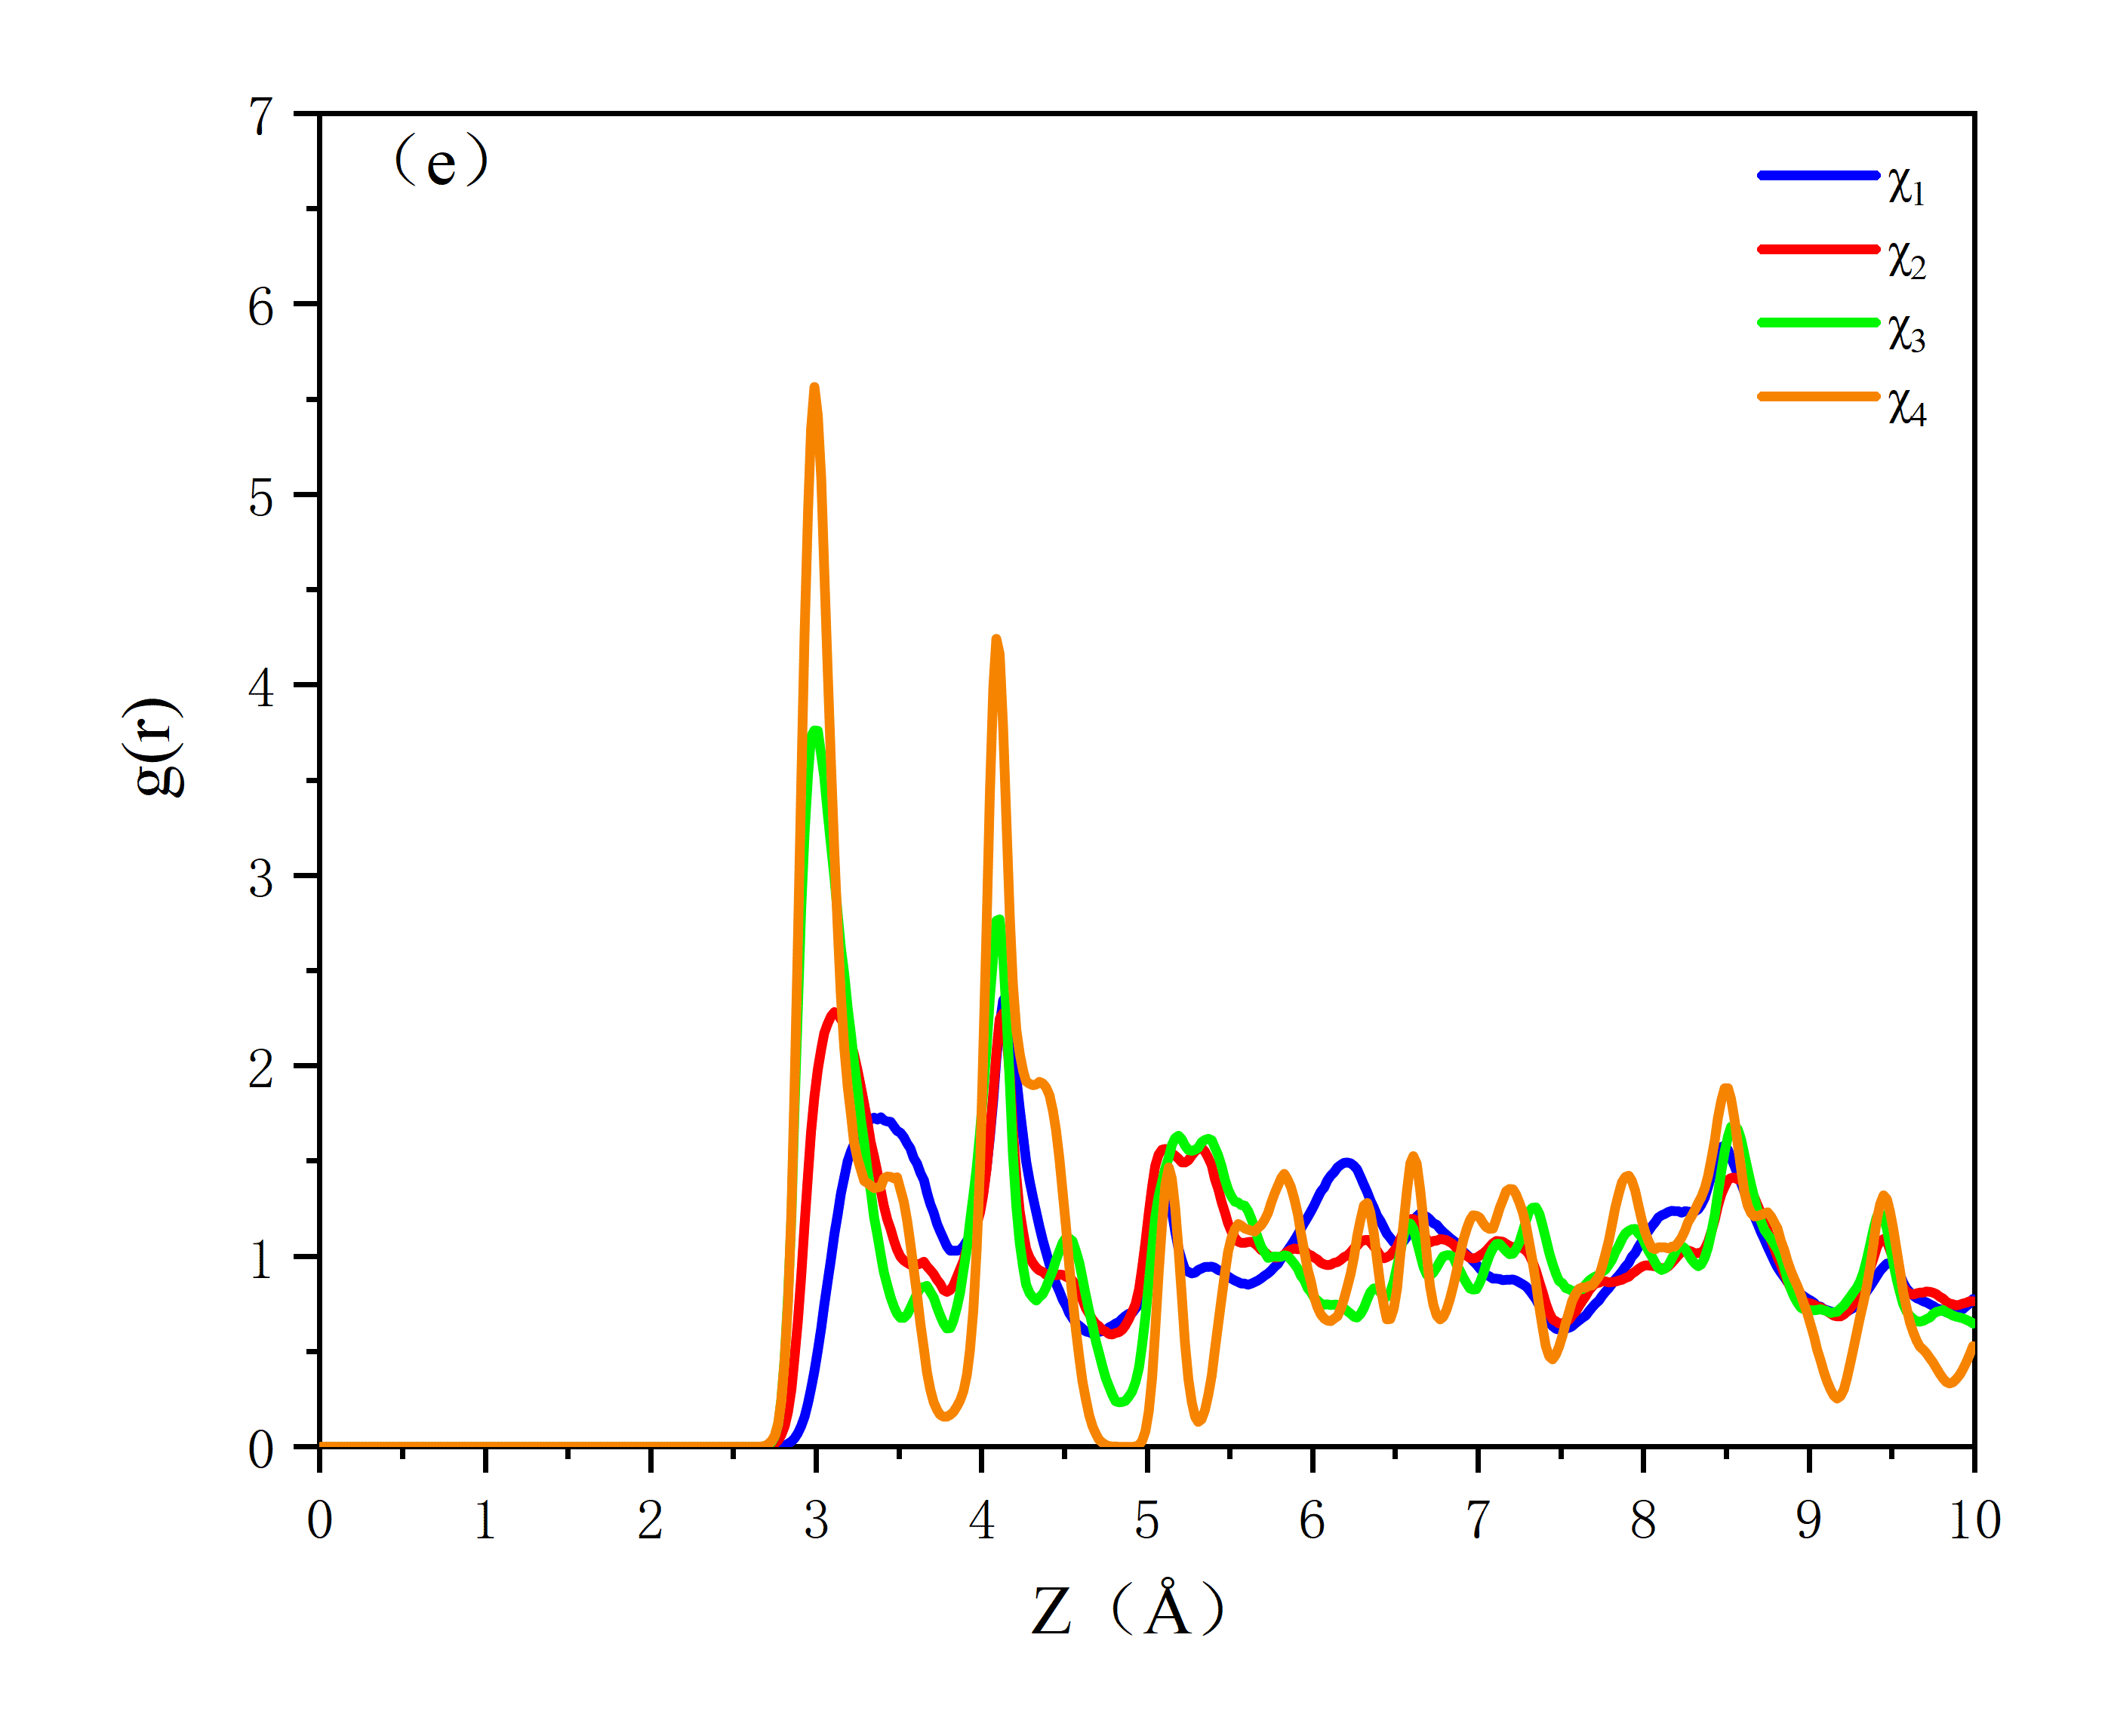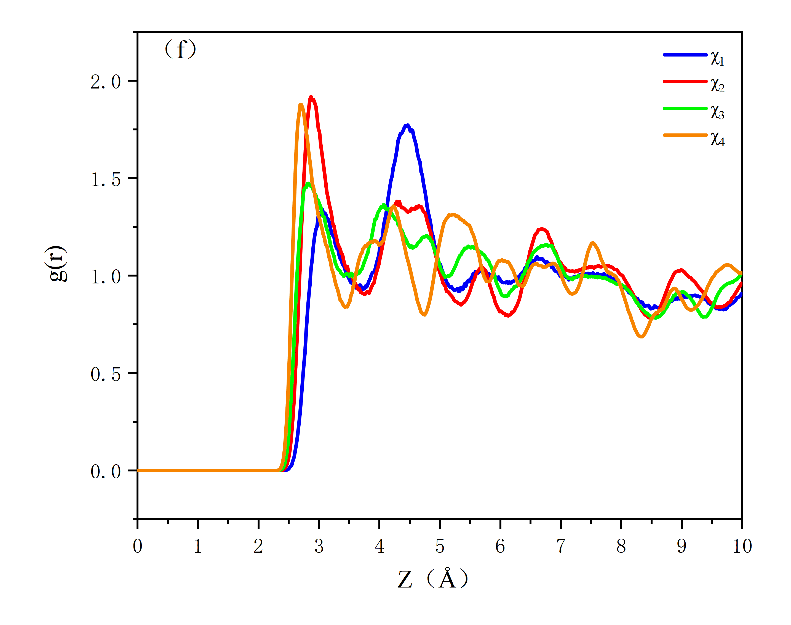
Fig.s2 RDF patterns of SO₂ adsorption with different values of χ_{i}. (a) S-S; (b) S-O_{w}; (c) S-Si; (d) Mg-O_{w}; (e) Si-O_{w}; (f) S-O_{s}. S: S atom in SO₂; O_{w}: O atom in zeolitic water molecule; Si: Si atom in sepiolite; Mg: Mg atom in sepiolite; Os: O atom in structural water molecule.

