Characterization of Brazillian Palygorskite (Guadalupe Region) and adsorptive behavior for Solvatochromic Dyes

Cristiane Gimenes de Souzaª, Tammy Caroline Lima de Jesusª, Rafael Cavalcante dos Santos^{b}, Lívia Melo Bomfim^{c}, Luiz Carlos Bertolino^{d}, Débora França de Andrade^{e}, Luiz Antonio d´Avila^{b}, Luciana S. Spinelli^{a,f}
- Program in Nanotechnology Engineering, COPPE, Federal University of Rio de Janeiro, Cidade Universitária, Rio de Janeiro, CEP 21941-909, Brazil
- Program in Chemical and Biochemical Process Engineering, School of Chemistry, Federal University of Rio de Janeiro, Cidade Universitária, Rio de Janeiro, CEP 21941-909, Brazil.
- School of Chemistry, Federal University of Rio de Janeiro, Cidade Universitária, Rio de Janeiro, CEP 21941-909, Brazil.
- Mineral Technology Center (CETEM), Cidade Universitária, Rio de Janeiro, CEP 21941-908, Brazil
- Institute of Chemistry, Federal University of Rio de Janeiro, Cidade Universitária, Rio de Janeiro, CEP 21941-908, Brazil
- Institute of Macromolecules, Federal University of Rio de Janeiro, Cidade Universitária, Rio de Janeiro, CEP 21941-908, Brazil
Corresponding author: cristianegimenes@yahoo.com.br
https://orcid.org/0000-0002-9642-9770

Supplementary Material

S1. BET results from benefited palygorskite.
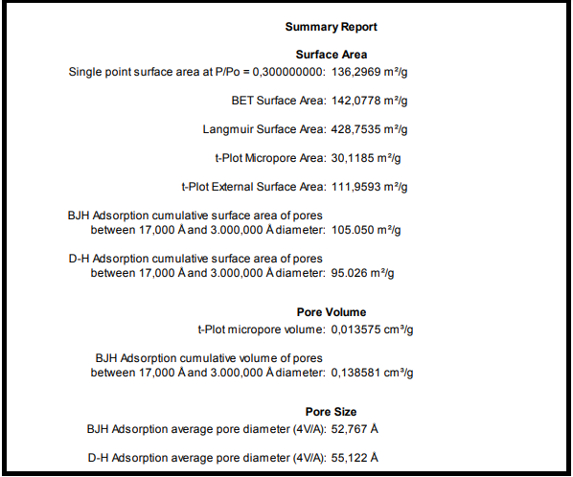
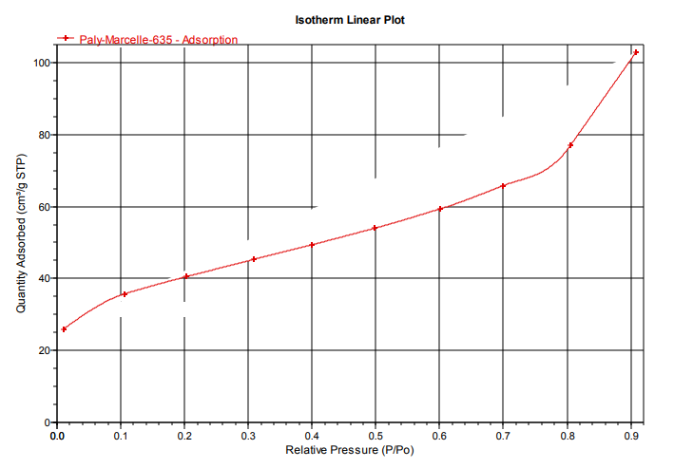
Fig 1. Adsorption isotherm from the processed palygorskite sample
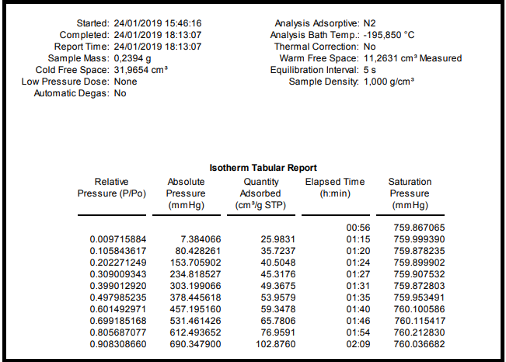

S2. Zeta potential results from benefited palygorskite

Fig.2: Zeta potential of benefited palygorskite.
S3. X-ray Diffractometry signal for Palygorskite samples
DRX signal (intensity vs 2θ) for palygorskite samples analyzed in this work, ROM (run of mine sample), Paly (beneficiated palygorskite), PalyTT (beneficiated/heat-treated palygorskite), are provided in file drxpaly.xls.

