SUPPLEMENTARY MATERIALS

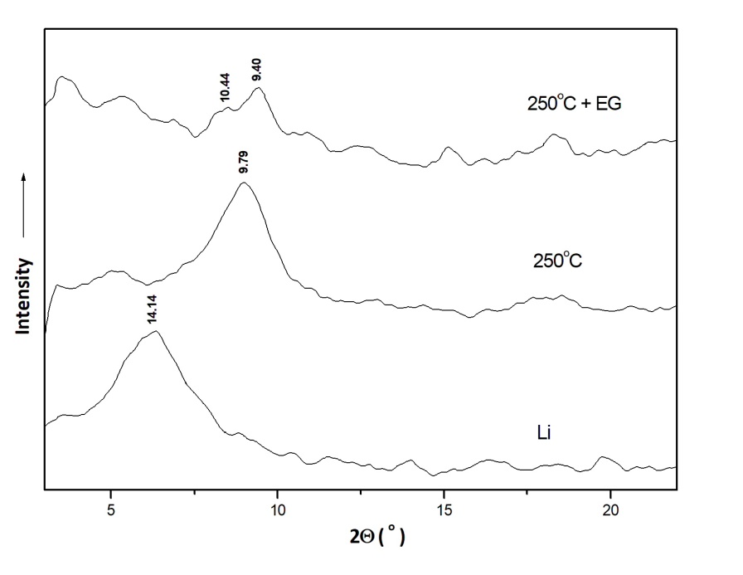
Fig. 9. Greene-Kelly test (XRD patterns of the Li saturated montmorillonite (Li), Li saturated montmorillonite heated at 250°C (250°C), and Li saturated montmorillonite heated at 250°C and saturated with ethylene glycol (250°C+EG)).

