Supplementary information
Copper supported on acid-activated vermiculite as an efficient and recyclable catalyst for the Biginelli reaction: a green approach
C.E. Torres-Méndez^{1,}* and B. López-Mayorga¹
¹ Escuela de Química, Universidad de San Carlos de Guatemala, 11 Av. Ciudad de Guatemala 01012, Guatemala
*E-mail: torres.carlos@usac.edu.gt

Characterization of materials
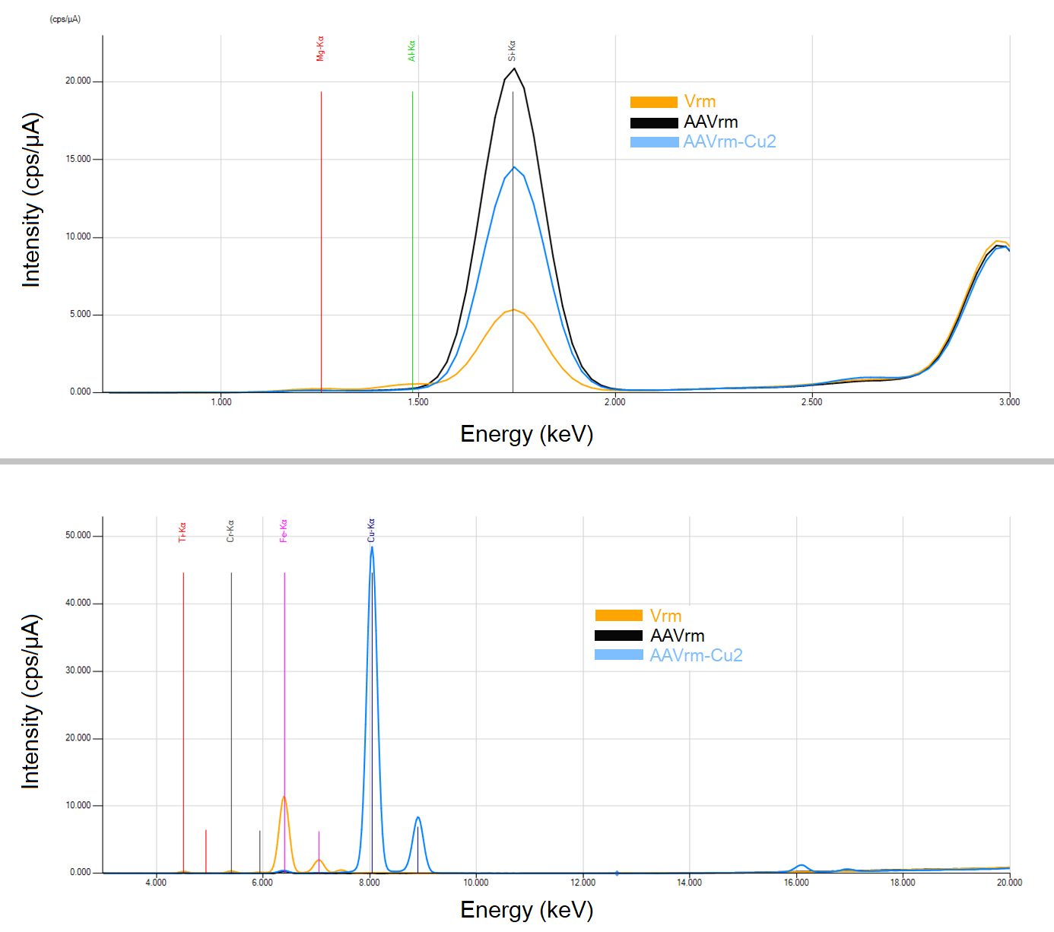
Fig. S1. XRF spectra of Vrm, AAVrm and AAVrm-Cu2.

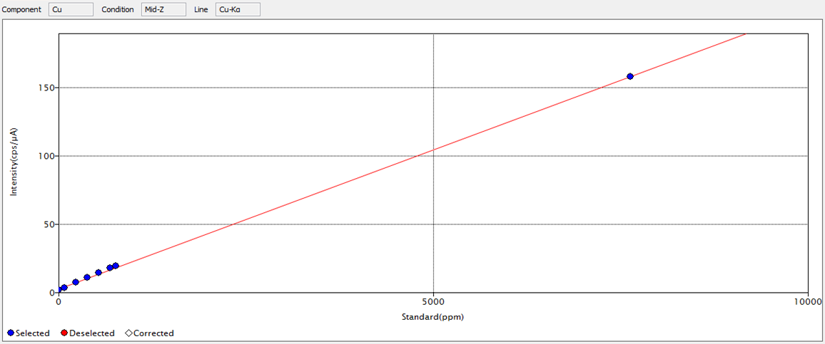
Fig. S2. XRF calibration curve of copper standard dissolutions (76–7635 ppm) used to quantify copper fixated in AAVrm-Cu2 and possible copper leachates in the remnant liquid phase of the Biginelli reaction.

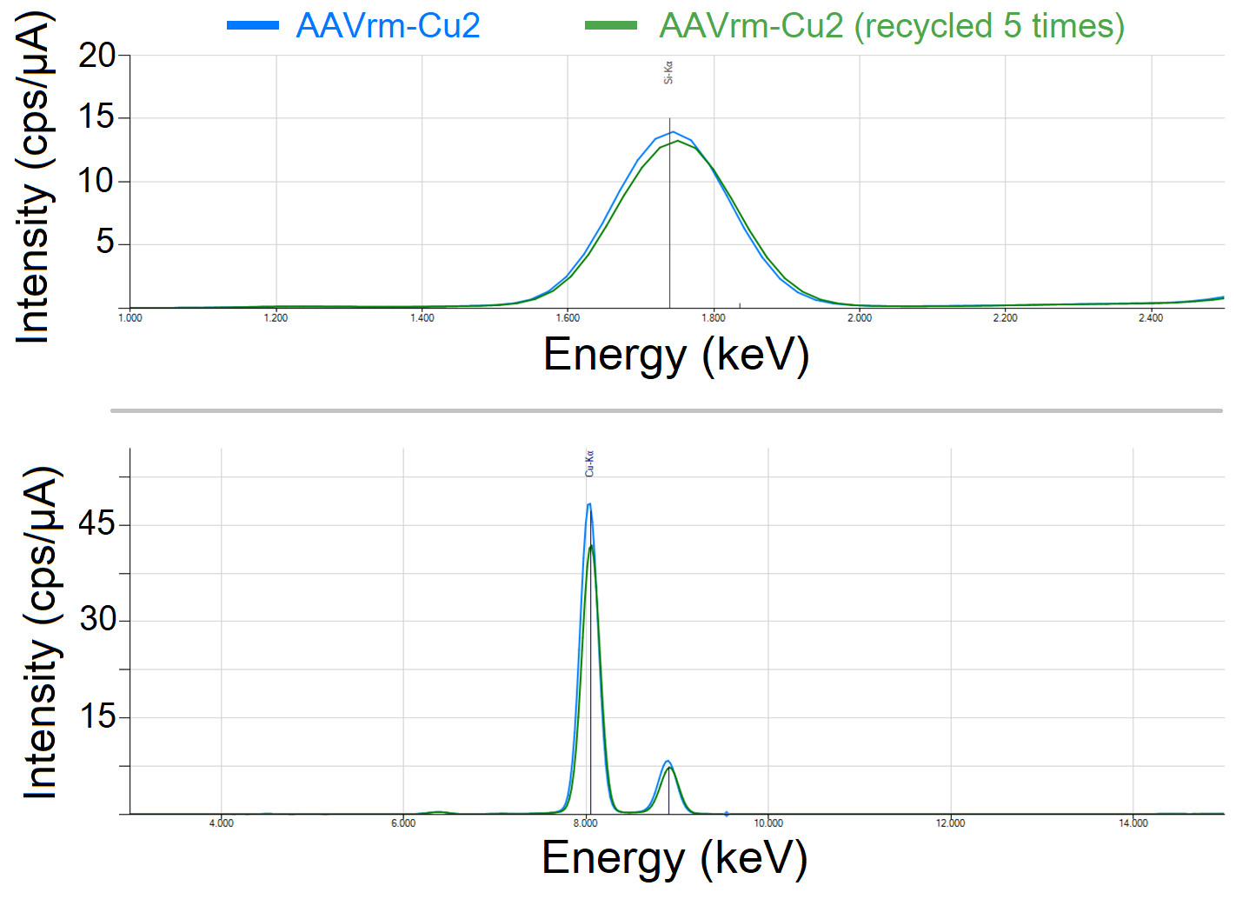 Fig. S3. XRF spectra of catalyst AAVrm-Cu2 and recycled AAVrm-Cu2 (five cycles).

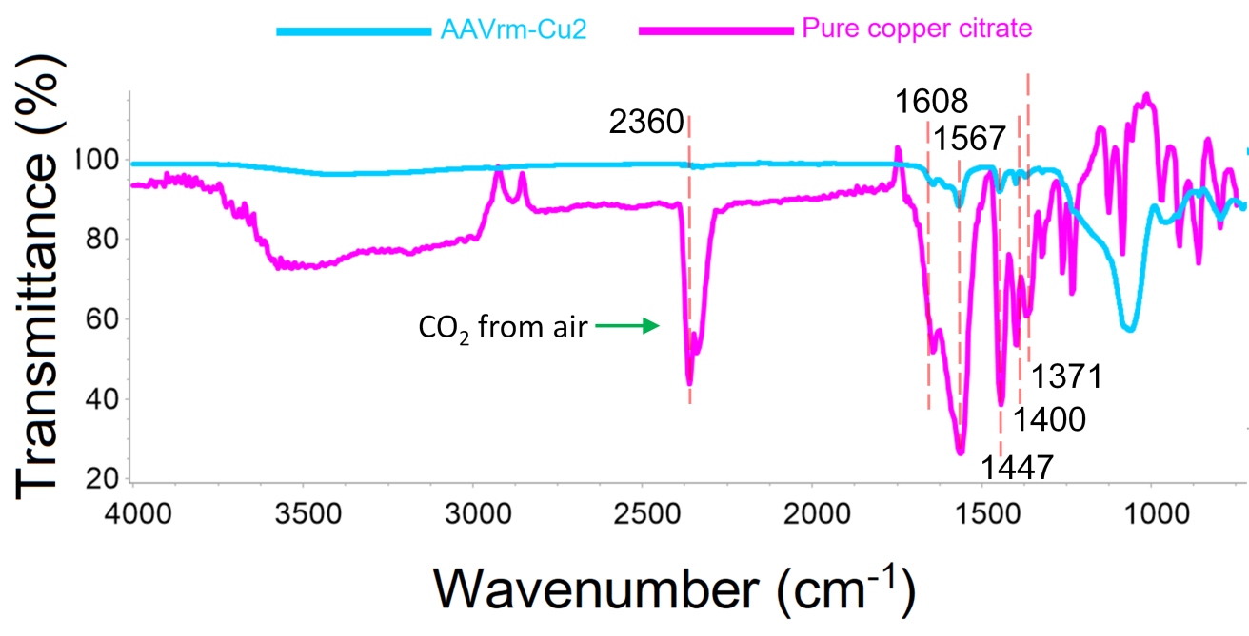
Fig. S4. FTIR spectra of AAVrm-Cu2 and pure copper citrate synthesized in this work.
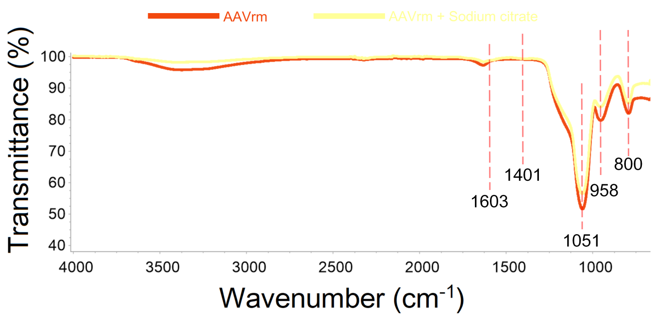
Fig. S5. FTIR spectra of AAVrm and AAVrm + sodium citrate.

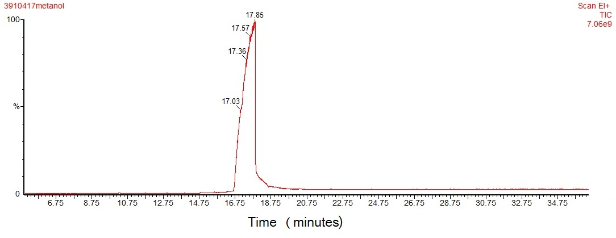
Fig. S6. Chromatogram (GC) of 4a.

Table S1. Spectroscopic data of 4a–4d.
Ethyl 6-methyl-2-oxo-4-phenyl-1,2,3,4-tetrahydropyrimidine-5-carboxylate (4a)
White solid, mp 206-207°C found (208°C reported). ¹H NMR (300 MHz, CDCl₃): δ ppm) = 8.11 (br, 1H, NH), 7.33 (m, 5H, C₆H₅), 5.76 (br, 1H, NH), 5.42 (s, 1H, CH₃), 4.08 (q, 2H, J = 7.1 Hz), 2.36 (s, 3H, CH₃), 1.17 (t, 3H, CH₃, J = 7.1 Hz). ¹³C NMR (75 MHz CDCl₃): δ (ppm) = 165.61 (C=O), 153.28 (-NH-C=O-NH-), 146.20 (C_{alkene}), 143.67 (C_{aromatic}), 128.72 (2C_{aromatic}), 127.97 (2C_{aromatic}), 126.60 (C_{aromatic}), 101.42 (C_{alkene}), 60.03 (CH₂), 55.77 (CH), 18.69 (CH₃), 14.13 (CH₃). FTIR-ATR (cm^{–1}): 3,237 (N-H heterocyclic), 3115 (C-H aromatic), 2978 (C-H aliphatic), 1718 (C=O ester), 1643 (C=O heterocyclic), 1217 (C-O ester). MS-EI (m/z): 260 [M], 231, 187, 183 (100 %), 155, 137.

Ethyl 6-methyl-4-(4-nitrophenyl)-2-oxo-1,2,3,4-tetrahydropyrimidine-5-carboxylate (4b)
White solid, mp 206-208°C found (203°C reported). ¹H NMR (300 MHz CDCl₃): δ (ppm) = 8.21 (d, 2H, J = 8.7 Hz), 7.53 (d, 2H, J = 8.8 Hz), 7.41 (s, 1H, NH), 5.71 (s, 1H, NH), 5.53 (s, 1H, CH), 4.11 (q, 2H, CH_{2,} J = 7.2 Hz), 2.38 (s, 3H, CH₃), 1.20 (t, 3H, CH₃, J = 7.1 Hz). FTIR-ATR (cm^{–1}): 3226 (N-H heterocycle), 3115 (C-H aromatic), 2976 (C-H aliphatic), 1720 (C=O ester), 1638 (C=O heterocycle), 1208 (C-O ester). DART-MS (m/z): 306 [C₁₄H₁₅N₃O₅ (M+H)]
Ethyl 4-[4-(dimethylamino)phenyl]-6-methyl-2-oxo-1,2,3,4-tetrahydropyrimidine-5-carboxylate (4c)
White solid, mp 256-267°C found (261°C reported). ¹H NMR (300 MHz, CDCl₃): δ (ppm) = 7.18 (d, 2H, Ar, J = 8.3 Hz), 6.96 (s, 1H, NH), 6.65 (d, 2H, Ar, J = 8.2 Hz), 5.31 (s, 1H, N-H), 5.31 (s, 1H, CH), 4.10 (q, 2H, CH₂, J = 6.9 Hz), 2.97 (s, 6H, 2CH₃), 2.35 (s, 3H, CH₃), 1.20 (t, 3H, CH₃, J = 7.2 Hz). FTIR-ATR (cm^{–1}): 3,241 (N-H heterocyclic), 3,109 (C-H aromatic), 2,955 (C-H aliphatic), 1,720 (C=O ester), 1,644 (C=O heterocyclic), 1217 (C-O ester). DART-MS (m/z): 304.13[C₁₆H₂₂N₃O₃ (M+H)].
Ethyl 4-(4-hydroxyphenyl)-6-methyl-2-oxo-1,2,3,4-tetrahydropyrimidine-5-carboxylate (4d)
White solid, mp 232-234°C found (236°C reported). ¹H NMR (300 MHz DMSO); δ (ppm)= 9.35 (s, 1H, OH), 9.10 (s, br, NH), 7.61 (s, br, NH), 7.02 (d, 2H, J = 8.5 Hz), 6.70 (d, 2H, J = 8.6 Hz), 5.05 (s, 1H, CH), 3.99 (q, 2H, CH₂ ester), 2.23 (s, 3H, CH₃), 1.10 (t, 3H, CH₃, J = 7.1 Hz). ¹³C NMR (75 MHz DMSO); δ (ppm) = 165.9 (C_{carbonyl ester}), 157 (C_{-OH phenol}), 152.7 (-NH-C=O-NH-), 148.2 (C_{alkene}), 128.1, 135.9 (2C, _{ipso-phenyl}), ) 127.6 (C_{aromatic}), 115.43 (C_{aromatic}), 100.2 (C_{alkene}), 59.6 (CH₂), 54.0 (CH), 18.3 (CH₃), 14.4 (CH₃). FTIR-ATR (cm^{–1}); 3503 (OH), 3,232 (N-H heterocycle), 3,108 (C-H aromatic), 2,981 (C-H alifatic), 1,680 (C=O ester), 1,640 (C=O heterocycle). DART-MS (m/z): 277.06 [C₁₄H₁₆N₂O₄ (M+H)].
Melting points were compared to the results reported by: Yao N., Lu M., Liu X.B., Tan J. & Hu Y.L. (2018) Copper-doped mesoporous silica supported dual acidic ionic liquid as an efficient and cooperative reusability catalyst for Biginelli reaction. Journal of Molecular Liquids, 262, 328-335.

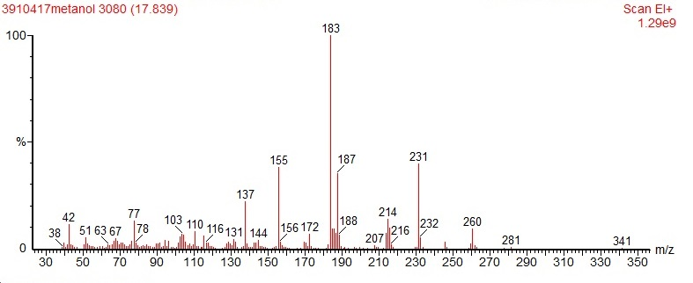
Fig. S7. Mass spectra of 4a.

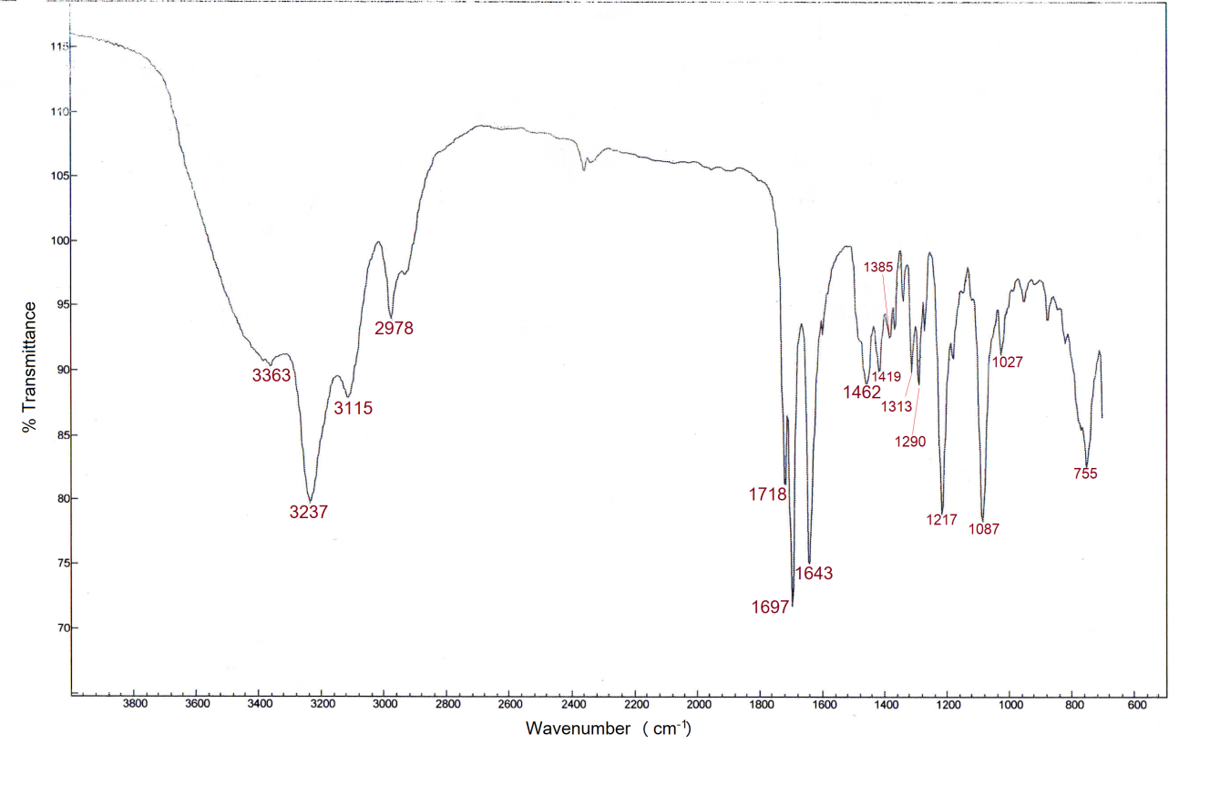
Fig. S8. FTIR-ATR spectra of 4a.

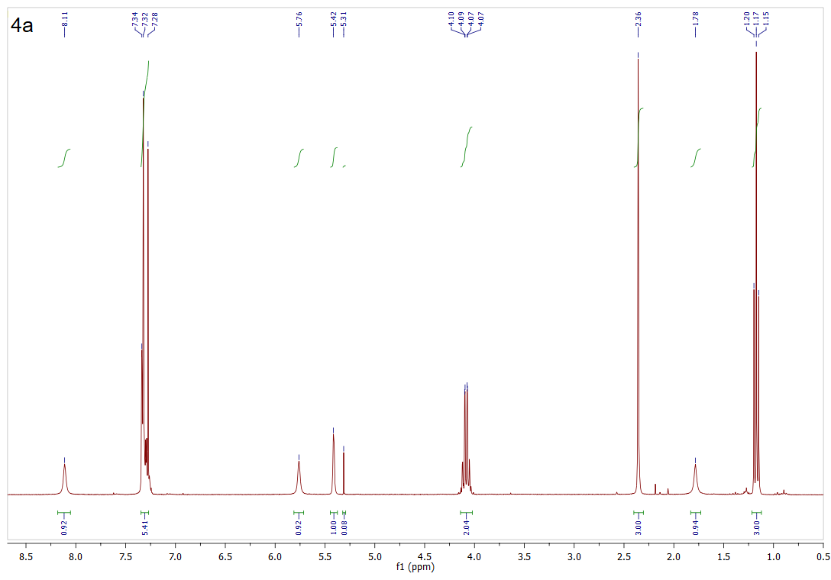
Fig. S9. ¹H NMR spectra of 4a.

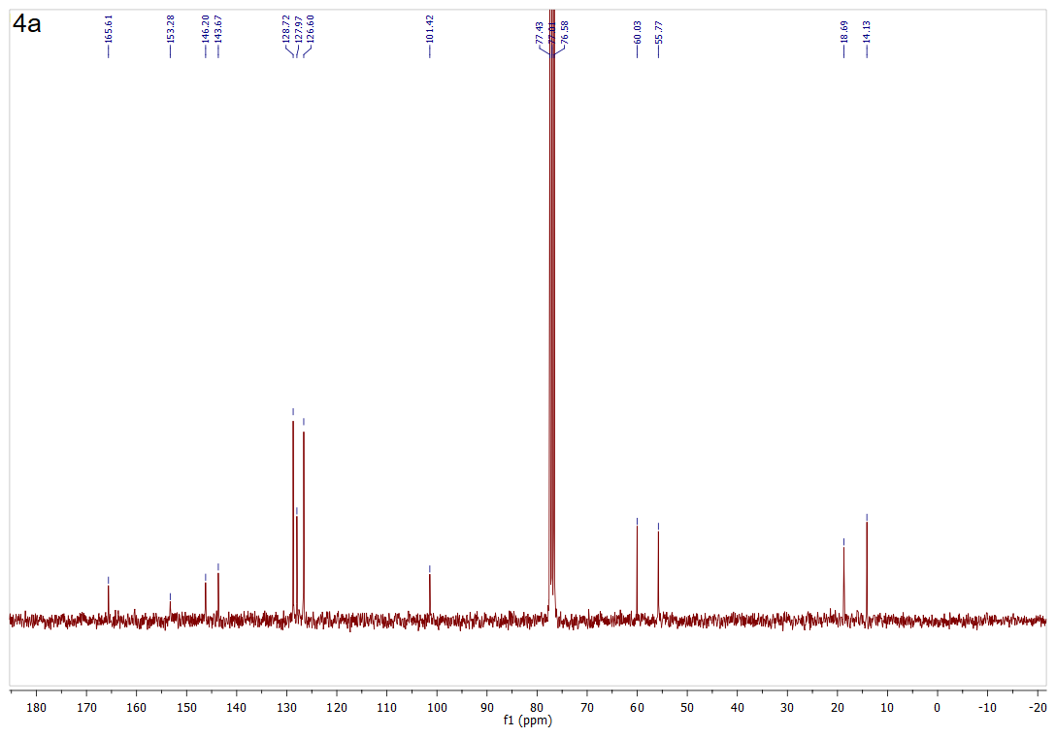
Fig. S10. ¹³C NMR spectra of 4a.
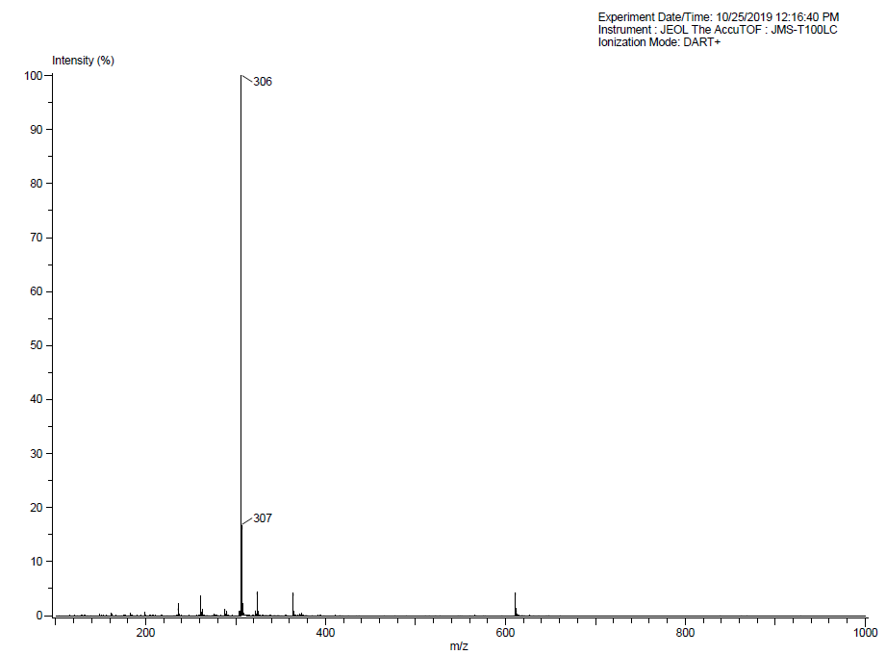
Fig. S11. Mass spectra of 4b.

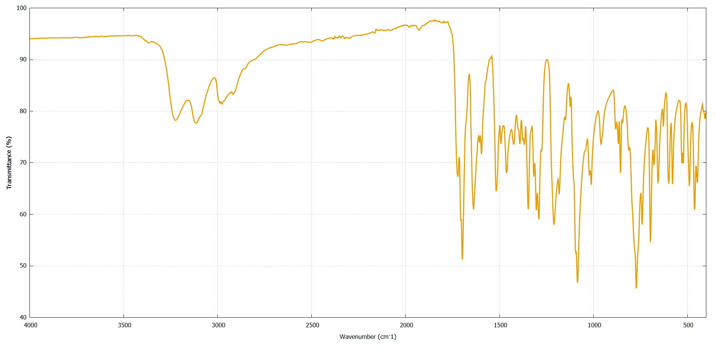
Fig. S12. FTIR-ATR spectra of 4b.
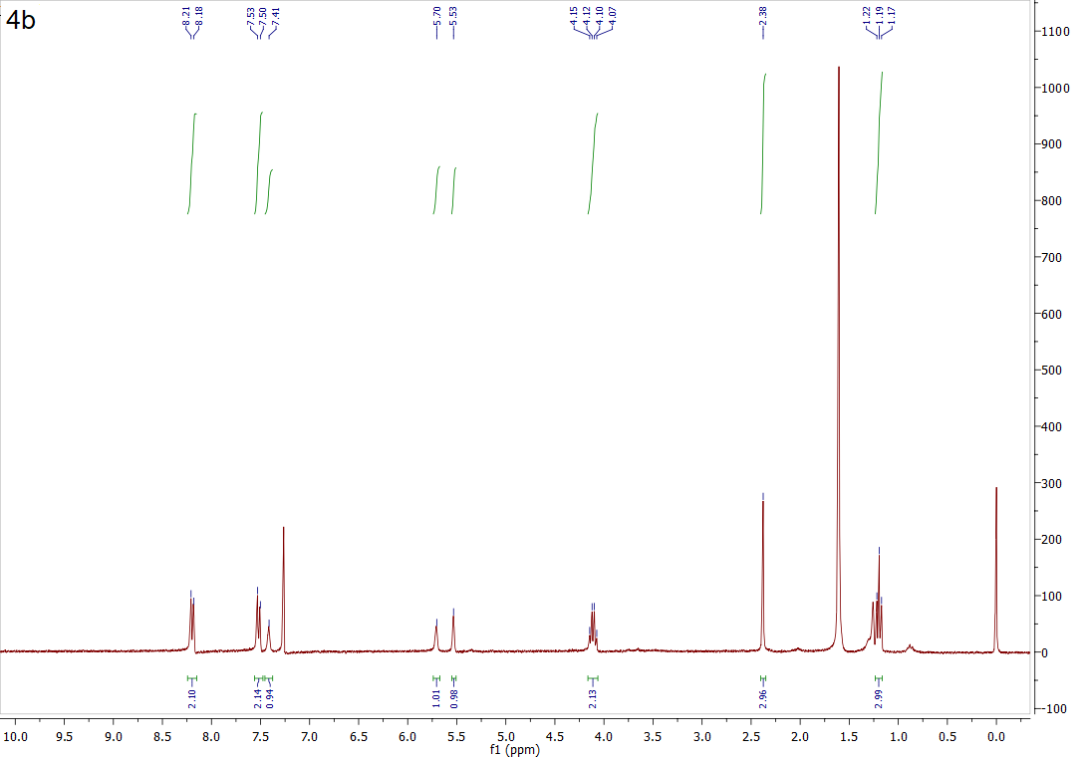
Fig. S13. ¹H NMR spectra of 4b.

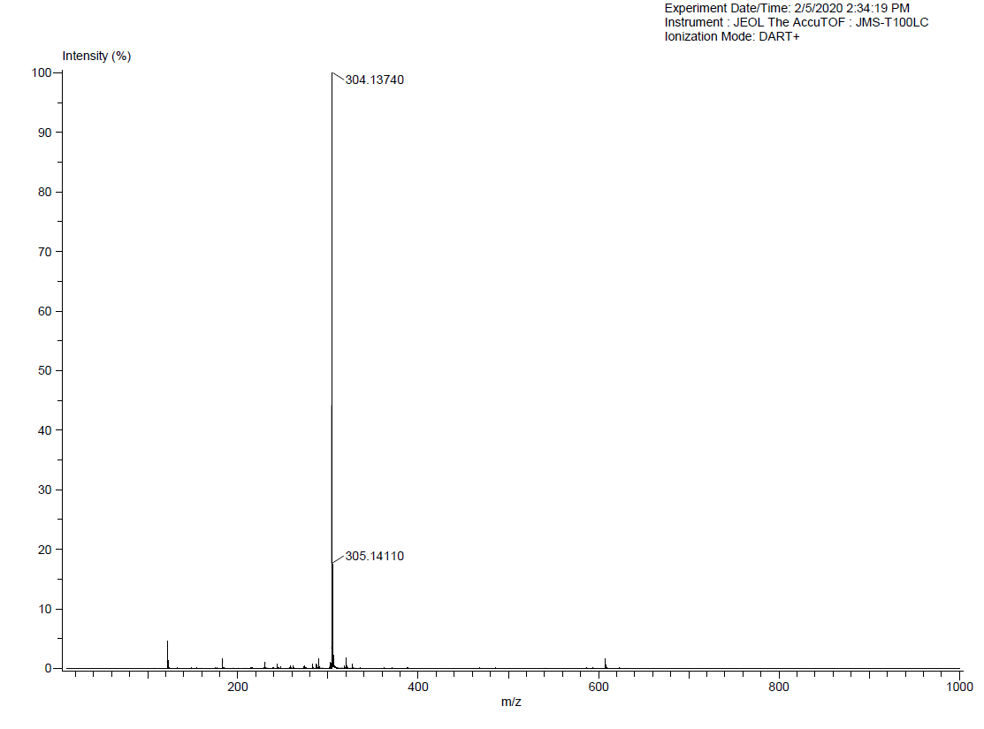
Fig. S14. Mass spectra of 4c.
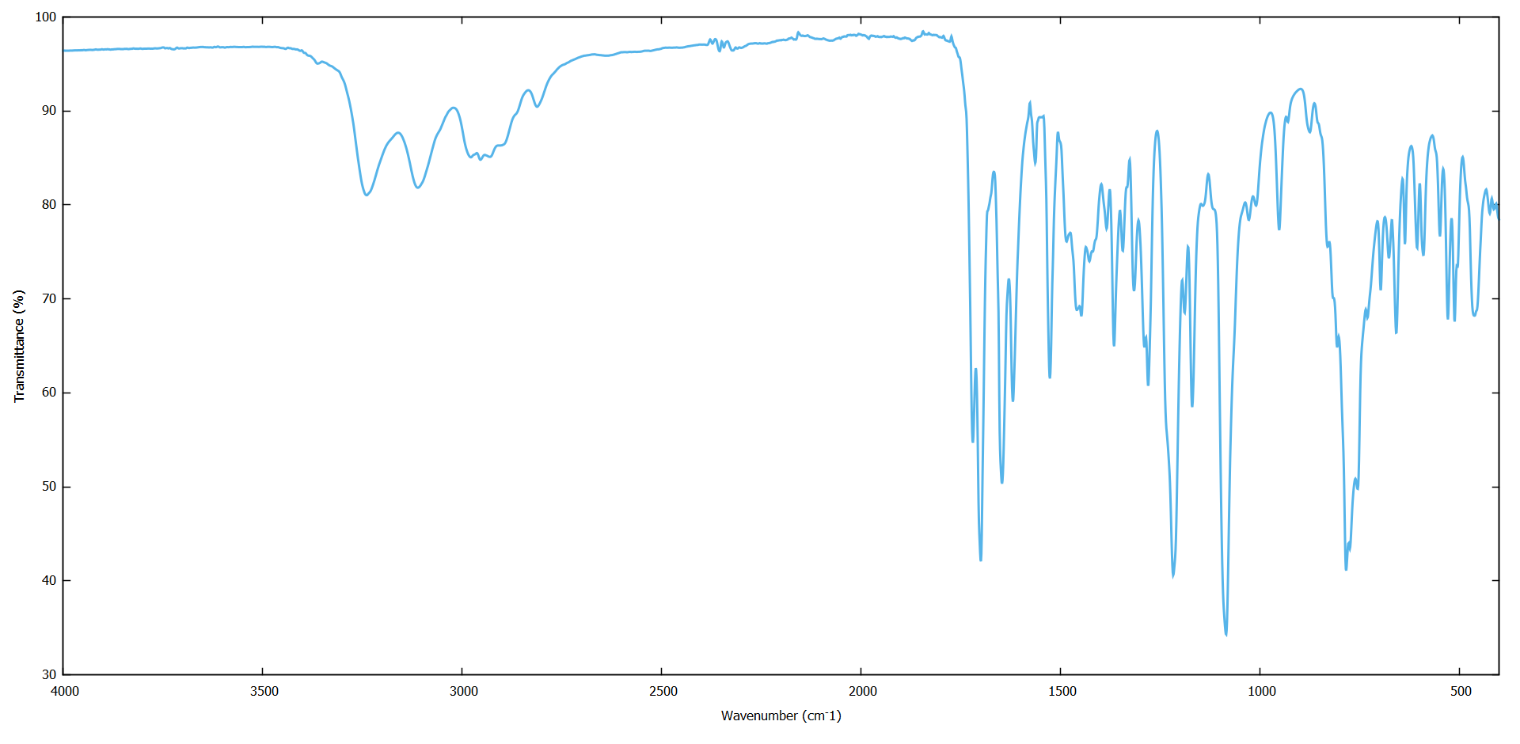
Fig. S15. FTIR-ATR spectra of 4c.

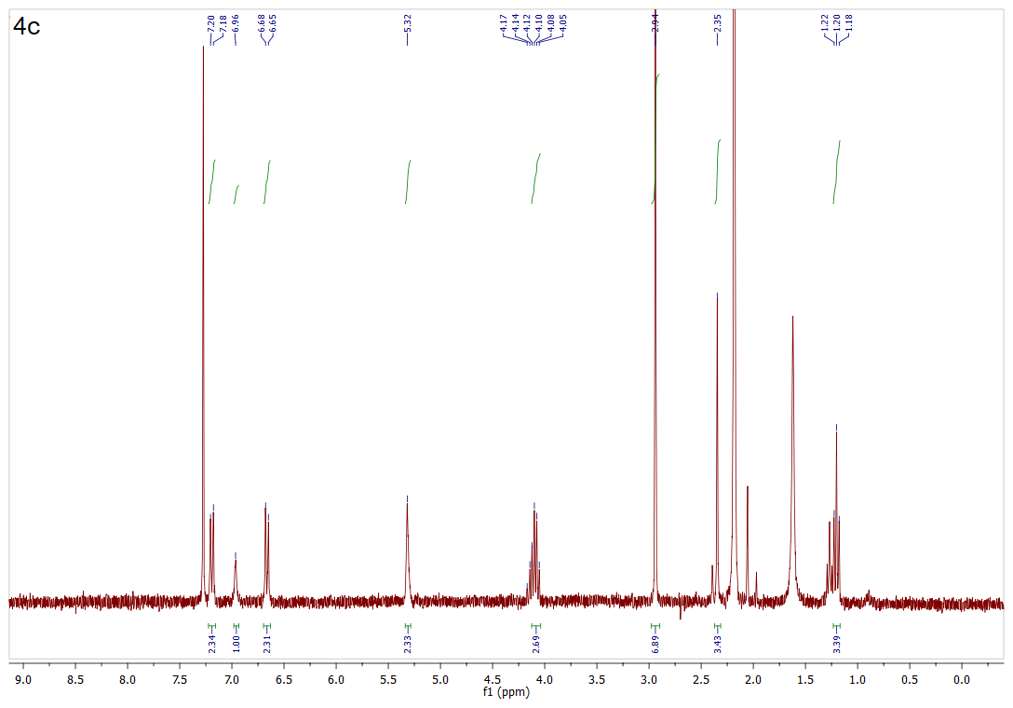
Fig. S16. ¹H NMR spectra of 4c.
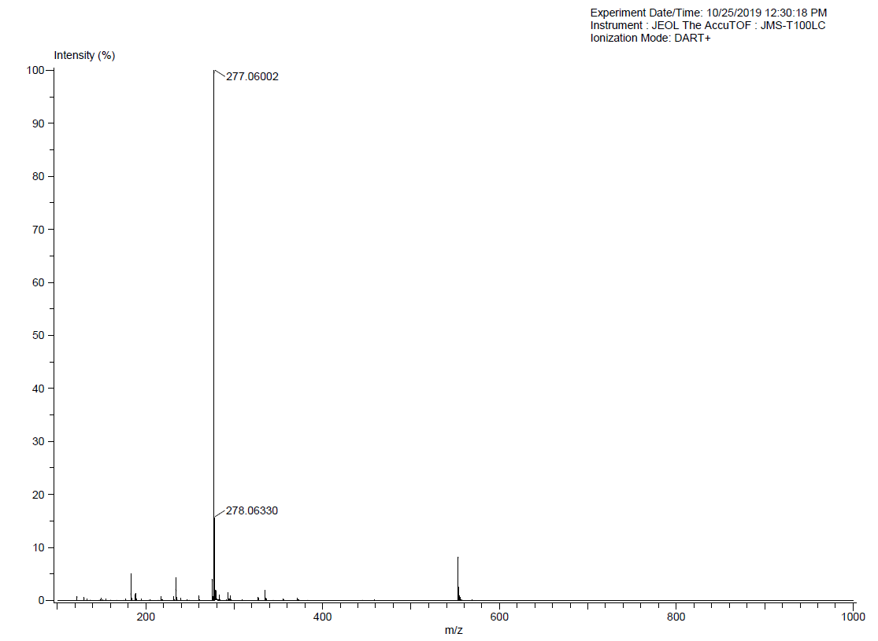
Fig. S17. Mass spectra of 4d.

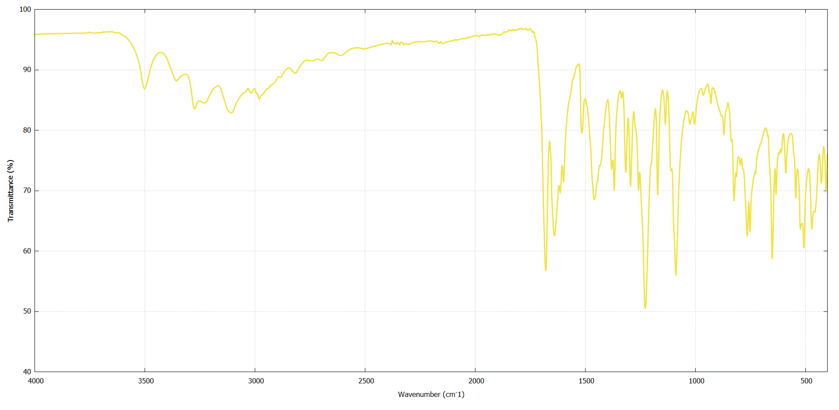
Fig. S18. FTIR-ATR spectra of 4d.

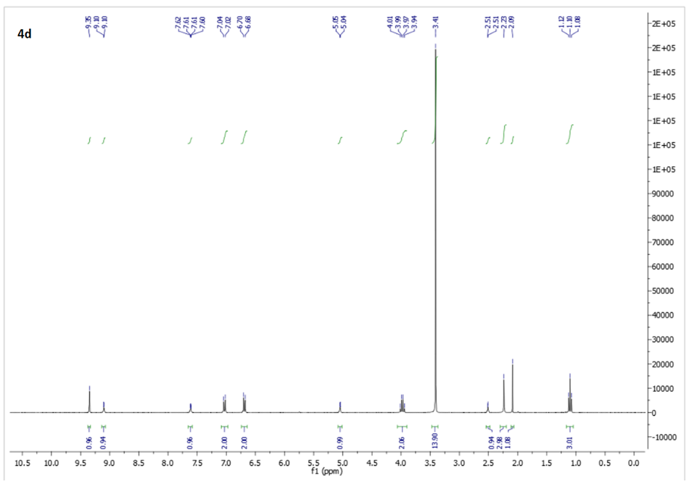
Fig. S19. ¹H NMR spectra of 4d.

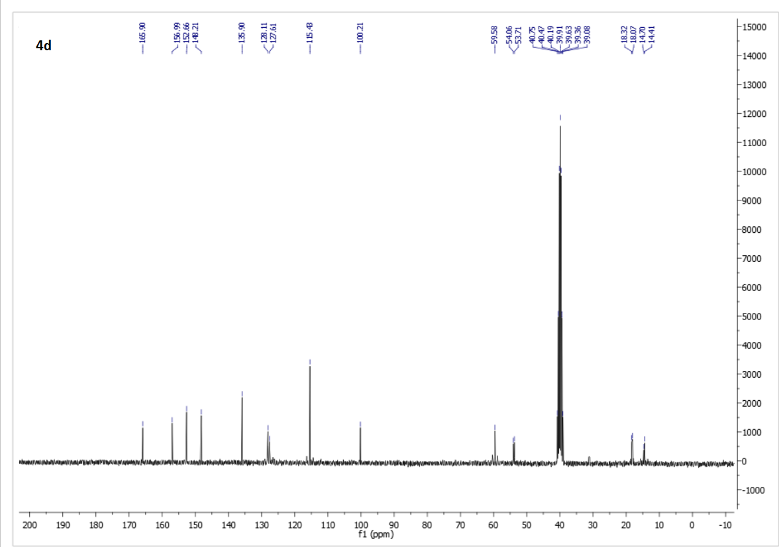
Fig. S20. ¹³C NMR spectra of 4d

