Supplementary material

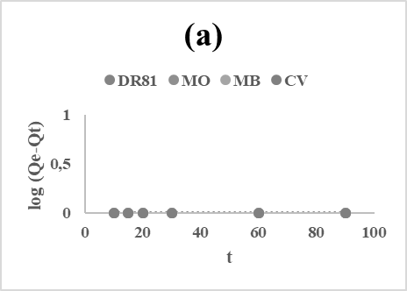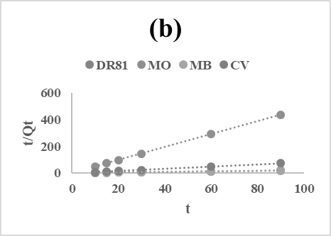
(a) The pseudo first order (b) the pseudo second order for adsorption of DR81, MO, MB and CV onto halloysite.

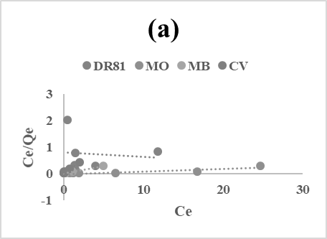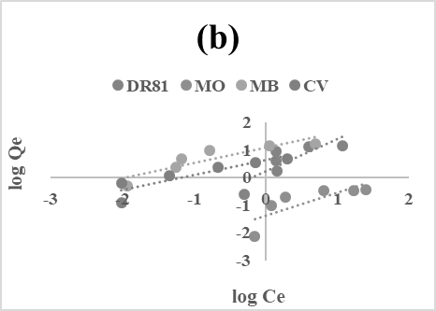
- - Langmuir (b) - Freundlich adsorption isotherm models of DR81, MO, MB and CV dyes onto halloysite.
The pseudo first order (b) the pseudo second order for adsorption of DR81, MO, MB and CV The Langmuir (a) and Freundlich (b) adsorption isotherm models of DR81, MO, MB and CV dyes onto halloysite

