Supplementary material

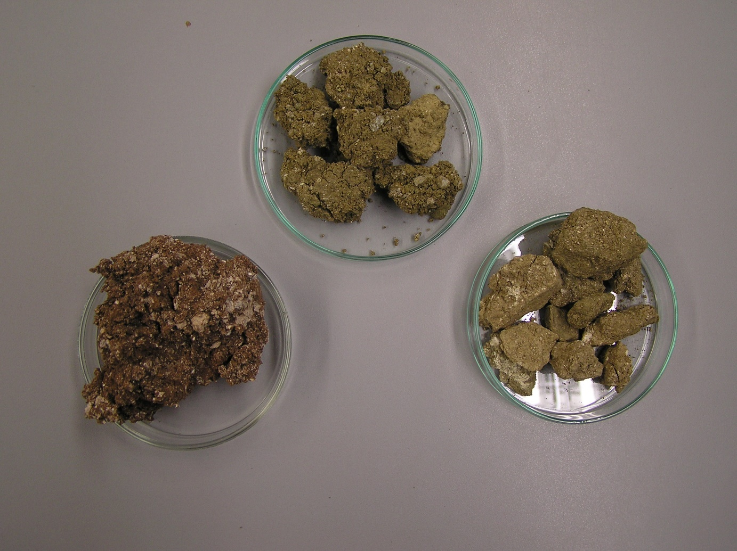
Figure S1: Photographs of the bulk samples investigated in the present study (B63 left, B64 centre, B65 right). The samples are from the Pilori (B63) and Velanida deposits (B64, B65).

Figure S2: SEM EDX analysis for the determination of the structural formula.

