Supplementary material

A. X-ray patterns decomposition
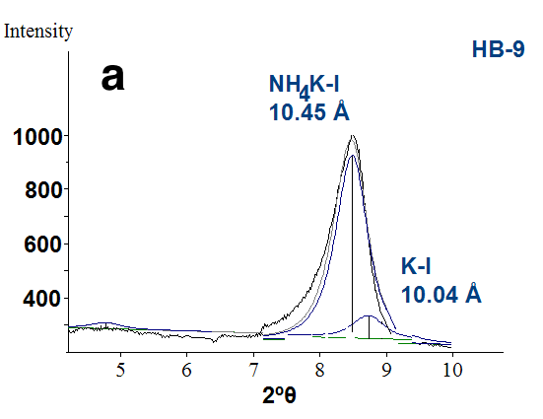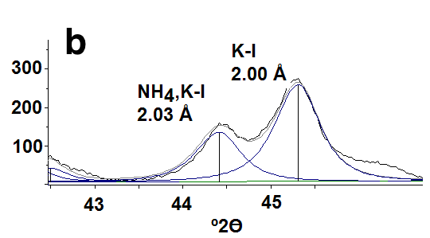
Fig. 1. Decomposition of the 001 and 005 peaks of sample HB-9
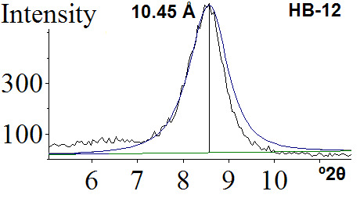
Fig. 2. Decomposition of 001 peak of sample HB-12

B. Chemistry of the <2 μm clay fractions and Sr²⁺ saturated clay fractions
Introduction
Sample HB-12 was revisited in terms of chemical composition, because a high amount of Na₂O was measured by flame photometry in the <2 μm clay fractions. The TEM-AEM data obtained in this study confirmed the presence of Na⁺ as the third fixed or exchangeable interlayer cation. X-ray pattern of this sample was interpreted as NH₄-I-S mixed layered with 12 %S. where the presence of NH₄,K,Na-I was not recognized. Nevertheless, TEM-AEM data identified two distinct packets of NH₄-I-S and NH₄NaK-I. To clarify if the Na⁺ is exchangeable cation in smectite layers or fixed in illite layers, we saturated with 0.1M SrCl₂ the <2 μm clay fractions of samples HB-12.
Chemical analyses of the <2 μm clay fractions
A combination of several analytical methods was used for obtaining the accurate chemical composition of the <2 µm clay fractions. Al_{total}, Fe_{total}, Mg²⁺, Mn²⁺ and Ca²⁺ were analyzed by atomic absorption spectroscopy, after dissolving the samples by HF-HClO₄ digestion. Si⁴⁺ was determined gravimetrically, following decomposition by Na₂CO₃ fusion. Fe²⁺ was determined by dichromate titration. Na⁺ and K⁺ were analyzed by flame photometry. Al^{IV} was calculated by its difference from Si^{IV}, whereas Al^{VI} = Al_{total} – Al^{IV}. The H₂O⁺ content was determined using the Penfield method (Sandell 1952).
Sr²⁺ saturation. The experiments were carried out by adding 1 gram of sample into the polypropylene centrifuge tubes with 100 mL of 0.1M SrCl₂. Suspensions were shaken for 24 hours, then centrifuged, separated and the solutions resulted were preserved by adding HNO₃ (65%) and stored at 4 ºC for subsequent chemical analyses. Most of the clay suspension was converted into Sr²⁺ form by four exchanges with 0.1M SrCl₂. Prior to the analyses previously described, separate clay samples were subsequently washed and then dialyzed, so that Sr²⁺ would be the only exchangeable cation in the NH₄-I clays selected. Sr²⁺ was analyzed in clay fractions by atomic absorption spectrometry.
After Sr²⁺ saturated clay fractions, the Ca²⁺ and Sr²⁺-aqueous solutions were analyzed by atomic absorption spectrometry, whereas a possible presence of Na⁺ in solution by flame photometry.

Results
Chemical compositions of the <2 µm clay fractions (samples HB-18, HB-12 and HB-9) not saturated and saturated with Sr²⁺ are shown in Table 1. The Ca²⁺ was exchanged with Sr²⁺in samples HB-12* and HB-9, confirming that only Ca²⁺ is free exchangeable cation.

TABLE 1. Chemical compositions of the <2 μm clay fractions
Samples SiO₂ TiO₂ Al₂O₃ Fe₂O₃ MgO CaO Na₂O K₂O (NH₄)₂O SrO H₂O Total
HB-18ª 49.90 0.00 31.26 0.16 1.81 0.15 0.05 1.58 4.08 - 11.03 100.00
HB-12 49.56 0.23 31,44 0.83 1.78 0.47 1.26 2.14 3.11 - 9.180 100.00
HB-9 48.71 0.55 30.16 1.14 1.41 0.31 0.46 3.43 2.91 - 10.82 100.00
HB-18* 49.88 0.00 31.24 0.15 1.81 0.00 0.05 1.57 4.08 0.64 10.58 100.00
HB-12* 49.28 0.17 31,32 0.68 1.71 0.00 1.24 2.11 3.11 1.27 9.10 100.00
HB-9 * 48.68 0.51 30.10 1.11 1.38 0.00 0.55 3.41 2.91 0.83 10.42 100.00
a: from Bobos (2012); *Sr²⁺ - saturated forms
Aqueous solutions after Sr²⁺ saturation clays were analyzed for Sr²⁺, Ca²⁺ and Na⁺ (Table 2).

TABLE 2. Amount of Sr²⁺ and Na⁺ measured in aqueous solution after saturation
Samples Ca²⁺ -solution Sr²⁺-solution %Sr²⁺ solution Na⁺ solution
HB-18 2.6786 x 10⁻⁶ mol 9.973 x 10⁻³ mol 99.63% 0
HB-12 8.382 x 10^{~6} mol 9.916 x 10⁻³ mol 99.16% 0
HB-9 5.529 x 10^{~6} mol 9.945 x 10⁻³ mol 99.45% 0

Crystal chemistry of NH₄-I (sample HB-18) is given (Table 3) for comparison with the AEM data. The crystal chemistry formula for samples HB-12 and HB-9 was not calculated because both samples represent a mixture of two distinct illitic minerals.
TABLE 3. Crystal chemistry of NH₄-I calculated on 11 oxygens
Si Ti Al Fe Mg Ca Na K NH₄ Sr
HB-18* 3.35 0.00 2.47 0.01 0.18 0.00 0.00 0.13 0.60 0.02
HB-12* -
HB-9* -

Conclusion
After Sr²⁺ saturation clay fractions was replaced only Ca²⁺ from smectite layers. Therefore, Na⁺ is a fixed interlayer cation in illite structure of samples HB-12 and HB-9.

References

Bobos, I. (2012) Characterization of smectite to NH₄-illite conversion series in the

fossil hydrothermal system of Harghita Bãi, East Carpathians, Romania. American Mineralogist, 97, 5, 962–982.
Sandell, P. (1952) Micro determination of water by the Penfield method. Micro
chimica Acta, 38, 487–491.

