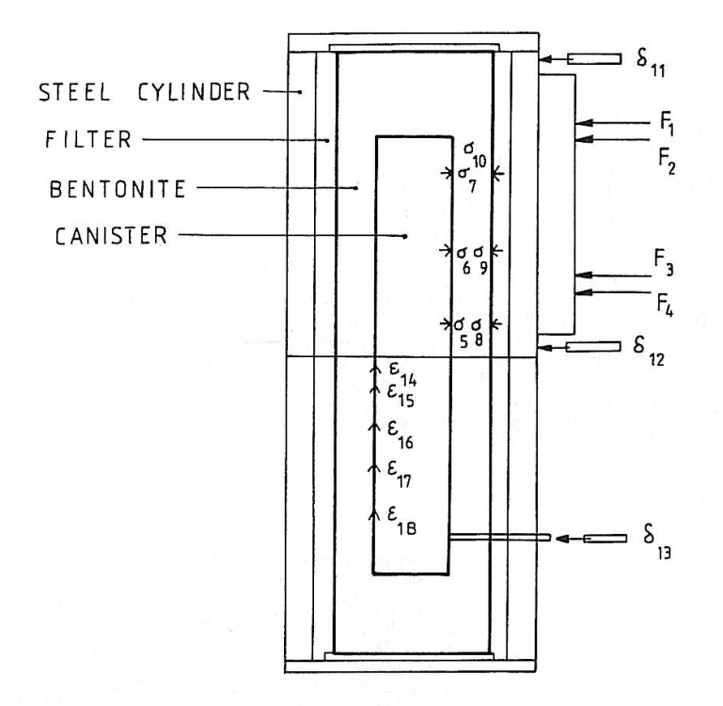

Fig. S1. Outline figure of the test and the measuring equipment

F1–F4 force transducers

5–10 pressure transducers

11–13 displacement transducers

14–18 strain gauges

|  |  |
| --- | --- |
|  |  |

Fig. S2. Pictures of the equipment during mounting (left), where the shear plane and the very stiff immovable part of the equipment are seen, and during shear (right).