Appendices

Appendix A: Political Knowledge questions from the 2011 CES
The knowledge variable is calculated as the proportion of correct answers in response to the following questions. The correct answers are provided in bracket.

- If someone working has to take care of seriously ill relatives, how many weeks of compassionate care benefits are paid? [6 weeks]
  - 2 weeks
  - 6 weeks
  - 12 weeks
  - 20 weeks
  - Don’t know
- If someone had to go to court and could not afford a lawyer, where would be the BEST place to go for help? [Legal Aid]
  - Bar Association
  - Human Rights Commission
  - Legal Aid
  - Ombudsman
  - Don’t know
- Can people with low incomes receive a GST tax credit from the Canada Revenue Agency? [Yes]
  - Yes
  - No
  - Don’t know
- Can people who QUIT their job because they don't enjoy it receive employment insurance benefits? [No]
  - Yes
  - No
  - Don’t know
- Which group uses a rainbow flag as their symbol? [Gay and lesbian groups]
  - Aboriginal groups
  - Environmental groups
  - Gay and lesbian groups
  - Women's groups
  - Don’t know
- Who is the founder of WikiLeaks? [Julian Assange]
  - Julian Assange
  - David Cameron
  - Ariana Huffington
  - Mark Zuckerberg
  - Don’t know
- In which of these provinces are the tar sands located? [Alberta]
  - British Columbia
  - Alberta
  - Manitoba
  - Nova Scotia
  - Don’t know
- Sierra Club Canada is an organization devoted to which cause? [Protecting the environment]
  - Protecting the environment
  - Protecting consumer rights
  - Protecting women's abortion rights
  - Supporting low wage workers in the third world
  - Don’t know

Evaluating the validity of the measure of Political Knowledge
To establish that the variable measures political knowledge, the analysis considers in turn different types of validity, based on tests that have already been conducted in the relevant literature. Once again, the 2011 CES includes the variables necessary to conduct these tests. Concurrent validity consists of showing that two separate assessments of the same concept are related. The 2011 CES included an interviewer assessment of political knowledge in addition to the battery of questions. This test of validity has already been used by Luskin (1987). The interviewer assessment is regressed on the measure of political knowledge. The test reveals that the two measures are indeed positively and significantly related at p<0.001. This shows that the measure of political knowledge exhibits concurrent validity.
Table A1: Linear Regression of Reviewer Assessment and Political Knowledge
 | Coefficient | Standard Error
Political Knowledge | 1.19*** | 0.13
Constant | 3.13*** | 0.09
N | 1201
R-Squared | 0.06
Legend: α : 0.1 * : 0.05 **: 0.01 ***: 0.001

The second test examines predictive validity, which consists of testing whether the measure can predict particular events. The literature has already established that voters who have higher levels of political knowledge are more likely to vote (Delli Carpini and Keeter, 1996; Milner, 2010). Regressing turnout in the 2011 election on the measure of political knowledge reveals a positive, statistically significant relationship between the two at p<0.001. The measure thus exhibits predictive validity.

Table A2: Logistic Regression of Turnout and Political Knowledge
 | Coefficient | Standard Error
Political Knowledge | 2.64*** | 0.64
Constant | 1.42*** | 0.38
N | 1179
Pseudo R-Squared | 0.04
Legend: α : 0.1 * : 0.05 **: 0.01 ***: 0.001
A final test investigates the constraints of voters’ political opinions as a function of their political knowledge. This is the approach pioneered by Converse (1964). To this end, the test focuses on five political values. Héroux-Legault (2016) has identified moral traditionalism, egalitarianism, pluralism, attitudes toward immigration, and personal responsibility as the five most important dimensions structuring political opinion in Canada. A principal component analysis is conducted to identify how well a single component can account for variation in the items that constitute each of these political values. The items that constitute each political value, based on previous work (Héroux-Legault, 2016), are as follow:
Moral traditionalism: Opinions regarding whether people should marry before having children, opinions regarding gay marriage, views about traditions, views about new lifestyles, and whether women should stay home with children
Egalitarianism: Opinions regarding redistribution for minorities, women, Quebec, and opinions regarding the income gap
Pluralism: Feelings towards racial minorities, Indigenous Peoples, and feminists
Immigration: Opinions regarding how many immigrants Canada should accept, opinions regarding the contribution of immigrants to Canadian society, whether Canadians should come first, and opinions regarding whether immigrants fit in Canadian society
Personal responsibility: Opinions regarding whether people can find a job on their own, whether they should blame the system if they do not succeed, opinion regarding the welfare state, and opinions regarding the importance of cracking down on crime
Since informed voters are expected to have stronger constraints, a single component should offer a better explanation of their positions than it would for less informed voters. This assessment is based on three separate measures. First, it is assessed by comparing the proportion of the variance of the items explained by a single component. If the measure is valid, then a greater proportion should be explained among better informed voters. Second, it is measured by identifying which group has the higher average correlation between its items and the principal component. Stronger constraints would be shown as higher loadings, and as such they should be expected among the most informed group. Finally, the test also considers the average level of uniqueness, that is, the proportion of the common variance of the variables not associated with the components. This is a sign of weak constraints, and as such should be higher for voters with low levels of political knowledge. As this test implies comparing constraints within groups, two groups were formed from respondents who obtained 0.5 or less on the measure and those who obtained more than 0.5 on the measure. The results are displayed in the table below:

Table A3: Principal Component Analysis of the Five Most Important Political Values in Canada by Political Knowledge
 |  | Proportion Explained | Average Item Correlation with Component | Average Uniqueness
Moral traditionalism  N=1150 | Uninformed | 0.42 | 0.65 | 0.58
 | Informed | 0.53 | 0.72 | 0.47
Egalitarianism  N=1180 | Uninformed | 0.48 | 0.69 | 0.53
 | Informed | 0.57 | 0.74 | 0.43
Pluralism  N=1055 | Uninformed | 0.59 | 0.76 | 0.41
 | Informed | 0.66 | 0.81 | 0.34
Immigration  N=1155 | Uninformed | 0.53 | 0.73 | 0.47
 | Informed | 0.56 | 0.75 | 0.45
Personal Responsibility  N=1159 | Uninformed | 0.46 | 0.67 | 0.54
 | Informed | 0.54 | 0.73 | 0.47

As shown in the table above, the proportion explained is always higher for the informed group than for the uninformed group for the five dimensions under study. The same can be said of the average item correlation with the component. As expected, higher values of uniqueness are found among uninformed rather than among informed voters. This confirms, once again, that the variable is a good measure of political knowledge.
In conclusion, the measure has undergone three different tests of validity. All of these tests are based on established benchmarks in the literature (Delli Carpini and Keeter, 1996; Milner, 2010; Converse, 1964; Luskin, 1987, Héroux-Legault, 2016). Every single one of these tests supports the conclusion that the measure of political knowledge is valid.

Appendix B: Survey Tables
Table B1: Descriptive Statistics For Study 1

Variable |  |  |  | Mean | Std. Dev. |  | Min |  | Max
Vote |  |  |  | 0.25 | 0.43 | 0.00 |  | 1.00
Ideological Proximity |  |  |  | 0.70 | 0.22 | 0.00 |  | 1.00
Party Identification |  |  |  | 0.22 | 0.42 | 0.00 |  | 1.00
Leader Evaluations |  |  |  | 0.44 | 0.30 | 0.00 |  | 1.00
Economic Evaluations |  |  |  | 0.24 | 0.43 | 0.00 |  | 1.00
KnowledgeXProximity |  |  |  | 0.47 | 0.20 | 0.00 |  | 1.00
KnowledgeXParty Identification |  |  |  | 0.15 | 0.29 | 0.00 |  | 1.00
KnowledgeXLeader Evaluations |  |  |  | 0.30 | 0.22 | 0.00 |  | 1.00
KnowledgeXEconomic Evaluations |  |  |  | 0.16 | 0.30 | 0.00 |  | 1.00
Age |  |  |  | 59.98 | 13.83 | 20.00 |  | 91.00
Married |  |  |  | 0.64 | 0.48 | 0.00 |  | 1.00
French |  |  |  | 0.06 | 0.23 | 0.00 |  | 1.00
Education |  |  |  | 7.44 | 2.13 | 1.00 |  | 11.00
Political Knowledge |  |  |  | 0.68 | 0.18 | 0.00 |  | 1.00
Country Economy 1 |  |  |  | 1.29 | 0.70 | 0.00 |  | 2.00
Country Economy 2 |  |  |  | 1.28 | 0.62 | 0.00 |  | 2.00
Personal Economy 1 |  |  |  | 0.98 | 0.59 | 0.00 |  | 2.00
Personal Economy 2 |  |  |  | 0.99 | 0.46 | 0.00 |  | 2.00
Catholic |  |  |  | 0.25 | 0.43 | 0.00 |  | 1.00
Atheist |  |  |  | 0.25 | 0.43 | 0.00 |  | 1.00
Religiosity |  |  |  | 2.40 | 1.55 | 0.00 |  | 4.00
Atlantic |  |  |  | 0.16 | 0.36 | 0.00 |  | 1.00
West |  |  |  | 0.40 | 0.49 | 0.00 |  | 1.00
Male |  |  |  | 0.53 | 0.50 | 0.00 |  | 1.00
N(i)= 2768
N(j)=692

Table B2: Survey Evidence for the Impact of the Determinants of the Vote by Political Knowledge
 | All Parties |  | Liberal |  | NDP |  | Green
 | Coef. | Std. Err. | Coef. | Std. Err. | Coef. | Std. Err. | Coef. | Std. Err.
Ideological Proximity | -1.99 | 2.03 | - | - | - | - | - | -
Party Identification | 2.06*** | 0.65 | - | - | - | - | - | -
Leader Evaluations | 6.45** | 2.41 | - | - | - | - | - | -
Best on Economy | 1.85** | 0.71 | - | - | - | - | - | -
ProximityX Knowledge | 5.72* | 2.82 | - | - | - | - | - | -
Party IdentificationX Knowledge | -1.23 | 0.90 | - | - | - | - | - | -
Leader EvaluationsX Knowledge | -1.92 | 3.29 | - | - | - | - | - | -
Best on EconomyX Knowledge | -1.47 | 0.99 | - | - | - | - | - | -
Age | - | - | 0.02 | 0.02 | 0.01 | 0.01 | 0.001 | 0.02
Married | - | - | -0.04 | 0.42 | 0.35 | 0.39 | 0.24 | 0.57
French | - | - | 0.38 | 0.95 | -0.25 | 0.95 | -11.87 | 547.20
Education | - | - | 0.11 | 0.10 | 0.02 | 0.09 | -0.01 | 0.15
Political Knowledge | - | - | -1.49 | 1.39 | -0.75 | 1.39 | -2.73 | 1.97
Country Economy 1 | - | - | 0.27 | 0.36 | 0.15 | 0.34 | -0.73 | 0.48
Country Economy 2 | - | - | -0.46 | 0.40 | -0.36 | 0.37 | -0.37 | 0.54
Personal Economy 1 | - | - | 0.02 | 0.39 | -0.66 | 0.37 | 0.22 | 0.52
Personal Economy 2 | - | - | 0.08 | 0.53 | -0.16 | 0.49 | -0.33 | 0.73
Catholic | - | - | 0.50 | 0.51 | 0.78 | 0.48 | -1.34 | 1.28
Atheist | - | - | 1.11 | 0.99 | -0.52 | 0.89 | -0.37 | 1.50
Religiosity | - | - | 0.21 | 0.28 | -0.26 | 0.25 | -0.25 | 0.44
Atlantic | - | - | 0.96 | 0.56 | 0.20 | 0.54 | 0.12 | 1.02
West | - | - | 0.29 | 0.45 | 0.89* | 0.42 | 1.41* | 0.63
Male | - | - | 0.07 | 0.42 | -0.13 | 0.40 | 0.60 | 0.58
Intercept | - | - | -1.91 | 1.90 | 0.87 | 1.81 | 1.76 | 2.86

N(i)=2768
Legend
* : 0.05 **: 0.01 ***: 0.001
N(j)=692
Log-likelihood=-307.75

Appendix C: Examples of the Experimental Stimuli
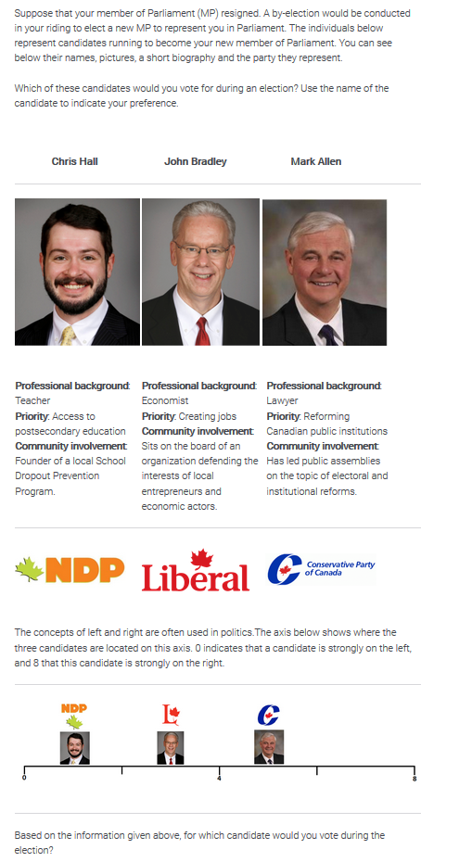

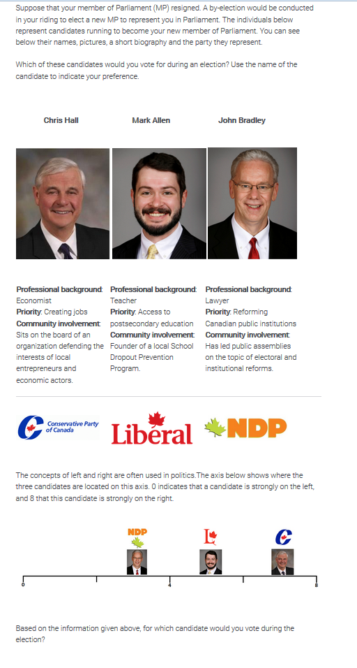
Appendix D: Additional Knowledge Questions used in the Experiment
The following questions were added to the questions found in Appendix A to measure knowledge in the experiment. The correct answers are provided in bracket.

- The new Liberal government elected in 2015 changed the parameters of the Canadian mission against ISIS. How did these parameters change? [There are less airstrikes and more forces on the ground.]
- There are less airstrikes and less forces on the ground.
- There are less airstrikes and more forces on the ground.
- There are more airstrikes and less forces on the ground.
- There are more airstrikes and more forces on the ground.
- Don’t know
- On what topic was the Canadian government required by the Supreme Court to adopt a law by June 2016? [Assisted dying]
- Legalizing marijuana
- Assisted dying
- Missing and murdered Indigenous women
- Protecting the environment
- Don’t know
- According to the 2016 Canadian budget, what is approximately the projected size of the deficit for the next five years? [100 billion]
  - 5 billion
  - 10 billion
  - 50 billion
  - 100 billion
  - Don’t know
- What document has animated discussions during the most recent convention of the federal NDP? [The LEAP manifesto]
- The LEAP manifesto
- The Regina manifesto
- The Sherbrooke Declaration
- The Meech Lake Accord
- Don’t know

Appendix E: Experimental Tables
Table E1: Descriptive Statistics for Study 2

Variable | Mean | Std. dev. | Min | Max
Vote | 0.33 | 0.47 | 0 | 1
Ideological Proximity | 0.70 | 0.22 | 0 | 1
Party Identification | 0.23 | 0.42 | 0 | 1
Candidate Economic Competence | 0.33 | 0.47 | 0 | 1
KnowledgeXProximity | 0.36 | 0.17 | 0 | 1
KnowledgeXParty Identification | 0.12 | 0.24 | 0 | 1
KnowledgeX Candidate Competence | 0.17 | 0.26 | 0 | 1
Party Economic Competence | 4.81 | 2.63 | 0 | 10
Party Thermometer Score | 4.78 | 2.94 | 0 | 10
Political Knowledge | 0.51 | 0.18 | 0 | 1
Male | 0.48 | 0.50 | 0 | 1
Education | 3.61 | 1.55 | 1 | 8
Catholic | 0.22 | 0.41 | 0 | 1
Atheist | 0.48 | 0.50 | 0 | 1
Age | 45.59 | 15.88 | 19 | 94
French | 0.07 | 0.25 | 0 | 1
Atlantic | 0.09 | 0.29 | 0 | 1
West | 0.36 | 0.48 | 0 | 1

N(i)= 4539
N(j)= 1513

Table E2: Experimental Evidence for the Impact of the Determinants of the Vote by Political Knowledge

 | All Candidates |  |  |  |  |  |  | Candidate 2 |  |  |  |  |  | Candidate 3
 | Coef. |  |  | Std. Err. |  |  |  | Coef. |  |  | Std. Err. |  |  | Coef. |  |  | Std. Err.
Ideological Proximity |  | -0.56 |  |  |  |  | 0.52 |  |  | - |  |  | - |  |  | - |  |  | -
Party Identification |  | 0.53* |  |  |  |  | 0.23 |  |  | - |  |  | - |  |  | - |  |  | -
Candidate Economic Competence |  | 0.35* |  |  |  |  | 0.18 |  |  | - |  |  | - |  |  | - |  |  | -
KnowledgeXProximity |  | 2.29* |  |  |  |  | 0.98 |  |  | - |  |  | - |  |  | - |  |  | -
KnowledgeXParty Identification |  | 0.07 |  |  |  |  | 0.42 |  |  | - |  |  | - |  |  | - |  |  | -
KnowledgeXCandidate Competence |  | 0.10 |  |  | 0.34 |  |  |  | - |  |  | - |  |  | - |  |  | -
Party Economic Competence |  | 0.09*** |  |  | 0.03 |  |  |  | - |  |  | - |  |  | - |  |  | -
Party Thermometer Score |  | 0.13*** |  |  | 0.02 |  |  |  | - |  |  | - |  |  | - |  |  | -
Political Knowledge |  |  | - |  |  | - |  |  |  | 0.48 |  |  | 0.43 |  |  | 0.06 |  |  | 0.44
Male |  |  | - |  |  | - |  |  |  | -0.04 |  |  | 0.15 |  |  | 0.11 |  |  | 0.15
Education |  |  | - |  |  | - |  |  |  | 0.04 |  |  | 0.05 |  |  | 0.04 |  |  | 0.05
Catholic |  |  | - |  |  | - |  |  |  | -0.14 |  |  | 0.21 |  |  | 0.07 |  |  | 0.21
Atheist |  |  | - |  |  | - |  |  |  | -0.08 |  |  | 0.17 |  |  | 0.08 |  |  | 0.17
Age |  |  | - |  |  | - |  |  |  | -0.01 |  |  | 0.01 |  |  | 0.004 |  |  | 0.01
French |  |  | - |  |  | - |  |  |  | 0.82** |  |  | 0.30 |  |  | 0.47 |  |  | 0.31
Atlantic |  |  | - |  |  | - |  |  |  | 0.22 |  |  | 0.25 |  |  | 0.26 |  |  | 0.26
West |  |  | - |  |  | - |  |  |  | 0.17 |  |  | 0.16 |  |  | 0.29 |  |  | 0.16
Intercept |  |  | - |  |  | - |  |  |  | 0.21 |  |  | 0.45 |  |  | -0.71 |  |  | 0.46

N(i)= 4539
Legend
*: 0.05 **: 0.01 ***: 0.001
N(j)= 1513
Log-likelihood=-1336.62

