Appendix:
The Changing Nature of Class Voting in Canada, 1965–2019

Appendix

A1 Descriptive Statistics
A2 Attitudinal policy variable questions
A3 Class Voting in Canada over time (Alternative Figure 1)
A4 Coefficients from Quebec and Rest of Canada OLS models predicting party vote by the working class (Alternative Figure 2)
A5 OLS Regression Results of Working-Class Vote, 1993-2019 for Quebec only

A1 Descriptive Statistics

For the categorical variables (Class, Religion, Region, and Income) we provide the mean and standard deviation of each category within the variable, so the means can be interpreted as percentages.

Variable | Observations | Mean | Std. Dev.
(Class) Professional | 7,111 | 0.2467555 | 0.4311307
(Class) Managers | 4,109 | 0.1425845 | 0.3496547
(Class) Routine Non-Manual | 7,766 | 0.2694844 | 0.4436996
(Class) Working-Class | 5,741 | 0.1992158 | 0.3994176
(Class) Self-Employed | 4,091 | 0.1419599 | 0.349015
Age | 51,583 | 47.53169 | 17.07638
Male | 52,808 | 0.4813286 | 0.499656
Degree | 51,015 | 0.2350289 | 0.424021
(Religion) None | 7,517 | 0.1490847 | 0.3561755
(Religion) Catholic | 21,151 | 0.4194879 | 0.4934801
(Religion) Protestant | 19,255 | 0.3818845 | 0.4858533
(Religion) Other | 2,498 | 0.0495428 | 0.2170007
(Region) East | 7,541 | 0.1432534 | 0.3503344
(Region) Quebec | 13,197 | 0.2506981 | 0.4334191
(Region) Ontario | 15,331 | 0.2912369 | 0.4543367
(Region) West | 16,572 | 0.3148116 | 0.4644452
(Income) 1 | 8,182 | 0.1704583 | 0.3760389
(Income) 2 | 10,421 | 0.2171042 | 0.4122784
(Income) 3 | 10,236 | 0.21325 | 0.409607
(Income) 4 | 8,989 | 0.1872708 | 0.3901328
(Income) 5 | 10,172 | 0.2119167 | 0.4086704
Union | 44,544 | 0.349542 | 0.4768307
Redistribution | 26,597 | 0.763752 | 0.248011
Market Liberalism | 30,243 | 0.492548 | 0.279086
Moral Traditionalism | 30,208 | 0.410905 | 0.324837
Immigration Rates | 31,223 | 0.572383 | 0.341206
NDP | 38,122 | 0.1631341 | 0.3694929
Liberal | 38,122 | 0.3622842 | 0.4806667
Conservative | 38,122 | 0.3741409 | 0.4839066
Bloc | 38,122 | 0.0537747 | 0.2255756
NDP vs Right | 20,482 | 0.3036325 | 0.459837
Liberal vs Right | 28,074 | 0.4919498 | 0.4999441
Bloc vs Right | 16,313 | 0.1256666 | 0.3314834

A2 Attitudinal policy variable questions

Variable | Question(s) | Year(s)
Market Liberalism | - Government should leave it entirely to the private sector to create jobs. | 1993–2019
 | - People who don't get ahead should blame themselves not the system. | 1993–2019
Moral Traditionalism | - Society would be better off if more women stayed home with their children. | 1993–2019
 | - Gays and lesbians should be allowed to get married | 1993–2015
 | - How much do you think should be done for Gays & Lesbians | 2019
Redistribution | - How much should be done to reduce the gap between the rich and the poor in Canada | 1993–2019
Immigration  Rates | - Do you think Canada should admit: more immigrants, fewer immigrants, or about the same | 1993–2019

A3 Class Voting in Canada over time

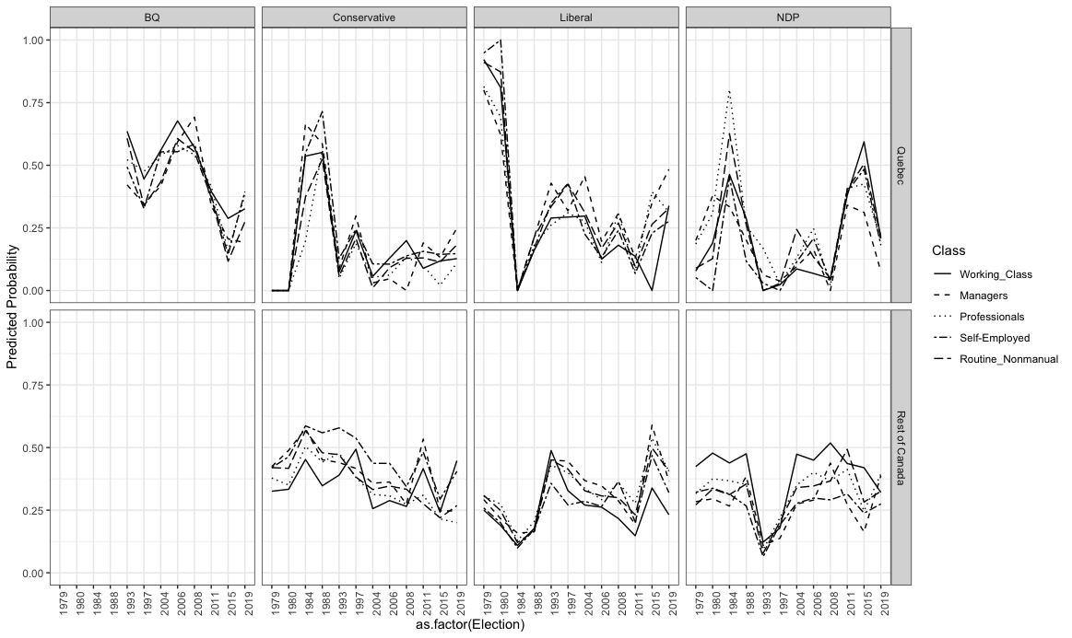
Figure A3a: Effect of social class on party vote, with self-employed and controls, 1979-2019.

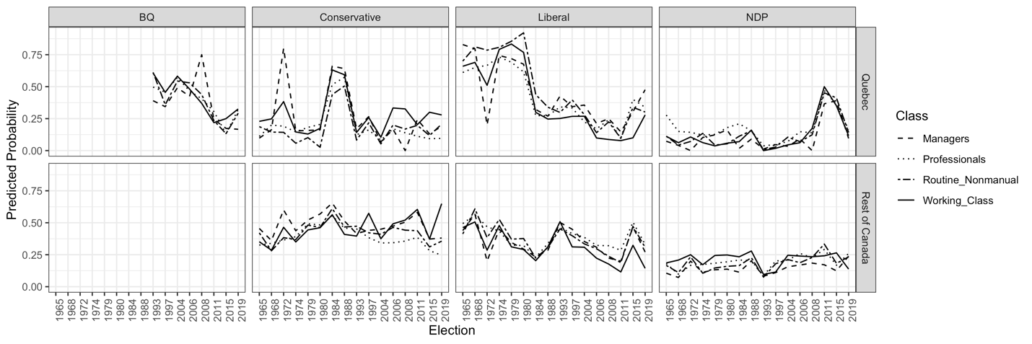
Figure A3b: Effect of social class on party vote, with no controls, and with no self-employed, 1965-2019.

A4 Working Class Party Voting for Quebec and Rest of Canada (ROC)

Quebec
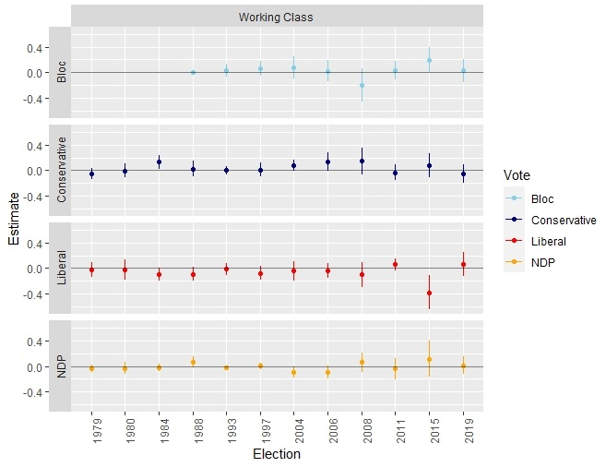
Coefficients from rest of Canada (ROC) OLS models predicting party vote by working class, with key class-related controls for age, degree, gender, income, region, religion, and union status.

Rest of Canada
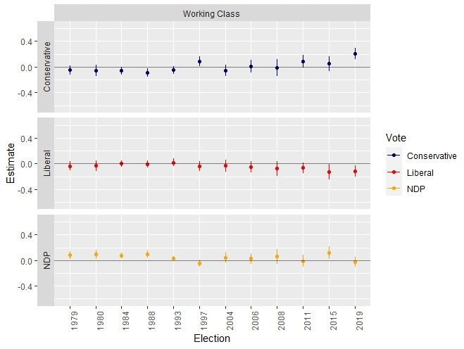
Coefficients from Quebec OLS models predicting party vote by working class, with key class-related controls for age, degree, gender, income, religion, and union status.

A5 OLS Logistic Regression Results of Working-Class Vote for Quebec

Table A5a: OLS Regression of Working-Class Vote for Bloc Québécois, 1993-2019
 | Bloc
 | 1990s | 2000s | 2010s
 | (1) | (2) | (3)
Age | -0.003 | -0.003 | -0.002
 | (0.003) | (0.004) | (0.005)
Male | 0.032 | -0.145 | -0.181
 | (0.086) | (0.106) | (0.177)
Income | -0.000 | 0.049 | -0.006
 | (0.038) | (0.037) | (0.052)
Degree | -0.035 | -0.025 | 0.276
 | (0.164) | (0.138) | (0.168)
Union | 0.293*** | -0.092 | 0.130
 | (0.085) | (0.090) | (0.115)
(Religion) None | (ref) | (ref) | (ref)
(Religion) Cath. | 0.155 | -0.020 | -0.380**
 | (0.283) | (0.145) | (0.141)
(Religion) Prot. | -0.075 | -0.191 | -0.521
 | (0.363) | (0.218) | (0.504)
(Religion) Other | 0.030 |  | -0.416
 | (0.386) |  | (0.502)
Redistribution | -0.209 | -0.271 | 0.101
 | (0.146) | (0.169) | (0.233)
Market Lib. | -0.140 | -0.457** | 0.036
 | (0.146) | (0.150) | (0.242)
Immigration | 0.014 | 0.082 | 0.132
 | (0.123) | (0.166) | (0.161)
Traditionalism | 0.006 | -0.218⁺ | -0.158
 | (0.151) | (0.129) | (0.213)
Constant | 0.123 | 0.717* | 0.849*
 | (0.354) | (0.287) | (0.402)
Fixed Effects | Year | Year | Year
N | 152 | 155 | 96
R² | 0.24 | 0.16 | 0.18
Adjusted R² | 0.17 | 0.08 | 0.03
Table A5a: OLS models predicting Bloc Québécois vote of the working class, with key class-related controls for age, gender, income, region, religion, and union status.

Table A5b: OLS Regression of Working-Class Vote for National Parties in Quebec, 1993-2019
 | NDP |  |  | Liberal |  |  | Conservative
 | 1990s | 2000s | 2010s | 1990s | 2000s | 2010s | 1990s | 2000s | 2010s
 | (1) | (2) | (3) | (4) | (5) | (6) | (7) | (8) | (9)
Age | -0.000 | 0.003 | -0.005 | -0.001 | 0.001 | 0.010** | 0.007* | -0.001 | -0.002
 | (0.001) | (0.002) | (0.005) | (0.003) | (0.003) | (0.003) | (0.003) | (0.003) | (0.004)
Male | -0.010 | 0.068 | 0.118 | -0.103 | 0.048 | 0.049 | 0.054 | 0.039 | 0.015
 | (0.015) | (0.049) | (0.181) | (0.077) | (0.075) | (0.129) | (0.073) | (0.093) | (0.157)
Income | -0.011⁺ | 0.003 | -0.003 | 0.014 | -0.074** | -0.009 | 0.002 | 0.035 | 0.018
 | (0.006) | (0.017) | (0.053) | (0.033) | (0.026) | (0.038) | (0.032) | (0.032) | (0.046)
Degree | 0.113*** | -0.070 | -0.043 | 0.091 | 0.093 | -0.068 | -0.159 | -0.043 | -0.165
 | (0.028) | (0.063) | (0.172) | (0.146) | (0.098) | (0.123) | (0.139) | (0.120) | (0.150)
Union | 0.001 | 0.039 | 0.012 | -0.237** | -0.010 | 0.046 | -0.043 | 0.046 | -0.188
 | (0.015) | (0.041) | (0.118) | (0.076) | (0.064) | (0.084) | (0.072) | (0.079) | (0.103)
(Religion) None | (ref) | (ref) | (ref) | (ref) | (ref) | (ref) | (ref) | (ref) | (ref)
(Religion) Cath. | 0.024 | -0.141* | 0.163 | 0.344 | 0.057 | 0.085 | -0.196 | 0.072 | 0.133
 | (0.048) | (0.066) | (0.144) | (0.251) | (0.103) | (0.103) | (0.239) | (0.126) | (0.125)
(Religion) Prot. | -0.023 | -0.188⁺ | 0.651 | 0.736* | 0.335* | -0.284 | -0.289 | 0.052 | 0.155
 | (0.062) | (0.100) | (0.516) | (0.322) | (0.155) | (0.368) | (0.307) | (0.191) | (0.448)
(Religion) Other | -0.018 |  | 0.116 | 0.390 |  | 0.496 | -0.050 |  | -0.195
 | (0.066) |  | (0.513) | (0.343) |  | (0.366) | (0.327) |  | (0.446)
Redistribution | 0.001 | -0.009 | -0.383 | -0.096 | 0.187 | 0.088 | 0.306* | 0.114 | 0.194
 | (0.025) | (0.077) | (0.238) | (0.129) | (0.120) | (0.170) | (0.123) | (0.148) | (0.207)
Market Lib. | -0.027 | 0.006 | -0.195 | 0.002 | 0.134 | 0.005 | 0.176 | 0.326* | 0.154
 | (0.025) | (0.069) | (0.247) | (0.130) | (0.107) | (0.177) | (0.124) | (0.131) | (0.215)
Immigration | -0.008 | -0.087 | 0.126 | -0.015 | -0.168 | -0.291* | -0.013 | 0.177 | 0.034
 | (0.021) | (0.076) | (0.165) | (0.109) | (0.118) | (0.118) | (0.104) | (0.145) | (0.143)
Traditionalism | -0.023 | -0.033 | -0.163 | 0.126 | 0.151 | 0.235 | -0.156 | 0.079 | 0.086
 | (0.026) | (0.059) | (0.218) | (0.134) | (0.091) | (0.156) | (0.128) | (0.112) | (0.190)
Constant | 0.076 | 0.093 | -0.117 | -0.050 | 0.280 | -0.005 | 0.474 | -0.168 | 0.274
 | (0.060) | (0.131) | (0.411) | (0.315) | (0.204) | (0.294) | (0.300) | (0.250) | (0.358)
Fixed Effects | Year | Year | Year | Year | Year | Year | Year | Year | Year
N | 152 | 155 | 96 | 152 | 155 | 96 | 152 | 155 | 96
R² | 0.17 | 0.09 | 0.20 | 0.15 | 0.21 | 0.30 | 0.15 | 0.15 | 0.10
⁺ p < 0.1, * p < 0.05, ** p < 0.01, *** p < 0.001
Table A5b: OLS models predicting national party voting of the working class, with key class-related controls for age, gender, income, region, religion, and union status.

