Appendix

Table A1: The Government of Canada organizations divided by departments and agency type.
Depts | Administrative agencies | Adjudicative  Agencies | Regulatory agencies | Enforcement agencies | Parliamentary agencies
ESDC – 002  DoD – 003  FOC – 005  HC – 006  PSPC – 007  Agr – 009  ISEDC – 010  ECCC – 011  TC – 012  IRC – 013  GA – 014  NRC – 015  INAC – 017  VA – 018  DoJ – 019  Herit – 020  FIN – 024  TBS – 026  PCO – 028  WED – 043  PSafe – 053  InfC – 082  SOW – 140 | CRA – 001  Stats – 008  PSC – 021  CAS – 030  ACOA – 032  CSA – 033  EDQR – 034  SSC – 037  TSBC – 039  PHAC – 070  LAC – 074  FTRA – 087  Parks – 088  ATSS – 091  NFB – 092  FDev– 093  CICC – 103 | IRB – 023  CRTC – 031  PBC – 036  CHRC – 041  MPCC – 101  CRBC – 105  IJC – 107  NFPC – 109  PMPR -111  CRCC – 114  MGER – 119  RPER – 125  VRAB – 150 | CGC – 025  CEAA – 047  CTA – 054  NEB – 075  CFIA - 086  OCLC – 139  IOG – 149 | CSC – 004  RCMP – 016  ODPP – 046  CBSA – 083  CSEC – 089 | OCEO – 040  OCOL – 042  OAG – 052  OGG – 073  OPC – 080  OCJA – 110  OPSI – 143  OCI – 147  OICA – 151
N = 134,191 | N = 68,226 | N = 2,650 | N = 2,154 | N = 47,177 | N = 1,920
Note: See the PSES 2017 survey guide for acronym definitions. The numbers are the codes given to each organization in the survey guide book.

Table A2: Covariates used for matching methods and subsequent regressions
Variable | Original codes | Transformed codes to dummy
gender | M (1); F (2); Other (3); NS (9) | M (1); rest (0)
age_group | <24 (1); 25-29 (2); 30-34 (3); 35-39 (4); 40-44 (5); 45-49 (6); 50-54 (7); 55-59 (8); 60+ (9); NS (99) | <24, 25-29, 30-34, 35-39 (1); rest (0)
like_job | SA (1)-SD (5); n/a (6), DK (97), NS (99) | SA, A (1); rest (0)
occ_groups | Executive (1); Scientific and Professional (2); Administration and Foreign Services (3); Technical (4); Administrative Support (5); Operational (6); Other (7); NS (99) | Executive; Scientific and Professional; Administration and Foreign Services (1); rest (0)
region | Atlantic (1); Quebec, excl NCR (2); Ontario, excl NCR (3); Prairies, Nunavut, NWT (4); BC, Yukon (5); National Capital Region (6); Outside Canada (7); NS (99) | NCR (1); rest (0)
Figure A1:
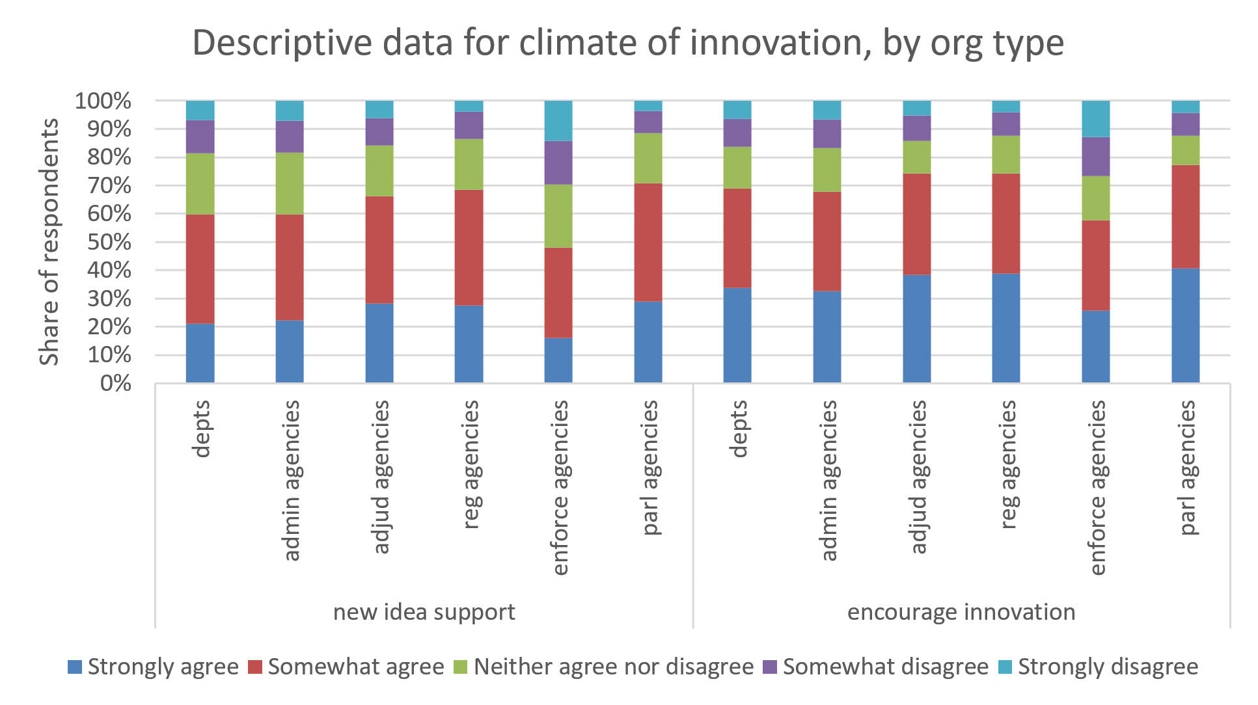

Figure A2:
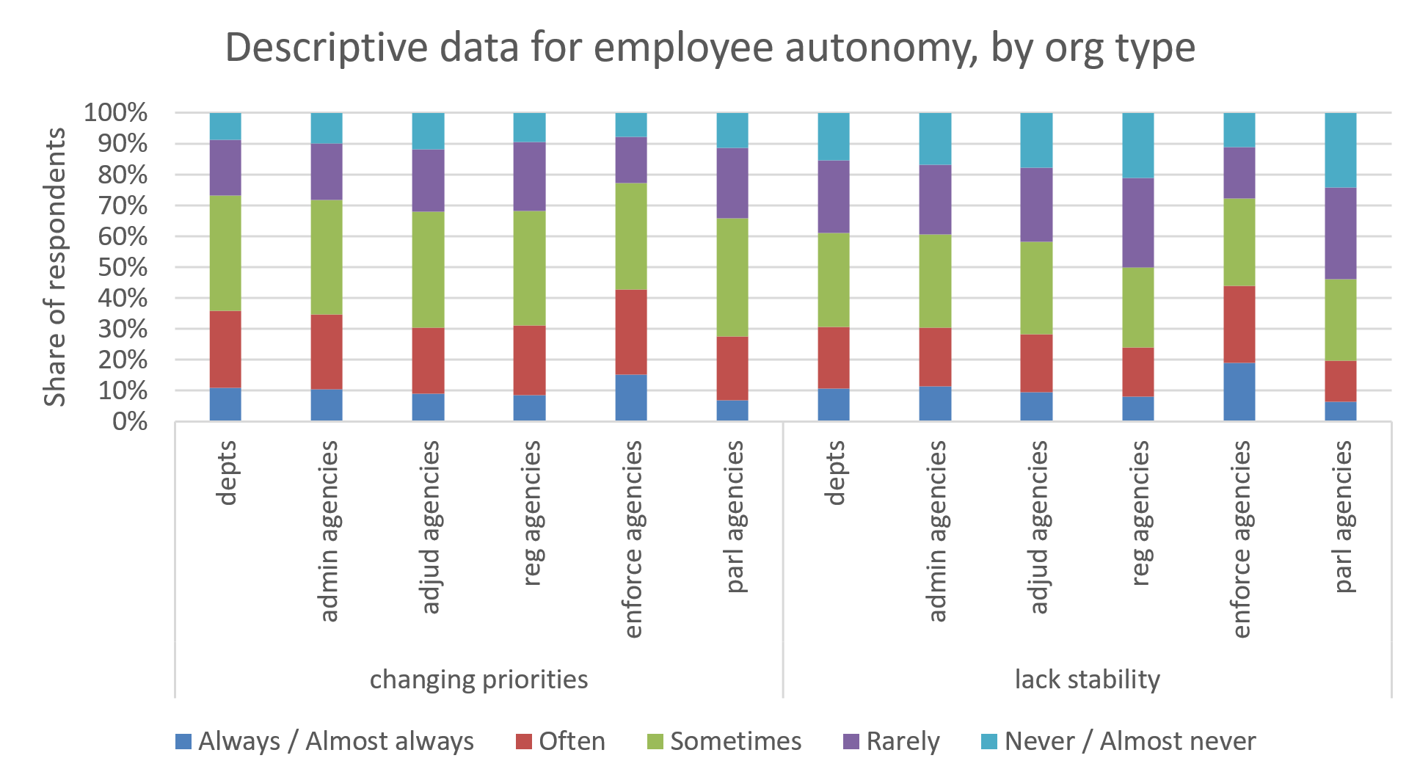

Figure A3:

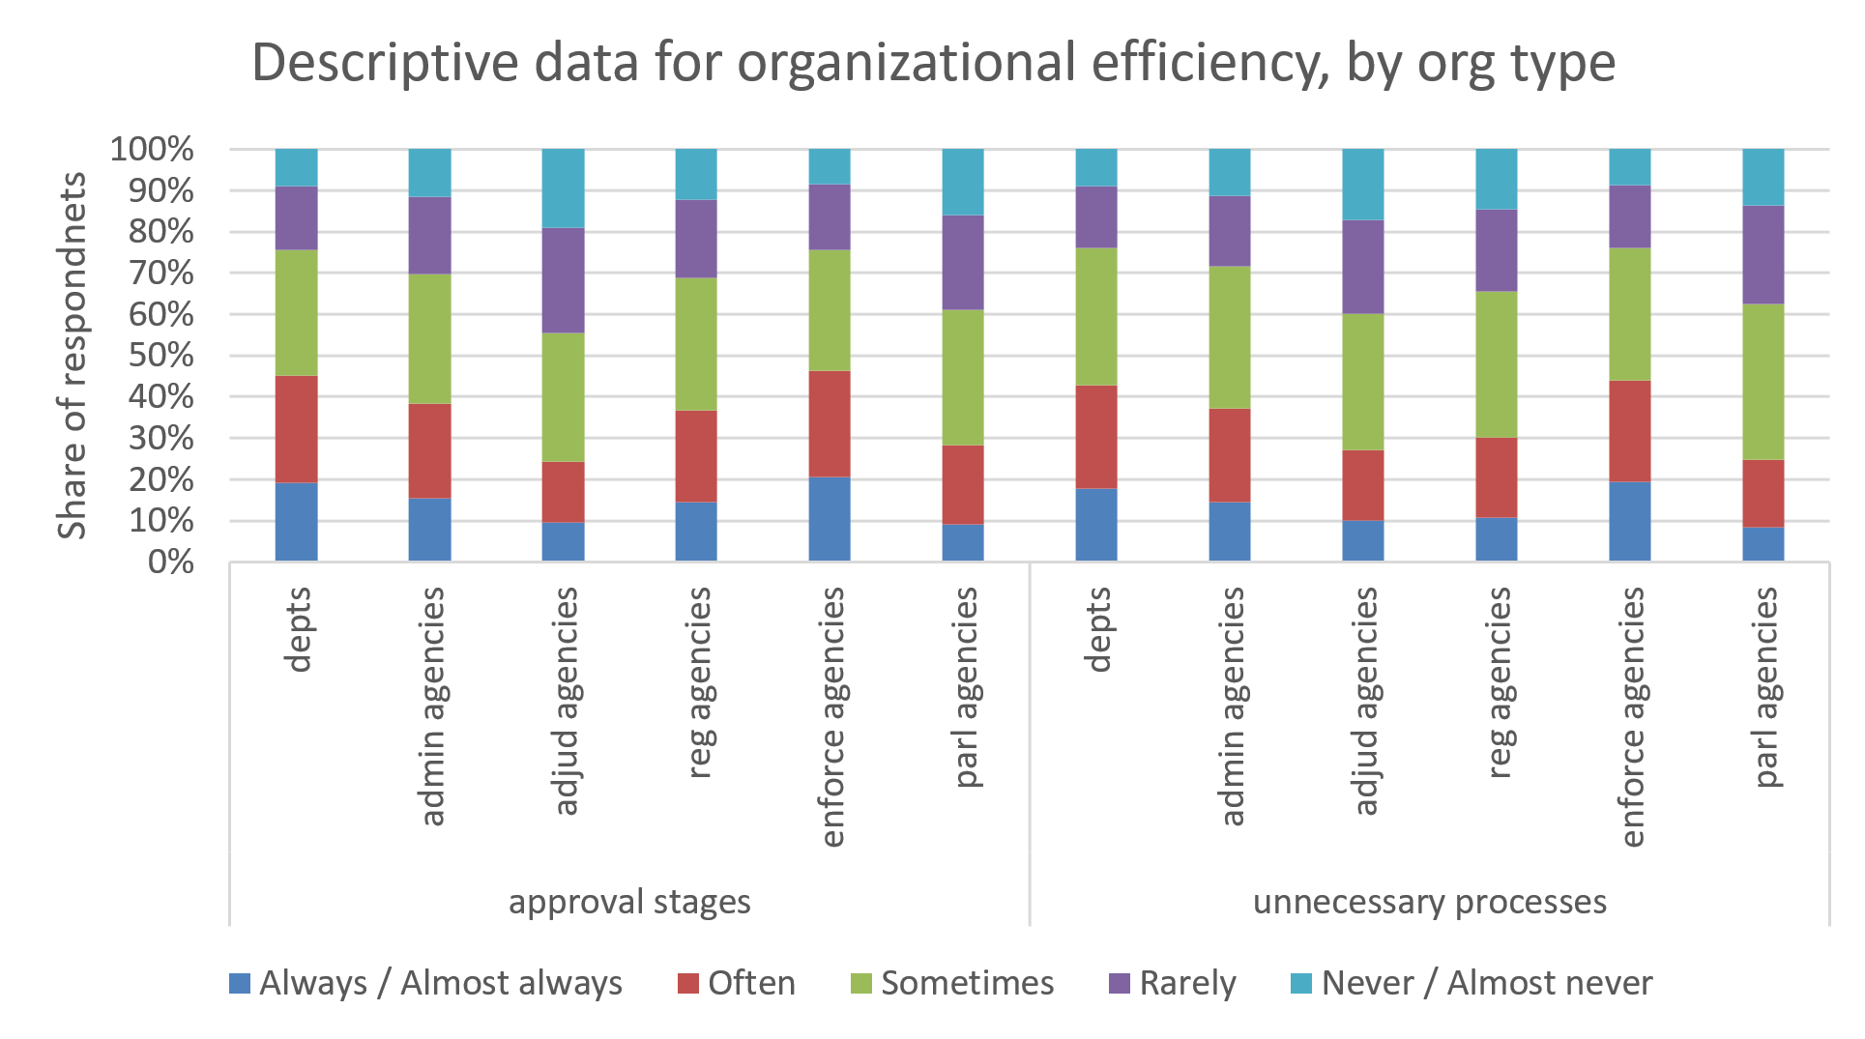

Table A3: New idea support logistic regression results (matched data)
 | Model 1 | Model 2 | Model 3 | Model 4 | Model 5 | Model 6
Intercept | 0.27***  (0.26-0.28) | 0.28***  (0.26-0.29) | 0.24***  (0.19-0.31) | 0.24***  (0.18-0.31) | 0.24***  (0.16-0.35) | -0.26***  (0.25-0.28)
Agency (all) | 0.91***  (0.89-0.93) | - | - | - | - | -
Administrative  agency | - | 1.05***  (1.03-1.08) | - | - | - | -
Regulatory  agency | - | - | 1.69***  (1.46-1.96) | - | - | -
Adjudicative agency | - | - | - | 1.28***  (1.12-1.46) | - | -
Parliamentary  agency | - | - | - | - | 1.55***  (1.32-1.83) | -
Enforcement agency | - | - | - | - | - | 0.71***  (0.69-0.74)
gender (male) | 0.99  (0.97-1.01) | 0.99  (0.96-1.08) | 0.98  (0.85-1.13) | 0.87*  (0.75-0.99) | 1.11  (0.94-1.31) | 1.05*  (1.01-1.08)
age_group  (young) | 0.83***  (0.81-0.85) | 0.82***  (0.79-0.84) | 0.81** (0.69-0.94) | 0.79**  (0.69-0.91) | 0.83*  (0.70-0.97) | 0.85***  (0.82-0.88)
like_job  (like) | 5.92***  (5.76-6.08) | 5.76***  (5.56-5.97) | 6.18***  (5.09-7.53) | 6.22***  (5.11-7.61) | 5.96***  (4.83-7.41) | 5.92***  (5.64-6.21)
occ_group  (policy/advice) | 1.20***  (1.17-1.23) | 1.12***  (1.09-1.16) | 1.32**  (1.11-1.56) | 1.27**  (1.09-1.47) | 1.14  (0.95-1.38) | 1.29***  (1.24-1.34)
region  (NCR) | 1.40***  (1.36-1.43) | 1.39***  (1.36-1.43) | 1.44***  (1.24-1.66) | 1.65***  (1.42-1.89) | 1.38*  (1.03-1.84) | 1.45***  (1.39-1.51)
Matching N | treated (84,470); unmatched (5,604) | treated (51,684); unmatched (71,176) | treated (1,802); unmatched (170,940) | treated (2,001); unmatched (170,542) | treated (1,465); unmatched (171,614) | treated (43,221); unmatched (88,102)
Note: Odds ratios, confidence intervals in brackets for 95%. *p<.05; **p<.01; ***p<.001

Table A4: Encouraged innovation logistic regression results (matched data)
 | Model 1 | Model 2 | Model 3 | Model 4 | Model 5 | Model 6
Intercept | 0.32*** | 0.32***  (0.30-0.33) | 0.35***  (0.27-0.44) | 0.27***  (0.21-0.36) | 0.31***  (0.20-0.48) | 0.30***  (0.29-0.32)
Agency (all) | 0.86***  (0.84-0.88) | - | - | - | - | -
Administrative  agency | - | 1.02*  (0.99-1.05) | - | - | - | -
Regulatory  agency | - | - | 1.35***  (1.15-1.59) | - | - | -
Adjudicative agency | - | - | - | 1.22***  (1.05-1.41) | - | -
Parliamentary  agency | - | - | - | - | 1.24***  (1.03-1.49) | -
Enforcement agency | - | - | - | - | - | 0.67***  (0.65-0.70)
gender (male) | 1.15***  (1.12-1.17) | 1.11***  (-1.08-1.15) | 1.17***  (1.00-1.38) | 1.07  0.92-1.25) | 1.17  (0.97-1.42) | 1.26***  (1.21-1.31)
age_group  (young) | 0.87***  (0.85-0.89) | 0.86***  (0.83-0.89) | 0.87  (0.74-1.03) | 0.88  (0.75-1.04) | 0.94  (0.78-1.14) | 0.87***  (0.84-0.91)
like_job  (like) | 8.25***  (8.03-8.47) | 7.99***  (7.72-8.27) | 8.15***  (6.76-9.85) | 8.75***  (7.22-10.65) | 9.65***  (7.79-11.99) | 8.28***  (7.91-8.67)
occ_group  (policy/advice) | 1.16***  (1.14-1.19) | 1.09***  (1.06-1.13) | 1.32***  (1.09-1.59) | 1.16  (0.98-1.37) | 1.11  (0.89-1.38) | 1.26***  (1.21-1.31)
region  (NCR) | 1.65***  (1.61-1.69) | 1.68***  (1.63-1.74) | 1.23***  (1.05-1.44) | 1.86***  (1.59-2.19) | 1.33  (0.95-1.84) | 1.78***  (1.69-1.86)
Matching N | treated (84,470); unmatched (5,604) | treated (51,684); unmatched (71,176) | treated (1,802); unmatched (170,940) | treated (2,001); unmatched (170,542) | treated (1,465); unmatched (171,614) | treated (43,221); unmatched (88,102)
Note: Odds ratios, confidence intervals in brackets for 95%. *p<.05; **p<.01; ***p<.001

Table A5: Changing priorities logistic regression results (matched data)
 | Model 1 | Model 2 | Model 3 | Model 4 | Model 5 | Model 6
Intercept | 0.82***  (0.79-0.85) | 0.80***  (0.77-84) | 0.75***  (0.60-0.93) | 0.98  (0.77-1.25) | 0.65***  (0.44-0.96) | 0.82***  (0.78-0.87)
Agency (all) | 1.07***  (1.05-1.07) | - | - | - | - | -
Administrative  agency | - | 0.88***  (0.86-0.90) | - | - | - | -
Regulatory  agency | - | - | 0.87  (0.76-1.00) | - | - | -
Adjudicative agency | - | - | - | 0.82***  (0.72-0.94) | - | -
Parliamentary  agency | - | - | - | - | 0.66***  (0.56-0.78) | -
Enforcement agency | - | - | - | - | - | 1.40***  (1.36-1.46)
gender (male) | 0.99  (0.97-1.01) | 1.02  (0.99-1.04) | 1.15  (0.99-1.33) | 0.97  (0.85-1.12) | 1.22***  (1.03-1.43) | 0.91***  (0.88-0.95)
age_group  (young) | 1.28***  (1.25-1.29) | 1.32***  (1.28-1.36) | 1.36***  (1.17-1.58) | 1.22***  (1.05-1.41) | 1.25***  (1.06-1.47) | 1.23***  (1.19-1.28)
like_job  (like) | 0.43***  (0.41-0.44) | 0.44***  (0.42-0.46) | 0.47***  (0.39-0.56) | 0.38***  (0.32-0.46) | 0.46***  (0.38-0.56) | 0.43***  (0.41-0.45)
occ_group  (policy/advice) | 1.08***  (1.05-1.10) | 1.11***  (1.08-1.14) | 0.92  (0.78-1.08) | 1.11  (0.95-1.30) | 1.14  (0.94-1.38) | 1.13***  (1.09-1.17)
region  (NCR) | 0.98***  (0.96-0.99) | 1.01  (0.98-1.03) | 0.87  (0.75-1.00) | 0.85***  (0.74-0.99) | 1.09  (0.81-1.48) | 0.98  (0.94-1.02)
Matching N | treated (84,470); unmatched (5,604) | treated (51,684); unmatched (71,176) | treated (1,802); unmatched (170,940) | treated (2,001); unmatched (170,542) | treated (1,465); unmatched (171,614) | treated (43,221); unmatched (88,102)
Note: Odds ratios, confidence intervals in brackets for 95%. *p<.05; **p<.01; ***p<.001

Table A6: Lack stability logistic regression results (matched data)
 | Model 1 | Model 2 | Model 3 | Model 4 | Model 5 | Model 6
Intercept | 0.99  (0.96-1.03) | 1.03  (0.98-1.08) | 1.29***  (1.03-1.63) | 1.48***  (1.15-1.90) | 0.67  (0.43-1.02) | 0.97  (0.92-1.02)
Agency (all) | 1.22***  (1.19-1.24) | - | - | - | - | -
Administrative  agency | - | 0.88***  (0.86-0.91) | - | - | - | -
Regulatory  agency | - | - | 0.62***  (0.52-0.72) | - | - | -
Adjudicative agency | - | - | - | 0.94  (0.81-1.09) | - | -
Parliamentary  agency | - | - | - | - | 0.57***  (0.47-0.68) | -
Enforcement agency | - | - | - | - | - | 1.76***  (1.70-1.83)
gender (male) | 0.91***  (0.89-0.93) | 0.93***  (0.91-0.96) | 1.04  (0.90-1.22) | 0.87  (0.74-1.01) | 0.90  (0.75-1.07) | 0.85***  (0.82-0.88)
age_group  (young) | 1.26***  (1.23-1.28) | 1.26***  (1.23-1.30) | 1.31***  (1.11-1.54) | 1.17***  (1.01-1.37) | 1.06  (0.89-1.27) | 1.19***  (1.15-1.24)
like_job  (like) | 0.31***  (0.30-0.32) | 0.32***  (0.31-0.33) | 0.28***  (0.24-0.34) | 0.26***  (0.21-0.30) | 0.34***  (0.28-0.42) | 0.32***  (0.30-0.33)
occ_group  (policy/advice) | 0.93***  (0.91-0.95) | 0.98  (0.95-1.01) | 0.92  (0.77-1.10) | 0.86  (0.73-1.01) | 1.09  (0.89-1.35) | 0.99  (0.96-1.04)
region  (NCR) | 0.81***  (0.79-0.83) | 0.83***  (0.80-0.85) | 0.62***  (0.53-0.72) | 0.73***  (0.62-0.85) | 1.36  (0.97-1.95) | 0.86***  (0.82-0.90)
Matching N | treated (84,470); unmatched (5,604) | treated (51,684); unmatched (71,176) | treated (1,802); unmatched (170,940) | treated (2,001); unmatched (170,542) | treated (1,465); unmatched (171,614) | treated (43,221); unmatched (88,102)
Note: Odds ratios, confidence intervals in brackets for 95%. *p<.05; **p<.01; ***p<.001

Table A7: Approval stages logistic regression results (matched data)
 | Model 1 | Model 2 | Model 3 | Model 4 | Model 5 | Model 6
Intercept | 1.13***  (1.09-1.17) | 1.02  (0.98-1.07) | 1.10  (0.89-1.37) | 1.05  (0.82-1.35) | 1.12  (0.76-1.63) | 1.01  (0.96-1.06)
Agency (all) | 0.86***  (0.84-0.88) | - | - | - | - | -
Administrative  agency | - | 0.77***  (0.75-0.79) | - | - | - | -
Regulatory  agency | - | - | 0.90  (0.78-1.04) | - | - | -
Adjudicative agency | - | - | - | 0.44***  (0.38-0.51) | - | -
Parliamentary  agency | - | - | - | - | 0.51***  (0.44-0.60) | -
Enforcement agency | - | - | - | - | - | 1.26***  (1.21-1.30)
gender (male) | 0.80***  (0.79-0.82) | 0.81***  (0.79-0.83) | 0.87  (0.76-1.00) | 0.88  (0.77-1.02) | 0.85**  (0.72-0.99) | 0.77***  (0.74-0.79)
age_group  (young) | 1.25***  (1.23-1.28) | 1.25***  (1.22-1.28) | 1.08  (0.94-1.25) | 1.39***  (1.20-1.62) | 1.33***  (1.14-1.57) | 1.24***  (1.19-1.28)
like_job  (like) | 0.48***  (0.47-0.49) | 0.49***  (0.48-0.51) | 0.48***  (0.40-0.57) | 0.42***  (0.35-0.50) | 0.43***  (0.35-0.52) | 0.47***  (0.45-0.48)
occ_group  (policy/advice) | 1.08***  (1.06-1.10) | 1.15***  (1.12-1.19) | 1.09  (0.93-1.28) | 0.97  (0.83-1.14) | 0.99  (0.83-1.19) | 1.12***  (1.08-1.16)
region  (NCR) | 1.09***  (1.07-1.12) | 1.16***  (1.12-1.19) | 0.96  (0.83-1.10) | 1.18***  (1.01-1.36) | 1.23  (0.92-1.67) | 1.13***  (1.09-1.18)
Matching N | treated (84,470); unmatched (5,604) | treated (51,684); unmatched (71,176) | treated (1,802); unmatched (170,940) | treated (2,001); unmatched (170,542) | treated (1,465); unmatched (171,614) | treated (43,221); unmatched (88,102)
Note: Odds ratios, confidence intervals in brackets for 95%. *p<.05; **p<.01; ***p<.001

Table A8: Unnecessary processes logistic regression results (matched data)
 | Model 1 | Model 2 | Model 3 | Model 4 | Model 5 | Model 6
Intercept | 1.21***  (1.17-1.25) | 1.13***  (1.08-1.18) | 1.28***  (1.02-1.59) | 1.32***  (1.03-1.69) | 1.12  (0.76-1.65) | 1.08***  (1.03-1.14)
Agency (all) | 0.85***  (0.83-0.87) | - | - | - | - | -
Administrative  agency | - | 0.76***  (0.74-0.78) | - | - | - | -
Regulatory  agency | - | - | 0.74***  (0.64-0.86) | - | - | -
Adjudicative agency | - | - | - | 0.65***  (0.56-0.75) | - | -
Parliamentary  agency | - | - | - | - | 0.55***  (0.46-0.64) | -
Enforcement agency | - | - | - | - | - | 1.22***  (1.17-1.26)
gender (male) | 0.80***  (0.84-0.87) | 0.81***  (0.79-0.83) | 0.84***  (0.72-0.97) | 0.82***  (0.71-0.95) | 0.89  (0.76-1.06) | 0.77***  (0.74-0.80)
age_group  (young) | 1.34***  (1.31-1.37) | 1.35***  (1.31-1.39) | 1.25***  (1.07-1.45) | 1.52***  (1.30-1.76) | 1.44***  (1.22-1.71) | 1.27***  (1.22-1.32)
like_job  (like) | 0.38***  (0.37-0.39) | 0.39***  (0.38-0.41) | 0.35***  (0.29-0.41) | 0.31***  (0.26-0.37) | 0.36***  (0.29-0.44) | 0.39***  (0.37-0.40)
occ_group  (policy/advice) | 1.26***  (1.24-1.29) | 1.31***  (1.27-1.35) | 1.12  (0.95-1.32) | 0.99  (0.84-1.16) | 1.10  (0.91-1.34) | 1.26***  (1.22-1.31)
region  (NCR) | 0.84***  (0.82-0.86) | 0.86***  (0.84-0.88) | 0.81***  (0.70-0.93) | 0.82***  (0.70-0.95) | 0.88  (0.65-1.19) | 0.90***  (0.87-0.94)
Matching N | treated (84,470); unmatched (5,604) | treated (51,684); unmatched (71,176) | treated (1,802); unmatched (170,940) | treated (2,001); unmatched (170,542) | treated (1,465); unmatched (171,614) | treated (43,221); unmatched (88,102)
Note: Odds ratios, confidence intervals in brackets for 95%. *p<.05; **p<.01; ***p<.001

