Supplemental Appendix

Table S1: Balance Tests for the Vignette Experiment

 | Mean age | Mean deprivation | Proportion male | Proportion college
Conservative/lockdown | 47.43 | 0.41 | 0.40 | 0.31
Liberal/lockdown | 49.02 | 0.40 | 0.53 | 0.24
NDP/lockdown | 48.30 | 0.38 | 0.50 | 0.29
No party/lockdown | 47.92 | 0.42 | 0.48 | 0.24
Conservative/open | 46.90 | 0.42 | 0.51 | 0.23
Liberal/open | 49.08 | 0.43 | 0.50 | 0.24
NDP/open | 45.69 | 0.42 | 0.50 | 0.28
No party/open | 48.38 | 0.45 | 0.49 | 0.25
 | F=1.205 | F = 1.093 | F = 1.798 | F = 1.310

Figure S1: Support for Executive Aggrandizement by Premier’s Lockdown Policy
and Partisanship

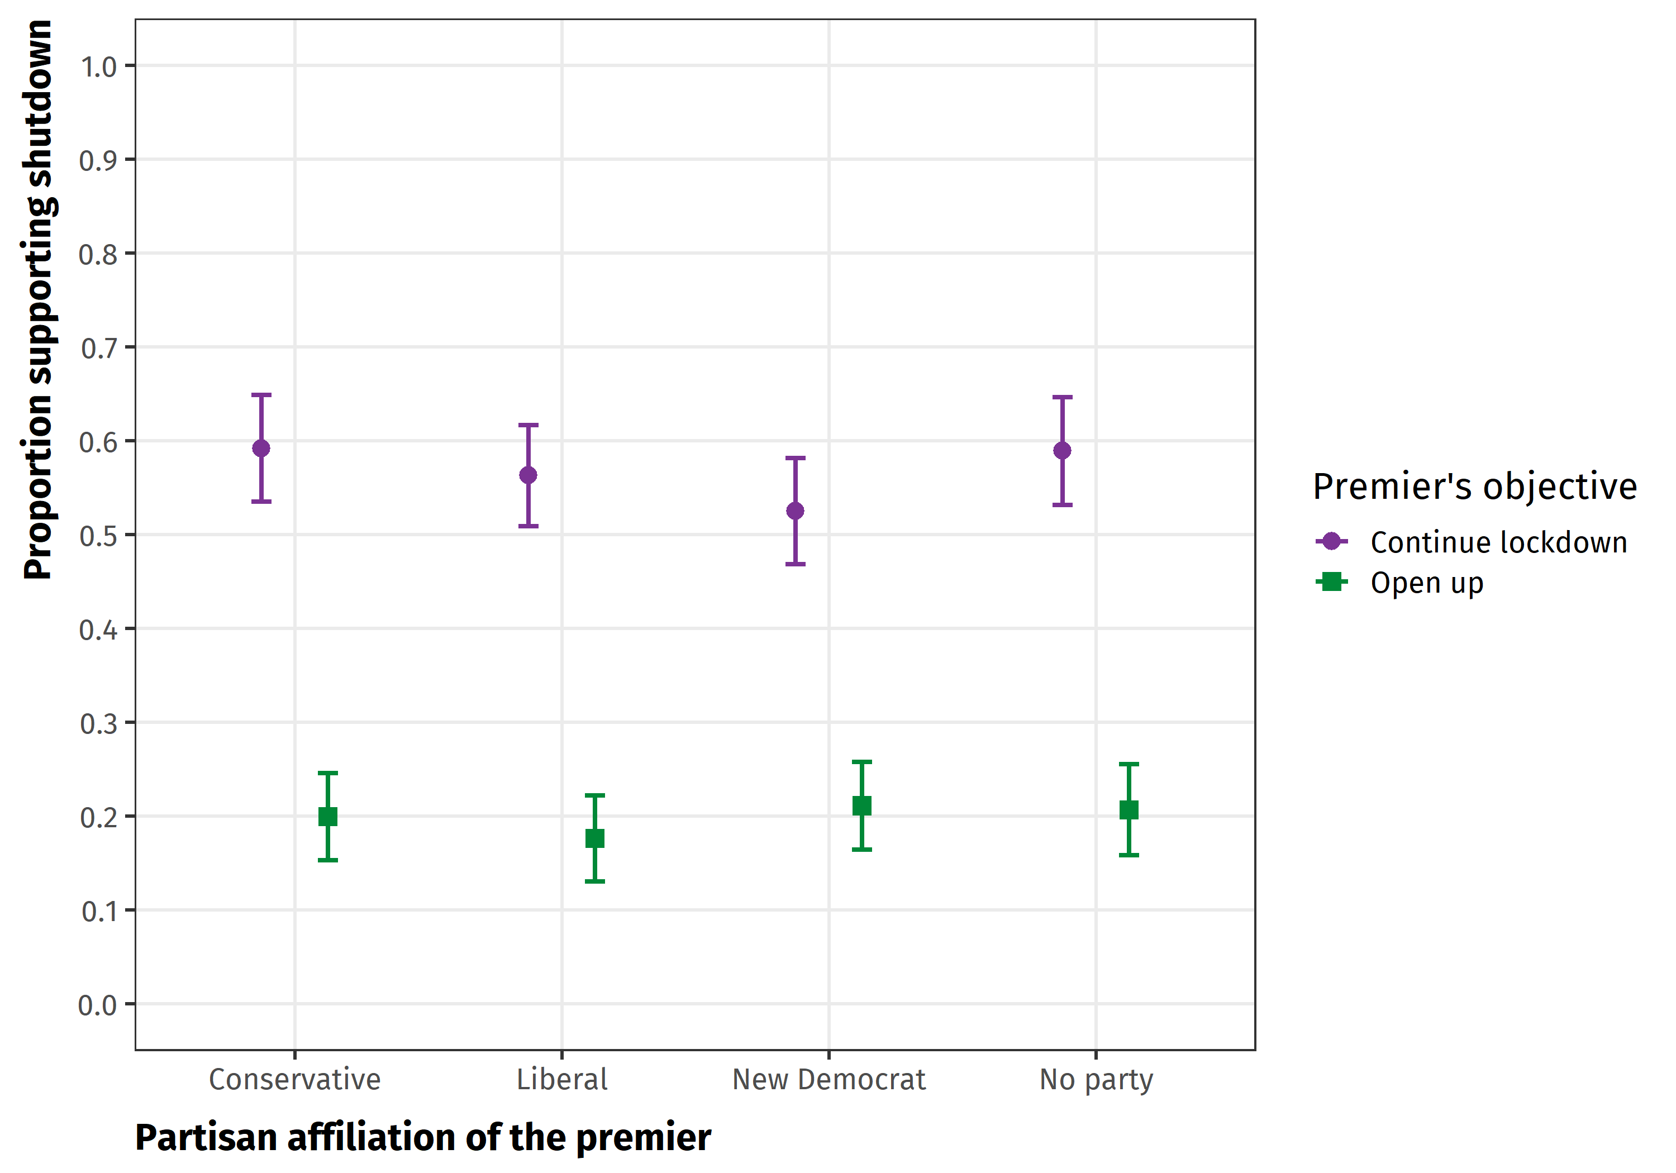

Figure S2: Support for Executive Aggrandizement by Premier’s Partisanship and Respondent’s Partisanship

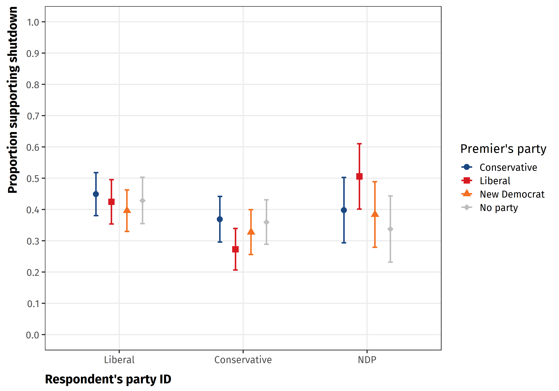

Figure S3: The Effect of Time Restrictions on Estimated AMCEs

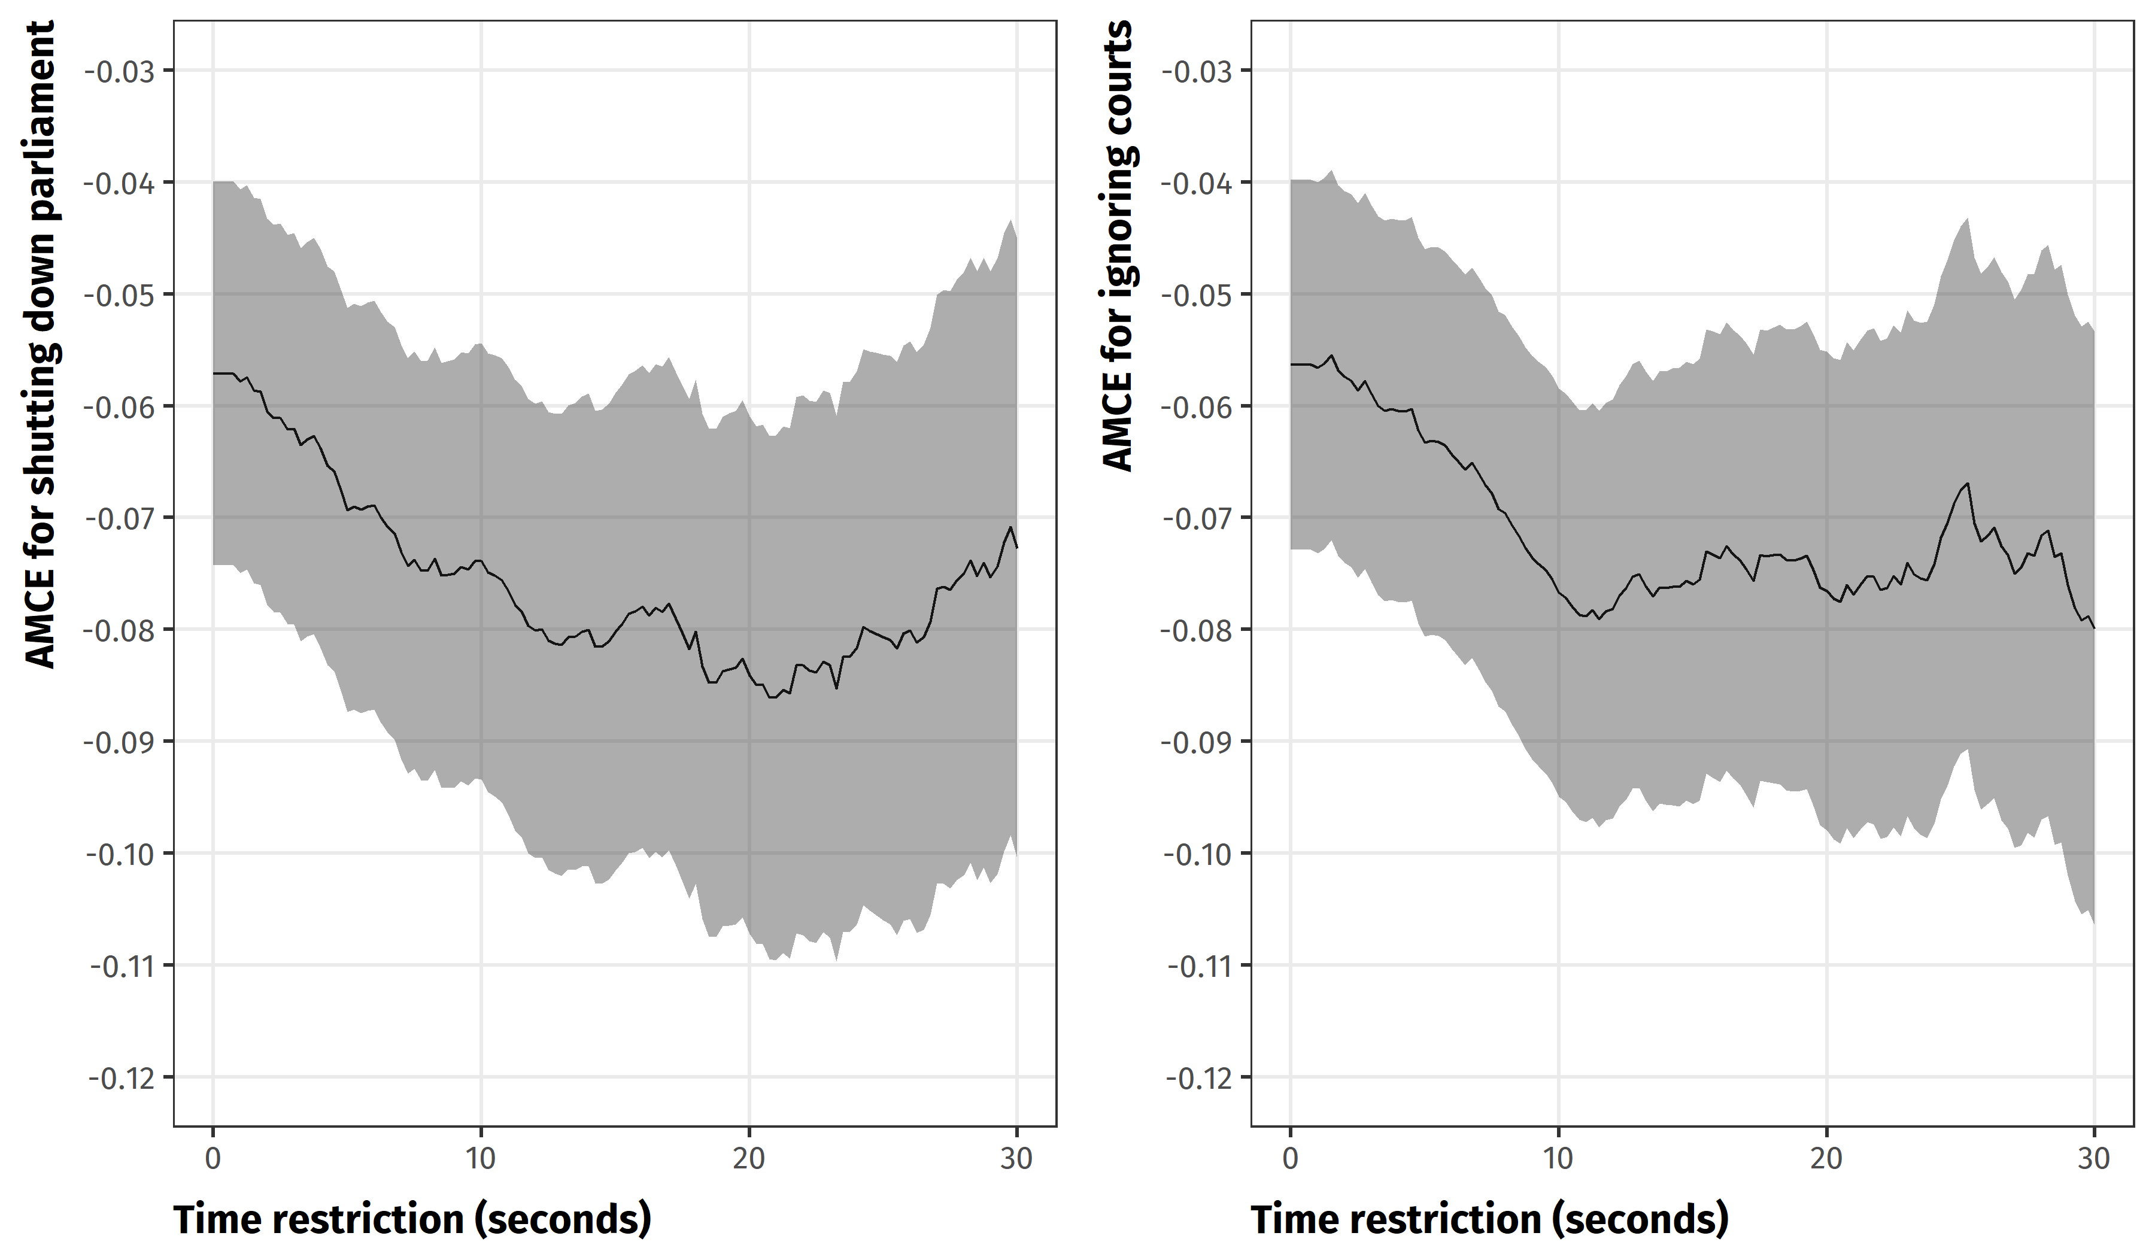

Figure S4a: Full Conjoint Results (Legislative checks)
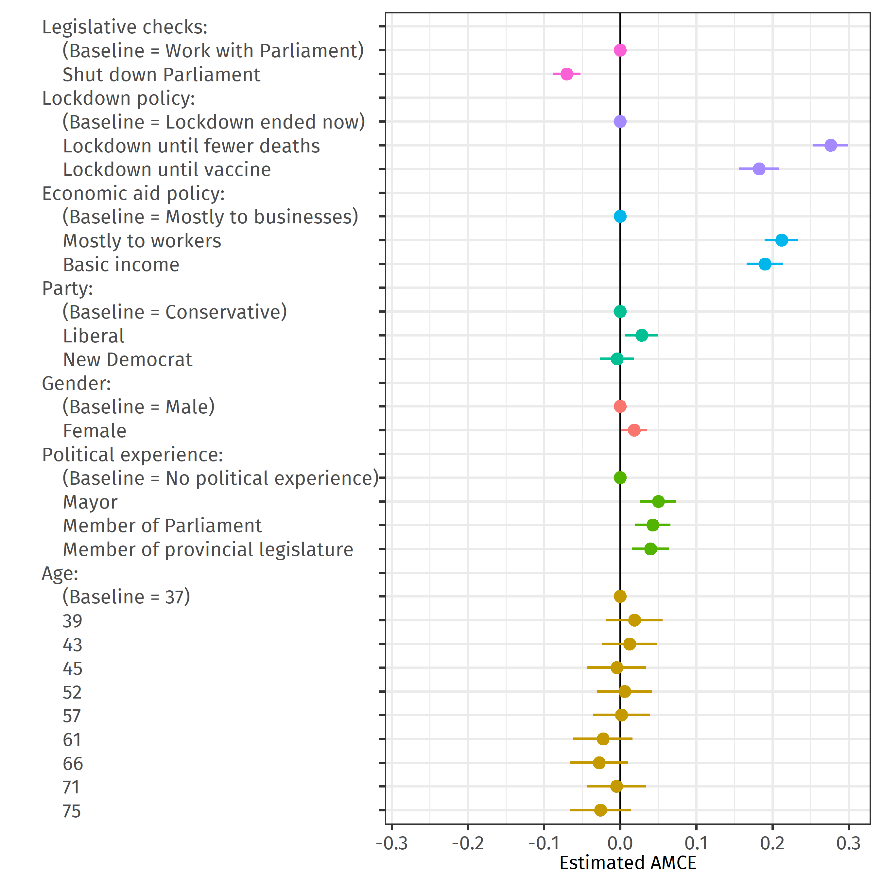

Figure S4b: Full Conjoint Results (Judicial checks)
