Appendix I: Figures excluding USSR federated entities
Figure 1B. Number of IEAs that include federated entities among their signatories and number of IEAs with at least one of the 3 types of provisions relating to federated entities. 1945-2015 (Moving Average ± 2 Years) (Excluding IEAs signed by USSR federated entities)
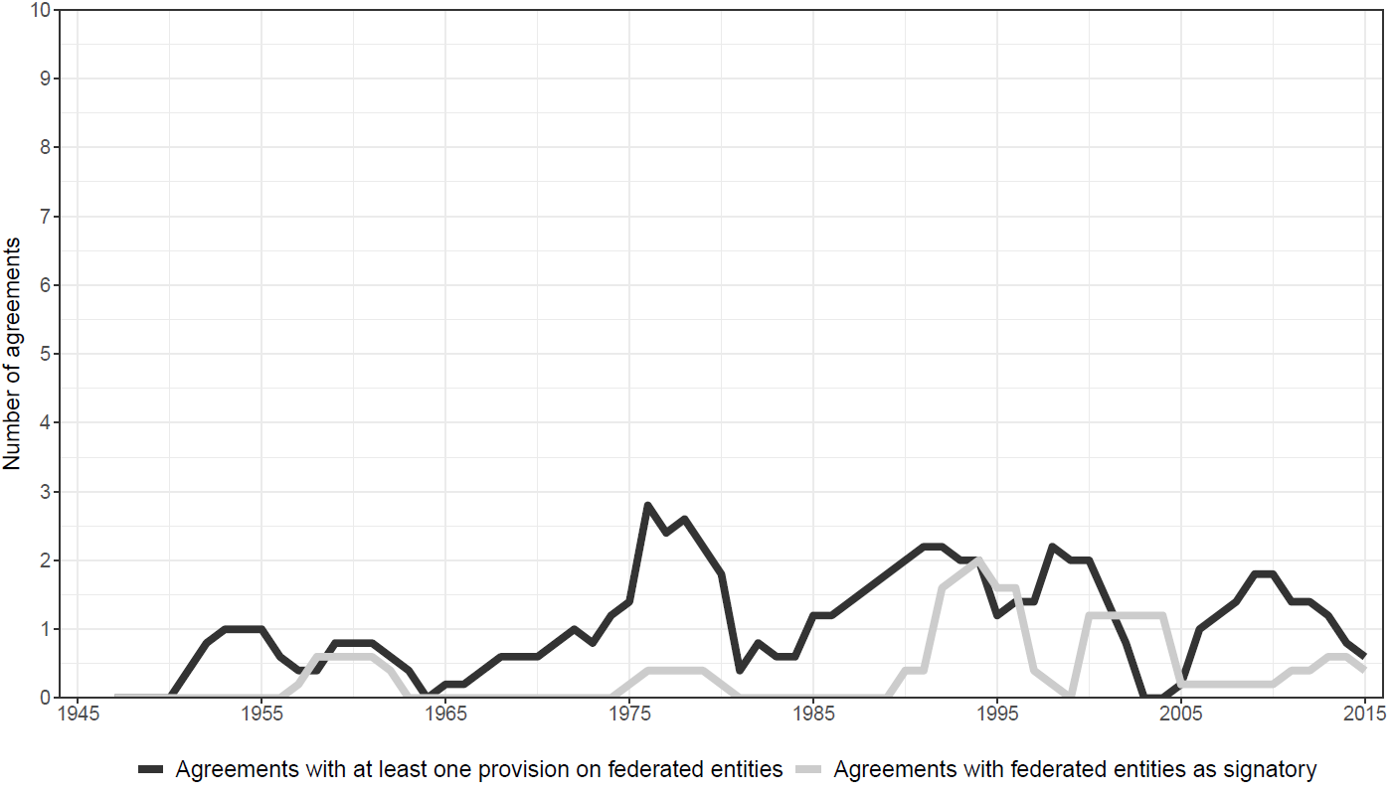
Figure 1B excludes all agreements signed by a USSR federated entity. However, all but one of these agreements did not include provisions from types 1 to 3. This explains why the black line in Figure 1B is similar to the one in Figure 1. Figure 1B suggests that treaty provisions relating to federated entities are neither a recent, nor an increasingly common phenomenon. The figure does show an increase in the number of signatories in the early 1990s.
Figure 2B. Number of IEAs that include federated entities among their signatories or at least one of the 3 types of provisions relating to federated entities, divided by the total number of environmental agreements for that year (moving average ± 2 years) (Excluding IEAs signed by USSR federated entities)
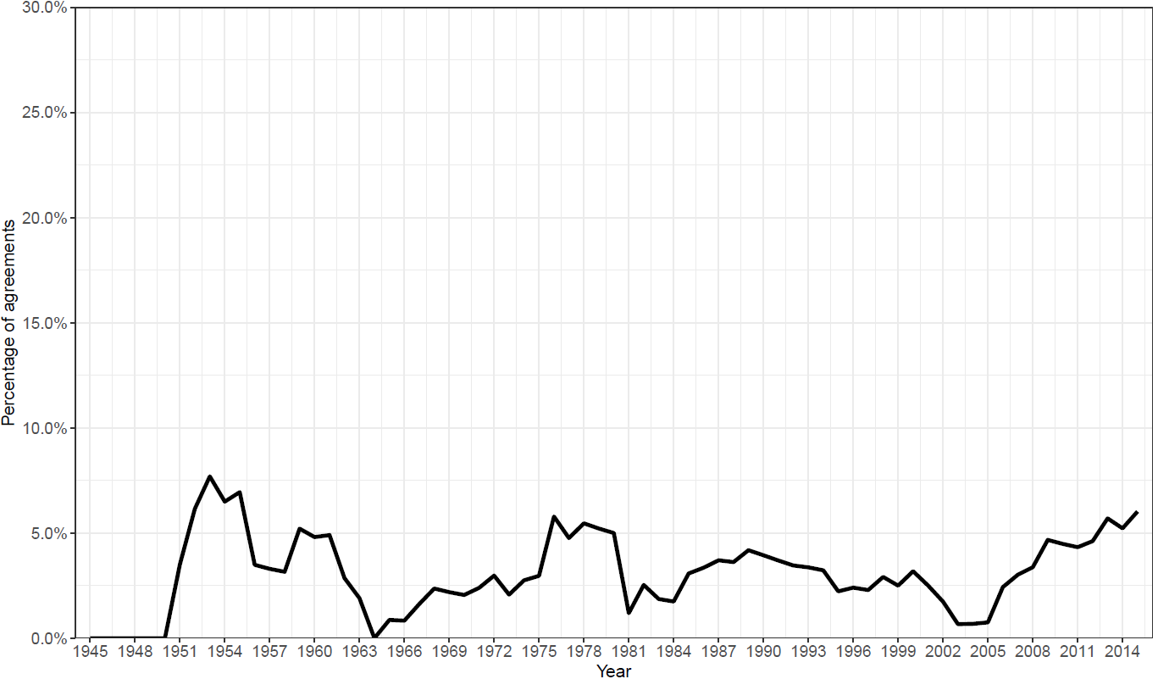
Figure 2B excludes USSR federated entities as signatories. It is quite different from Figure 2, which includes all federated entities. Yet, Figure 2B still supports the finding that the involvement of federated entities in IEAs is not strictly a recent phenomenon. Despite the less prominent variation of the line, increases are apparent in the 1950s, the 1970s and after the mid-2000s.
Figure 4B. Number of IEAs that were either signed by or refer to federated entities (including at least one type of provision) by issue-area (Excluding IEAs signed by USSR federated entities)

In accordance with Figure 4, which includes federated entities from the USSR, this figure shows that the main issue-areas covered by agreements involving a federated entity are fisheries and freshwater.

