Supplementary Materials for
Ideological and Partisan Bias in the Canadian Public

Table S1. Robustness tests, Study 2
 | Binary |  | Ordinal
 | Logistic Regression |  | OLS Regression |  | Ordered Logistic Regression
 | Coef. | SE | Coef. | SE | Coef. | SE
Accuracy | 0.16 | 0.23 | 0.10 | 0.13 | 0.15 | 0.21
Direction | -0.16 | 0.22 | -0.10 | 0.12 | -0.17 | 0.20
Cues | -0.12 | 0.19 | -0.10 | 0.11 | -0.16 | 0.19
Cues * Accuracy | -0.18 | 0.28 | -0.08 | 0.15 | -0.13 | 0.26
Cues * Direction | 0.48** | 0.27 | 0.28** | 0.15 | 0.45** | 0.25
Constant | 0.04 | 0.16 | 3.52*** | 0.09
Cut 1 |  |  |  |  | -3.04 | 0.19
Cut 2 |  |  |  |  | -1.60 | 0.16
Cut 3 |  |  |  |  | -0.08 | 0.15
Cut 4 |  |  |  |  | 1.27 | 0.16
N | 1463 |  | 1463 |  | 1463
* p<0.1, ** p<0.05, *** p<0.01, one-tailed

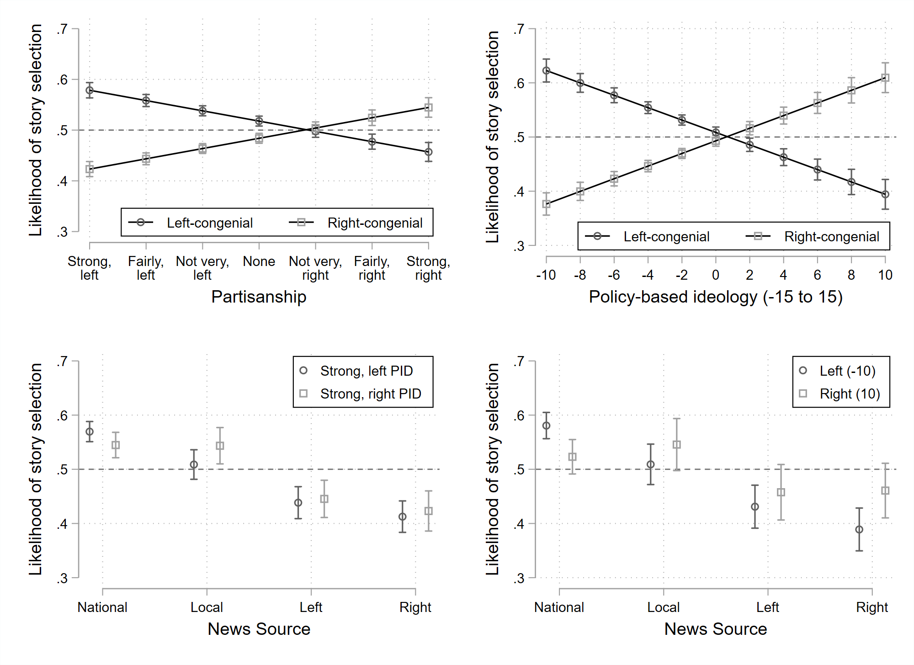
Figure S1. Predicted likelihood of story selection by congeniality of the headline (top) or source (bottom) across levels of partisanship (left) and policy-based ideology (right). Note: 95 per cent confidence intervals. English respondents only.
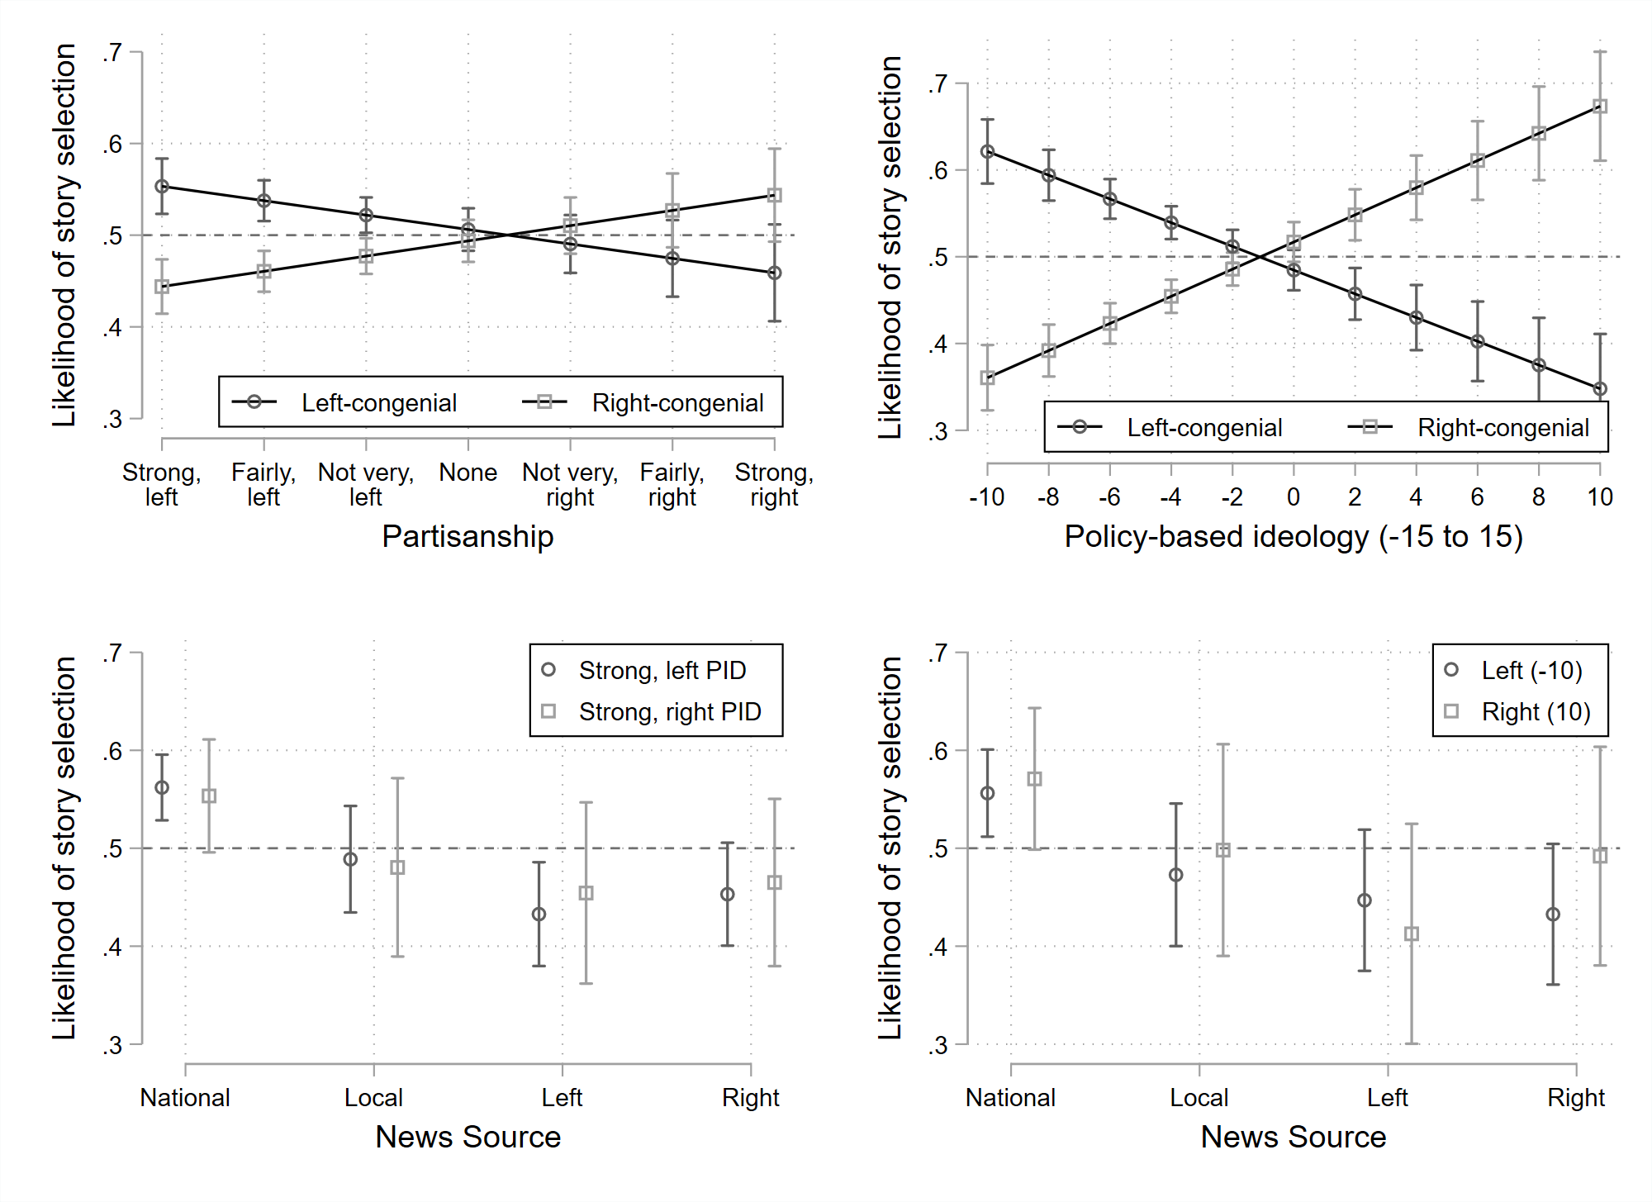
Figure S2. Predicted likelihood of story selection by congeniality of the headline (top) or source (bottom) across levels of partisanship (left) and policy-based ideology (right). Note: 95 per cent confidence intervals. French respondents only.

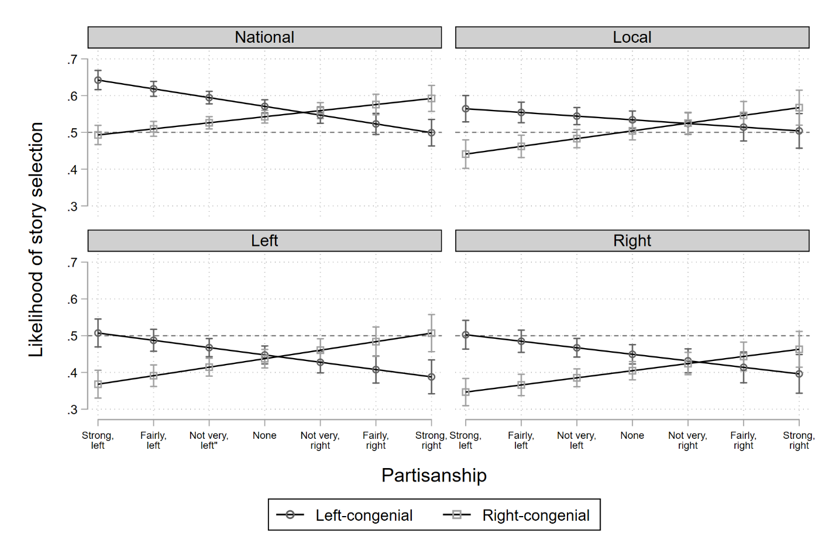
Figure S3. Predicted likelihood of story selection by congeniality of the headline and source across levels of partisanship. Note: 95 per cent confidence intervals. Estimation from otherwise identical models from Figure 1 that interact ideology, source, and headline.

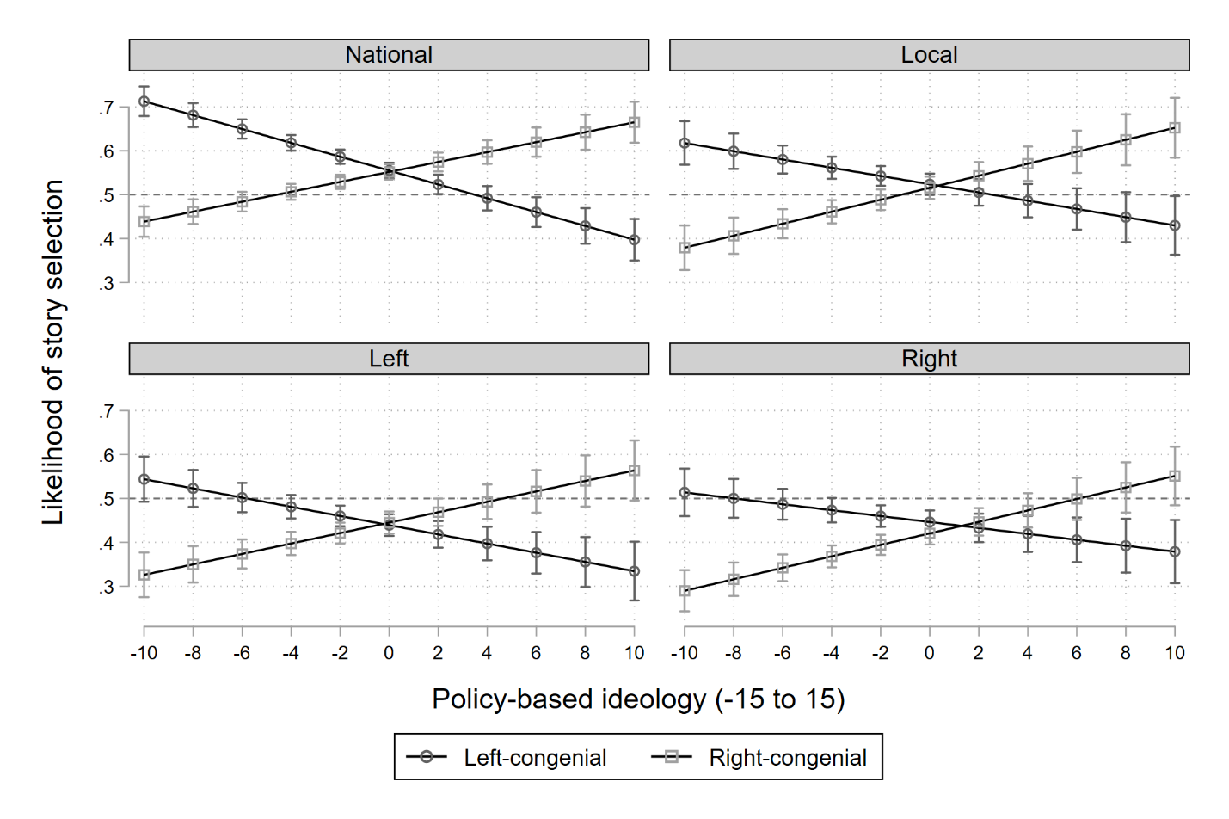
Figure S4. Predicted likelihood of story selection by congeniality of the headline and source across levels of policy-based ideology. Note: 95 per cent confidence intervals. Estimation from otherwise identical models from Figure 1 that interact ideology, source, and headline.
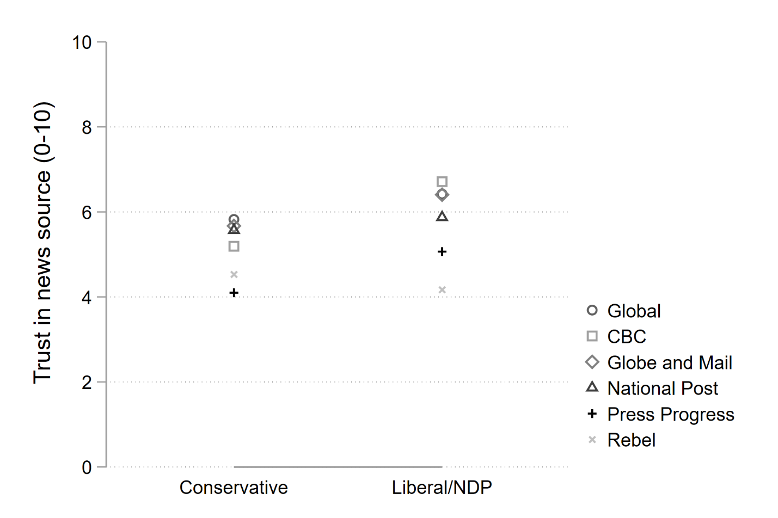
Figure S5. Trust in news outlets by partisan group. Data collected in wave 5 of the Digital Democracy project, fielded from September 19-24, 2019 (N=1,630). Data weighted within Canadian region by age and gender.
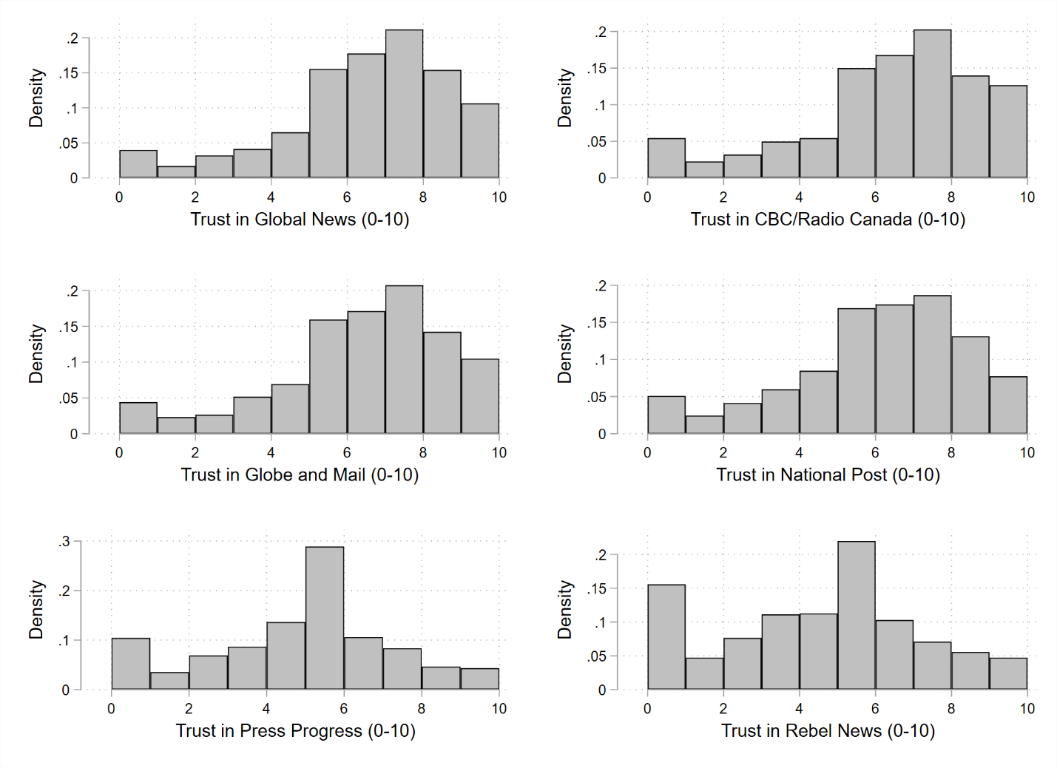
Figure S6. Distribution of trust in news outlets. Data collected in wave 5 of the Digital Democracy project, fielded from September 19-24, 2019 (N=1,630). Data weighted within Canadian region by age and gender.

Table S2. Balance test, Study 1
 | OLS |  | Multinomial logit
 | Headline (1= right) |  | Local vs. National |  | Right vs. National |  | Left vs. National
 | Coef. | SE | Coef. | SE | Coef. | SE | Coef. | SE
Conservative | -0.01 | 0.01 | 0.04 | 0.06 | 0.01 | 0.06 | 0.05 | 0.06
NDP | 0.01 | 0.01 | 0.04 | 0.07 | -0.03 | 0.07 | 0.13* | 0.07
Bloc | -0.03 | 0.02 | -0.16 | 0.12 | -0.10 | 0.1 | -0.14 | 0.11
Green | -0.01 | 0.02 | -0.02 | 0.11 | 0.02 | 0.11 | -0.10 | 0.12
Other | 0.04 | 0.04 | -0.16 | 0.20 | 0.33 | 0.23 | 0.08 | 0.24
None | 0.00 | 0.01 | 0.04 | 0.06 | 0.00 | 0.06 | -0.05 | 0.06
Bachelor's degree | 0.00 | 0.01 | -0.04 | 0.05 | -0.11** | 0.05 | -0.12*** | 0.05
Age | 0.00 | 0.00 | 0.00 | 0.00 | 0.00 | 0.00 | 0.00 | 0.00
Female | 0.00 | 0.01 | -0.05 | 0.05 | -0.02 | 0.05 | 0.00 | 0.05
French | -0.01 | 0.03 | -0.10 | 0.14 | 0.32** | 0.15 | 0.08 | 0.13
Quebec | -0.01 | 0.03 | 0.11 | 0.15 | -0.10 | 0.17 | 0.14 | 0.15
Ontario | -0.02 | 0.02 | -0.01 | 0.08 | 0.20** | 0.1 | 0.10 | 0.09
West | -0.02 | 0.02 | 0.03 | 0.09 | 0.21** | 0.1 | 0.13 | 0.10
Constant | 0.53*** | 0.03 | -0.52*** | 0.18 | -1.09*** | 0.2 | -0.83*** | 0.19
N | 15968 |  | 15968
* p<0.1, ** p<0.05, *** p<0.01

Table S3. Balance test, Study 2, multinomial logit estimates
 | In-party cue vs. control |  | Accuracy prime vs. control
 | Coef. | SE | Coef. | SE
Conservative | 0.00 | 0.15 | -0.18 | 0.15
NDP | -0.01 | 0.19 | 0.04 | 0.18
Bachelor's degree | -0.01 | 0.14 | 0.00 | 0.13
Age | 0.00 | 0.00 | 0.00 | 0.00
Female | -0.15 | 0.14 | -0.17 | 0.14
French | -0.01 | 0.42 | -0.24 | 0.41
Quebec | 0.21 | 0.46 | 0.32 | 0.46
Ontario | 0.38 | 0.28 | 0.35 | 0.29
West | 0.34 | 0.29 | 0.26 | 0.29
Constant | -0.46 | 0.54 | 0.02 | 0.54
 | Out-party cue vs. control |  | Directional prime vs. control
 | Coef. | SE | Coef. | SE
Conservative | -0.02 | 0.15 | 0.19 | 0.15
NDP | 0.04 | 0.18 | 0.08 | 0.19
Bachelor's degree | 0.12 | 0.13 | -0.10 | 0.14
Age | 0.00 | 0.00 | 0.00 | 0.00
Female | -0.09 | 0.14 | -0.21 | 0.14
French | 0.25 | 0.41 | -0.32 | 0.43
Quebec | 0.21 | 0.45 | 0.09 | 0.46
Ontario | 0.34 | 0.28 | 0.02 | 0.28
West | 0.41 | 0.29 | -0.01 | 0.28
Constant | -0.55 | 0.54 | 0.24 | 0.54
N | 1461 |  | 1461
* p<0.1, ** p<0.05, *** p<0.01

Table S4. Balance test, Study 3, OLS estimates
DV = political treatment | Coef. | SE
Conservative | 0.01 | 0.03
NDP | 0.03 | 0.04
Bloc | -0.09 | 0.06
Green | -0.03 | 0.06
Other | 0.07 | 0.11
None | -0.01 | 0.03
Bachelor's degree | -0.03 | 0.02
Age | 0.00 | 0.00
Female | -0.03 | 0.02
French | -0.04 | 0.07
Quebec | 0.11 | 0.08
Ontario | 0.02 | 0.05
West | 0.06 | 0.05
Constant | 0.50*** | 0.09
N | 1996
* p<0.1, ** p<0.05, *** p<0.01

