**Online Appendix**

**A1. Homeownership, Housing Prices, and Executive Approval**

We posit that homeowners’ material concerns explain why rising housing prices mainly benefit right incumbents. Therefore, it has a value to look at how homeownership rates moderate the relationship between housing price changes and government popularity. Even though most OECD countries have homeownership rates greater than 50 percent,[1] housing prices may not relate to government popularity in a context (i.e., Germany) where many voters do not own their homes.

We collect all available homeownership rates from official government statistics and European Central Bank.[2] However, we cannot use this data alone because only two countries, the United States and New Zealand, have quarterly measurements, and most countries in our sample only measure it through census data every five years. Thus, we adopt two alternate approaches: First, we code the dummy variable of low homeownership countries based on average home ownership rates in our sample. We code 5 countries - Austria (56.1%), Denmark (52.67%), Germany (42.9%), France (57.3%) and Japan (61.0%) as low homeownership countries.[3] Homeownership rates do not change much over time in these low homeownership countries. For instance, the maximum and the minimum level of homeownership rates are 45.7 and 40 in Germany and 57.8 and 53.3 in Austria. Thus, homeownership mainly varies across countries, not within countries. This provides a justification for using a homeownership dummy variable. Second, we linearly interpolate homeownership rates. This provides evidence that the choice of homeownership dummy variable does not primarily drive our results.

Table A1. Housing Prices, Government Partisanship, Homeownership, and Executive Approval

|  |  |  |
| --- | --- | --- |
|  | Model A1  (Homeownership Dummy) | Model A2  (Homeownership: Continuous) |
| Lagged Approval | 0.867*** | 0.777*** |
|  | (0.014) | (0.018) |
| Change in Housing Prices | -0.032 | -0.300 |
|  | (0.114) | (0.630) |
| Lagged Partisanship | 0.004 | 0.052 |
|  | (0.003) | (0.039) |
| Homeownership | 0.313 | 0.177** |
|  | (0.464) | (0.081) |
| Change in Housing Prices | 0.004** | -0.008 |
| * Lagged Partisanship | (0.002) | (0.012) |
| Change in Housing Prices | -0.065 | 0.004 |
| *Homeownership | (0.255) | (0.009) |
| Lagged Partisanship | -0.008 | -0.001 |
| *Homeownership | (0.008) | (0.001) |
| Partisanship*Change in Housing Prices | -0.001 | 0.000 |
| *Homeownership | (0.004) | (0.000) |
| Majority status | 0.231 | 0.234 |
|  | (0.239) | (0.239) |
| District Magnitude (Log) | 0.677*** | 0.719*** |
|  | (0.233) | (0.235) |
| Lagged Unemployment | -0.061 | -0.018 |
|  | (0.042) | (0.072) |
| Lagged Inflation Rate | 0.061 | 0.162 |
|  | (0.077) | (0.098) |
| Lagged GDP Growth | 0.290** | 0.343** |
|  | (0.120) | (0.143) |
| Lagged FDI Inflow | -0.037 | -0.077* |
|  | (0.029) | (0.039) |
| Lagged Trade | -0.005 | 0.023 |
|  | (0.005) | (0.020) |
| Honeymoon | 2.396*** | 2.417*** |
|  | (0.472) | (0.492) |
| Constant | 4.593** | -2.671 |
|  | (2.027) | (5.492) |
| Observations | 1,624 | 1,463 |
| Number of Countries | 16 | 16 |
| R-squared | 0.829 | 0.822 |

Note: Panel-corrected standard errors in parentheses. Coefficients for country and year dummies are not reported. *** p<0.01, ** p<0.05, * p<0.1. In Model A1, homeownership denotes the dummy for countries with fewer homeowners. In Model A2 homeownership denotes interpolated homeownership rate.

To test the moderating impact of homeownership rates, we interact homeownership rates with the housing price changes and government partisanship. In Model A1, homeownership rate is measured using a dummy variable capturing countries with fewer homeowners, and homeownership rate is measured using linearly interpolated quarterly homeownership rate in Model A2. Models A1 and A2 in Table A1 show the coefficient estimates for including 3-way interactions among homeownership, housing price changes, and government partisanship.[4] It is not easy to interpret the modes with 3-way interaction term without considering how both homeownership and government partisanship moderate the marginal effect of housing prices. Thus, using Model A1 estimates, we generate marginal effect plots (Figure A1) for the change in housing prices across two different cases, countries with low homeownership rate and countries with high homeownership rate. The lower panel of Figure A1 shows that housing price changes do not affect government popularity in countries with a low proportion of homeowners. Here, across all government types, housing price changes do not seem to affect government popularity. On the other hand, the upper panel of Figure A1 indicates that housing price changes have greater importance in explaining government popularity among countries with greater homeownership rates. While housing price changes do not affect government popularity under non-right governments, it does affect government popularity under right governments, where more than 50 percent of cabinet members are from right parties.

Figure A1. Housing Prices, Government Partisanship, Homeownership, and Government Popularity

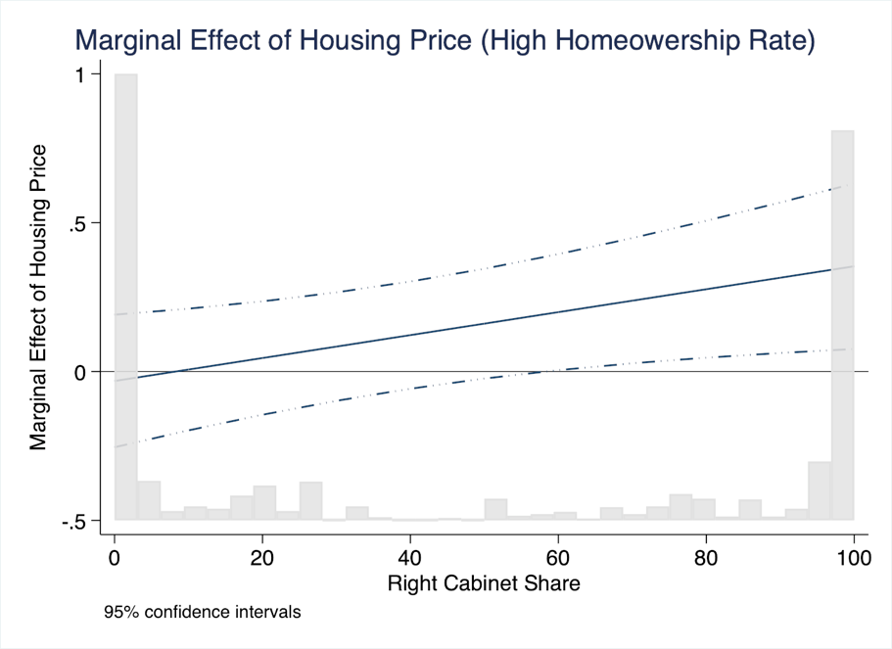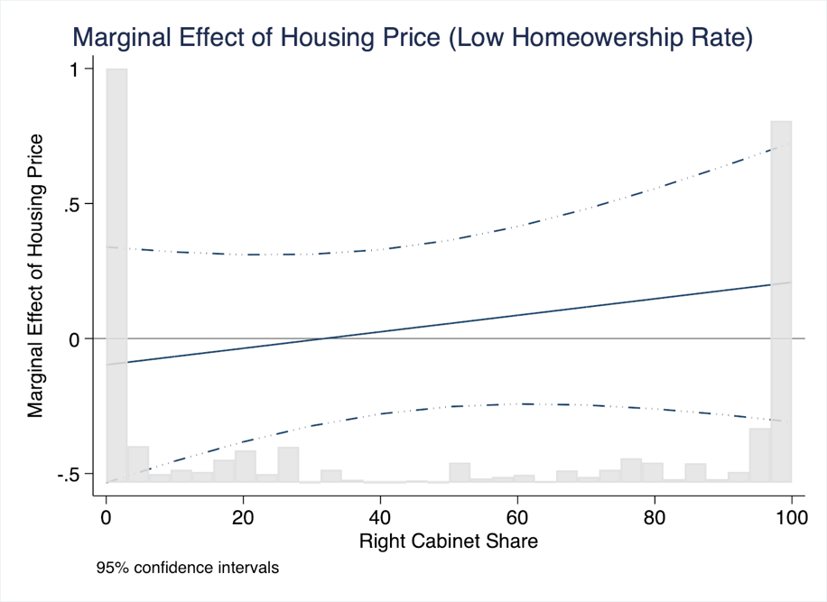

Note: The y-axis shows the marginal effect of the change in real housing prices. The x-axis shows government partisanship. Greater values indicate more rightist positions. The solid line denotes the marginal effect line and dashed lines denote the 95% confidence intervals. The figure is based on Model A1 estimates.

Using Model A2 estimates, Figure A2 shows the marginal effect of housing price changes across two different countries. For easier interpretation, we generate marginal effect plots by fixing homeownership rate based on two country cases: One from Germany (average homeownership rate is 42.4%) and the other from Australia (average homeownership rate is 69.2%).[5] Similar to Figure A1, Figure A2 shows that a change in housing prices seems to increase government popularity only in countries with greater homeownership rates. In these countries, mostly right incumbents get rewards from housing price increases while housing price changes do not relate to government popularity in non-right governments. However, housing price changes do not seem to affect government popularity in low homeownership countries such as Germany. These results are consistent with our argument that homeowners reward incumbent governments with rising housing prices because a rise in housing prices materially benefits homeowners. Thus, the impact of housing price changes would be less pronounced in countries with fewer homeownership rates.

Figure A2 Housing Prices, Government Partisanship, Interpolated Homeownership, and Government Popularity

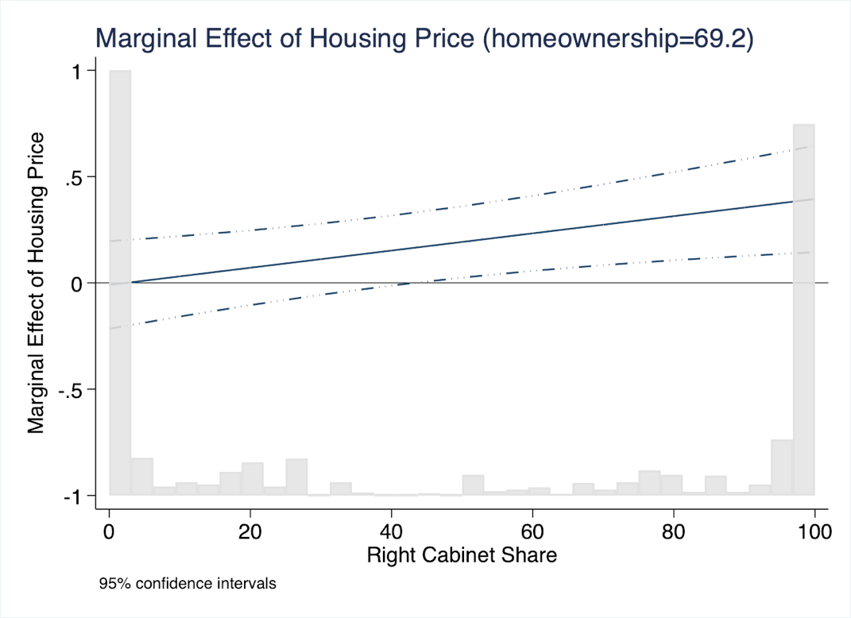

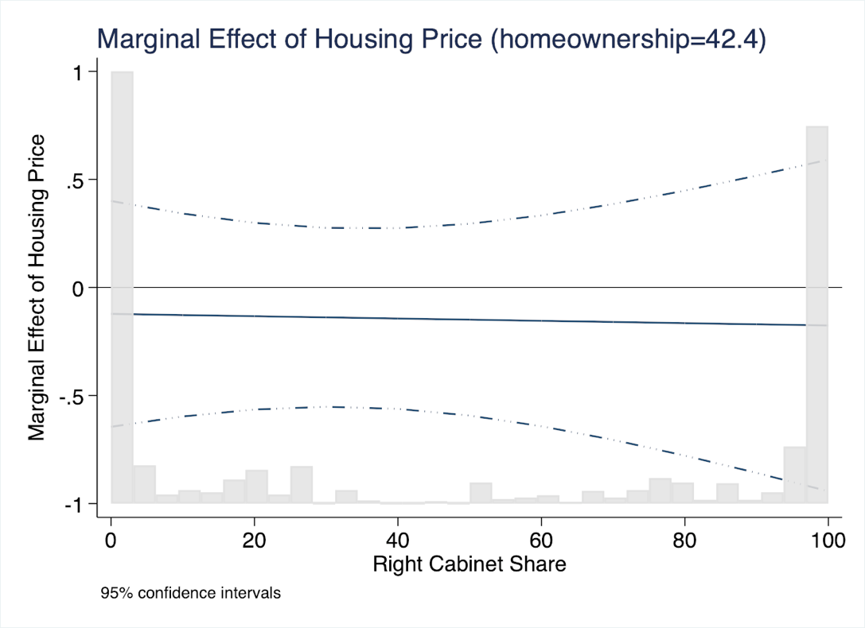

Note: The y-axis shows the marginal effect of the change in real housing prices. The x-axis shows government partisanship. Greater values of x-axis indicate more rightist positions. The solid line denotes the marginal effect line and dashed lines denote the 95% confidence intervals. The figure is based on model 4’s estimates.

**A2. Homeownership, Housing Price Changes, and Support for Incumbent Parties.**

Our micro-level analysis find that regional housing price changes mainly benefit the right incumbent party. However, some may still question how homeowners and non-homeowners respond to hosing price changes differently. To answer this question, using the same micro-level data in the United Kingdom (BHPS), we run the models of estimating support for the Labour and Conservatives incumbents. We use the same controls we previously used in Table 2 but change our dependent variable as the support for the incumbent Labour and the Conservatives, respectively. We divide the case of the incumbent Labour and the Conservatives because housing price change would have different impact on the left (Labour Party) and the right (Conservatives) government.

*How do homeowners evaluate left-leaning governments when housing prices rise?*

Model A3 in Table A2 shows the coefficient estimate of how housing price changes affect the support for left-leaning governments (Labour Party). It seems that homeownership itself does not affect the support for the incumbent Labour Party. However, individual housing price changes would have a negative impact on the Labour support. It may be because rising housing prices would make homeowners, particularly those who own expensive housing, would be more likely to support the Conservative Party because they recognize the right-wing party better represents the interest of homeowners. To test this possibility, we additionally estimate the model (Model A4) by including the interaction term between individual housing price change and the value of individual housing. The coefficient estimate for this interaction term is negative and significant, indicating that homeowners of expensive housing are less likely to support the incumbent Labour Party with housing price increases. To better illustrate this effect, we create a Figure A3, showing the marginal effect of housing price change conditioned by the housing price level. Figure A3 suggests that individuals with having housing value above 70,000 UK pounds would evaluate incumbent Labour party negatively if their housing price increases.

Table A2. Housing Price and Support for Incumbent

|  |  |  |  |  |
| --- | --- | --- | --- | --- |
|  | Model A3 | Model A4 | Model A5 | Model A6 |
|  | Labour Incumbent | Labour Incumbent | Conservatives Incumbent | Conservatives Incumbent |
| Labour Support (1) | 2.264*** | 2.270*** |  |  |
|  | (0.060) | (0.060) |  |  |
| Conservative Support (1) |  |  | 3.109*** | 3.112*** |
|  |  |  | (0.120) | (0.120) |
| Lagged DV | 1.521*** | 1.517*** | 1.239*** | 1.238*** |
|  | (0.032) | (0.032) | (0.058) | (0.058) |
| Lagged Individual Housing Price | -0.087*** | -0.108*** | 0.056 | 0.053 |
|  | (0.017) | (0.019) | (0.107) | (0.107) |
| ∆ Regional Housing Price | 0.002 | -0.000 | 0.007 | 0.036 |
|  | (0.007) | (0.007) | (0.031) | (0.062) |
| ∆ Individual Housing Price | -0.046*** | -0.022 | 0.044 | 0.044 |
|  | (0.015) | (0.018) | (0.081) | (0.081) |
| Lagged Homeownership | -0.045 | -0.006 | 0.207 | 0.198 |
|  | (0.074) | (0.076) | (0.153) | (0.154) |
| Lagged Individual Housing Price* |  | -0.002*** |  |  |
| ∆ Individual Housing Price |  | (0.001) |  |  |
| Lagged Homeownership* |  |  |  | -0.038 |
| ∆ Regional Housing Prices |  |  |  | (0.070) |
| Lagged Mortgage Presence | 0.077 | 0.070 | -0.196* | -0.196* |
|  | (0.053) | (0.053) | (0.105) | (0.105) |
| Lagged Income | -0.008 | -0.007 | -0.028 | -0.028 |
|  | (0.012) | (0.012) | (0.035) | (0.035) |
| Lagged Education | 0.005 | 0.007 | -0.034 | -0.035 |
|  | (0.044) | (0.044) | (0.086) | (0.085) |
| Lagged Unemployment | 0.001 | 0.002 | -0.208 | -0.209 |
|  | (0.080) | (0.081) | (0.132) | (0.132) |
| Lagged Self Employment | -0.058 | -0.059 | -0.224* | -0.226* |
|  | (0.071) | (0.071) | (0.136) | (0.136) |
| Gender | 0.007 | 0.008 | -0.042 | -0.042 |
|  | (0.030) | (0.030) | (0.049) | (0.049) |
| Age | -0.002 | -0.001 | 0.000 | 0.000 |
|  | (0.001) | (0.001) | (0.002) | (0.002) |
| Constant | -1.634*** | -1.638*** | -2.438*** | -2.433*** |
|  | (0.127) | (0.127) | (0.196) | (0.197) |
| Regional fixed effect | Yes | Yes | Yes | Yes |
| Observations | 54,439 | 54,439 | 21,454 | 21,454 |
| Number of Individuals | 10,743 | 10,743 | 6,425 | 6,425 |
| AIC | 25987.34 | 25982.56 | 5783.154 | 5784.859 |
| Log Likelihood | -12945.67 | -12942.28 | -2843.577 | -2843.429 |

Note: Clustered standard errors in parentheses. The dependent variable is support for the Incumbent Party. Coefficients for average of time-varying independent variables and initial level of independent variables are not reported. *** p<0.01, ** p<0.05, * p<0.1

Figure A3. Marginal Effect of Individual Housing Price Change on Incumbent Support



*How do non-homeowners evaluate right-leaning govts when housing prices rise?*

Models A5 and A6 in Table A2 show how housing price rise affects the evaluation of right incumbent governments. Model 5 shows that most of housing-related variable does not affect the support for incumbent Conservative Party. First, homeownership status does not seem to affect the support for the incumbent Conservatives. Also, either individual housing price or regional housing price changes do not affect the support for incumbent Conservatives. Even though this result is somewhat contradictory to our previous findings on macro-level analysis, the interpretation of this result should be made with a caution. First, in our sample of incumbent Conservatives (between 1993 and 1997), it was the period when the Conservatives maintained low government popularity under prime minister John Major: his governmental approval rate in this period was about 22 percentage point. Given the low popularity of the incumbent Conservatives in this period, it may be likely that only strong Conservative partisans were likely to support the incumbent Conservatives.

To explore how the inclusion of this factor affects the impact of the housing price on the support for incumbent Conservatives, we re-estimate Models A5 and A6 without controlling the support

for the Conservatives in the beginning of the sample period (***Conservative (1****)*). Models A7 and A8 in Table M2 indicate that inclusion of ***Conservative (1)*** significantly moderates the effect of housing price and homeownership on the support for incumbent Conservatives. In Model A7, the coefficient estimates for homeownership and regional housing price are both positive and significant, indicating that the incumbent Conservatives receive greater support from home owners, and voters in regions with housing price increase. Given that the coefficient estimates for these two factors become insignificant after inclusion of ***Conservative (1)*** in Model A5, it may imply that many homeowners and voters in the regions with housing price increase are strong supporters of the Conservatives. In Model A6, we additionally include the interaction term between homeownership and regional housing price increases. [6] The coefficient estimate for this interaction term is positive and significant, indicating that regional housing price change would have greater impact among homeowners, not the non-homeowners, whether they support the incumbent Conservatives.

However, we cannot find the evidence whether or not non-homeowners support the incumbent Conservatives in the regions of housing price increase, given that baseline coefficient estimate for regional housing price changes becomes insignificant in Model A8 with the interaction term. Once again, we believe that it is partly explained by that many none-homeowners are traditional supporters of the Labour Party (left-wing). Thus, regional housing price change would not make them to alter their support to the Conservative party regardless of the change in regional housing price.

Table A3 Housing Price and Support for Incumbent Conservatives (without Conservatives (1))

|  |  |  |
| --- | --- | --- |
|  | Model M5 | Model M6 |
|  | Conservatives Incumbent | Conservatives Incumbent |
| Lagged DV | 2.913*** | 2.914*** |
|  | (0.028) | (0.028) |
| Lagged Individual Housing Price | 0.038 | 0.048 |
|  | (0.073) | (0.073) |
| ∆ Regional Housing Price | 0.085*** | 0.013 |
|  | (0.021) | (0.041) |
| ∆ Individual Housing Price | 0.041 | 0.041 |
|  | (0.056) | (0.056) |
| Lagged Homeownership | 0.198* | 0.219** |
|  | (0.104) | (0.104) |
| Lagged Homeownership* |  | 0.096** |
| ∆ Regional Housing Prices |  | (0.047) |
| Lagged Mortgage Presence | -0.174** | -0.175** |
|  | (0.071) | (0.071) |
| Lagged Income | -0.042* | -0.042* |
|  | (0.023) | (0.023) |
| Lagged Education | 0.033 | 0.035 |
|  | (0.060) | (0.060) |
| Lagged Unemployment | -0.064 | -0.062 |
|  | (0.089) | (0.089) |
| Lagged Self Employment | 0.035 | 0.036 |
|  | (0.089) | (0.089) |
| Gender | 0.012 | 0.012 |
|  | (0.031) | (0.031) |
| Age | 0.005*** | 0.005*** |
|  | (0.001) | (0.001) |
| Constant | -2.340*** | -2.357*** |
|  | (0.126) | (0.126) |
| Regional fixed effect | Yes | Yes |
| Observations | 22,256 | 22,256 |
| Number of Individuals | 7,057 | 7,057 |
| AIC | 9903.19 | 9898.994 |
| Log Likelihood | -4904.595 | -4902.497 |

Note: Clustered standard errors in parentheses. The dependent variable is support for the Incumbent Party. Coefficients for average of time-varying independent variables and initial level of independent variables are not reported. *** p<0.01, ** p<0.05, * p<0.1. Housing Price and Support for Incumbent Conservatives (without Conservatives (1))

Table A4. Robustness Check: Using Alternative Measures of Government Partisanship

|  |  |  |
| --- | --- | --- |
|  | Model A3  (Using a dummy scale of partisanship) | Model A4  (Using 2-point scale of partisanship) |
| Lagged Approval | 0.799*** | 0.798*** |
|  | (0.016) | (0.016) |
| Change in Housing Prices | 0.008 | 0.028 |
|  | (0.099) | (0.098) |
| Lagged Partisanship | 0.437 | 0.087 |
|  | (0.300) | (0.173) |
| Change in Housing Prices | 0.325** | 0.187** |
| * Lagged Partisanship | (0.134) | (0.083) |
| Majority status | 0.250 | 0.226 |
|  | (0.239) | (0.239) |
| District Magnitude (Log) | 0.742*** | 0.702*** |
|  | (0.235) | (0.235) |
| Lagged Unemployment | -0.069 | -0.066 |
|  | (0.056) | (0.056) |
| Lagged Inflation Rate | 0.166** | 0.158* |
|  | (0.084) | (0.084) |
| Lagged GDP Growth | 0.300** | 0.296** |
|  | (0.118) | (0.118) |
| Lagged FDI Inflow | -0.078** | -0.075** |
|  | (0.031) | (0.031) |
| Lagged Trade | 0.011 | 0.007 |
|  | (0.017) | (0.017) |
| Honeymoon | 2.385*** | 2.409*** |
|  | (0.465) | (0.465) |
| Constant | 7.623*** | 8.052*** |
|  | (2.044) | (2.053) |
| Observations | 1,623 | 1,623 |
| Number of Countries | 16 | 16 |
| R-squared | 0.836 | 0.835 |

Note: Panel-corrected standard errors in parentheses. The dependent variable is the change in executive approval. Coefficients for country and year dummies are not reported.

*** p<0.01, ** p<0.05, * p<0.1

Table A5. Robustness Check: Housing Prices, Government Partisanship, and Executive Approval

|  |  |  |
| --- | --- | --- |
|  | Model A5 | Model A6 |
| Lagged Approval | 0.799*** | 0.800*** |
|  | (0.016) | (0.016) |
| Change in Housing Prices | 0.011 | 0.012 |
|  | (0.101) | (0.101) |
| Lagged Partisanship | 0.003 |  |
| (Relative Right Seat Shares) | (0.003) |  |
| Change in Housing Prices | 0.003** |  |
| * Relative Right Seat Shares | (0.002) |  |
| Lagged Partisanship |  | 0.002 |
| (Right Seat Shares) |  | (0.006) |
| $∆$ Housing Prices |  | 0.006** |
| * Right Seat Shares |  | (0.003) |
| Majority status | 0.250 | 0.226 |
|  | (0.239) | (0.239) |
| District Magnitude (Log) | 0.742*** | 0.702*** |
|  | (0.235) | (0.235) |
| Lagged Unemployment | -0.068 | -0.069 |
|  | (0.056) | (0.056) |
| Lagged Inflation Rate | 0.156* | 0.153* |
|  | (0.084) | (0.084) |
| Lagged GDP Growth | 0.293** | 0.289** |
|  | (0.118) | (0.118) |
| Lagged FDI Inflow | -0.076** | -0.077** |
|  | (0.031) | (0.031) |
| Lagged Trade | 0.009 | 0.008 |
|  | (0.017) | (0.017) |
| Honeymoon | 2.394*** | 2.385*** |
|  | (0.465) | (0.466) |
| Constant | 7.879*** | 8.101*** |
|  | (2.057) | (2.048) |
| Observations | 1,623 | 1,623 |
| Number of Countries | 16 | 16 |
| R-squared | 0.835 | 0.835 |

Note: Panel-corrected standard errors in parentheses. The dependent variable is the change in executive approval. Coefficients for country and year dummies are not reported.

*** p<0.01, ** p<0.05, * p<0.1

Table A6. Housing Prices, Government Partisanship, and Executive Approval

|  |  |  |
| --- | --- | --- |
|  | Model A7 | Model A8 |
| Lagged Approval | 0.794*** | 0.791*** |
|  | (0.017) | (0.018) |
| Change in Housing Prices | 0.131 | -0.041 |
|  | (0.084) | (0.103) |
| Lagged Partisanship | 0.005 | 0.003 |
|  | (0.003) | (0.003) |
| Change in Housing Prices |  | 0.004** |
| * Lagged Partisanship |  | (0.002) |
| Majority status | 0.407* | 0.390 |
|  | (0.247) | (0.246) |
| District Magnitude (Log) | 0.754*** | 0.800*** |
|  | (0.238) | (0.240) |
| Lagged Unemployment | -0.073 | -0.087 |
|  | (0.060) | (0.061) |
| Lagged Inflation Rate | 0.189** | 0.180* |
|  | (0.093) | (0.093) |
| Lagged GDP Growth | 0.242** | 0.248** |
|  | (0.118) | (0.117) |
| Lagged FDI Inflow | -0.041 | -0.038 |
|  | (0.029) | (0.028) |
| Lagged Trade | 0.012 | 0.017 |
|  | (0.020) | (0.020) |
| Honeymoon | 2.241*** | 2.206*** |
|  | (0.476) | (0.475) |
| Debt to GDP ratio | -0.016 | -0.018 |
|  | (0.016) | (0.016) |
| Constant | 8.507*** | 8.947*** |
|  | (2.860) | (2.844) |
| Observations | 1,522 | 1,522 |
| Number of Countries | 16 | 16 |
| R-squared | 0.840 | 0.841 |

Note: Panel-corrected standard errors in parentheses. The dependent variable is the change in executive approval. Coefficients for country and year dummies are not reported.

*** p<0.01, ** p<0.05, * p<0.1

Table A7. Robustness Check: Replication of Model 2 (Country-wise Jackknife)

|  |  |  |  |
| --- | --- | --- | --- |
| Excluded Country | Change in Housing Prices | Lagged Partisanship | Housing Prices* Lagged Partisanship |
| Model 2 | 0.014 | 0.003 | 0.004** |
|  | (0.101) | (0.003) | (0.002) |
| Australia | -0.045 | 0.003 | 0.004** |
|  | (0.104) | (0.00) | (0.002) |
| Austria | -0.003 | 0.003 | 0.004** |
|  | (0.109) | (0.003) | (0.002) |
| Canada | 0.034 | 0.004 | 0.003** |
|  | (0.104) | (0.004) | (0.002) |
| Denmark | 0.034 | 0.002 | 0.004** |
|  | (0.103) | (0.003) | (0.002) |
| France | -0.006 | 0.002 | 0.004** |
|  | (0.102) | (0.003) | (0.002) |
| Germany | -0.047 | 0.002 | 0.004** |
|  | (0.108) | (0.003) | (0.002) |
| Greece | 0.031 | 0.002 | 0.003** |
|  | (0.097) | (0.003) | (0.002) |
| Iceland | -0.051 | 0.003 | 0.004** |
|  | (0.104) | (0.003) | (0.002) |
| Ireland | 0.009 | 0.004 | 0.003* |
|  | (0.106) | (0.003) | (0.002) |
| Italy | 0.051 | 0.003 | 0.003** |
|  | (0.102) | (0.003) | (0.002) |
| Japan | 0.040 | 0.004 | 0.003** |
|  | (0.100) | (0.003) | (0.002) |
| Portugal | 0.065 | 0.003 | 0.003** |
|  | (0.104) | (0.003) | (0.002) |
| Spain | -0.014 | 0.003 | 0.004** |
|  | (0.121) | (0.003) | (0.002) |
| United Kingdom | 0.033 | 0.002 | 0.003** |
|  | (0.108) | (0.004) | (0.002) |
| United States | 0.014 | 0.003 | 0.004** |
|  | (0.101) | (0.003) | (0.002) |

Note: Panel-corrected standard errors in parentheses. The dependent variable is the executive approval. *** p<0.01, ** p<0.05, * p<0.1

Table A8. Homeownership rate across left and right partisans (Based on International Social Survey Programme (ISSP) 2009)

|  |  |  |  |
| --- | --- | --- | --- |
| Country | Homeownership  (Average) | Homeownership  (Right Support) | Homeownership  (Left Support) |
| Australia | 85.6% | 87.5% | 83.9% |
| Austria | 72.8% | 75.5% | 70.0% |
| Denmark | 82.1% | 87.9% | 76.8% |
| France | 83.1% | 84.3% | 81.0% |
| Germany | 71.9% | 78.1% | 71.9% |
| Iceland | 84.2% | 86.3% | 84.0% |
| Italy | 87.0% | 87.5% | 86.9% |
| Japan | 85.2% | 88.1% | 72.2% |
| Portugal | 90.0% | 94.3% | 85.4% |
| Spain | 88.7% | 91.2% | 89.9% |
| United States | 80.4% | 85.4% | 81.3% |

Note: ISSP 2009 does not have data for Canada, Greece, Ireland, Portugal, and United Kingdom. Please note that the interpretation of the result should be taken with a caution, given that respondents of ISSP 2009 tend to over-report homeownership rates even though it still captures the difference of homeownership rates across left and right partisans in these countries. For instance, European Union (EU) reports homeownership rate of Germany in 2010 is about 45.7%, which is much lower than the estimate from 2009 (EU does not have data-point of German homeownership rate in 2009).

Table A9. Homeownership rate across left and right partisans (Based on European Social Survey (ESS) round 2: years 2004-2005)

|  |  |  |  |
| --- | --- | --- | --- |
| Country | Homeownership  (Average) | Homeownership  (Right Support) | Homeownership  (Left Support) |
| Austria | 67.4% | 80.3% | 58.7% |
| Denmark | 67.7% | 68.7% | 63.9% |
| France | 69.3% | 80.7% | 76.4% |
| Germany | 49.3% | 60.6% | 54.5% |
| Greece | 79.6% | 88.6% | 82.9% |
| Iceland | 86.5% | 93.9% | 85.2% |
| Ireland | 85.4% | 90.5% | 84.1% |
| Italy | 81.6% | 79.5% | 84.9% |
| Portugal | 81.2% | 87.8% | 75.6% |
| Spain | 87.1% | 90.9% | 88.1% |
| United Kingdom | 65.9% | 84.1% | 65.5% |

Note: ESS only covers European countries. We code left supporters those who feel closer to communist, socialist, and social democratic parties. We code right supporters those who feel closer to conservative, Christian democratic, and right parties. Coding for these party families are based on ParlGov database (Döring and Manow 2019)

Figure A4. Correlation between change in housing price and government approval



All governments



Right governments



Left governments

Figure A5. Housing Prices, Left Powers, and Government Popularity (Using alternative measures of partisanship)

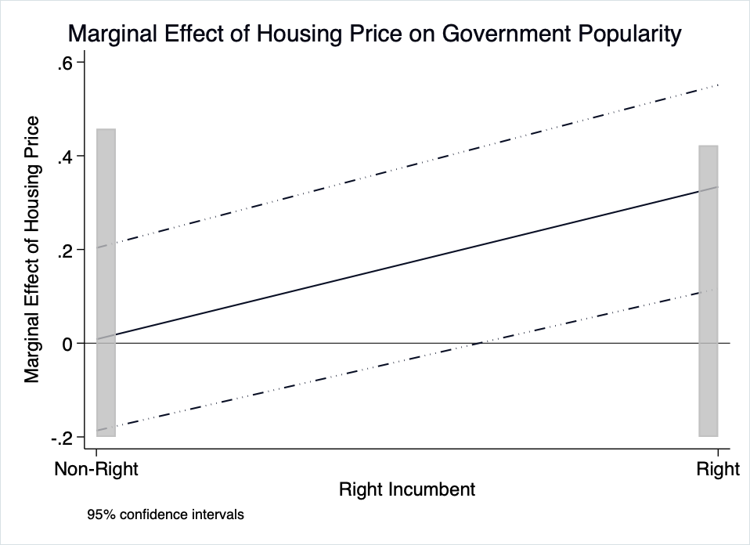

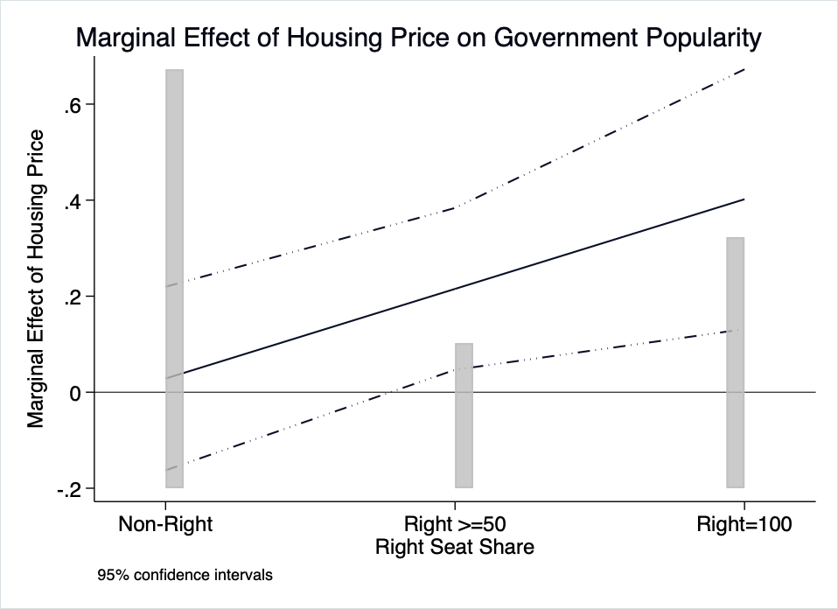

Note: The y-axis shows the marginal effect of the change in real housing prices. The x-axis shows government partisanship. The solid line is the marginal effect line and dashed lines are the 95% confidence intervals. The upper panel is based on model A4 estimates and lower panel is based on model A4 estimates.

Figure A6. Housing Prices, Left Powers, and Government Popularity (Using alternative measures of partisanship)

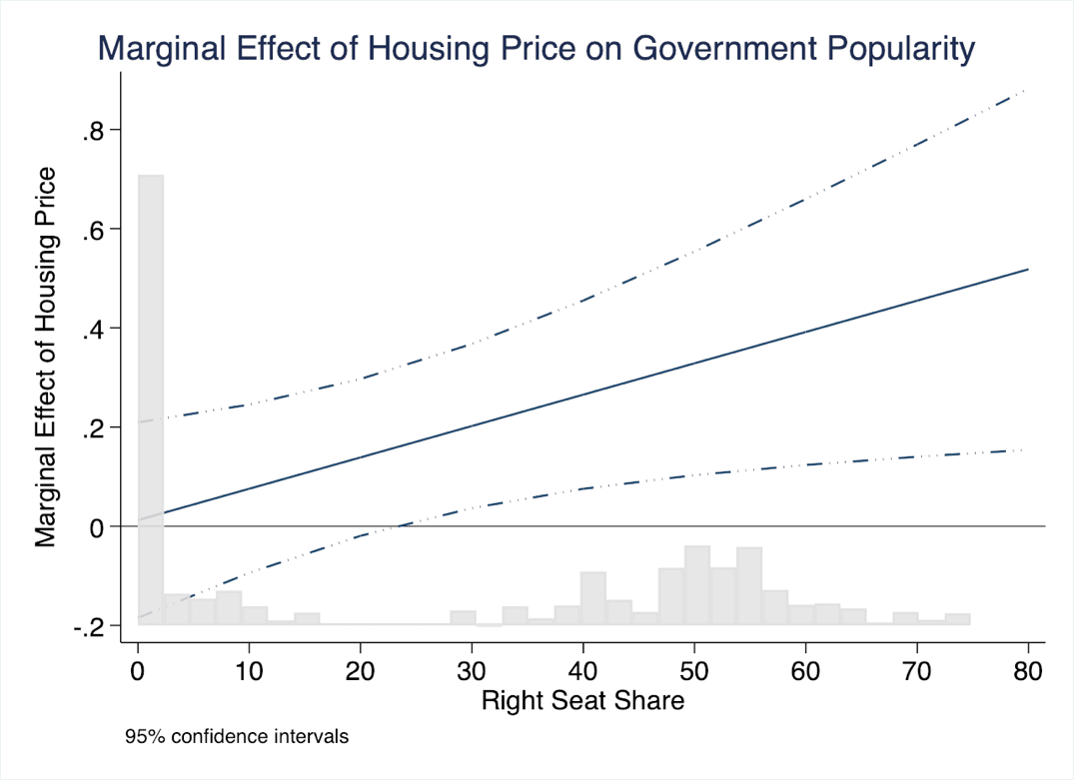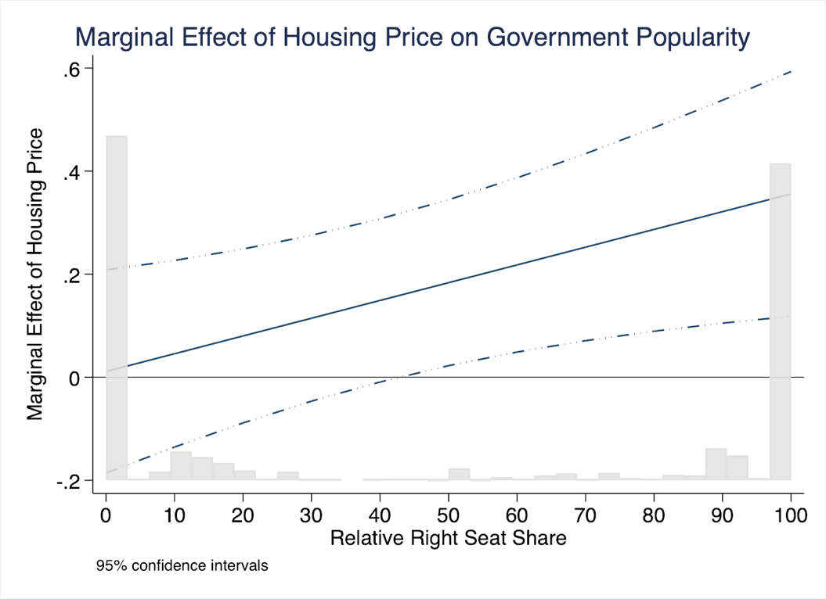

Note: The y-axis shows the marginal effect of the change in real housing prices. The x-axis shows government partisanship. Greater values of x-axis indicate more rightist positions. The solid line is the marginal effect line and dashed lines are the 95% confidence intervals. The upper panel is based on Model A5 estimates and lower panel is based on Model A6 estimates.

Figure A7. Time Trends in Housing Price Change



Figure A8. Time Trends in Consumer Price Index



1. https://www.oecd.org/els/family/HM1-3-Housing-tenures.pdf
2. We collect homeownership rates from a number of sources. United States' homeownership from census data (https://www.census.gov/), European data from the European Central Bank https://sdw.ecb.europa.eu/home.do), Canadian data from Statistics Canada (https://www.statcan.gc.ca), Japanese data from Statistics of Japan (https://www.e-stat.go.jp), ,Australian data from Australian bureau of statistics (https://www.abs.gov.au), and New Zealand dats from Statistics New Zealnd (https://stats, govt.nz).
3. Next countries with lowest level of homeownerships are Canada (64.97%) and United Kingdom (65.12%) in our data. We do not code these countries as low homeownership countries because homeownership rates for these countries are quite close to the average homeownership rates in our data and it is hard to classify them as low or high. However, considering one or two of them to be in the low homeownership category does not change the main results.
4. Here, we exclude country fixed effect. First, country fixed effect is directly correlated with homeownership dummy so homeownership dummy is automatically dropped with homeownership dummy. Second, even though we could use country fixed effect in Model A2 with an interpolated homeownership variable, country fixed effect is still significantly correlated with this variable, which makes it hard to estimate the moderating effect of homeownership.
5. Even if we select the other country such as Ireland (homeownership rate of 75.9%) or Italy (homeownership rate of 77.1%) instead of United States, the marginal effect plot looks similar. As well, the marginal effect plot in the above panel looks similar if we the change homeownership level in other low homeownership countries such as Austria (56.33%).
6. We cannot control interaction between homeownership and individual housing price increases given that non-homeowners do not own housing. For non-homeowners, only way they could sense housing price change is the price change in their regions.