(Un)covering the COVID-19 pandemic
Framing analysis of the crisis in Canada

Online Appendix

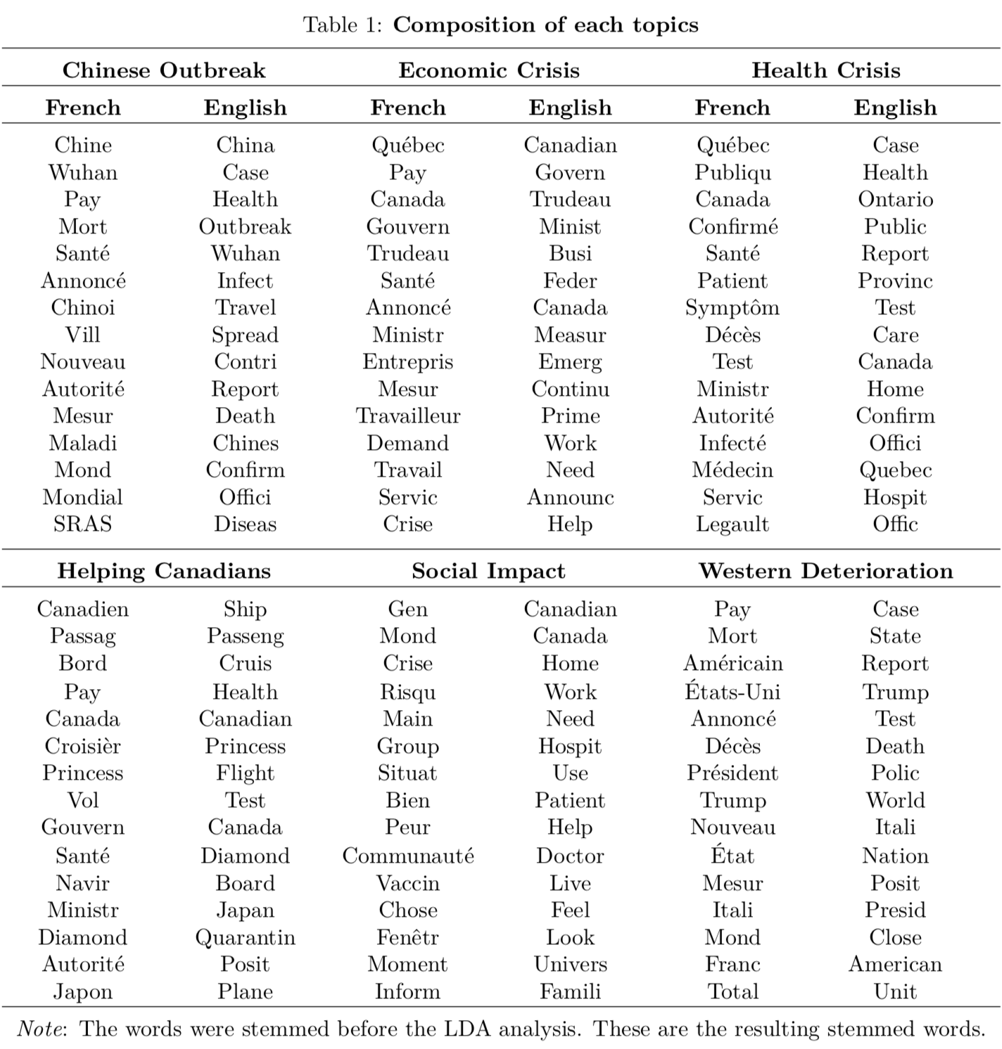
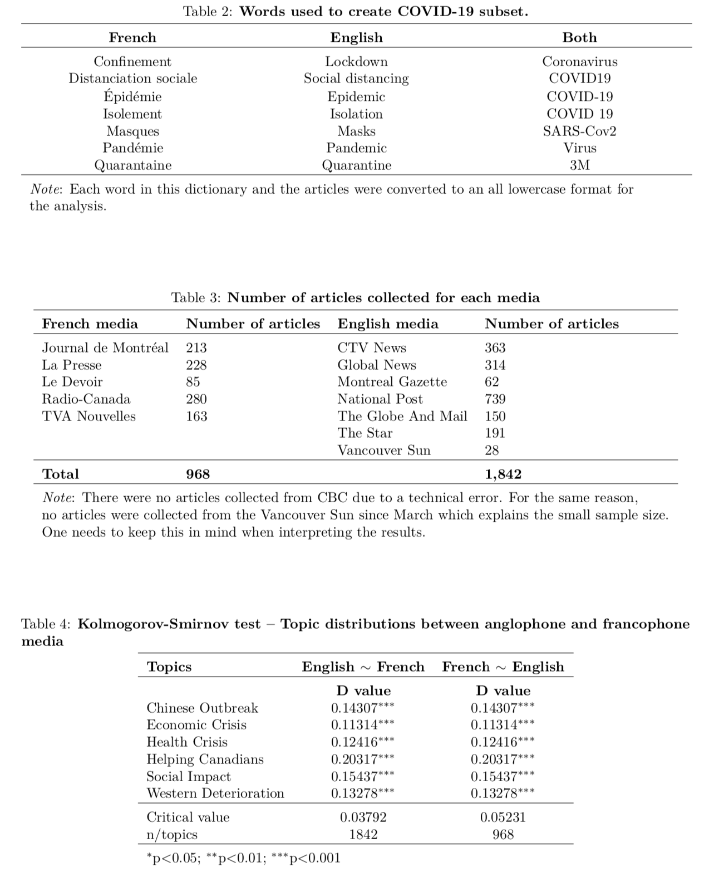

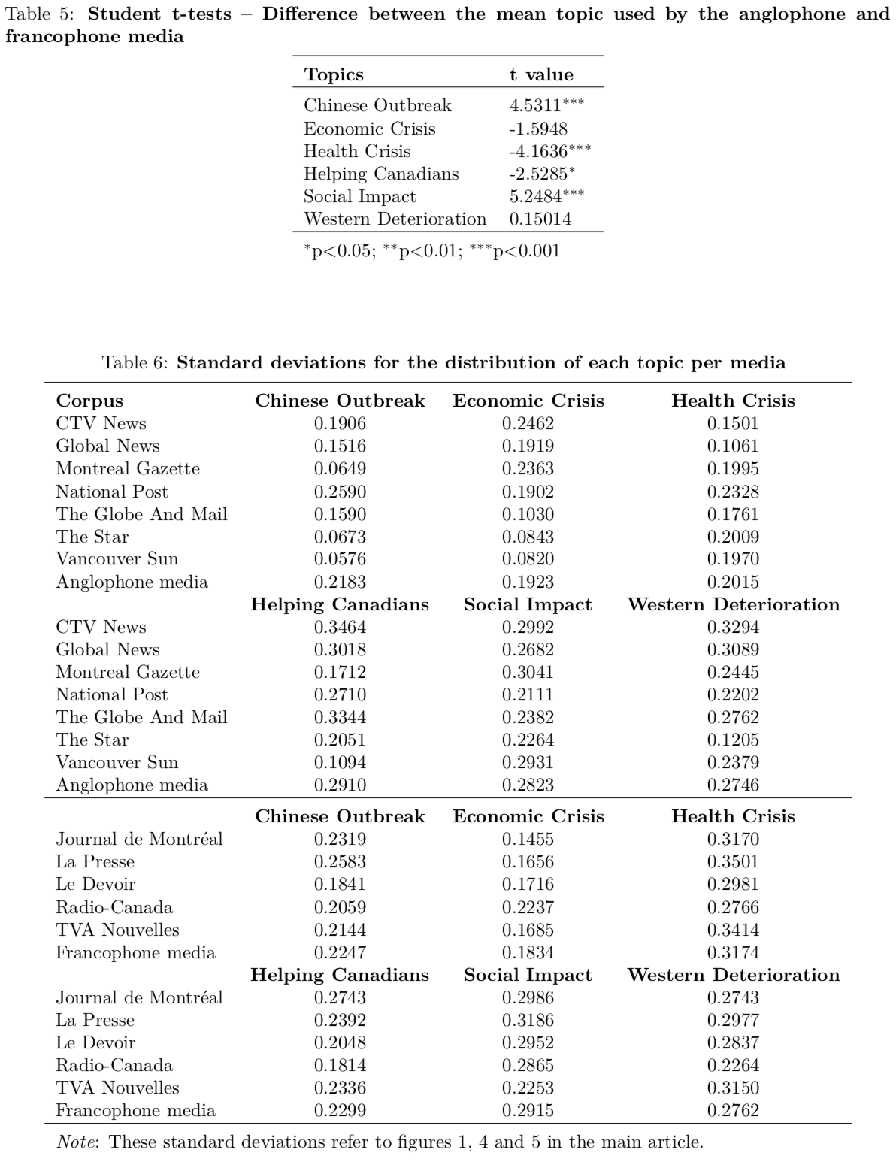
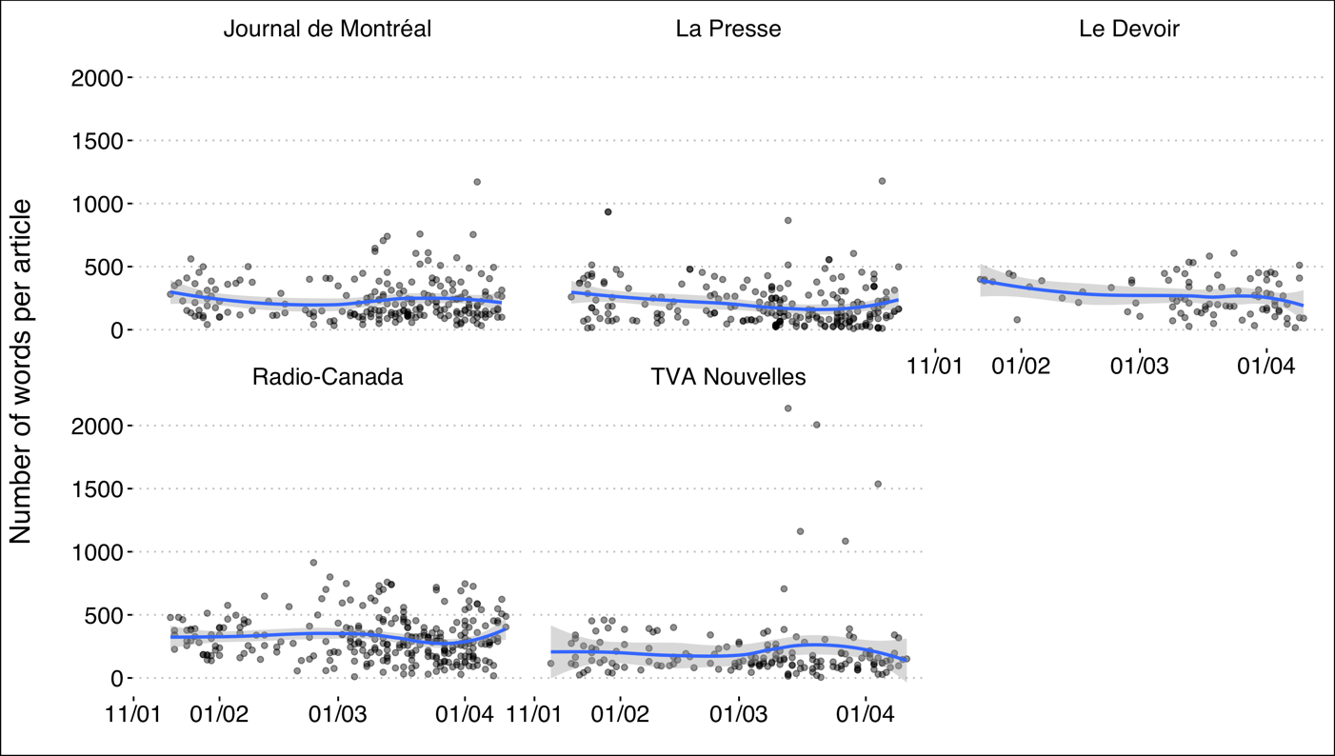
Figure A1: Number of words per article per day for each francophone media
Source: Radar+, from January 11th to April 11th, 2020.
Note: n = 968.
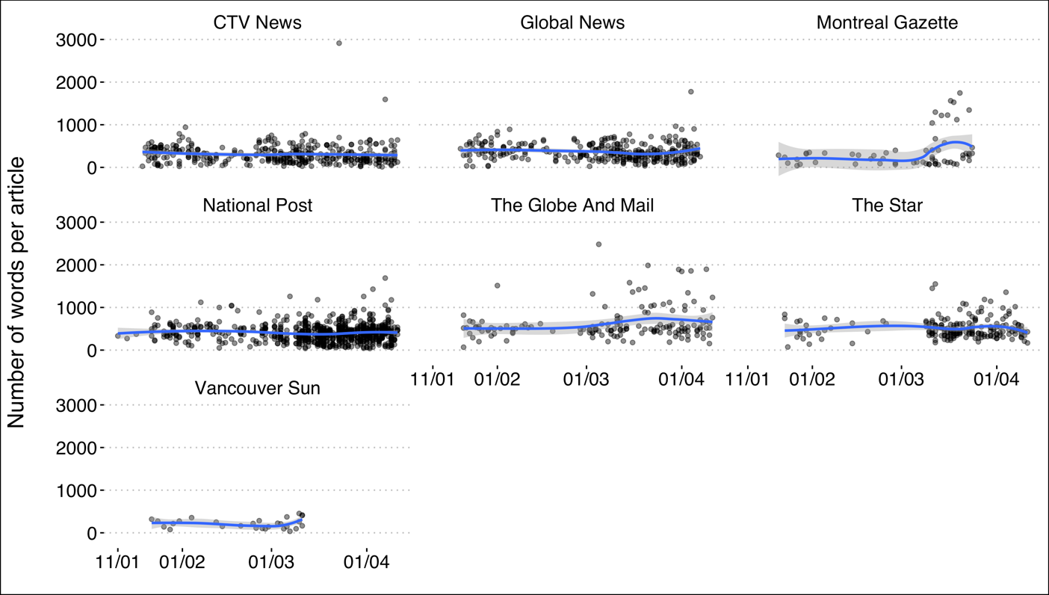
Figure A2: Number of words per article per day for each anglophone media
Source: Radar+, from January 11th to April 11th, 2020.
Note: n = 1,842.

