Appendices

Exact wording of the questions:

Because of the COVID-19 epidemic, governments are asking everyone to stay home, except for strictly essential work and basic necessities like grocery shopping. How strongly do you support or oppose that decision? (0 to 10 scale; I fully oppose to I fully support)

When do you think that governments will allow nearly everyone to go back to work?

April 2020
May 2020
June 2020
July 2020
August 2020
September 2020
October 2020
November 2020
December 2020
Sometime in 2021
Never

Example of question wording for the two treatments

Here is a graph showing the evolution of COVID-19 cases in Canada:

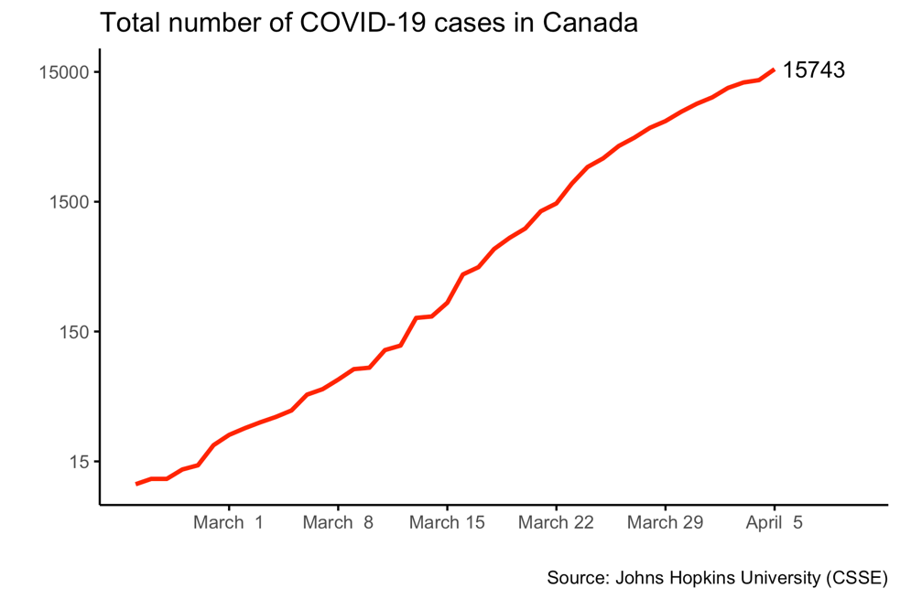

Here is a graph showing the evolution of COVID-19 cases in Canada:

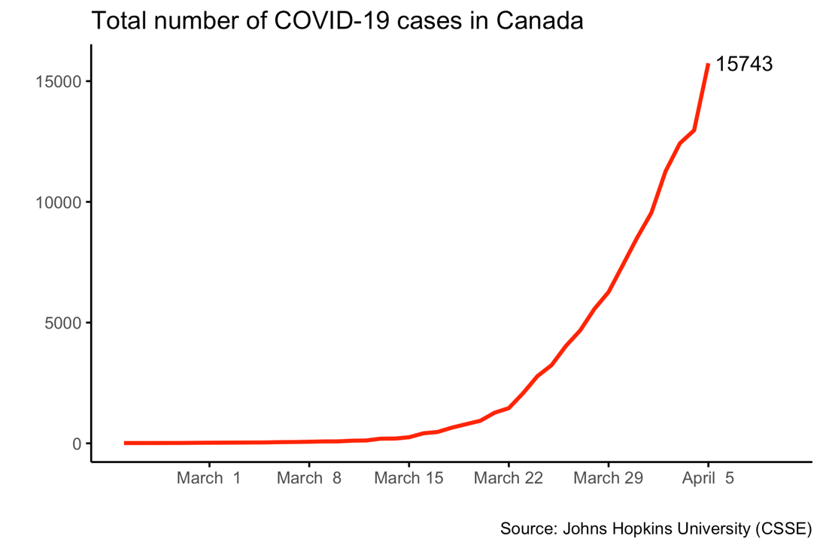

Distribution of the dependent variables

Figure 1: Distribution of responses for the pessimism and support variables

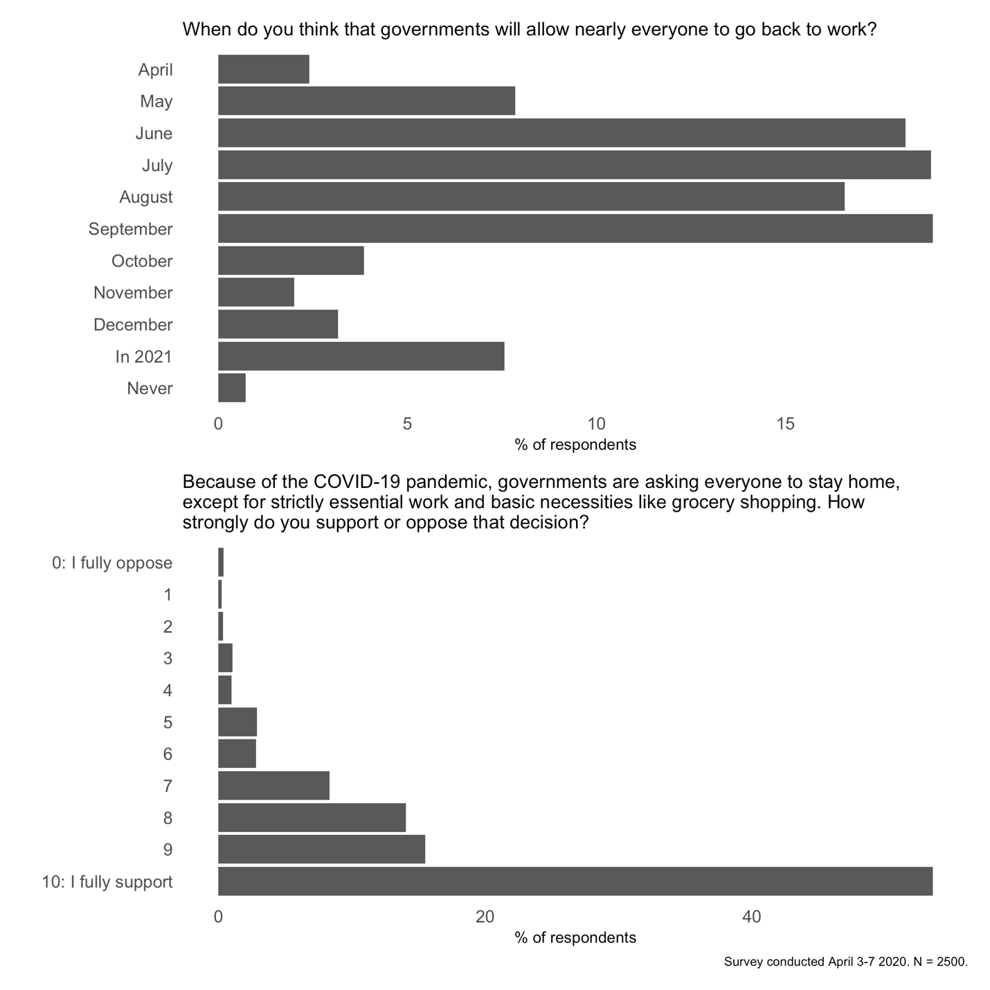

Figure 2: Distribution of responses for the pessimism and support variables by treatment

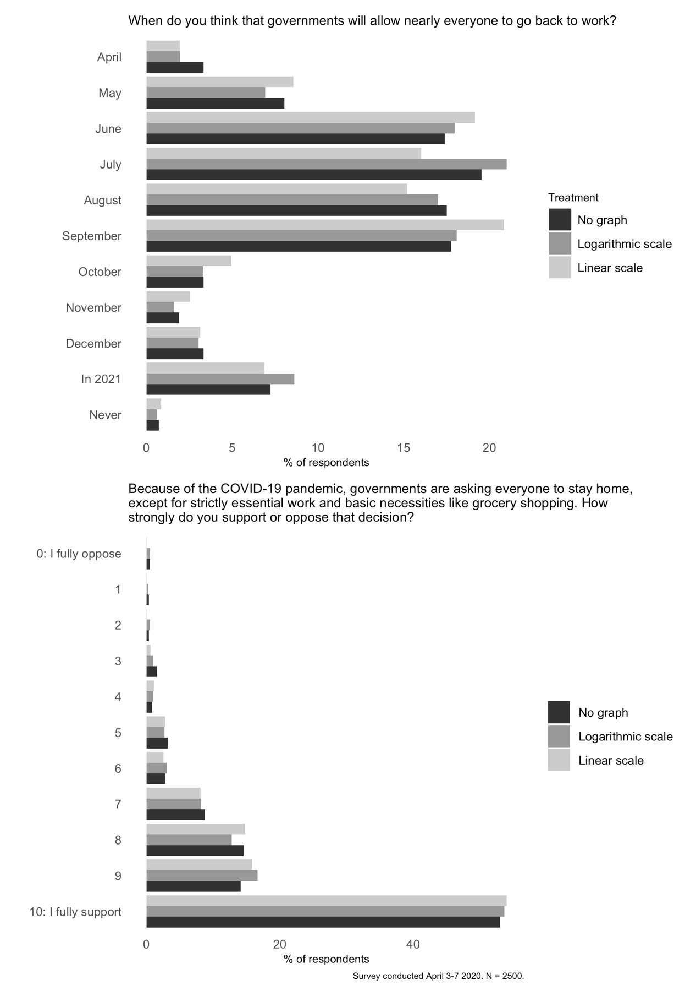

Full regression results

Table 1. Full results (pessimism) by experimental condition, age group, region, and gender (OLS regression)
 | Lin vs. Log | Lin or Log | Gender | Age | Education | Region
Linear scale | 0.106
 | (0.111)
Logarithmic scale | 0.108
 | (0.112)
Either Graph |  | 0.107
 |  | (0.096)
Women |  |  | -0.052
 |  |  | (0.091)
30-64 |  |  |  | -0.036
 |  |  |  | (0.126)
65+ |  |  |  | 0.289
 |  |  |  | (0.155)
Education: Low |  |  |  |  | 0.335
 |  |  |  |  | (0.189)
Education: Middle |  |  |  |  | 0.135
 |  |  |  |  | (0.097)
Quebec |  |  |  |  |  | -0.155
 |  |  |  |  |  | (0.166)
Atlantic |  |  |  |  |  | 0.114
 |  |  |  |  |  | (0.220)
Ontario |  |  |  |  |  | 0.301
 |  |  |  |  |  | (0.155)
Prairies |  |  |  |  |  | -0.029
 |  |  |  |  |  | (0.217)
BC |  |  |  |  |  | 0.356
 |  |  |  |  |  | (0.184)
Intercept | 4.920 | 4.920 | 5.017 | 4.961 | 4.891 | 4.857
 | (0.078) | (0.078) | (0.065) | (0.112) | (0.076) | (0.136)
Num.Obs. | 2499 | 2499 | 2499 | 2499 | 2499 | 2499
R2 | 0.000 | 0.000 | 0.000 | 0.003 | 0.002 | 0.008
Adj.R2 | -0.000 | 0.000 | -0.000 | 0.002 | 0.001 | 0.006
AIC | 11210.7 | 11208.7 | 11209.6 | 11204.6 | 11208.0 | 11198.4
BIC | 11234.0 | 11226.2 | 11227.1 | 11227.9 | 11231.3 | 11239.1
Log.Lik. | -5601.356 | -5601.356 | -5601.809 | -5598.309 | -5600.017 | -5592.179
Table 2: Full results (support) by experimental condition, age group, region, and gender (OLS regression)
 | Lin vs. Log | Lin or Log | Gender | Age | Education | Region
Linear scale | 0.157
 | (0.083)
Logarithmic scale | 0.078
 | (0.084)
Either Graph |  | 0.118
 |  | (0.072)
Women |  |  | 0.314
 |  |  | (0.068)
30-64 |  |  |  | 0.420
 |  |  |  | (0.093)
65+ |  |  |  | 0.831
 |  |  |  | (0.115)
Education: Low |  |  |  |  | -0.708
 |  |  |  |  | (0.141)
Education: Middle |  |  |  |  | -0.071
 |  |  |  |  | (0.072)
Quebec |  |  |  |  |  | 0.086
 |  |  |  |  |  | (0.125)
Atlantic |  |  |  |  |  | -0.021
 |  |  |  |  |  | (0.166)
Ontario |  |  |  |  |  | 0.089
 |  |  |  |  |  | (0.116)
Prairies |  |  |  |  |  | 0.124
 |  |  |  |  |  | (0.163)
BC |  |  |  |  |  | 0.094
 |  |  |  |  |  | (0.138)
Intercept | 8.767 | 8.767 | 8.684 | 8.418 | 8.934 | 8.771
 | (0.059) | (0.059) | (0.049) | (0.084) | (0.056) | (0.102)
Num.Obs. | 2499 | 2499 | 2499 | 2499 | 2499 | 2499
R2 | 0.001 | 0.001 | 0.008 | 0.021 | 0.010 | 0.001
Adj.R2 | 0.001 | 0.001 | 0.008 | 0.020 | 0.009 | -0.001
AIC | 9769.6 | 9768.5 | 9749.9 | 9721.4 | 9747.6 | 9777.8
BIC | 9792.9 | 9786.0 | 9767.4 | 9744.7 | 9770.9 | 9818.6
Log.Lik. | -4880.811 | -4881.259 | -4871.960 | -4856.698 | -4869.821 | -4881.909

