Supplementary Information for “Explaining Variation in Oil Sands Pipeline Projects”

Part A: Case descriptions

Table S1: Project description, purpose, and capacity
Project name | Company | Description | Purpose | Capacity
Alberta Clipper Expansion Project | Enbridge Pipelines Inc. | Construction of 1,074 km of new pipeline from Alberta (Hardisty terminal) to Canada/United States border (in Manitoba) to Wisconsin (Superior terminal) | To increase capacity to transport light and heavy crude oil from Western Canada (i.e., the Western Canada Sedimentary Basin [WCSB]) to markets in the traditional and extended Petroleum Administration for Defense District (PADD) II and eastern Canada | Initial capacity of 450,000 barrels per day (b/d) expandable to 800,000 b/d
Alberta Clipper Capacity Expansion Project | Enbridge Pipelines Inc. | Construction of facilities for the Alberta Clipper Pipeline (Line 67) | To increase the capacity of the Alberta Clipper Pipeline (Line 67) | To increase capacity from 450,000 b/d to 570,000 b/d
Alberta Clipper Capacity Expansion Project Phase 2 | Enbridge Pipelines Inc. | Construction of facilities for the Alberta Clipper Pipeline (Line 67) | To increase the capacity of the Alberta Clipper Pipeline (Line 67) | To increase capacity from 570,000 b/d to 800,000 b/d
Alida to Cromer Capacity Expansion Project | Enbridge Pipelines (Westspur) Inc. | Converting existing 60 km pipeline from natural gas to crude oil and construction of 60 km pipeline to transport natural gas from Saskatchewan (Alida terminal) to Manitoba (Cromer terminal) | To increase the capacity of the Enbridge Westspur system to transport crude oil | 188,130 b/d (original pipeline capacity of 25,000 cubic meters per day or 157,300 barrels per day)
Bakken Pipeline Project | Enbridge Bakken Pipeline Company Inc. | Construction of 123 km of new pipeline and acquisition of 34 km Enbridge Westspur pipeline from Saskatchewan (proposed Bakken pump station near Steelman) to Manitoba (Cromer terminal) | To transport light crude oil from the Bakken Formation (in North Dakota and Montana) to refinery markets in North America (via the Enbridge Pipeline Inc.’s Mainline System) | Initial capacity of 148,500 b/d expandable to 325,000 b/d
Edmonton to Hardisty Pipeline Project | Enbridge Pipelines Inc. | Construction of 182 km of new pipeline within Alberta (from Edmonton to Hardisty terminals) | To increase transportation capacity of Enbridge Mainline system | Initial capacity of 570,000 b/d with additional pump station to bring capacity to 800,000 b/d
Keystone Pipeline | TransCanada Keystone Pipeline GP Ltd. | Construction of 1,235 km of pipeline from Alberta (Hardisty terminal) to Canada/United States border (near Haskett, Manitoba) to Illinois; the Canadian portion of the project would convert 864 km of gas pipeline to oil and construct 371 km of new pipeline | To transport crude oil to markets in the United States | Initial capacity of 435,000 b/d expandable to 591,000 b/d
Keystone XL | TransCanada Keystone Pipeline GP Ltd. | 1,905 km of new pipeline (529 km in Canada) from Alberta (Hardisty terminal) to Canada/United States border (in Saskatchewan) and then to Steel City Kansas (through Montana, South Dakota and Nebraska) plus an additional 480 km of new line from Cushing, Oklahoma to the Gulf of Mexico (the Cushing Extension) | To transport a variety of crude oil products (i.e., light, medium and heavy crude) from Hardisty (a supply hub) to markets in the Gulf Coast area; an addition to the Base Keystone pipeline (the original Keystone Pipeline and the Cushing expansion) | Initial capacity of 700,000 b/d expandable to 900,000 b/d
Line 3 Replacement Project | Enbridge Pipelines Inc. | Replacement of 1,765 km line from Alberta (Hardisty terminal) to Canada/United States border (at Manitoba) to Superior, Wisconsin (through North Dakota and Minnesota) and decommissioning the existing Line 3 pipeline (note 1,067 km is in Canada) | To transport a variety of crude oils from Western Canada to markets in PADD II and eastern Canada | Restore original pipeline’s design capacity of 760,000 b/d (was operating at 390,000 b/d at the time)
Line 4 Extension Project | Enbridge Pipelines Inc. | Construction of three pipeline segments totaling 138 km within Alberta (from Hardisty to Edmonton terminals) | To increase capacity and flexibility of Enbridge Mainline system | Increase capacity to 880,600 b/d (the project will increase capacity between Edmonton and Hardisty, but  will not result in an overall capacity increase to the mainline system on its own as Line 4 capacity downstream of Hardisty is 880,600 b/d)
Line 9 Reversal Phase I Project | Enbridge Pipelines Inc. | Reverse the 194 km segment of Line 9 from the Sarnia Terminal to the North Westover Station, in Ontario to flow in an eastward direction | To transport a variety of crude oils (predominately light crude) sourced from western Canada and the U.S. Bakken region to refineries in Quebec | Initial capacity of 169,000 b/d  expandable to 250,000 b/d
Line 9B Reversal and Line 9 Capacity Expansion Project | Enbridge Pipelines Inc. | Reverse a 639 km section of Line 9 between North Westover Station, in Ontario to the Montreal Terminal, in Quebec and expand the capacity of Line 9 | See above, and to expand the overall annual capacity of Line 9 from Sarnia to Montreal | Increase capacity of Line 9 from 240,000 b/d to 300,000 b/d (to a maximum of 333,333 b/d)
Northern Gateway Pipelines Project | Northern Gateway Pipelines Limited Partnership | Construction of two new 1,178 km pipelines between Alberta (Bruderheim terminal) and British Columbia (Kitimat terminal) and a new tanker terminal (in Kitimat) | To transport a variety of crude oil products (majority diluted bitumen) from Western Canada to international markets; and to supply condensate (used to dilute bitumen) to Western Canada) | Initial capacity of 525,000 b/d (oil products pipeline) and 193,000 b/d (condensate pipeline) expandable to 850,000 b/d and 275,000 b/d respectively
Southern Access Expansion Stage 1 | Enbridge Pipelines Inc. | Construction of facilities affecting Lines 2, 3 and 4 | To expand the capacity of the Enbridge mainline system from Edmonton, Alberta to points in the U.S. Midwest (PADD II) to transport heavy crude | Increase capacity by 120,000 b/d (from 1.1 to 1.2 million b/d)
Southern Access Expansion Stage 2 | Enbridge Pipelines Inc. | Construction of facilities for Line 4 | To expand the capacity of Line 4 to transport heavy crude | Increase capacity by 148,000 b/d (from 733,000 to 881,000 b/d)
Southern Lights Project | Enbridge Southern Lights GP | Reverse Line 13 (2,560 km) from Edmonton to the Canada/United States border (in Manitoba) to Chicago, Illinois (through North Dakota, Minnesota and Wisconsin); construction of a new pipeline (and Line 2 modifications) from Cromer, Manitoba to the Canada/United States border (in Manitoba) to Illinois | To carry diluent from Chicago, Illinois to Edmonton, Alberta as part of the Enbridge Pipelines Inc. mainline (in order to dilute heavy oil and bitumen from Western Canada); in order to do so, the project would remove Line 13 from service (which moved crude oil from Edmonton southbound) – the lost capacity would be replaced by Line 2 modifications and a new pipeline to transport light sour crude oil | 180,000 b/d (diluent pipeline) and 50,400 b/d (between Edmonton and Cromer) (combined Line 2 modifications and the light sour pipeline)
Trans Mountain Expansion Anchor Loop | Terasen Pipelines (Trans Mountain) Inc. | Construction of 159 km of pipeline loop from Alberta (Hinton) to British Columbia (near Rearguard) | To increase capacity of Trans Mountain pipeline and increase access to west coast markets | Incremental capacity of 40,000 b/d (with the November 2005 approval of the Trans Mountain Pump Station Expansion Project total capacity would increase to 300,000 b/d)
Trans Mountain Expansion Project | Trans Mountain Pipeline Unlimited Liability Corporation (ULC) (Kinder Morgan Canada) | Twinning the existing 1,147 km system (with 987 km of new buried pipeline) from Edmonton (Alberta) to Burnaby (British Columbia) | To increase the capacity of the existing Trans Mountain Pipeline system (which transports oil from Western Canada to the west coast) | Increase capacity to 890,000 b/d (from 300,000 b/d)

Part B: Calibration details

Outcome
While the ultimate outcome (that is, whether a project is built or not) is preferred analytically, three projects that have faced significant delays – KXL, TMEP, and the L3R – may yet be built. However, there is still value in understanding the conditions that have led to major delays for oil pipelines. Notably, there are no empirical cases in the dataset that are coded 0.6 or 0.9. Following Ragin (2009: Table 5.1), I use 0, 0.1, 0.4, 0.6, 0.9 and 1 for a six-value scale.

Commercial support condition
In the Northern Gateway Pipelines and Trans Mountain Expansion Pipeline projects, the NEB required commercial support as a condition of both projects (Canada, 2014: 369; Canada, 2016: 447). As only two cases in the dataset belong in the set, the commercial support condition (CSC) has skewed membership. However, as it is the only condition that has skewed membership, it should not distort the results (Thomann and Maggetti, 2017: 17). According to Thomann et al., skewness is problematic if the vast majority of cases (>85 per cent) in a set have membership above 0.5, or if the vast majority of cases have membership below 0.5 (Thomann et al., 2018: 589). I use XY plots, per Schneider and Wagemann, to detect skewedness (Schneider and Wagemann, 2012: 235).

Legal risk
To operationalize legal risk, I counted legal cases brought against either a government entity or the proponent. If a case had an outcome and was appealed, I considered it a separate legal case. If a case was deferred to another court, I did not consider it a separate legal case. Projects that do not have any legal challenges are coded 0. One legal challenge appears to have very little impact on a project, thus cases with only one legal case are coded 0.1. Projects that attracted between two and four legal cases were coded 0.4. Projects coded 0.4 – Keystone, Southern Lights and Line 9B – had three legal challenges each, which did not appear to have a significant impact on the project timeline. Projects with between five and eight legal cases were coded 0.6, and projects with between nine and 14 cases were coded 0.9. I use the threshold of five legal to determine cases that are more in than out of the set because the Alberta Clipper Expansion project had legal challenges from a range of actors, on a range of issues, in several courts. It can be argued that because the legal challenges for the Alberta Clipper did not substantially delay the project, it is more out of the set than in. If this case is recoded to 0.4, the results change very little (see Part D). I maintain the original coding because it is plausible that another project with five legal challenges creates delays and uncertainty. The L3R has, at the time of writing, nine legal challenges, some of which have delayed the regulatory process. There is a clear empirical break in the data where KXL, NGP, and TMEP all had around 15 to 20 legal challenges, and they are coded 1.

Long distance
The Canadian Energy Pipeline Association (CEPA) suggested that only projects that require 500 km of new right of way in Canada should be subject to a federal impact assessment (CEPA, 2018). While no proposed oil pipelines exceed this threshold (except the former Energy East pipeline), 500 km of total distance of new pipeline captures the reality that these projects cross many properties and Indigenous territories and involve comparatively more stakeholders, thus increasing the potential for opposition. Long distance is also an indicator that a project is capital intensive – all projects in the dataset that require over 500 km of new pipeline also cost at least 2 billion CAD. This reflects, in part, the significant costs of negotiating agreements with affected landowners and Indigenous nations. There is a clear break in the data where no pipelines are close to the 500 km threshold. In fact, almost all pipeline projects in this set require more than 1000 km of new pipeline.

Social mobilization
Cases with no protests were coded 0. Projects with between one and three protest events were coded a 0.1; only one case fit this code – the original Alberta Clipper Expansion. Cases with between six and 19 protests events were coded 0.6. I use six events as the threshold to determine cases that are more in than out of the set because the Alberta Clipper Capacity Expansion included a protest where 20 demonstrators were arrested (Taylor and Kerr, 2015). Protests with civil disobedience and arrests are more disruptive and attract media attention, and thus I include it in the set of social mobilization. There was a clear break in the data where NGP, TMEP and L3R all had between approximately 20 and 49 protest events – these were coded 0.9. KXL had the greatest number of protest events by a large margin with several hundred events. For the KXL case, I drew on collected by 350.org, an environmental NGO (see 350.org, 2019). Events for all other cases were located using search terms in Internet searches and on organization websites. It is possible that the number of protest events for some cases is slightly lower than the number of events organized, depending on how much media attention protest events received. However, given the flexibility with how the thresholds are defined, it is very unlikely that a case is coded incorrectly.

Major regulatory barrier
Cases are coded 1 if there was more than one MRB, 0.67 if there was one regulatory barrier, and 0.33 if there were only minor delays in the regulatory process. Examples of minor delays include additional hydrostatic testing in the case of Line 9B or delays in the State Department’s decision regarding the Alberta Clipper Capacity Expansion project (The Minnesota Court of Appeals, 2019). They are considered minor because when compared to a major regulatory barrier they do not create significant uncertainty about a project. For example, in the case of Line 9B, the NEB had already approved the project. And in the case of the Alberta Clipper Capacity Expansion project, the company believed the State Department would ultimately approve the project (The Canadian Press, 2014). It is possible that some minor regulatory barriers were missed for some BUILT projects, but this does not affect the results of the analysis.

Table S2: Raw data
Project | BUILT | CSC | LD | LR | MRB | SM
Alida to Cromer Capacity Expansion Project (ACCE) | 1 | 0 | 0 | 0.1 | 0 | 0
Alberta Clipper Expansion Project | 1 | 0 | 1 | 0.6 | 0 | 0.1
Alberta Clipper Capacity Expansion Project (AbCCE 1) | 1 | 0 | 0 | 0 | 0 | 0
Alberta Clipper Capacity Expansion Project Phase 2 (AbCCE 2) | 1 | 0 | 0 | 0.1 | 0.33 | 0.6
Bakken Pipeline Project | 1 | 0 | 0 | 0 | 0 | 0
Edmonton to Hardisty Pipeline Project | 1 | 0 | 0 | 0.1 | 0 | 0
Keystone Pipeline | 1 | 0 | 1 | 0.4 | 0 | 0
Keystone XL (KXL) | 0.1 | 0 | 1 | 1 | 1 | 1
Line 3 Replacement Project (L3R) | 0.4 | 0 | 1 | 0.9 | 0.67 | 0.9
Line 4 Extension Project | 1 | 0 | 0 | 0 | 0 | 0
Line 9 Reversal Phase I Project | 1 | 0 | 0 | 0 | 0 | 0
Line 9B Reversal and Line 9 Capacity Expansion Project | 1 | 0 | 0 | 0.4 | 0.33 | 0.6
Northern Gateway Pipelines (NGP) Project | 0 | 1 | 1 | 1 | 0.67 | 0.9
Southern Access Expansion Stage 1 | 1 | 0 | 0 | 0 | 0 | 0
Southern Access Expansion Stage 2 | 1 | 0 | 0 | 0 | 0 | 0
Southern Lights Project | 1 | 0 | 1 | 0.4 | 0 | 0
Trans Mountain Expansion Project (TMEP) | 0.1 | 1 | 1 | 1 | 0.67 | 0.9
Trans Mountain Expansion Anchor Loop Project | 1 | 0 | 0 | 0 | 0 | 0

Part C: Supplemental information for analysis of necessary and sufficient conditions

Figure S1: Necessary conditions for BUILT outcome
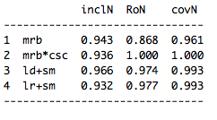

Figure S2: Necessary conditions for ~BUILT
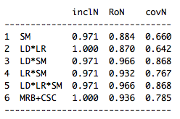
Figure S3: Truth table for BUILT
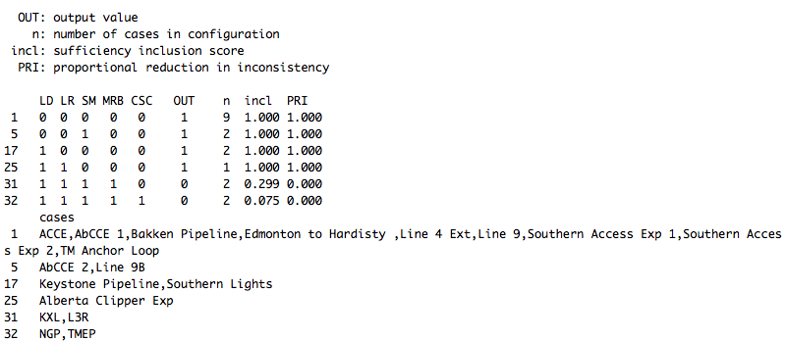

Figure S3 is the truth table for the BUILT outcome. A configuration can apply to multiple cases (shown by the “n” column). Note the “OUT” column specifies the output values not the outcome. The inclusion value (“incl” column) which refers to the degree to which one set is included by another (Thiem and Dușa, 2013). Importantly, there are no logically contradictory rows (where some cases have membership in the outcome and others do not).

Figure S4: Complex solution for BUILT
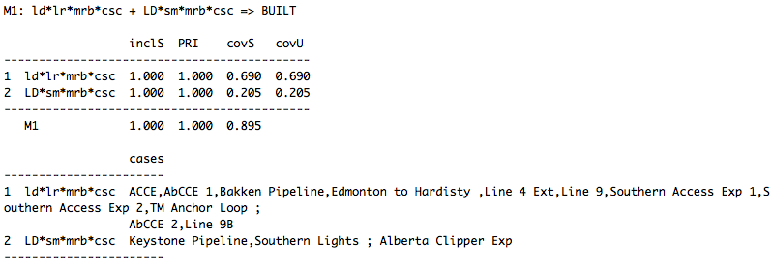

The conservative solution (illustrated in Figure S4) does not make any assumptions about logical remainders. Thus, the truth table is minimized using only the rows that have empirical information (that is, cases) that match them. This solution is sometimes called the complex solution because of the number of conditions or configurations that are included. The parsimonious solution (illustrated in Figure S5) by contrast uses the logical remainder rows and makes assumptions about hypothetical cases in order to produce the simplest solution (that is, it includes the fewest conditions). The intermediate solution (illustrated in Figure S6) uses theory to produce easy assumptions or counterfactuals. In order to do so, the researcher provides directional expectations for each condition. The expectation specifies the presence of condition X – and not its absence – should appear in combinations of conditions generating outcome Y.

Figure S5: Parsimonious solution for BUILT
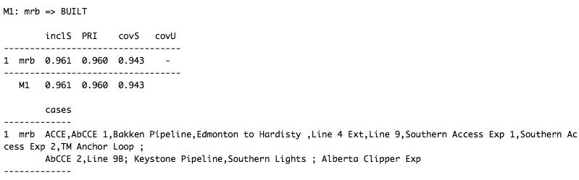

Figure S6: Intermediate solution for BUILT
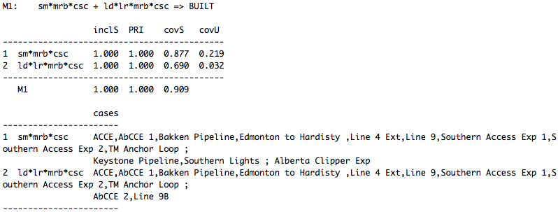

Figure S7: Truth table for ~BUILT
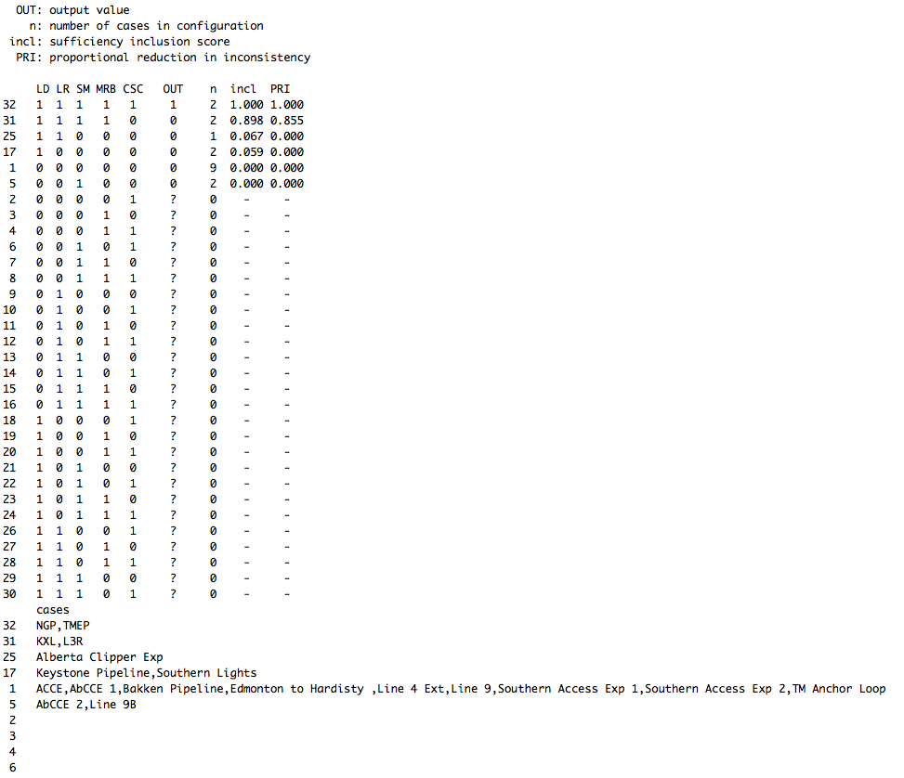

Figure S8: Complex solution for ~BUILT
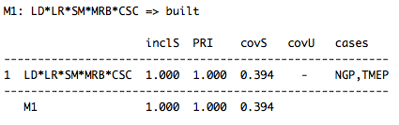

Figure S9: Parsimonious solution for ~BUILT
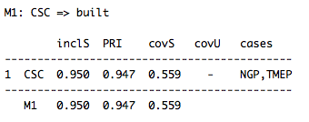

Figure S10: Intermediate solution for ~BUILT
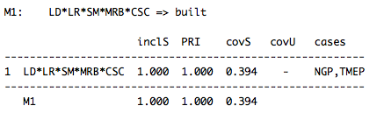

Figure S11: Sufficiency plot for BUILT
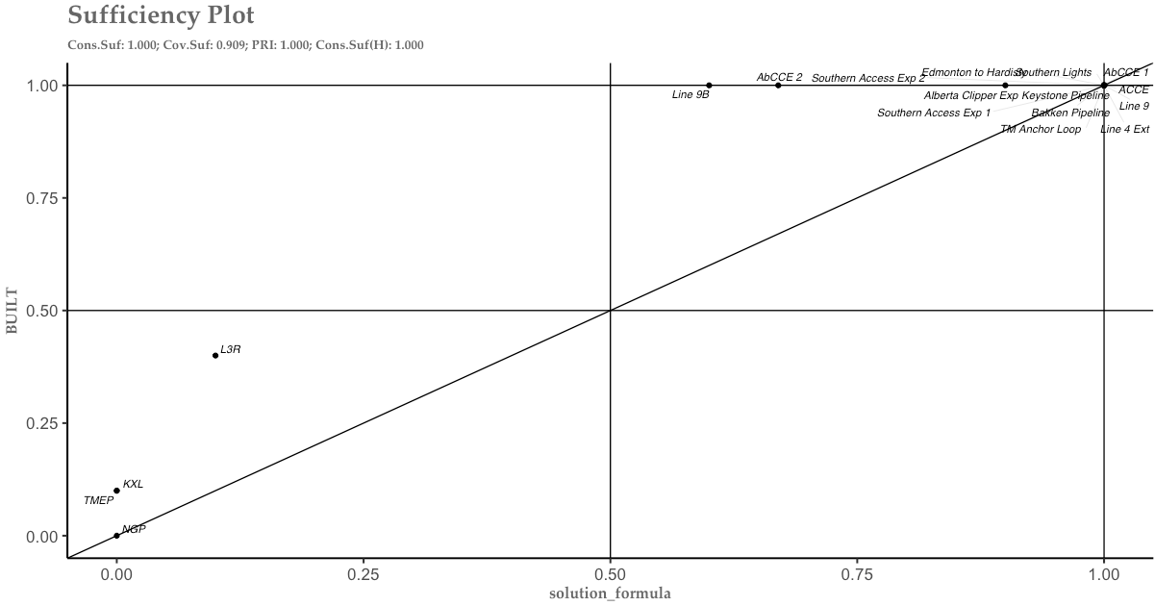

Figure S12: Sufficiency plot for ~BUILT
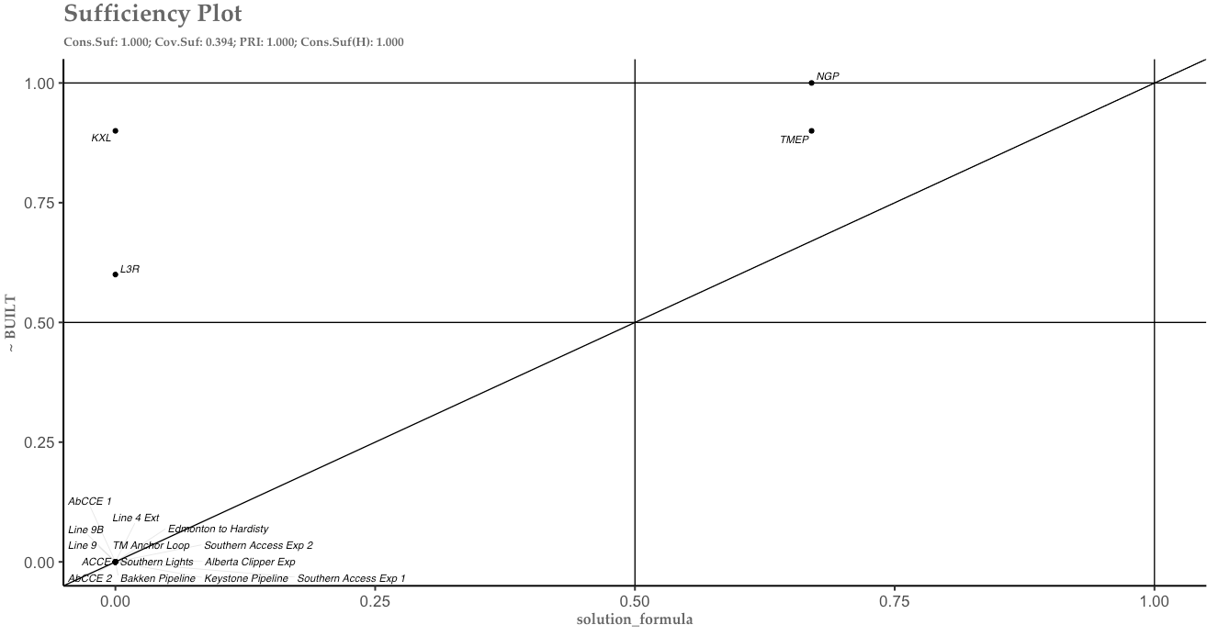

The intermediate solution formulas for each outcome are graphically represented in Figures S11 and S12. The y-axis represents the outcome and the x-axis represents the necessary conjunction (that is, two or more conditions). Following Schneider and Wagemann (2012: 69), for a condition to be sufficient, all cases should be located around or above the diagonal line, which they are.

Part D: Robustness checks

There are five types of robustness checks: (i) the frequency thresholds, (ii) the inclusion thresholds, (iii) the cases analyzed, (iv) the conditions used, and (v) the calibration decisions (Ide, 2015). I, like Ide (2015), do not employ the first test given the number of cases. According to Ragin (2009: 105) a frequency threshold of 1 for 18 cases is reasonable and a higher threshold is hard to justify.
A second test concerns the inclusion or consistency threshold. I use the recommended threshold for analysis of necessity, 0.9 (Thomann et al., 2018: 589). The threshold for the analysis of sufficiency is lower, at 0.75 (ibid., 589; see also Schneider and Wagemann, 2012). I use an inclusion cut off of 0.9 for the analysis of sufficiency for the BUILT outcome. Lowering the cut off to 0.8 does not change the results. For the ~BUILT outcome, I lower the threshold to 0.8. If I use 0.9, the condition CSC is added to the intermediate solution, but it has weak coverage since it only covers the NGP and TMEP cases.
A third test involves adding or dropping a case(s). I have included all potential oil pipeline projects regulated by the NEB. I do not include the Energy East project because the NEB did not make a decision on the project, which makes it harder to compare to other projects. However, for the purposes of the robustness check I include it here. The project was proposed by TransCanada to the NEB in October 2014. The project would transport 1.1 million b/d of a range of crude products. The project consisted of 4,500 km of new and existing pipeline from Alberta and Saskatchewan to Québec and New Brunswick; the project would involve construction of 1,520 km of new pipeline and related facilities and the conversion of 3,000 km of the TransCanada Mainline from gas to oil (Canada, 2019). The project was withdrawn by the proponent in October 2017.
At the time of the project’s application, Energy East had long-term shipping commitments for 995,000 barrels per day (Energy East Pipeline Ltd., 2016). As there was no NEB decision, I cannot reasonably assign it a value for the CSC condition; however, for the purposes of this check I will assign it a 0 (meaning that a commercial support condition was not required). It is worth noting that Andrew Leach, Associate Professor at the Alberta School of Business, argues that TransCanada cancelled the project in part so that it could allow shippers to re-commit to KXL (Leach, 2017). This argument is difficult to confirm given the private nature of contracts with shippers. However, some industry sources suggest the project was economically less viable than other existing proposals, including KXL (Markham, 2017). The project required over 500 km of new pipeline, had six legal cases and several dozen protest events before the project was cancelled. Even though a decision had yet not been made on the project, legal risk and social mobilization were high, evidence of the amount of opposition the project faced. The project also faced a major regulatory barrier when the NEB panel recused itself in 2016 after concerns of a conflict of interest, which restarted the review process (McSheffrey, 2017). Table S3 includes the data for the Energy East case. When the case is included in the analysis, the results change only slightly. For the analysis of necessity for the ~BUILT outcome, legal risk becomes a necessary condition.

Table S3: Energy East data table
Project | BUILT | CSC | LD | LR | MRB | SM
Energy East | 0 | 0 | 1 | 0.6 | 0.67 | 0.9

If I include only projects that involve new pipeline construction, I exclude six cases – projects concerning the Line 9, Southern Access, and Alberta Clipper Capacity Expansion pipelines. Notably, for the analysis of necessity for the BUILT outcome, the absence of social mobilization becomes an individually necessary condition (Figure S13). The analysis of sufficiency for BUILT is simpler with only one pathway for the intermediate solution: the absence of social mobilization and a major regulatory barrier and a commercial support condition (Figure S14). For the analysis of necessity for the ~BUILT outcome, legal risk becomes a necessary condition. However, with 12 cases, I can have a maximum of four conditions (Marx and Dușa, 2011: 114). This benchmark prevents the model from detecting patterns in arbitrary data. As all five conditions appear in the solutions of either the analysis of necessity or sufficiency, I cannot justifiably drop a condition. Since the case-to-condition ratio is problematic, it is not feasible to reduce the number of cases.

Figure S13: Analysis of necessary conditions for BUILT
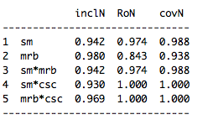

Figure S14: Intermediate solution for BUILT

A fourth test involves adding or dropping a condition. If I add a binary condition about whether a project crosses an international border (IB) – with the expectation that the absence of an international border crossing should be linked to the presence of the BUILT outcome – the results do not change significantly (see coding in Table S4). When analyzed as an individual condition, IB has the lowest parameters of fit. It appears in the analysis of necessity for the BUILT outcome where either IB or LR is necessary and either IB or SM is necessary. And it appears in the analysis of sufficiency for the ~BUILT outcome because both the KXL and L3R projects cross an international border. Having six conditions also exceeds Marx and Dușa’s recommended threshold and so this condition can justifiably be dropped from the analysis (2011: 114).

Table S4: Coding for international border (IB) condition
Project | IB
ACCE | 0
Alberta Clipper Exp. | 1
AbCCE 1 | 1
AbCCE 2 | 1
Bakken Pipeline | 0
Edmonton to Hardisty | 0
Keystone | 1
KXL | 1
L3R | 1
Line 4 Extension | 0
Line 9 Reversal 1 | 0
Line 9B | 0
NGP | 0
Southern Access 1 | 1
Southern Access 2 | 1
Southern Lights | 1
TMEP | 0
Trans Mountain Anchor Loop | 0

If I use a condition that captures how capital intensive a project is, I get the same calibration results as when I use the long distance condition. Capital intensive projects are more challenging to finance and require adequate commercial support before a final investment decision is made. For a measure of capital intensity, I use a threshold of 2 billion CAD in total capital costs for the project (this includes project costs in both the United States and Canada, as indicated in initial application[s]). Projects that require over 500 km of new pipeline are estimated to cost at least 2 billion CAD at the time of their application.
In terms of adding new conditions, one might presume that the number of intervenors would shed light on the amount of opposition a project faces. Given differences in the regulatory process it is not appropriate to use the number of intervenors because I would need to include intervenors in US state regulatory processes, which does not exist in all cases (meaning projects where the route does not cross the Canada-United States border). Another potential condition could be the right of way (RoW), as an alternative measure to long distance. The expectation would be projects that require more RoW face more difficulties because they are more resource intensive and have greater mobilization potential. However, given lack of publicly available documents about pipelines in the United States this is not possible. However, in general, pipelines that require 500 km of new construction generally require significant RoW.
Another potential condition – per Hoberg (2013) – is the jurisdictional separation of risks and benefits. I argue this is not a necessary or sufficient condition because all transboundary pipelines involve this separation by virtue of being transboundary. However, it is plausible that in different projects this separation is more or less salient. Hoberg also suggests the salience of place-based, concentrated environmental risks increases the political risk of a project. I assume that this is not a condition on its own, but it may contribute to mobilization against a project.
A final test involves calibration. For each concept there is usually only small range where the threshold is plausible (Schneider and Wagemann, 2012: 26). The only conditions where the calibration could plausibly be changed are legal risk and social mobilization. For the legal risk condition there is one plausible alternative, which is to raise the threshold slightly. The only case where the coding would change substantially is the Alberta Clipper project, which had five legal cases. Despite several legal challenges, Enbridge did not wait for court decisions before proceeding with construction. The project went into service in April 2010, as expected by Enbridge (2010). According to this logic, it is plausible to recode the Alberta Clipper Expansion so that it falls below the threshold (where it is more out than in of the set). I thus recode the Alberta Clipper to 0.4 and I also recode the L3R to 0.6 (from 0.9). The results change very little. For the analysis of necessity for BUILT, legal risk or long distance is a necessary condition. And for the analysis of sufficiency for BUILT, the intermediate solution, all the same conditions but slightly different configuration: ld*lr*mrb*csc + lr*sm*mrb*csc => BUILT (compared to sm*mrb*csc + ld*lr*mrb*csc => BUILT).
Similarly, for social mobilization, it is plausible to raise the threshold to belong in the set. The Alberta Clipper Capacity Expansion had six protest events, including one where 20 demonstrators were arrested (Taylor and Kerr, 2015). However, opposition was not as sustained and as significant as it was for KXL, TMEP, L3R and NGP projects. I can plausibly recode the Alberta Clipper Capacity Expansion to 0.4 so that it belongs more out than in of the set. The results do not change. However, if I expect that there is something categorically different about the scale and strength of opposition to the KXL, TMEP, L3R and Northern Gateway projects, I also recode Line 9B, which had approximately ten protest events (including one where 19 demonstrators were arrested) so that it belongs more out than in of the set (see Table S5) (Patterson, 2018). Analyzing the dataset with the alternate coding rules for social mobilization, the results change. Notably, for the analysis of necessity for BUILT, the absence of social mobilization becomes an individually necessary condition (Figure S15). The analysis of sufficiency for ~BUILT changes slightly: LD*LR, SM+CS and MRB+CSC (compared to LD*LR*SM and MRB+CSC). The results for the analysis of sufficiency for BUILT yield only one pathway: the absence of social mobilization and the absence of a major regulatory barrier and the absence of a commercial support condition.

Table S5: Alternative coding for social mobilization
Project | SM
ACCE | 0
Alberta Clipper Exp. | 0
AbCCE 1 | 0
AbCCE 2 | 0.33
Bakken Pipeline | 0
Edmonton to Hardisty | 0
Keystone | 0
KXL | 1
L3R | 0.67
Line 4 Extension | 0
Line 9 Reversal 1 | 0
Line 9B | 0.33
NGP | 0.67
Southern Access 1 | 0
Southern Access 2 | 0
Southern Lights | 0
TMEP | 0.67
Trans Mountain Anchor Loop | 0

Figure S15: Analysis of necessity for BUILT
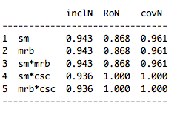

Part E: R script

# Load packages
library(QCA)
library(SetMethods)

# Set Working Directory
setwd()

datafile <- read.csv("DataTable.csv", row.names = 1)
datafile

# Skew check
skew.check(datafile)

#### NECESSITY Y
QCAfit(datafile[, 1:6], datafile$BUILT, necessity=T)

conds <- c("LD", "LR", "SM", "MRB", "CSC")

SUIN_y <- superSubset(data = datafile,
outcome = "BUILT",
conditions = conds,
relation = "necessity",
incl.cut = 0.9,
cov.cut = 0.7,
ron.cut = 0.6,
depth = 2)
SUIN_y

pimplot(data = datafile,
results = SUIN_y,
outcome = "BUILT" , necessity = TRUE, jitter = TRUE, all_labels = TRUE)

#### NECESSITY ~Y
QCAfit(datafile[, 1:6], datafile$BUILT, necessity=T, neg.out = TRUE)

SUIN_ny <- superSubset(data = datafile,
outcome = "BUILT",
conditions = conds,
relation = "necessity", neg.out = TRUE,
incl.cut = 0.9,
cov.cut = 0.6,
ron.cut = 0.6,
depth = 4)
SUIN_ny

pimplot(data = datafile,
results = SUIN_ny,
outcome = "BUILT" , neg.out = TRUE, necessity = TRUE, jitter = TRUE, all_labels = TRUE)

#### SUFFICIENCY Y
TT_y <- truthTable(data = datafile,
outcome = "BUILT",
conditions = conds,
incl.cut = 0.8,
complete = FALSE,
show.cases = TRUE,
sort.by = c("incl", "n"))
TT_y

### MINIMIZATION for Y
# The conservative solution
sol_yc <- minimize(TT_y,
details = TRUE)
sol_yc

pimplot(data = datafile,
results = sol_yc, jitter = TRUE, all_labels=TRUE,
outcome = "BUILT")

# The parsimonious solution
sol_yp <- minimize(TT_y,
details = TRUE,
include = "?")
sol_yp

pimplot(data = datafile,
results = sol_yp,
outcome = "BUILT" , jitter = TRUE, all_labels=TRUE)

# the intermediate solution:
sol_yi <- minimize(TT_y,
details = TRUE,
include = "?",
dir.exp = c(0,0,0,0,0))
sol_yi

pimplot(data = datafile,
results = sol_yi,
outcome = "BUILT", jitter = TRUE, necessity=FALSE, all_labels=TRUE)

### Sufficiency ~Y
TT_ny <- truthTable(data = datafile,
outcome = "BUILT",
neg.out = TRUE,
conditions = conds,
incl.cut = 0.9,
show.cases = TRUE,
sort.by = c("OUT", "incl"),
complete = TRUE)
TT_ny

### MINIMIZATION for ~Y
# The conservative solution
sol_nyc <- minimize(TT_ny,
details = TRUE)
sol_nyc

pimplot(data = datafile,
results = sol_nyc,
outcome = "BUILT", neg.out=TRUE, jitter = TRUE, necessity=FALSE, all_labels=TRUE)

# The parsimonious solution
sol_nyp <- minimize(TT_ny,
details = TRUE,
include = "?")
sol_nyp

pimplot(data = datafile,
results = sol_nyp,
outcome = "BUILT", neg.out = TRUE, jitter = TRUE, necessity=FALSE, all_labels=TRUE)

# the intermediate solution:
sol_nyi <- minimize(TT_ny,
details = TRUE,
include = "?",
dir.exp = c(1,1,1,1,1))
sol_nyi

pimplot(data = datafile,
results = sol_nyi,
outcome = "BUILT", neg.out = TRUE, jitter = TRUE, necessity=FALSE, all_labels=TRUE)

Works Cited

350.org. 2019. “Stop the Keystone XL Pipeline.” https://350.org/stop-keystone-xl/ (November 29, 2019).
Canada. Canada Energy Regulator. 2019. “Energy East and Eastern Mainline Projects.” October 18, 2019 (last updated). https://www.cer- rec.gc.ca/pplctnflng/mjrpp/nrgyst/index-eng.html?=undefined&wbdisable=true
(November 29, 2019).
Canada. National Energy Board. 2014. Report of the Joint Review Panel for the Enbridge Northern Gateway Project. Vol. 2.
Canada. National Energy Board. 2016. National Energy Board Report - Trans Mountain Expansion Project.
Canadian Energy Pipeline Association (CEPA). 2018. Submission to Government of Canada on the Approach to Revising the Project List.
[The] Canadian Press. 2014. “Enbridge’s Alberta-Wisconsin Pipeline Expansion Delayed by US Regulators.” February 14, 2014.
Enbridge. 2008. “Enbridge Receives NEB Approval on Line 4 Extension Project.” April 15, 2008.
https://www.enbridge.com/media-center/news/details?lang=en&year=2008&id=844249
(November 29, 2019).
Enbridge. 2010. The Energy You Count On: Enbridge Inc. 2010 Annual Report. http://ar.enbridge.com/ar2010/assets/Downloads/2010_Enbridge-Inc-Annual-Report.pdf (November 28, 2019).
Energy East Pipeline Ltd. 2016. “Volume 3: Commercial, Section 2: Transportation Terms and Tolls.” In Energy East Pipeline Ltd. Consolidated Application.
https://apps.cer-rec.gc.ca/REGDOCS/Item/View/2957699 (November 29, 2019).
Hislop. Markham. 2017. “Energy East pipeline: Risky Business Gamble or Liberal Regulatory, Political Machinations?” EnergiMedia. October 10, 2017.
Hoberg, George. 2013. “The Battle Over Oil Sands Access to Tidewater: A Political Risk Analysis of Pipeline Alternatives.” Canadian Public Policy / Analyse de Politiques 39 (3): 371–91.
Ide, Tobias. 2015. “Why Do Conflicts over Scarce Renewable Resources Turn Violent? A Qualitative Comparative Analysis.” Global Environmental Change 33 (July): 61–70.
Leach, Andrew. 2017. “How Donald Trump Killed the Energy East Pipeline.” The Globe and Mail. October 9, 2017.
McSheffrey, Elizabeth. 2017. “Energy East Pipeline Review Restarting from Scratch.” National Observer. January 27, 2017.
Marx, Axel, and Adrian Duşa. 2011. “Crisp-Set Qualitative Comparative Analysis (CsQCA), Contradictions and Consistency Benchmarks for Model Specification.” Methodological Innovations Online 6 (2): 103–48.
[The] Minnesota Court of Appeals. In re Applications of Enbridge Energy, Limited Partnership, for a Certificate of Need and a Routing Permit for the Proposed Line 3 Replacement Project in Minnesota from the North Dakota Border to the Wisconsin Border, A18-1283, A18-1291, A18-1292 (June 3, 2019).
Patterson, Brent. 2018. “The Ongoing Fight to Shut Down the Enbridge Line 9 Pipeline.” Rabble.ca. December 2, 2018.
Ragin, Charles C. 2009. “Qualitative Comparative Analysis Using Fuzzy Sets (fsQCA).” In Configurational Comparative Methods: Qualitative Comparative Analysis (QCA) and Related Techniques, ed. Benoît Rihoux and Charles C. Ragin. Thousand Oaks: Sage.
Schneider, Carsten Q. and Claudius Wagemann. 2012. Set-Theoretic Methods for the Social Sciences: A Guide to Qualitative Comparative Analysis. Cambridge University Press.
Taylor, Dhyana and Jacob Kerr. 2015. “Environmental Activists Arrested Outside John Kerry’s House. HuffPost. August 25, 2015.
Thiem, Alrik and Adrian Dușa. 2013. “QCA: A Package for Qualitative Comparative Analysis.” The R Journal 5: 11.
Thomann, Eva, and Martino Maggetti. 2017. “Designing Research with Qualitative Comparative Analysis (QCA): Approaches, Challenges, and Tools.” Sociological Methods & Research (October): 1-31.

Thomann, Eva, Nadine van Engen, and Lars Tummers. 2018. “The Necessity of Discretion: A Behavioral Evaluation of Bottom-Up Implementation Theory.” Journal of Public Administration Research and Theory 28 (4): 583–601.

This table contains information for projects that meet the selection criteria outlined in the article. The table was compiled using information from NEB documents. Figures are rounded. Pipeline project descriptions do not include construction of related facilities.
Short forms for case names are used in the tables and figures. For example, the Alberta Clipper Expansion Project becomes the Alberta Clipper Exp..
Output values are based on the sufficiency inclusion score and indicate “the degree to which the evidence is consistent with the hypothesis that a sufficiency relationship between a configuration and the outcome set exists” (Thiem and Dușa 2013, 91).
I use the consistency cut off of 0.75 per Thomann et al. (2018: 589).
I use the same calibration rules as the original dataset.
While the Line 4 Extension project crosses and international border it is coded 0 because the extension was in Canada and thus only required an application to the NEB (Enbridge, 2008).
The revised coding rules are as follows: 1 = 50 or more protest events; 0.67 = between 15 and 49 events; 0.33 = between one and 14 events; 0 = no events.

