Is there a distinct Quebec media subsystem in Canada? Evidence of ideological and political orientations among Canadian news media organizations

Supplementary Material

APPENDIX A
Methodology and question wording
The Canadian Media System Survey is an expert survey inspired by the European Media Systems Survey (Popescu et al., 2011) from which we drew some of our questions. Question A6 and A7 listed below were drawn from the study of Pfetsch et al. (2014: 99). Questions B6 and B7 were inspired from the Chapel Hill expert survey by Bakker et al. (2015: 144) and B9 from the 2011 Canadian Election Study.

To identify and to contact the experts, we compiled a database of journalism educators, as well as professors of communication and political science employed by Canadian universities, colleges, and CÉGEPs (in Quebec) whose expertise is related to the news media. In journalism studies, we selected scholars whose teaching or research activities are focused on journalism, and those who have practised journalism or another relevant professional role in the media. In communication studies and political science, we selected scholars whose teaching or research activities focus on the news media, political communication, interactions between politics and media, and the role of journalists specifically in the Canadian context.

This approach is in line with other research drawing on expert surveys to measure party positions (for example, Benoit and Laver, 2006). As professionals engaged in scholarly research on the media and in the training of future journalists, the experts surveyed here are well positioned to provide a broad assessment of the media landscape. Rather than sampling journalists, we draw on expert knowledge from those at arm’s length of news organizations. This should minimize the risk of socially desirable responding that may be present in similar studies sampling from active practitioners of journalism, as academics and other media educators do not find themselves in the situation of evaluating their employer or competitors. Experts in our sample are, of course, not free of biases that may affect their assessment, including ideological ones, as Curini (2010) demonstrated. Despite their limitations, expert surveys have methodological as well as practical benefits, such as allowing for relatively quick and cost-effective data collection where content analyses would either be prohibitively time consuming or computationally intensive.

Conducting expert surveys can be challenging given the experts’ fatigue for being over-solicited, and the likelihood of a low response (Maurer and Vähämaa, 2014: 62). Hence, response rates can vary greatly, ranging, for example, from 20 per cent in a recent comparative study by Nai, Coma and Maier (2019: 617) to 36 per cent for the European Media Systems Survey (Popescu et al., 2011: 11). Several authors suggest that reaching close to a 40 per cent response rate and over is an achievement in itself. Huber and Inglehart (1995: 76) write that they “obtained a surprisingly good response rate (almost 40 per cent)”, while Ray (1999: 286) notes that 45 per cent was a “rather high response rate for an expert survey,” probably due to the “brevity” of its questionnaire.

We identified and invited 476 experts to participate in our online survey. We received completed questionnaires from 192 experts, achieving a response rate of 40.3 per cent. We also received partially completed surveys from 17 additional participants, who responded to statements on journalism and journalists in Canada (section A of the questionnaire), but who didn’t answer questions about specific media outlets (section B of the questionnaire). Their data have been included in the following analyses bringing the total number of observations at 209 participants. Given the above observations, our response rate was relatively high.

The questionnaire was managed online through the Qualtrics platform. Data collection ran from March 26 to April 25, 2018. During data collection, up to three reminders were sent to participants.

Experts were surveyed according to a list of the most politically significant media outlets in their province. Each list combined major national and provincial television networks (CBC, CTV and Global, or Radio-Canada and TVA), daily newspapers with the largest readership in each province, as well as most popular private talk radio stations (audiences measured by Numeris, 2017a; 2017b). These criteria were chosen to balance the political relevance of the selected news media. However, they lead to the exclusion of some distinctions, for example, between Radio-Canada and CBC, as well as politicized news sources whose audience is relatively small (for example, The Rebel Media) when compared with major news media. Colleagues familiar with provincial media scenes validated our lists of news media.

The question wording of items used in this article, as well as the party list and media list displayed in each provincial version of the questionnaire, appear below. The response option, “I don’t know,” was provided alongside the scale for each item below.

A1 To your knowledge, to what extent is it true that the following statements apply to journalism and journalists in Canada? Please select 1 if you think that the statement is entirely untrue and 7 if you think that it is entirely true.
A1.1 Journalists in Canada agree on the criteria for judging excellence in their profession regardless of their political orientations.
A1.2 Journalists have sufficient training to ensure that basic professional norms like accuracy, relevance, completeness, balance, timeliness, double-checking and source confidentiality are respected in news-making practices.
A1.3 The production costs of hard news content are so high that most news media cannot afford to present carefully researched facts and analyses.
A1.4 The political orientation of the most prominent journalists is well-known to the public.
A1.5 The journalistic content of public television in Canada (CBC/Radio-Canada) is entirely free from governmental political interference.

A6 Generally speaking, how strong do you think is the impact that commercial pressures have on media coverage in Canada? Scale from 1 (“Not strong at all”) to 7 (“Very strong”).

A7 Generally speaking, how strong would you say is the impact of political pressures on media coverage in Canada? Scale from 1 (“Not strong at all”) to 7 (“Very strong”).

Introduction to section B – The next section contains questions on specific media outlets in your province. For media with content on multiple platforms (for example, print press, radio, television, internet, mobile apps), do not distinguish between platforms. Please think about the general content of these media outlets; that is, their news coverage, but also their editorials, columns, blogs and other opinions pieces, if that applies.

B1 How much is the political coverage of each of the following media outlets influenced by its owners? Scale from 1 (“Not at all”) to 7 (“Strongly”). See the list of news media outlets below.

Introduction to questions B6 to B9 – As stated earlier, some people believe that most media are generally balanced or neutral, while others believe that the media have political or ideological preferences. For the following four statements, we would like you to rate whether or not you believe the following media outlets exhibit preferences on specific issues by selecting a number on a 1-7 scale. The centre of the scale – 4 – means that a media’s coverage is balanced or neutral. Please think about the general content of these media outlets; that is, their news coverage, but also their editorials, columns, blogs and other opinions pieces, if that applies.

B6 On economic issues, media on the left would emphasize an active role for governments in the economy to reduce social inequalities (for example, favouring wealth redistribution, expanding public services, etc.). Media on the right would emphasize a reduced role for governments in the economy to promote market freedom (for example, lower taxes, less regulation, a leaner welfare state, etc.). With this in mind, where would you place the coverage of the following media outlets on this scale? Scale from 1 (“Left”) to 7 (“Right”), with the midpoint (4) labelled, “Balanced.”

B7 On social issues, media on the left would tend to promote liberal values (for example, access to abortion, same-sex marriage, medically assisted death, etc.). Media on the right would tend to emphasize conservative values (for example, order, tradition, stability, etc.). With this in mind, where would you place the coverage of the following media outlets on this scale ? Scale from 1 (“Left”) to 7 (“Right”), with the midpoint (4) labelled, “Balanced.”

B8 With respect to religious diversity in our society, some media might offer less favourable coverage towards accommodating religious minorities, whereas other media might offer more favourable coverage. With this in mind, where would you place the coverage of the following media outlets on this scale ? Scale from 1 (“Less favourable towards accommodation”) to 7 (“More favourable towards accommodation”), with the midpoint (4) labelled, “Balanced.”

B9 On issues concerning Quebec, some media would offer less favourable coverage towards Quebec, whereas other media would offer more favourable coverage. With this in mind, where would you place the coverage of the following media outlets on this scale ? Scale from 1 (“Less favourable towards Quebec”) to 7 (“More favourable towards Quebec”), with the midpoint (4) labelled, “Balanced.”

B10-11 How would you characterize the political colour of each of these media outlets in [province]? For each media outlet, please select the federal political party and provincial political party it agrees with most often. See the list of news media outlets, federal and provincial parties below. Each party list includes the “None” and “Don’t know” options.

C1 Finally, please indicate how often you get news and information about Canadian politics from each of the following sources, whatever their media platform (television, radio, web, print...). Options are “Everyday,” “3-5 days a week,” “1-2 days a week,” “Less than one day a week,” and “Never.”

News media outlets in all questionnaires (except French-language questionnaires in Quebec)
- CBC
- CTV
- Global
- Globe and Mail
- National Post

News media outlets in specific questionnaires
Newfoundland & Labrador (English questionnaire)
- NTV
- VOCM-AM
- The Telegram
- The Independent

Prince Edward Island (English questionnaire)
- The Guardian
- The Journal-Pioneer

Nova Scotia (English questionnaire)
- CJNI-FM (News 95.7)
- The Chronicle-Herald
- Metro Halifax
- allNovaScotia.com

New Brunswick (English and French questionnaires)
- Times & Transcript / Telegraph Journal / The Daily Gleaner (Brunswick News)
- L’Acadie Nouvelle

Quebec – Quebec City (French questionnaire)
- Radio-Canada
- TVA
- FM 93
- CHOI 98.1 Radio X
- Le Journal de Québec
- Le Soleil
- Le Devoir
- La Presse
- Globe and Mail
- National Post

Quebec – Montreal (French questionnaire)
- Radio-Canada
- TVA
- 98.5 FM
- La Presse
- Le Devoir
- Le Journal de Montréal
- Globe and Mail
- National Post

Quebec – Montreal (English questionnaire)
- CJAD 800 AM
- The Gazette

Ontario (English and French questionnaires)
- News Talk 1010
- Toronto Star
- Toronto Sun
- Ottawa Citizen

Manitoba (English and French questionnaires)
- CJOB
- Winnipeg Free Press
- Brandon Sun
- Winnipeg Sun

Saskatchewan (English questionnaire)
- 650 CKOM / 980 CJME
- The Leader-Post
- The StarPhoenix

Alberta (English questionnaire)
- News Talk 770 / 630 CHED
- Calgary Herald / The Edmonton Journal
- Calgary Sun / Edmonton Sun

British Columbia (English questionnaire)
- 980 CKNW
- The Province
- The Vancouver Sun
- The Tyee

Federal parties
- Liberal Party of Canada
- Conservative Party of Canada
- New Democratic Party of Canada
- Bloc Québécois
- Green Party

Provincial parties
- Liberal Party of Newfoundland and Labrador
- Progressive Conservative Party of Newfoundland and Labrador
- Newfoundland and Labrador New Democratic Party

- Prince Edward Island Liberal Party
- Progressive Conservative Party of Prince Edward Island
- Green Party of Prince Edward Island

- Nova Scotia Liberal Party
- Progressive Conservative Party of Nova Scotia
- Nova Scotia New Democratic Party

- New Brunswick Liberal Party
- Progressive Conservative Party of New Brunswick
- Green Party of New Brunswick

- Quebec Liberal Party
- Parti Québécois
- Coalition Avenir Québec
- Québec Solidaire

- Ontario Liberal Party
- Progressive Conservative Party of Ontario
- Ontario New Democratic Party

- Progressive Conservative Party of Manitoba
- New Democratic Party of Manitoba
- Manitoba Liberal Party

- Saskatchewan Party
- Saskatchewan New Democratic Party

- Alberta New Democratic Party
- United Conservative Party
- Alberta Party
- Alberta Liberal Party

- British Columbia Liberal Party
- British Columbia New Democratic Party
- Green Party of British Columbia

APPENDIX B
Descriptive analyses

The media owners’ influence

Figure B1
Average perception of owners’ influence on political coverage by media outlet

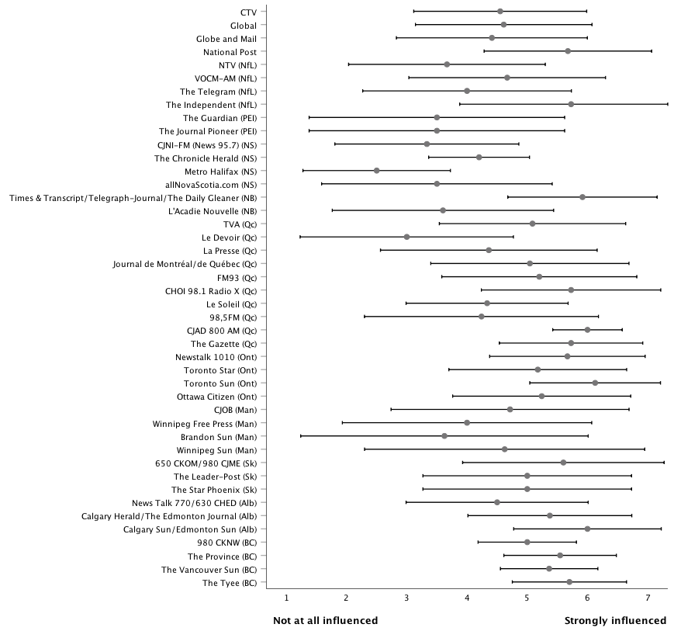
Note: Intervals represent one standard deviation below and above the mean.

The ideological orientation of the media
Figures B2.1 to B2.4 plot the mean scores and standard deviations in experts’ assessment of the coverage by each of these national and regional outlets, for each type of issue, from the left to the right on economic and social issues, and from the least favourable to the most favourable towards accommodating religious minorities and regarding Quebec issues. The midpoint – 4 – of the scale, which means balanced or neutral coverage, is highlighted by a vertical line.

Regarding economic issues, it is clear from a visual inspection of Figure B2.1 that experts locate most news media outlets on the right side of the ideological spectrum. This distribution of mean scores has the most distant mean (4.92) and median (5.00) values from the neutral or balanced point of the scale. Even the first quartile (4.45) is higher than the midpoint value (4). Radio-Canada (4.02) and the Winnipeg Free Press (4.13) are perceived as the closest to the centre of the spectrum. On opposite sides of the country, the average scores of The Tyee website (1.70) in BC and The Telegram (2.18) in Newfoundland and Labrador denote the most left-leaning content (with a large standard deviation in the latter case). Le Devoir (2.71) is third on the left of the spectrum. These are the only three out of 46 news media with an average score lower than 4 and at least one standard deviation distance from the balanced or neutral position (the Toronto Star (2.80) comes fourth with an interval barely crossing the middle line). Private talk radio stations, especially those in Quebec City, are among the most right-leaning. CHOI 98.1 Radio X (6.92) – which also has the smallest standard deviation –, the Toronto Sun (6.57), FM93 (6.55) and News Talk 770/630 CHED have the highest mean scores.

There is more diversity and more media outlets closer to the centre of the continuum regarding social issues (Figure B2.2). The first quartile (3.71) is slightly below the 4-point threshold whereas the third quartile has a value of 5.22, which still indicates that Canadian news media are perceived as leaning to the right side of the ideological spectrum. Once again, Quebec City radio stations CHOI 98.1 Radio X (6.77) and FM93 (6.00), the Toronto Sun (6.19), as well as its parent newspaper the Winnipeg Sun (6.14), have the highest mean scores. The Telegram (1.55), The Tyee (1.78), the Toronto Star (2.29), and Le Devoir (2.53) again appear to be the most progressive news media on social issues. The mean scores of CBC (2.93) and Radio-Canada (3.39) are also more left-wing, but within a one standard point distance from the neutral or balanced value of 4. The Independent (4.00), NTV (4.10) and VOCM-AM (3.78) in Newfoundland and Labrador, La Presse (4.06), CTV (4.08), and The Globe and Mail (4.10) appear closest to the centre on social issues.

It is on the religious diversity issues that the Canadian media landscape appears to be most scattered (Figure B2.3). The interquartile range (that is, the difference between the third and first quartiles) is the largest (1.68 points) among the four types of issues. Also, the median value of 4.00 points shows that media outlets are split equally on each side of the spectrum. The Leader-Post (4.00) and The StarPhoenix (4.00) in Saskatchewan, the Ottawa Citizen (4.00), VOCM-AM (3.89) in Newfoundland and Labrador, Global (4.13), the Winnipeg Free Press (4.13) and Le Soleil (3.85) in Quebec City are the closest to the centre. Three out of four media outlets perceived as the least favourable towards accommodating religious minorities are in Quebec – CHOI 98.1 Radio X (1.08), FM93 (1.91), Le Journal de Montréal/de Québec (2.05), with the Toronto Sun (2.13). The coverage of The Tyee (6.25) in BC, the Toronto Star (5.87), The Independent (5.70) in Newfoundland and Labrador, and CBC (5.52) is perceived as the most favourable towards accommodating religious minorities. Among the four types of issues, this is the one and only case where one of the two linguistic services of the Canadian public broadcaster is beyond one standard deviation from the middle point of the scale.

The fourth series of issues are those related to Quebec. Beyond the specific issue of sovereignist aspirations, Canadian politics is often punctuated by requests from the Quebec government to increase its jurisdiction in specific areas (for example, culture, immigration, income tax returns) and by inter-regional debates and struggles (for example, equalization, energy policies). Figure B2.4 shows a pattern which appears to follow the two solitudes principle. It is unsurprising that Quebec-based news media are the most favourable towards Quebec : the independent newspaper Le Devoir (6.07), the Quebecor-owned Le Journal de Montréal/de Québec (5.78) and TVA (5.41), as well as the 98.5FM (5.00) and Le Soleil (4.69) feature the highest scores. All news media with a score below 4 points are based in other provinces, with the exception of the English-language Montreal radio station CJAD (3.80). Various Sun newspapers – Winnipeg Sun (2.00), Toronto Sun (2.07), Calgary Sun/Edmonton Sun (2.33) – as well as the National Post (2.46), and some talk radio stations – 650 CKOM/980 CJME (2.00) in Saskatchewan, News Talk 770/630 CHED (2.00) in Alberta, and 980 CKNW (2.00) in British Columbia – have the lowest mean scores. That being said, Quebec issues are those for which there is the largest number of media outlets with mean scores in the centre of the scale : 20 news media are located between 3.50 and 4.50 points, compared with 10, 13 and 18 media outlets, respectively, on the scales of economic, social, and religious diversity issues.

Figure B2.1
Average perception of media’s coverage of economic issues

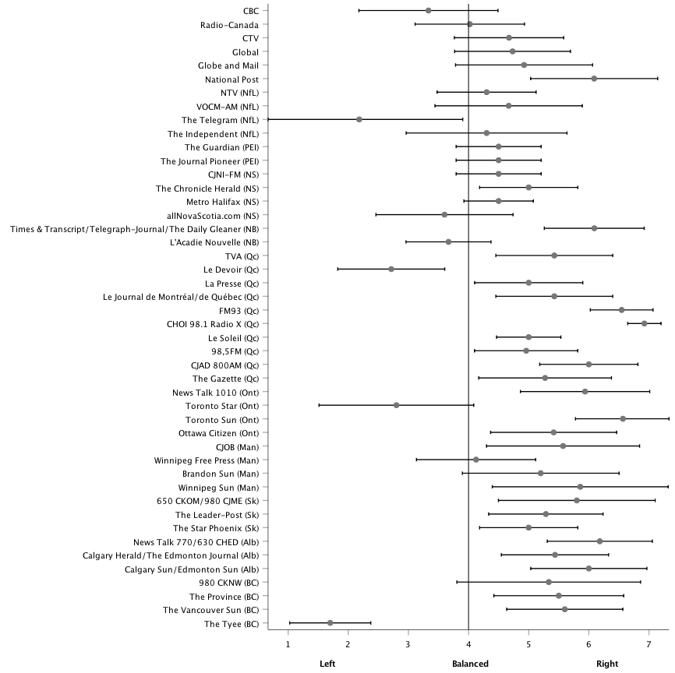

Figure B2.2
Average perception of media’s coverage of social issues

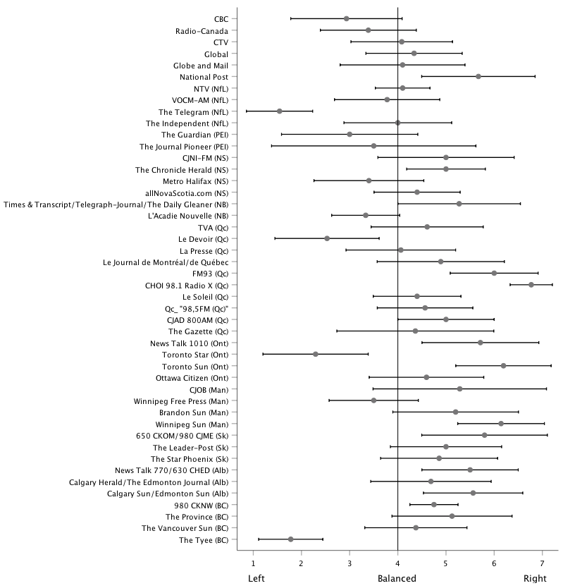

Figure B2.3
Average perception of media’s coverage of religious diversity issues

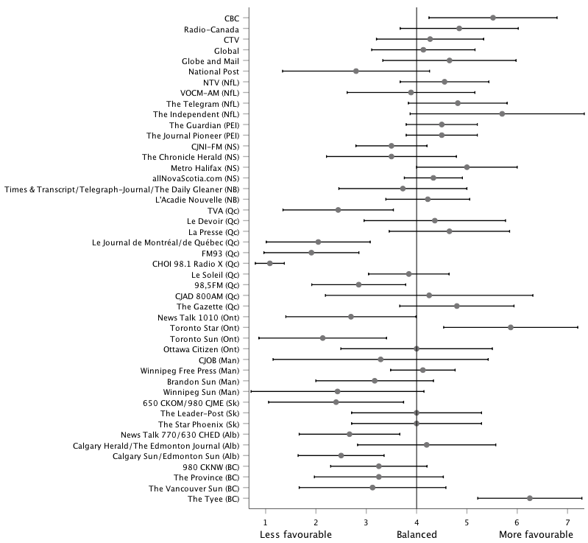

Figure B2.4
Average perception of media’s coverage of Quebec issues

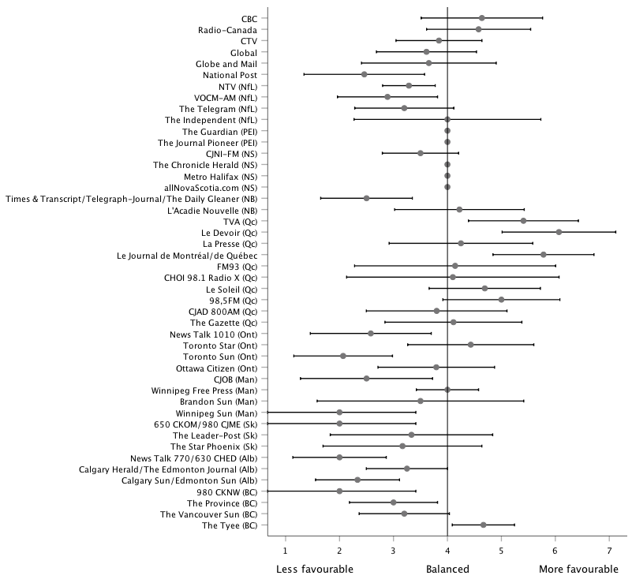

Media partisanship
Figure B3.1 plots the percentage of experts who identified a federal party each media agrees with most often. Among the 46 media outlets listed, two thirds of the experts (65.7 percent), on average, identified them with one of the federal parties. With a median value of 75.4 percent, it means that one half of these media outlets were perceived as agreeing more with a federal party by at least three quarters of the experts surveyed. CBC and Radio-Canada are below this average. No respondent identified The Guardian and The Journal-Pioneer in PEI, as well as Nova Scotia CJNI-FM News 95.7 station, with a federal party. However, the number of expert judgments for each of them was especially low (one or two responses).

Figure B3.2 plots the value of this partisanship index for each media outlet, regarding federal parties. Overall, there is a good range of variation among the 46 media outlets: the mean value of the partisanship index is .48, the first quartile is .24, the median is .43 and the third quartile is .75. The strongest perception of federal partisanship is observed for the Toronto Sun (1.0): among the 58 Ontarian experts who expressed a judgment about it, all indicated that it agrees most of the time with the Conservative Party of Canada. With a smaller number of respondents, Quebec City radio station FM93 also has the maximum score (1), while its competitor CHOI Radio X is close behind with a value of .92. The Calgary Sun/Edmonton Sun (.94), the National Post (.93), and Alberta News Talk 770 and 630 CHED radio stations (.90) are also perceived as strongly partisan. CBC and Radio-Canada are just slightly below the average: while more than one half of the experts do not perceive the national broadcaster close from any of the federal parties, almost all those who point out a political party select the same (the Liberal Party of Canada). For the opposite reason, in Quebec, Quebecor-owned Le Journal de Montréal/de Québec and TVA have low partisanship scores: a majority of the experts perceive them as close to one of the federal parties, but they disagree regarding which party (the Bloc Québécois, the Conservative Party or, to a lesser extent, the Liberal Party).

Figure B3.1
Percentage of experts identifying a federal party media agree with most often

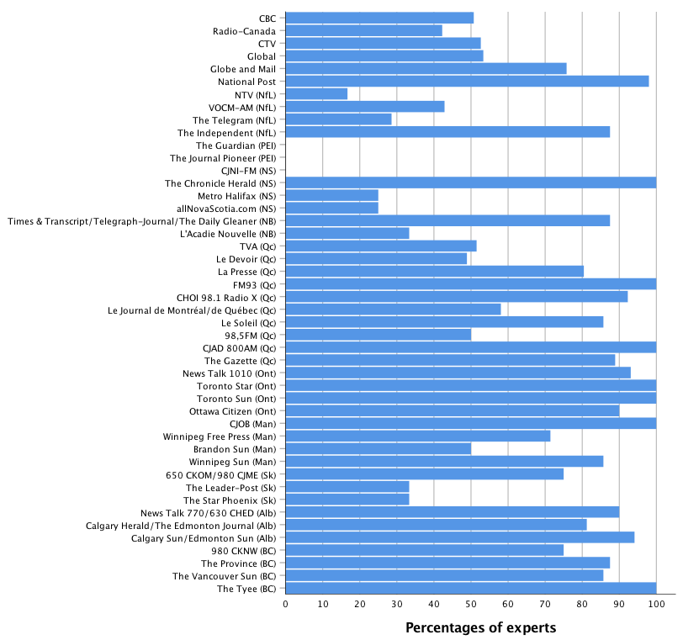

Figure B3.2
Federal partisanship index of the media

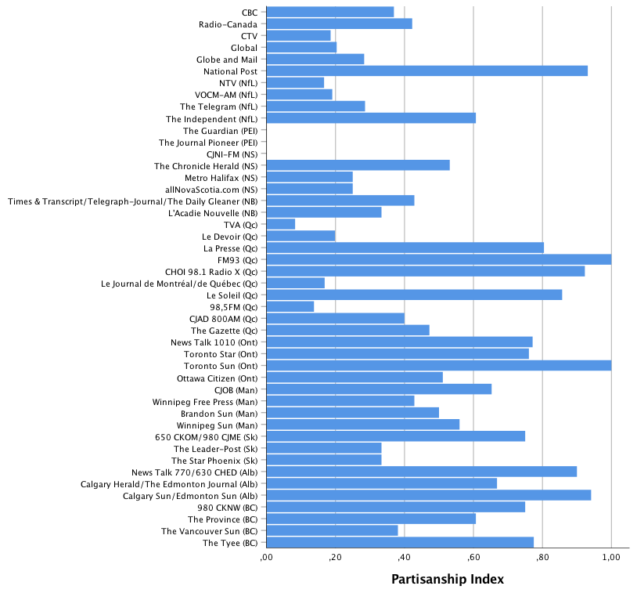

APPENDIX C
Robustness tests

Table C1.1
Perceptions of owners’ influence on political coverage (using the median value)

 | Owners’ influence
Quebec media | .14  (.38)
Private talk radio | .43  (.36)
Constant | 4.69  (.18) | ***
R² | .04
N | 44
*** p<.001 ** p<.01 * p<.05 † p<.10
Notes: Values are OLS regression coefficients; standard errors are in parentheses. The dependent variable is the median value on a 1-7 scale from Not influenced at all to Strongly influenced.

Table C1.2
Perceptions of owners’ influence on political coverage (media outlets with judgments made by at least 5 experts)

 | Impact of owners
Quebec media | -.02  (.33)
Private talk radio | .18  (.33)
Constant | 4.82  (.18) | ***
R² | .01
N | 39
*** p<.001 ** p<.01 * p<.05 † p<.10
Notes: Values are OLS regression coefficients; standard errors are in parentheses. The dependent variable is the mean value on a 1-7 scale from Not influenced at all to Strongly influenced.

Table C1.3
Perceptions of owners’ influence on political coverage (among experts reporting some exposure to each media outlet)

 | Impact of owners
Quebec media | .12  (.35)
Private talk radio | .19  (.33)
Constant | 4.66  (.18) | ***
R² | .01
N | 44
*** p<.001 ** p<.01 * p<.05 † p<.10
Notes: Values are OLS regression coefficients; standard errors are in parentheses. The dependent variable is the mean value on a 1-7 scale from Not influenced at all to Strongly influenced.

Table C1.4
Perceptions of owners’ influence on political coverage (Quebec media: contrasts Francophone media in Quebec to all other media)

 | Owners’ influence
Quebec media | -.16  (.37)
Private talk radio | .18  (.32)
Constant | 4.72  (.17) | ***
R² | .01
N | 44
*** p<.001 ** p<.01 * p<.05 † p<.10
Notes: Values are OLS regression coefficients; standard errors are in parentheses. The dependent variable is the mean value on a 1-7 scale from Not influenced at all to Strongly influenced.

Table C2.1
Perceptions of ideological leanings in media content (median values)

A. Economic issues |  |  |  |  |  |  | B. Social issues
 | Unbalanced model |  |  | Directional model |  |  |  | Unbalanced model |  |  | Directional model
Quebec media | .24  (.28) |  |  | .30  (.39) |  |  | Quebec media | -0.03  (.30) |  |  | .14  (.43)
Private talk radio | .47  (.26) | † |  | .87  (.37) | * |  | Private talk radio | .57  (.28) | † |  | 1.14  (.41) | **
Constant | 1.08  (.14) | *** |  | .65  (.20) | ** |  | Constant | .90  (.15) | *** |  | .11  (.22)
R² | .10 |  |  | .14 |  |  | R² | .09 |  |  | .17
N | 46 |  |  | 46 |  |  | N | 46 |  |  | 46
C. Religious diversity issues |  |  |  |  |  |  | D. Quebec issues
 | Unbalanced model |  |  | Directional model |  |  |  | Unbalanced model |  |  | Directional model
Quebec media | .46  (.30) |  |  | -.56  (.41) |  |  | Quebec media | -.06  (.30) |  |  | 1.45  (.32) | ***
Private talk radio | .02  (.28) |  |  | -.83  (.39) | * |  | Private talk radio | .40  (.28) |  |  | -.64  (.30) | *
Constant | .79  (.13) | *** |  | .14  (.21) |  |  | Constant | .70  (.15) | *** |  | -.59  (.16) | **
R² | .05 |  |  | .15 |  |  | R² | .05 |  |  | .35
N | 46 |  |  | 46 |  |  | N | 46 |  |  | 46
*** p<.001 ** p<.01 * p<.05 † p<.10
Notes: Values are OLS regression coefficients; standard errors are in parentheses. In unbalanced models, the dependent variable is the absolute difference of values between the balanced point and the observed median, ranging from 0 to 3 points. In the directional models, the dependent variable is the difference of values between the balanced point and the observed median, ranging from -3 to 3 points, that is, from left to right (economic and social issues), or from less favourable to more favourable (religious diversity and Quebec issues).

Table C2.2
Perceptions of ideological leanings in media content (media outlets with judgments made by at least 5 experts)

A. Economic issues |  |  |  |  |  |  | B. Social issues
 | Unbalanced model |  |  | Directional model |  |  |  | Unbalanced model |  |  | Directional model
Quebec media | .22  (.27) |  |  | .32  (.45) |  |  | Quebec media | -0.11  (.27) |  |  | .15  (.42)
Private talk radio | .40  (.27) |  |  | .82  (.45) | † |  | Private talk radio | .45  (.27) |  |  | .91  (.42) | *
Constant | 1.19  (.14) | *** |  | .65  (.23) | ** |  | Constant | .95  (.14) | *** |  | .21  (.22)
R² | .08 |  |  | .11 |  |  | R² | .07 |  |  | .12
N | 39 |  |  | 39 |  |  | N | 41 |  |  | 41
C. Religious diversity issues |  |  |  |  |  |  | D. Quebec issues
 | Unbalanced model |  |  | Directional model |  |  |  | Unbalanced model |  |  | Directional model
Quebec media | .38  (.28) |  |  | -.68  (.41) |  |  | Quebec media | -.15  (.26) |  |  | 1.62  (.30) | ***
Private talk radio | .35  (.28) |  |  | -1.17  (.41) | ** |  | Private talk radio | -.01  (.27) |  |  | -.61  (.31) | †
Constant | .80  (.14) | *** |  | .18  (.21) |  |  | Constant | .93  (.15) | *** |  | -.64  (.17) | **
R² | .10 |  |  | .26 |  |  | R² | .01 |  |  | .50
N | 39 |  |  | 39 |  |  | N | 34 |  |  | 34
*** p<.001 ** p<.01 * p<.05 † p<.10
Notes: Values are OLS regression coefficients; standard errors are in parentheses. In unbalanced models, the dependent variable is the absolute difference of values between the balanced point and the observed mean, ranging from 0 to 3 points. In the directional models, the dependent variable is the difference of values between the balanced point and the observed mean, ranging from -3 to 3 points, that is, from left to right (economic and social issues), or from less favourable to more favourable (religious diversity and Quebec issues).

Table C2.3
Perceptions of ideological leanings in media content (among experts reporting some exposure to each media outlet)

A. Economic issues |  |  |  |  |  |  | B. Social issues
 | Unbalanced model |  |  | Directional model |  |  |  | Unbalanced model |  |  | Directional model
Quebec media | .24  (.27) |  |  | .30  (.41) |  |  | Quebec media | -0.14  (.26) |  |  | .12  (.39)
Private talk radio | .45  (.26) | † |  | .84  (.39) | * |  | Private talk radio | .46  (.25) | † |  | 1.12  (.38) | **
Constant | 1.12  (.13) | *** |  | .65  (.20) | ** |  | Constant | .89  (.13) | *** |  | .07  (.20)
R² | .10 |  |  | .12 |  |  | R² | .08 |  |  | .19
N | 45 |  |  | 45 |  |  | N | 44 |  |  | 44
C. Religious diversity issues |  |  |  |  |  |  | D. Quebec issues
 | Unbalanced model |  |  | Directional model |  |  |  | Unbalanced model |  |  | Directional model
Quebec media | .28  (.26) |  |  | -.37  (.41) |  |  | Quebec media | -.16  (.28) |  |  | 1.52  (.30) | ***
Private talk radio | .30  (.25) |  |  | -.95  (.39) | * |  | Private talk radio | .38  (.26) |  |  | -.94  (.29) | **
Constant | .83  (.13) | *** |  | .08  (.20) |  |  | Constant | .78  (.13) | *** |  | -.48  (.16) | **
R² | .07 |  |  | .16 |  |  | R² | .05 |  |  | .43
N | 45 |  |  | 45 |  |  | N | 45 |  |  | 45
*** p<.001 ** p<.01 * p<.05 † p<.10
Notes: Values are OLS regression coefficients; standard errors are in parentheses. In unbalanced models, the dependent variable is the absolute difference of values between the balanced point and the observed mean, ranging from 0 to 3 points. In the directional models, the dependent variable is the difference of values between the balanced point and the observed mean, ranging from -3 to 3 points, that is, from left to right (economic and social issues), or from less favourable to more favourable (religious diversity and Quebec issues).

Table C2.4
Perceptions of ideological leanings in media content (Quebec media: contrasts Francophone media in Quebec to all other media)

A. Economic issues |  |  |  |  |  |  | B. Social issues
 | Unbalanced model |  |  | Directional model |  |  |  | Unbalanced model |  |  | Directional model
Quebec media | .32  (.27) |  |  | .30  (.43) |  |  | Quebec media | 0.06  (.27) |  |  | .22  (.43)
Private talk radio | .37  (.23) |  |  | .77  (.37) | * |  | Private talk radio | .35  (.24) |  |  | .90  (.37) | *
Constant | 1.11  (.13) | *** |  | .66  (.20) | ** |  | Constant | .91  (.13) | *** |  | .17  (.20)
R² | .09 |  |  | .11 |  |  | R² | .05 |  |  | .13
N | 46 |  |  | 46 |  |  | N | 46 |  |  | 46
C. Religious diversity issues |  |  |  |  |  |  | D. Quebec issues
 | Unbalanced model |  |  | Directional model |  |  |  | Unbalanced model |  |  | Directional model
Quebec media | .53  (.27) | † |  | -.94  (.38) | * |  | Quebec media | .12  (.27) |  |  | 1.66  (.29) | ***
Private talk radio | .20  (.23) |  |  | -.96  (.33) | ** |  | Private talk radio | .29  (.23) |  |  | -.73  (.25) | **
Constant | .75  (.12) | *** |  | .20  (.18) |  |  | Constant | .70  (.13) | *** |  | -.46  (.14) | **
R² | .11 |  |  | .28 |  |  | R² | .04 |  |  | .47
N | 46 |  |  | 46 |  |  | N | 46 |  |  | 46
*** p<.001 ** p<.01 * p<.05 † p<.10
Notes: Values are OLS regression coefficients; standard errors are in parentheses. In unbalanced models, the dependent variable is the absolute difference of values between the balanced point and the observed mean, ranging from 0 to 3 points. In the directional models, the dependent variable is the difference of values between the balanced point and the observed mean, ranging from -3 to 3 points, that is, from left to right (economic and social issues), or from less favourable to more favourable (religious diversity and Quebec issues).

Table C3.1
Perceptions of media partisanship (media outlets with judgments made by at least 5 experts)

A. Federal Parties
 | % indicating agreement with any party |  |  | Partisanship Index
Quebec media | 3.18  (9.79) |  |  | -.04  (.11)
Private talk radio | 6.91  (10.14) |  |  | .11  (.11)
Constant | 69.64  (5.31) | *** |  | .50  (.06) | ***
R² | .02 |  |  | .03
N | 37 |  |  | 37
B. Provincial Parties
 | % indicating agreement with any party |  |  | Partisanship Index |  |  |  | % indicating agreement with any party |  |  | Partisanship Index
Quebec media | 18.57  (9.03) | * |  | .10  (.11) |  |  | Quebec media | 9.08  (8.72) |  |  | .03  (.11)
Private talk radio | 11.80  (9.03) |  |  | .23  (.11) | * |  | Private talk radio | 2.30  (8.72) |  |  | .15  (.11)
 |  |  |  |  |  |  | CBC | -32.98 | ** |  | -.32 | **
 |  |  |  |  |  |  |  | (9.36) |  |  | (.12)
 |  |  |  |  |  |  | CTV | -20.29 | † |  | -.22 | †
 |  |  |  |  |  |  |  | (10.39) |  |  | (.13)
 |  |  |  |  |  |  | Global | -19.60 | † |  | -.14
 |  |  |  |  |  |  |  | (10.39) |  |  | (.13)
 |  |  |  |  |  |  | Globe and Mail | -25.15 | ** |  | -.22 | †
 |  |  |  |  |  |  |  | (9.36) |  |  | (.12)
 |  |  |  |  |  |  | National Post | 1.83 |  |  | .10
 |  |  |  |  |  |  |  | (9.36) |  |  | (.12)
Constant | 61.69  (3.33) | *** |  | .45  (.04) | *** |  | Constant | 74.35  (5.14) | *** |  | .55  (.06) | ***
R² | .10 |  |  | .09 |  |  | R² | .33 |  |  | .27
N | 68 |  |  | 68 |  |  | N | 68 |  |  | 68
*** p<.001 ** p<.01 * p<.05 † p<.10

Table C3.2
Perceptions of media partisanship (among experts reporting some exposure to each media outlet)

A. Federal Parties
 | % indicating agreement with any party |  |  | Partisanship Index
Quebec media | 11.24  (11.70) |  |  | .02  (.11)
Private talk radio | 6.62  (10.99) |  |  | .11  (.10)
Constant | 60.36  (5.91) | *** |  | .44  (.06) | ***
R² | .03 |  |  | .03
N | 46 |  |  | 46
B. Provincial Parties
 | % indicating agreement with any party |  |  | Partisanship Index |  |  |  | % indicating agreement with any party |  |  | Partisanship Index
Quebec media | 25.76  (10.38) | * |  | .18  (.11) |  |  | Quebec media | 15.14  (9.80) |  |  | .09  (.10)
Private talk radio | 10.79  (9.60) |  |  | .21  (.10) | * |  | Private talk radio | -1.02  (9.25) |  |  | .12  (.10)
 |  |  |  |  |  |  | CBC | -36.75 | *** |  | -.33 | *
 |  |  |  |  |  |  |  | (10.00) |  |  | (.10)
 |  |  |  |  |  |  | CTV | -26.45 | * |  | -.27 | *
 |  |  |  |  |  |  |  | (10.00) |  |  | (.10)
 |  |  |  |  |  |  | Global | -24.36 | * |  | -.15
 |  |  |  |  |  |  |  | (10.00) |  |  | (.10)
 |  |  |  |  |  |  | Globe and Mail | -31.24 | ** |  | -.27 | *
 |  |  |  |  |  |  |  | (10.00) |  |  | (.10)
 |  |  |  |  |  |  | National Post | 3.91 |  |  | .11
 |  |  |  |  |  |  |  | (10.00) |  |  | (.10)
Constant | 54.59  (3.44) | *** |  | .41  (.04) | *** |  | Constant | 69.94  (5.36) | *** |  | .53  (.06) | ***
R² | .10 |  |  | .10 |  |  | R² | .32 |  |  | .30
N | 91 |  |  | 91 |  |  | N | 91 |  |  | 91
*** p<.001 ** p<.01 * p<.05 † p<.10

Table C3.3
Perceptions of media partisanship (Quebec media: contrasts Francophone media in Quebec to all other media)

A. Federal Parties
 | % indicating agreement with any party |  |  | Partisanship Index
Quebec media | 5.38  (12.22) |  |  | .03  (.12)
Private talk radio | 6.62  (10.55) |  |  | .11  (.10)
Constant | 63.00  (5.65) | *** |  | .45  (.05) | ***
R² | .02 |  |  | .03
N | 46 |  |  | 46
B. Provincial Parties
 | % indicating agreement with any party |  |  | Partisanship Index |  |  |  | % indicating agreement with any party |  |  | Partisanship Index
Quebec media | 24.19  (11.14) | * |  | .10  (.11) |  |  | Quebec media | 13.67  (10.39) |  |  | .01  (.11)
Private talk radio | 14.43  (9.32) |  |  | .25  (.10) | ** |  | Private talk radio | 1.80  (9.05) |  |  | .15  (.09)
 |  |  |  |  |  |  | CBC | -36.03 | *** |  | -.34 | **
 |  |  |  |  |  |  |  | (9.80) |  |  | (.10)
 |  |  |  |  |  |  | CTV | -27.52 | ** |  | -.26 | *
 |  |  |  |  |  |  |  | (9.80) |  |  | (.10)
 |  |  |  |  |  |  | Global | -25.43 | * |  | -.16
 |  |  |  |  |  |  |  | (9.80) |  |  | (.10)
 |  |  |  |  |  |  | Globe and Mail | -29.76 | * |  | -.25 | *
 |  |  |  |  |  |  |  | (9.80) |  |  | (.10)
 |  |  |  |  |  |  | National Post | 3.49 |  |  | .12
 |  |  |  |  |  |  |  | (9.80) |  |  | (.10)
Constant | 53.87  (3.37) | *** |  | .40  (.03) | *** |  | Constant | 69.12  (5.20) | *** |  | .52  (.05) | ***
R² | .09 |  |  | .10 |  |  | R² | .31 |  |  | .31
N | 91 |  |  | 91 |  |  | N | 91 |  |  | 91
*** p<.001 ** p<.01 * p<.05 † p<.10

Works cited in the supplementary material

Bakker, Ryan, Catherine de Vries, Erica Edwards, Liesbet Hooghe, Seth Jolly, Gary Marks, Jonathan Polk, Jan Rovny, Marco Steenbergen and Milada Anna Vachudova. 2015. “Measuring party positions in Europe: The Chapel Hill expert survey trend file, 1999-2010.” Party Politics 21 (1): 143-152.

Huber, John and Ronald Inglehart. 1995. “Expert Interpretations of Party Space and Party Locations in 42 Societies.” Party Politics 1 (1): 73-111.

Benoit, Kenneth and Michael Laver. 2006. Party Policy in Modern Democracies. New York: Routledge.

Curini, Luigi. 2010. “Experts’ Political Preferences and their Impact on Ideological Bias.” Party Politics 16 (3): 299-321.

Maurer, Peter and Miika Vähämaa. 2014. “Methods and Challenges of Comparative Surveys of Political Communication Elites.” In Political Communication Cultures in Europe, ed. Barbara Pfetsch. New York: Palgrave.

Nai, Alessandro, Ferran Martínez i Coma and Jürgen Maier. 2019. “Donald Trump, Populism, and the Age of Extremes: Comparing the Personality Traits and Campaigning Styles of Trump and Other Leaders Worldwide.” Presidential Studies Quarterly 49 (3): 609-43.

Numeris. 2017a. Radio Market Ranking – PPM Topline (February 27, 2017 to May 28, 2017). https://urlzs.com/XMkxh (February 28, 2020)

Numeris. 2017b. Statistiques de base pour la radio. Printemps 2017 (27 février au 23 avril 2017). http://assets.numeris.ca/Downloads/2017_Spring_Radio_DI_ToplineReport_FR.pdf (February 28, 2020)

Pfetsch, Barbara, Eva Mayerhöffer and Tom Moring. 2014. “National or Professional? Types of Political Communication Culture across Europe.” In Political Communication Cultures in Europe, ed. Barbara Pfetsch. New York: Palgrave.

Popescu, Marina (with Gabor Toka, Tania Gosselin and Jose Santana Pereira). 2011. “European Media Systems Survey 2010: Results and Documentation.” Research Report. Colchester, UK: Department of Government. University of Essex. www.mediasystemsineurope.org (February 28, 2020).

Ray, Leonard. 1999. “Measuring party orientations towards European Integration: Results From an expert survey.” European Journal of Political Research 36 (2): 283-306.

See https://ces-eec.arts.ubc.ca/english-section/surveys/
In Quebec, we had three versions of the questionnaire: two (in French and in English) for the Montreal area, and a third one in French for Quebec City, each with specific regional media outlets.
We would like to acknowledge the input from Alex Marland (NF&L), Blake Andrew (PEI), Kelly Toughill (NS), J.P. Lewis (NB), April Lindgren (Ont), Shannon Sampert (Man), David McGrane and Loleen Berdahl (Sask), Linda Trimble (Alb), and Fred Cutler (BC). We take full responsibility for the final decisions.
Questions specific to Radio-Canada were asked only in Quebec. While French-language questionnaires were sent to Francophone respondents in New Brunswick, Ontario, and Manitoba, these versions only included the CBC. In the comments section, as well as in private e-mails sent to the survey managers, some respondents noted the important differences between Radio-Canada and CBC. Our current design does not do justice to them.
Renamed StarMetro Halifax, which ceased publication in December 2019.

