Online Appendices
To test the robustness of the findings, we challenge our models in several ways. First, our demonstration is based on analysis of performance voting that uses an indicator of citizens’ evaluations of government performance in general. However, most previous research in the field of retrospective voting and work on the moderating role of clarity of responsibility has studied the effects of economic perceptions. We would have liked to replicate the results in Table 1 of the manuscript when replacing the general performance measure for a measure of respondents’ retrospective and sociotropic economic evaluations. However, such a measure is not included in the second and third module of the CSES – which are the modules used for the analyses reported in Table 1. Fortunately, the first and fourth module of the CSES project did include such an item of citizens’ economic perceptions, and can hence be used to test whether our results are confirmed using evaluations of the economy. Appendix C reports the results of these analyses, using the data from the first and fourth modules of the CSES project. The results are in line with the findings reported in the main text: more positive economic evaluations positively affect the likelihood of voting for the incumbent, and this effect is strengthened when the polarisation of available alternatives increases.
Second, we tested the robustness of the results that are reported in Table 1 of the manuscript when slightly changing the coding of different key variables. Focusing on our key independent variable first, to construct our indicator of the polarization of the alternatives we make use average positions of every party (see Equation 1). However, the variation in perceived party positions provides a useful source of individual-level variation. Hence, we also estimated the models using each voter’s individual perceptions of the ideological position of the parties. The results of these analyses are reported in Appendix D. Surprisingly, the coefficients are smaller than those reported in Table 1. However, our conclusions still hold when using this alternative measure, as the interaction between performance evaluations and the perceived polarisation of available alternatives remains statistically significant. Second, the overall cohesion of the government parties has a mechanical effect on our polarisation measure: the more ideologically diverse the government is, the more likely it is that the mean position of the government is close to several opposition parties. While we control for this to some extent in the main models – as government cohesion is part of the clarity of responsibility index – including this element in a broader index might blur its effect. Therefore, we replicated our analyses using only the indicator of the cohesion of the government as a control for the clarity of responsibility. The results, reported in Appendix E, are in line with the conclusions presented in the main text. Third, the models include different covariates to control for their impact on the vote, but for most of these variables, we expect different directions of effects depending on the ideological leanings of the incumbent parties. As a robustness test, we therefore also conducted the analyses while adjusting the direction of the coding of the variables to the ideological position of the main incumbent party (see Nadeau, Lewis-Beck, & Bélanger, 2012). The results, reported in Appendix F, are largely in line with the conclusions reported in the main text; the main difference is that the interaction between performance evaluations and clarity of responsibility (as reported in Model 3 of Table 1) turns statistically significant.
We also tested whether our results hold in different subgroups. As previous research has indicated the important role of political sophistication in retrospective voting (de Vries & Giger, 2014), we replicated our analyses for the least- and most-knowledgeable groups separately. The results, reported in Appendix G, are in line with the results reported in the main text in both groups of voters.
Finally, as indicated in the main text, we control for endogeneity in perceptions of government performance using the method introduced by Duch, Palmer, and Anderson (2000) and Duch and Stevenson (2008). The results are summarised in Appendix H.

Appendix A: Election studies included in the analyses
Table 1: Election studies included in the analyses

Country | Year
Australia | 2004, 2007
Austria | 2008
Bulgaria | 2001
Canada | 2004, 2008
Croatia | 2007
Czech Republic | 2002, 2006, 2010
Germany | 2002, 2005, 2009
Denmark | 2001
Spain | 2004, 2008
Estonia | 2011
Finland | 2003, 2007, 2011
France | 2007
Great Britain | 2005
Greece | 2009
Hungary | 2002
Ireland | 2002, 2007
Iceland | 2003, 2007, 2009
Israel | 2006
Italy | 2006
the Netherlands | 2002
New Zealand | 2002, 2008
Poland | 2001, 2005, 2007
Portugal | 2002, 2005, 2009
Romania | 2004
Slovakia | 2008
Slovenia | 2004, 2008
Sweden | 2002, 2006
Switzerland | 2003, 2007
Turkey | 2001
United States of America | 2004, 2008

Appendix B: Results including party ID with incumbent
Table B.1: Replication of Table 1 in the text including incumbent party identification
 | (1) | (2) | (3) | (4)
 | B | B | B | B
Sex (ref.=male) | 0.064* | 0.071* | 0.074* | 0.071*
 | (0.031) | (0.032) | (0.033) | (0.032)
Age | 0.005*** | 0.006*** | 0.005*** | 0.006***
 | (0.001) | (0.001) | (0.001) | (0.001)
Education (ref.=no secondary)
Education: secondary | -0.061 | -0.087 | -0.153** | -0.087
 | (0.046) | (0.047) | (0.048) | (0.047)
Education: post-secondary | -0.054 | -0.050 | -0.084 | -0.051
 | (0.051) | (0.052) | (0.053) | (0.052)
Education: university | -0.020 | -0.021 | -0.076 | -0.021
 | (0.048) | (0.049) | (0.050) | (0.049)
Income | 0.052*** | 0.049*** | 0.047*** | 0.049***
 | (0.012) | (0.013) | (0.013) | (0.013)
Religion | -0.046** | -0.039** | -0.040** | -0.039**
 | (0.015) | (0.015) | (0.015) | (0.015)
Ideological position | 0.027*** | 0.036*** | 0.037*** | 0.036***
 | (0.007) | (0.007) | (0.007) | (0.007)
Incumbent PID | 3.723*** | 3.627*** | 3.641*** | 3.626***
 | (0.040) | (0.041) | (0.042) | (0.041)
Performance evaluation | 0.947*** | 0.724*** | 0.652* | 1.227***
 | (0.025) | (0.177) | (0.260) | (0.366)
Polarisation of alternatives | -0.023 | -0.028 | -0.025 | -0.025
 | (0.019) | (0.018) | (0.018) | (0.018)
Evaluation × polarisation |  | 0.032* | 0.030* | 0.028*
 |  | (0.014) | (0.013) | (0.014)
Clarity of responsibility |  |  | -0.743
 |  |  | (0.470)
Evaluation × clarity |  |  | 0.238
 |  |  | (0.335)
ENPP |  |  |  | 0.086
 |  |  |  | (0.106)
Evaluation × ENPP |  |  |  | -0.122
 |  |  |  | (0.078)
Constant | -1.660*** | -1.608*** | -1.106** | -1.959***
 | (0.247) | (0.237) | (0.367) | (0.496)
N (individuals) | 37230 | 37230 | 35274 | 37230
N (groups) | 52 | 52 | 50 | 52
Var(constant) | 0.873*** | 0.801*** | 0.738*** | 0.791***
 | (0.176) | (0.163) | (0.154) | (0.161)
Var(evaluation) |  | 0.417*** | 0.332*** | 0.398***
 |  | (0.091) | (0.076) | (0.087)
AIC | 27649.250 | 26904.541 | 25713.079 | 26905.533
BIC | 27760.073 | 27032.414 | 25857.085 | 27050.456
Note: Entries are log-odds coefficients, standard errors reported in parentheses. Data: CSES Module 2 and 3. Significance levels: *: p < 0.05; **: p < 0.01; ***: p < 0.001.
Appendix C: replication of the results using economic perceptions

Table C.1: Replication of Table 1 in the text using economic evaluations
 | (1) | (2) | (3) | (4)
 | B | B | B | B
 | (s.e.) | (s.e.) | (s.e.) | (s.e.)
Sex (ref.=male) | 0.165*** | 0.158*** | 0.158*** | 0.158***
 | (0.026) | (0.026) | (0.026) | (0.026)
Age | 0.005*** | 0.005*** | 0.005*** | 0.005***
 | (0.001) | (0.001) | (0.001) | (0.001)
Education (ref.=primary)
Education: secondary | -0.063 | -0.074* | -0.075* | -0.074*
 | (0.037) | (0.037) | (0.037) | (0.037)
Education: tertiary | -0.098** | -0.115*** | -0.116*** | -0.115***
 | (0.034) | (0.035) | (0.035) | (0.035)
Income | 0.058*** | 0.055*** | 0.055*** | 0.055***
 | (0.010) | (0.010) | (0.010) | (0.010)
Religion | -0.096*** | -0.097*** | -0.097*** | -0.097***
 | (0.010) | (0.010) | (0.010) | (0.010)
Ideological position | 0.048*** | 0.041*** | 0.041*** | 0.041***
 | (0.005) | (0.006) | (0.006) | (0.006)
Economic evaluation | 0.548*** | 0.357*** | 0.048 | 0.950***
 | (0.015) | (0.089) | (0.200) | (0.183)
Polarisation of alternatives | -0.004 | -0.006 | -0.006 | -0.009
 | (0.015) | (0.015) | (0.014) | (0.015)
Economy × polarisation |  | 0.021** | 0.023** | 0.017*
 |  | (0.008) | (0.008) | (0.007)
Clarity of responsibility |  |  | -0.012
 |  |  | (0.453)
Economy × clarity |  |  | 0.503*
 |  |  | (0.256)
ENPP |  |  |  | -0.101
 |  |  |  | (0.091)
Economy × ENPP |  |  |  | -0.144***
 |  |  |  | (0.041)
Constant | -0.520** | -0.487** | -0.415 | -0.067
 | (0.175) | (0.174) | (0.348) | (0.413)
N (individuals) | 29469 | 29469 | 29469 | 29469
N (groups) | 32 | 32 | 32 | 32
Var(constant) | 0.408*** | 0.405*** | 0.352*** | 0.389***
 | (0.105) | (0.104) | (0.085) | (0.100)
Var(evaluation) |  | 0.101*** | 0.112*** | 0.069***
 |  | (0.028) | (0.030) | (0.020)
AIC | 35913.182 | 35466.451 | 35461.376 | 35458.651
BIC | 36004.384 | 35574.235 | 35585.742 | 35583.018
Note: Entries are log-odds coefficients, standard errors reported in parentheses. Data: CSES module 1 and 4. Significance levels: *: p < 0.05; **: p < 0.01; ***: p < 0.001.

Figure C.1: Average marginal effect of economic performance evaluations at different values of ideological polarisation between government and opposition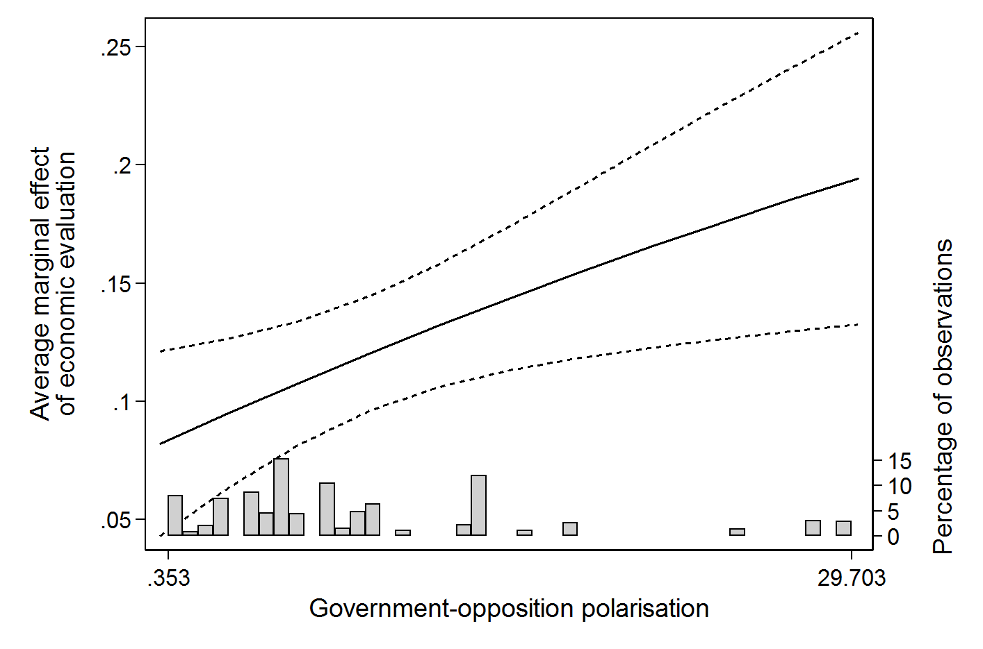
Note: the figure shows the average marginal effect and 95% confidence intervals of retrospective economic performance evaluations based on Model 2 in Table C.1. Data: CSES 1, CSES 4.

Appendix D: Results using individual perceptions of parties’ positions

Table D.1: Replication of Table 1 in the text using individual perceptions of parties’ positions
 | (1) | (2) | (3) | (4)
 | B | B | B | B
 | (s.e.) | (s.e.) | (s.e.) | (s.e.)
Sex (ref.=male) | 0.036 | 0.037 | 0.032 | 0.037
 | (0.025) | (0.025) | (0.026) | (0.025)
Age | 0.009*** | 0.010*** | 0.010*** | 0.010***
 | (0.001) | (0.001) | (0.001) | (0.001)
Education (ref.=no secondary)
Education: secondary | 0.010 | 0.012 | -0.087* | 0.012
 | (0.036) | (0.036) | (0.038) | (0.036)
Education: post-secondary | 0.013 | 0.014 | -0.039 | 0.014
 | (0.041) | (0.041) | (0.042) | (0.041)
Education: university | -0.013 | -0.011 | -0.080* | -0.008
 | (0.038) | (0.038) | (0.039) | (0.038)
Income | 0.093*** | 0.093*** | 0.082*** | 0.093***
 | (0.010) | (0.010) | (0.010) | (0.010)
Religion | 0.023 | 0.022 | 0.022 | 0.021
 | (0.012) | (0.012) | (0.012) | (0.012)
Ideological position | 0.047*** | 0.045*** | 0.058*** | 0.044***
 | (0.005) | (0.005) | (0.006) | (0.005)
Performance evaluation | 1.302*** | 1.141*** | 1.014*** | 1.457***
 | (0.020) | (0.029) | (0.063) | (0.073)
Polarisation of alternatives | 0.005*** | 0.004*** | 0.004*** | 0.004***
 | (0.001) | (0.001) | (0.001) | (0.001)
Evaluation × polarisation |  | 0.008*** | 0.010*** | 0.006***
 |  | (0.001) | (0.001) | (0.001)
Clarity of responsibility |  |  | -1.266**
 |  |  | (0.401)
Evaluation × clarity |  |  | 0.479***
 |  |  | (0.094)
ENPP |  |  |  | 0.130
 |  |  |  | (0.090)
Evaluation × ENPP |  |  |  | -0.080***
 |  |  |  | (0.017)
Constant | -0.748*** | -0.724*** | 0.098 | -1.213***
 | (0.114) | (0.114) | (0.271) | (0.352)
N (individuals) | 35892 | 35892 | 33920 | 35892
N (groups) | 52 | 52 | 50 | 52
Var(constant) | 0.624*** | 0.622*** | 0.541*** | 0.596***
 | (0.127) | (0.126) | (0.113) | (0.121)
AIC | 39863.616 | 39810.027 | 36653.576 | 39790.280
BIC | 39965.475 | 39920.374 | 36780.052 | 39917.604
Note: Entries are log-odds coefficients, standard errors reported in parentheses. Data: CSES Module 2 and 3. Significance levels: *: p < 0.05; **: p < 0.01; ***: p < 0.001.

Figure D.1: Average marginal effect of performance evaluations at different values of ideological polarisation between government and opposition
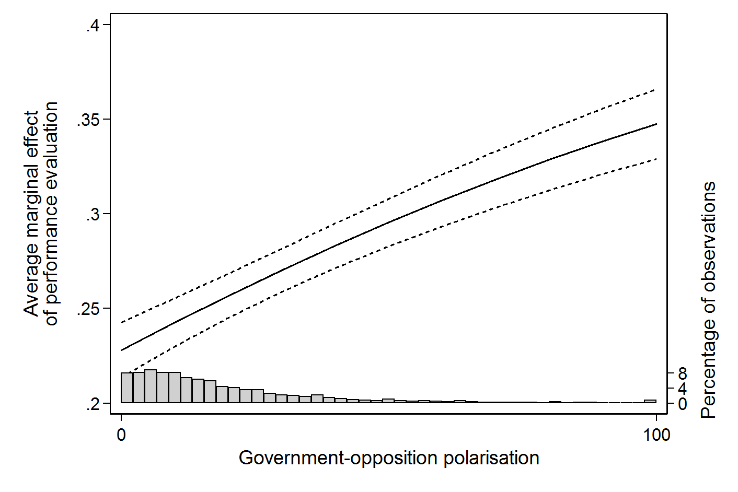
Note: the figure shows the average marginal effect and 95% confidence intervals of retrospective performance evaluations based on Model 2 in Table D.1. Data: CSES 2, CSES 3.

Appendix E: Results using only government cohesion as measure of clarity
Table E.1: Replication of Table 1 in the text with cohesion as indicator of clarity
 | (1) | (2) | (3) | (4)
 | B | B | B | B
 | (s.e.) | (s.e.) | (s.e.) | (s.e.)
Sex (ref.=male) | 0.023 | 0.029 | 0.030 | 0.030
 | (0.022) | (0.023) | (0.023) | (0.023)
Age | 0.009*** | 0.010*** | 0.010*** | 0.010***
 | (0.001) | (0.001) | (0.001) | (0.001)
Education (ref.=no secondary)
Education: secondary | -0.026 | -0.053 | -0.054 | -0.054
 | (0.032) | (0.033) | (0.033) | (0.033)
Education: post-secondary | -0.034 | -0.041 | -0.041 | -0.041
 | (0.036) | (0.037) | (0.037) | (0.037)
Education: university | -0.002 | -0.006 | -0.006 | -0.006
 | (0.034) | (0.036) | (0.036) | (0.036)
Income | 0.088*** | 0.084*** | 0.084*** | 0.084***
 | (0.009) | (0.009) | (0.009) | (0.009)
Religion | 0.026* | 0.031** | 0.031** | 0.031**
 | (0.010) | (0.011) | (0.011) | (0.011)
Ideological position | 0.044*** | 0.059*** | 0.059*** | 0.059***
 | (0.005) | (0.005) | (0.005) | (0.005)
Performance evaluation | 1.294*** | 0.989*** | -0.093 | 1.830***
 | (0.018) | (0.207) | (0.547) | (0.419)
Polarisation of alternatives | -0.025 | -0.035* | -0.028 | -0.032*
 | (0.015) | (0.015) | (0.015) | (0.015)
Evaluation × polarisation |  | 0.051** | 0.044** | 0.044**
 |  | (0.016) | (0.016) | (0.016)
Government cohesion |  |  | -1.324*
 |  |  | (0.555)
Evaluation × cohesion |  |  | 1.279*
 |  |  | (0.602)
ENPP |  |  |  | 0.086
 |  |  |  | (0.088)
Evaluation × ENPP |  |  |  | -0.205*
 |  |  |  | (0.090)
Constant | -0.339 | -0.290 | 0.831 | -0.640
 | (0.199) | (0.195) | (0.506) | (0.408)
N (individuals) | 45012 | 45012 | 45012 | 45012
N (groups) | 52 | 52 | 52 | 52
Var(constant) | 0.581*** | 0.555*** | 0.500*** | 0.545***
 | (0.117) | (0.113) | (0.102) | (0.111)
Var(evaluation) |  | 0.619*** | 0.567*** | 0.562***
 |  | (0.127) | (0.117) | (0.115)
AIC | 50229.280 | 47739.479 | 47733.806 | 47737.621
BIC | 50333.856 | 47861.485 | 47873.241 | 47877.056
Note: Entries are log-odds coefficients, standard errors reported in parentheses. Data: CSES Module 2 and 3. Significance levels: *: p < 0.05; **: p < 0.01; ***: p < 0.001.

Appendix F: Results using adjusted control variables

Table F.1: Replication of Table 1 in the text with adjusted control variables
 | (1) | (2) | (3) | (4)
 | B | B | B | B
 | (s.e.) | (s.e.) | (s.e.) | (s.e.)
Sex (ref.=male) | -0.001 | 0.001 | -0.001 | 0.001
 | (0.022) | (0.023) | (0.024) | (0.023)
Age | 0.003*** | 0.004*** | 0.003*** | 0.004***
 | (0.001) | (0.001) | (0.001) | (0.001)
Education (ref.=no secondary)
Education: secondary | 0.001 | -0.023 | -0.082* | -0.023
 | (0.033) | (0.034) | (0.035) | (0.034)
Education: post-secondary | -0.021 | -0.028 | -0.061 | -0.028
 | (0.036) | (0.037) | (0.038) | (0.037)
Education: university | 0.114** | 0.116** | 0.071 | 0.116**
 | (0.035) | (0.036) | (0.037) | (0.036)
Income | 0.055*** | 0.050*** | 0.042*** | 0.050***
 | (0.009) | (0.009) | (0.009) | (0.009)
Religion | 0.039*** | 0.044*** | 0.044*** | 0.044***
 | (0.011) | (0.011) | (0.011) | (0.011)
Ideological position | 0.200*** | 0.202*** | 0.216*** | 0.202***
 | (0.005) | (0.005) | (0.006) | (0.005)
Performance evaluation | 1.196*** | 0.970*** | 0.639* | 1.849***
 | (0.018) | (0.199) | (0.271) | (0.399)
Polarisation of alternatives | -0.026 | -0.036* | -0.031* | -0.033*
 | (0.016) | (0.016) | (0.015) | (0.016)
Evaluation × polarisation |  | 0.043** | 0.037** | 0.035*
 |  | (0.015) | (0.013) | (0.015)
Clarity of responsibility |  |  | -1.013**
 |  |  | (0.389)
Evaluation × clarity |  |  | 0.734*
 |  |  | (0.353)
ENPP |  |  |  | 0.082
 |  |  |  | (0.091)
Evaluation × ENPP |  |  |  | -0.215*
 |  |  |  | (0.086)
Constant | -0.366 | -0.326 | 0.311 | -0.662
 | (0.205) | (0.202) | (0.301) | (0.423)
N (individuals) | 45012 | 45012 | 42458 | 45012
N (groups) | 52 | 52 | 50 | 52
Var(constant) | 0.618*** | 0.595*** | 0.509*** | 0.586***
 | (0.124) | (0.121) | (0.107) | (0.119)
Var(evaluation) |  | 0.567*** | 0.396*** | 0.506***
 |  | (0.116) | (0.086) | (0.104)
AIC | 48827.974 | 46544.132 | 44126.411 | 46541.414
BIC | 48932.550 | 46666.137 | 44264.912 | 46680.849
Note: Entries are log-odds coefficients, standard errors reported in parentheses. Data: CSES Module 2 and 3. Significance levels: *: p < 0.05; **: p < 0.01; ***: p < 0.001.

Figure F.1: Average marginal effect of performance evaluations at different values of ideological polarisation between government and opposition
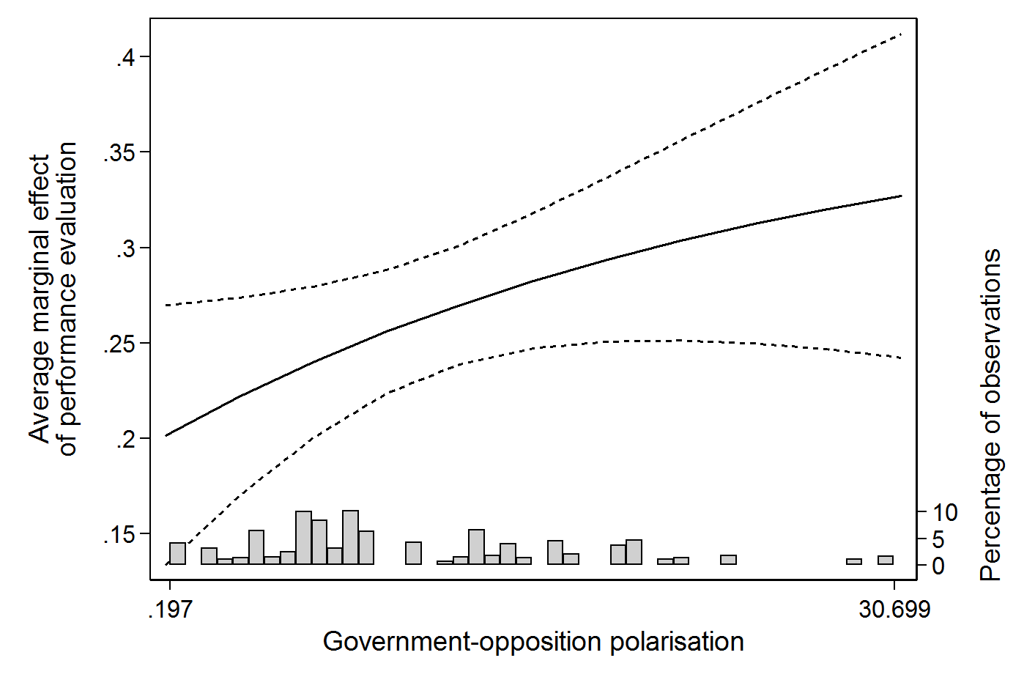
Note: the figure shows the average marginal effect and 95% confidence intervals of retrospective performance evaluations based on Model 2 in Table F.1. Data: CSES 2, CSES 3.

Appendix G: Results for different knowledge-groups
Table G.1: Replication of Table 1 in the text for the least knowledgeable respondents
 | (1) | (2) | (3) | (4)
 | B | B | B | B
 | (s.e.) | (s.e.) | (s.e.) | (s.e.)
Sex (ref.=male) | 0.074* | 0.079* | 0.086* | 0.079*
 | (0.034) | (0.035) | (0.036) | (0.035)
Age | 0.009*** | 0.010*** | 0.010*** | 0.010***
 | (0.001) | (0.001) | (0.001) | (0.001)
Education (ref.=no secondary)
Education: secondary | -0.072 | -0.073 | -0.105* | -0.075
 | (0.050) | (0.051) | (0.052) | (0.051)
Education: post-secondary | -0.003 | 0.011 | -0.006 | 0.009
 | (0.056) | (0.057) | (0.058) | (0.057)
Education: university | -0.058 | -0.051 | -0.073 | -0.052
 | (0.056) | (0.058) | (0.058) | (0.058)
Income | 0.076*** | 0.072*** | 0.073*** | 0.072***
 | (0.013) | (0.014) | (0.014) | (0.014)
Religion | 0.036* | 0.038* | 0.038* | 0.038*
 | (0.016) | (0.016) | (0.016) | (0.016)
Ideological position | 0.037*** | 0.042*** | 0.048*** | 0.041***
 | (0.007) | (0.008) | (0.008) | (0.008)
Performance evaluation | 1.458*** | 0.849*** | 0.490 | 1.680***
 | (0.029) | (0.206) | (0.295) | (0.422)
Polarisation of alternatives | -0.021 | -0.031* | -0.026 | -0.028
 | (0.016) | (0.015) | (0.014) | (0.015)
Evaluation × polarisation |  | 0.051** | 0.047** | 0.043**
 |  | (0.016) | (0.014) | (0.016)
Clarity of responsibility |  |  | -0.881*
 |  |  | (0.362)
Evaluation × clarity |  |  | 0.746
 |  |  | (0.382)
ENPP |  |  |  | 0.077
 |  |  |  | (0.087)
Evaluation × ENPP |  |  |  | -0.203*
 |  |  |  | (0.091)
Constant | -0.502* | -0.403* | 0.145 | -0.717
 | (0.213) | (0.193) | (0.282) | (0.405)
N (individuals) | 19772 | 19772 | 18889 | 19772
N (groups) | 52 | 52 | 50 | 52
Var(constant) | 0.647*** | 0.523*** | 0.423*** | 0.515***
 | (0.138) | (0.113) | (0.095) | (0.111)
Var(evaluation) |  | 0.580*** | 0.431*** | 0.528***
 |  | (0.131) | (0.104) | (0.119)
AIC | 21323.140 | 20697.465 | 20064.871 | 20695.942
BIC | 21417.845 | 20807.954 | 20190.413 | 20822.214
Note: Entries are log-odds coefficients, standard errors reported in parentheses. Data: CSES Module 2 and 3. Significance levels: *: p < 0.05; **: p < 0.01; ***: p < 0.001.

Figure G.1: Average marginal effect of performance evaluations at different values of ideological polarisation between government and opposition for the least knowledgeable respondents
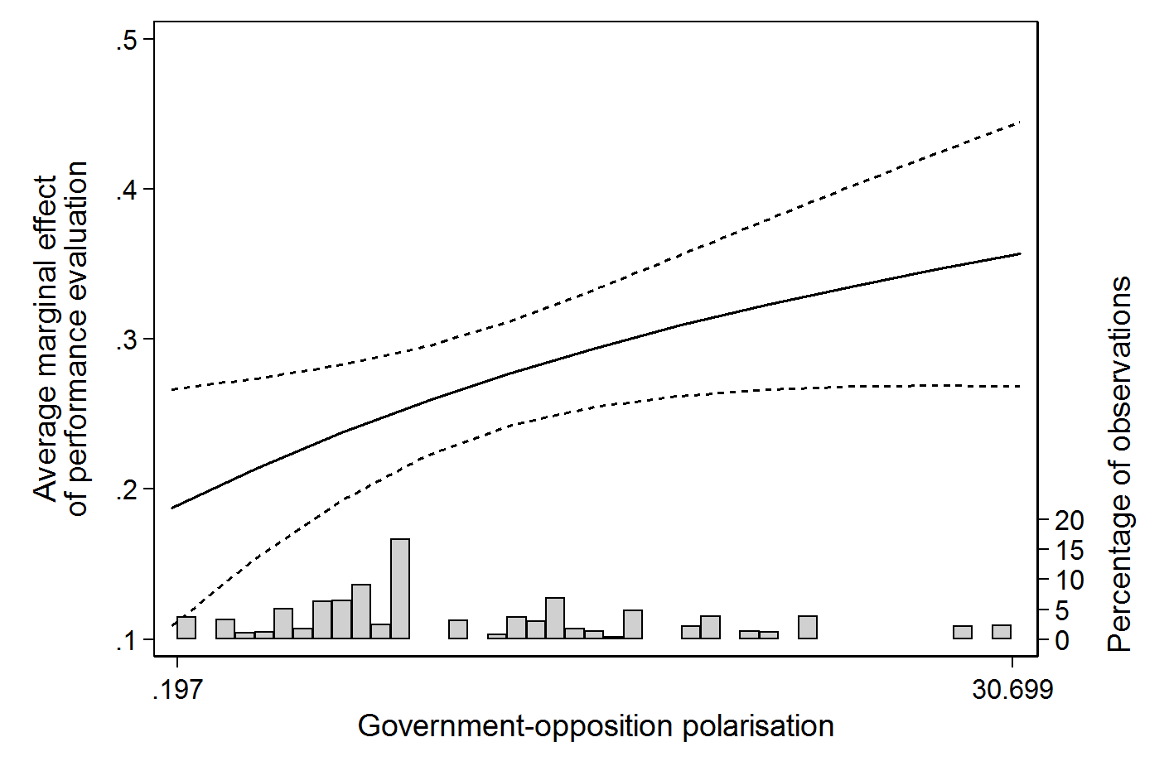

Note: the figure shows the average marginal effect and 95% confidence intervals of retrospective performance evaluations based on Model 2 in Table G.1. Data: CSES 2, CSES 3.

Table G.2: Replication of Table 1 in the text for the most knowledgeable respondents
 | (1) | (2) | (3) | (4)
 | B | B | B | B
 | (s.e.) | (s.e.) | (s.e.) | (s.e.)
Sex (ref.=male) | 0.027 | 0.032 | 0.021 | 0.032
 | (0.026) | (0.027) | (0.028) | (0.027)
Age | 0.008*** | 0.008*** | 0.009*** | 0.008***
 | (0.001) | (0.001) | (0.001) | (0.001)
Education (ref.=no secondary)
Education: secondary | -0.078* | -0.111** | -0.183*** | -0.112**
 | (0.039) | (0.041) | (0.043) | (0.041)
Education: post-secondary | -0.119** | -0.123** | -0.173*** | -0.124**
 | (0.043) | (0.045) | (0.045) | (0.045)
Education: university | -0.079 | -0.092* | -0.151*** | -0.092*
 | (0.040) | (0.042) | (0.043) | (0.042)
Income | 0.074*** | 0.072*** | 0.063*** | 0.072***
 | (0.010) | (0.011) | (0.011) | (0.011)
Religion | 0.026* | 0.031* | 0.031* | 0.031*
 | (0.012) | (0.013) | (0.013) | (0.013)
Ideological position | 0.055*** | 0.072*** | 0.075*** | 0.072***
 | (0.006) | (0.006) | (0.007) | (0.006)
Performance evaluation | 1.326*** | 1.105*** | 0.806* | 2.029***
 | (0.022) | (0.225) | (0.317) | (0.455)
Polarisation of alternatives | -0.029 | -0.039** | -0.035* | -0.036*
 | (0.015) | (0.015) | (0.014) | (0.015)
Evaluation × polarisation |  | 0.049** | 0.044** | 0.041*
 |  | (0.018) | (0.016) | (0.017)
Clarity of responsibility |  |  | -0.969*
 |  |  | (0.378)
Evaluation × clarity |  |  | 0.691
 |  |  | (0.414)
ENPP |  |  |  | 0.090
 |  |  |  | (0.087)
Evaluation × ENPP |  |  |  | -0.226*
 |  |  |  | (0.098)
Constant | -0.195 | -0.168 | 0.461 | -0.536
 | (0.195) | (0.194) | (0.292) | (0.405)
N (individuals) | 31289 | 31289 | 29613 | 31289
N (groups) | 52 | 52 | 50 | 52
Var(constant) | 0.550*** | 0.542*** | 0.473*** | 0.531***
 | (0.112) | (0.112) | (0.100) | (0.110)
Var(evaluation) |  | 0.718*** | 0.540*** | 0.650***
 |  | (0.149) | (0.118) | (0.136)
AIC | 35059.459 | 33081.635 | 31369.231 | 33079.549
BIC | 35159.671 | 33198.549 | 31501.966 | 33213.166
Note: Entries are log-odds coefficients, standard errors reported in parentheses. Data: CSES Module 2 and 3. Significance levels: *: p < 0.05; **: p < 0.01; ***: p < 0.001.

Figure G.2: Average marginal effect of performance evaluations at different values of ideological polarisation between government and opposition for the most knowledgeable respondents
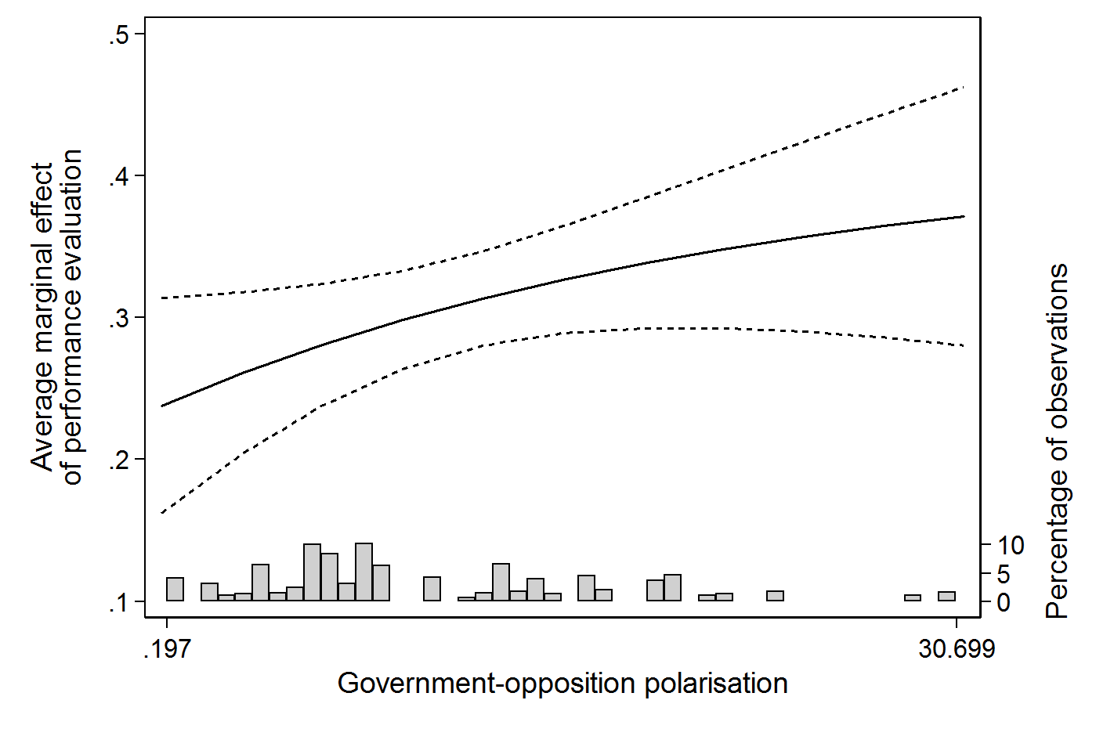
Note: the figure shows the average marginal effect and 95% confidence intervals of retrospective performance evaluations based on Model 2 in Table G.2. Data: CSES 2, CSES 3.

Appendix H: Controlling for endogeneity

Following the design of Duch and Stevenson (2008, pp. 127-128) and Duch, Palmer, and Anderson (2000), we create purged performance evaluations based on a three-step approach. First, we predict performance evaluations by means of a model that includes variables that can be expected to biased evaluations as well as objective economic indicators (unemployment rate, inflation, GDP growth). Following Duch and colleagues, we focus on party identification with the incumbent, and political information as sources of bias. Second, we estimate the same model, but this time excluding the objective economic indicators. As a result, this model only includes the ‘biased’ part of performance evaluations (${\hat{Evaluation}}_{i}^{S}$). By taking the difference of the two predictions, we obtain an estimate of performance evaluations based on actual economic conditions and purged from their endogeneity with the vote – and we label this variable Evaluation’. Hence, following Duch and Stevenson (2008, p. 128), we create the purged measure as follows:

$${Evaluation}_{i}=α_{1}\left(PID\right)+α_{2}\left(knowledge\right)+α_{3}\left(education\right)+α_{4}\left(unemployment\right)+α_{5}\left(inflation\right)+α_{6}\left(GDP\right)+ε_{i}$$

$${\hat{Evaluation}}_{i}^{S}=α_{1}\left(PID\right)+α_{2}\left(knowledge\right)+α_{3}\left(education\right)+ε_{i}$$

$${\hat{Evaluation}}_{i}^{'}={Evaluation}_{i}-{\hat{Evaluation}}_{i}^{S}$$

The purged variable is then included in the models as presented in the main text. The results of these models, that are reported in Table 1 in this note, allow verifying whether our conclusions hold using exogenized evaluations of the government’s performance. Note that, for this robustness test, we use standard OLS (first steps) and logit (presented) models, to allow the variation in objective economic indicators – which is at the election level – to have a varying effect on voters between countries.

Table H.1: Replication of Table 1 in the text using purged performance evaluations
 | (1) | (2) | (3) | (4)
 | B | B | B | B
 | (s.e.) | (s.e.) | (s.e.) | (s.e.)
Sex (ref.=male) | 0.029 | 0.026 | 0.030 | 0.035
 | (0.023) | (0.023) | (0.023) | (0.023)
Age | 0.009*** | 0.009*** | 0.008*** | 0.008***
 | (0.001) | (0.001) | (0.001) | (0.001)
Education (ref.=no secondary)
Education: secondary | 0.087** | 0.093** | 0.051 | 0.016
 | (0.030) | (0.030) | (0.031) | (0.031)
Education: post-secondary | 0.085* | 0.101** | 0.054 | 0.036
 | (0.034) | (0.034) | (0.035) | (0.035)
Education: university | 0.027 | 0.029 | 0.022 | -0.011
 | (0.033) | (0.033) | (0.034) | (0.034)
Income | 0.084*** | 0.083*** | 0.077*** | 0.086***
 | (0.009) | (0.009) | (0.009) | (0.009)
Religion | -0.004 | 0.018 | 0.019* | 0.033***
 | (0.009) | (0.010) | (0.010) | (0.010)
Ideological position | 0.044*** | 0.044*** | 0.045*** | 0.045***
 | (0.005) | (0.005) | (0.005) | (0.005)
Performance evaluation’ | 0.599*** | -1.062*** | -3.356*** | -2.670***
 | (0.073) | (0.182) | (0.270) | (0.369)
Polarisation of alternatives | -0.016*** | -0.013*** | -0.012*** | -0.009***
 | (0.002) | (0.002) | (0.002) | (0.002)
Evaluation’ × polarisation |  | 0.140*** | 0.156*** | 0.148***
 |  | (0.014) | (0.014) | (0.014)
Clarity of responsibility |  |  | -1.123***
 |  |  | (0.049)
Evaluation’ × clarity |  |  | 3.651***
 |  |  | (0.337)
ENPP |  |  |  | 0.096***
 |  |  |  | (0.011)
Evaluation’ × ENPP |  |  |  | 0.418***
 |  |  |  | (0.083)
Constant | -1.171*** | -1.218*** | -0.500*** | -1.583***
 | (0.066) | (0.066) | (0.074) | (0.082)
N | 32303 | 32303 | 32303 | 32303
Pseudo R² | 0.013 | 0.015 | 0.029 | 0.018
AIC | 43182.611 | 43085.032 | 42491.305 | 42947.278
BIC | 43274.823 | 43185.627 | 42608.665 | 43064.639
Note: Entries are log-odds coefficients, standard errors reported in parentheses. Data: CSES Module 2 and 3. Significance levels: *: p < 0.05; **: p < 0.01; ***: p < 0.001.

Figure H.1: Replication of Figure 1 of the text using instrumented performance evaluations
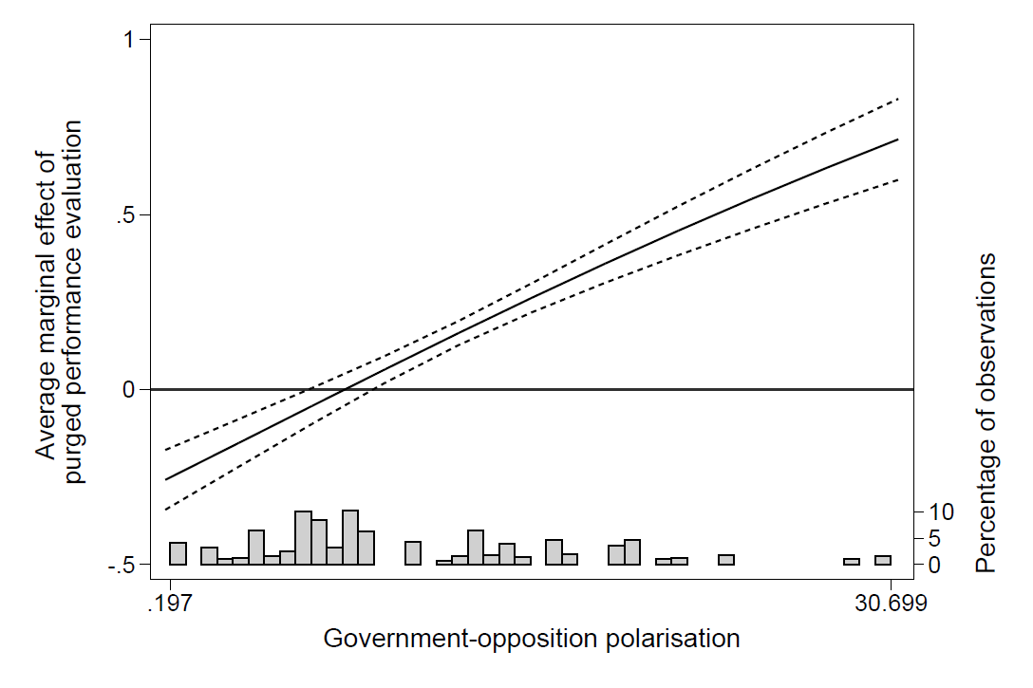
Note: the figure shows the average marginal effect and 95% confidence intervals of retrospective performance evaluations based on Model 2 in Table H.1. Data: CSES 2, CSES 3.

As can be seen in Table H.1, the results from the models with purged performance evaluations are very comparable to those using the possibly endogenous evaluations. The replication of Figure 1 of the text shows that the substantial results are very similar as well. Surprisingly, the effect of performance evaluations on incumbent voting seems to be negative at the lowest values of polarisation of alternatives. However, this result is most likely due to the fact that our models can never fully account for all bias nor the full objective situation of a country, and hence the purged evaluations we use are an approximation of reality-based performance evaluations rather than a perfect measure.

Note that Duch and Stevenson (2008) also include socio-economic status. However, as this variable was not included in some of the election studies, including it would lead to a substantial loss of observations.

