**Online Appendix**

**for**

**“Misperceptions of Chinese Investments in Canada and Their Correction:**

**Evidence from a Survey Experiment”**

**in**

***Canadian Journal of Political Science***

Xiaojun Li

Yingqiu Kuang

Linting Zhang

Department of Political Science

University of British Columbia

Table of Contents

A. Survey Experiment Design…………………………… 2

B. Results From Logistic Regressions…………………… 6

C. Sample Balance Check………………………………...7

D: Subgroup Analyses…………………………………….8

E: Results in Quebec……………………………………..11

# **A. Survey Experiment Design**

1. Every respondent read the following introduction at the beginning of the experiment.

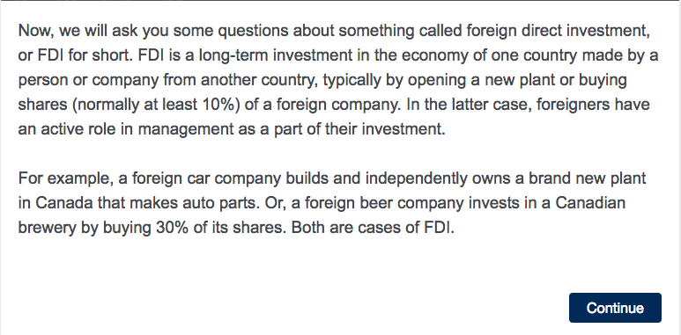

2. All respondents are asked to estimate the shares of FDI in Canada from the five countries.

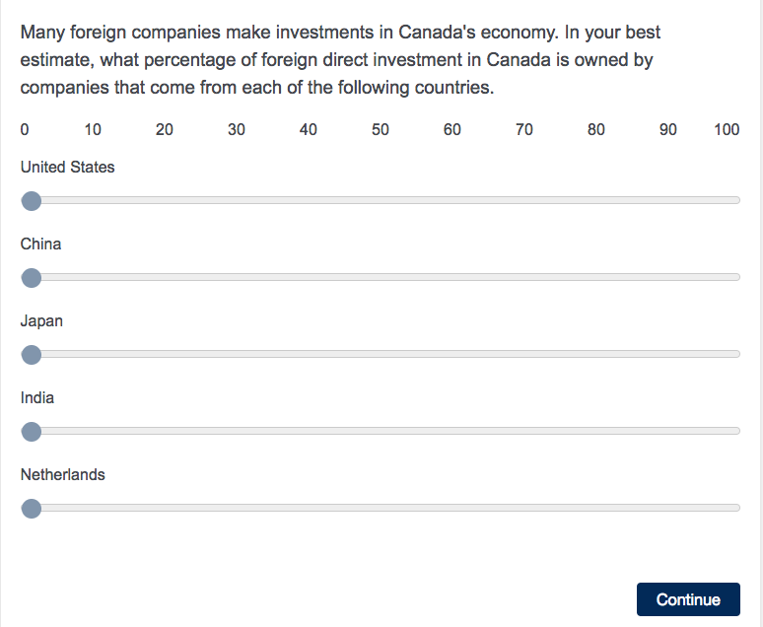

3. Respondents in the treatment group receive the correct amounts. The column “your estimates” will be filled with numbers from the previous question.

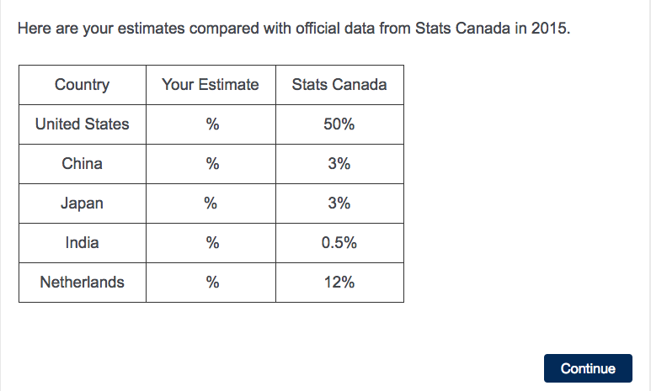

4. They also get the following question to ensure that the correction works.

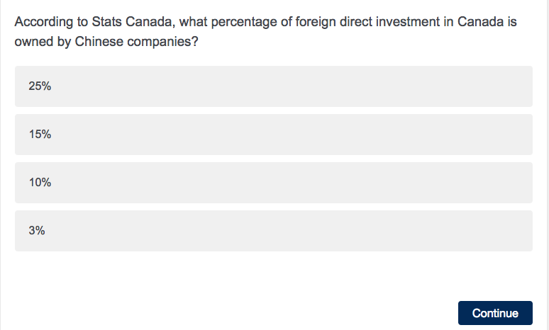

5. All respondents answer questions about the rules governing FDI. Respondents in the control group get all three statements on the same page.

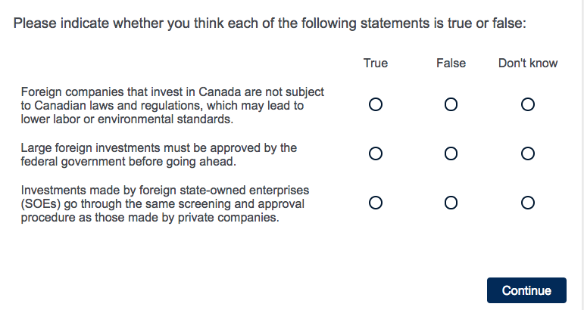

6. Respondents in the treatment groups see the three statements one by one and are presented with the answer immediately after they answer the questions. Depending on their choice, they see one of the following:

If their answer is wrong: Oops, you got it **wrong**!

If their answer is right: Great, you got it **right**!

If their answer is “don’t know”: The correct answer is **false/true.**

As well as a brief explanation:

According to**Global Affairs Canada** (formerly Department of Foreign Affairs and International Trade), foreign investors in Canada **must abide by** Canadian domestic laws. In other words, foreign investors in Canada are not exempt from domestic competition laws or local regulations relating to **health, labor or the environment**.

According to **Investment Canada Act (ICA)**, large foreign investments from private firms (over$600 million) and state owned enterprises (over $379 million) **must be reviewed and approved** by the federal government before going ahead.

According to **Investment Canada Act (ICA)**, in addition to the usual “net benefit” analysis, investments by state-owned enterprises, including sovereign wealth funds, are subject to **special guidelines** that involve broader and tighter check on such criteria as the nature and extent of control by the foreign government, the SOE’s corporate governance, and its adherence to free market principles.

7. All respondents answer the following question associated with the conjoint design. The table below is for illustration. Contents of the table (rows 2-4) are randomly chosen from a predetermined list of values.

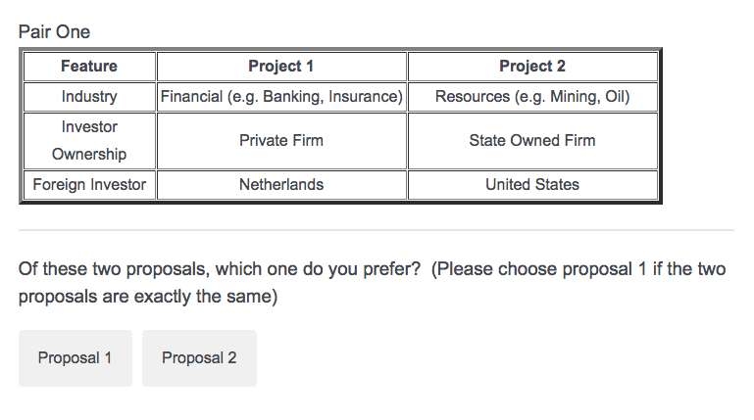

# **B. Results from Logistic Regressions**

Table A1: Effect of FDI Features on Individual Preferences

|  |  |  |  |  |  |
| --- | --- | --- | --- | --- | --- |
|  |  | Model (1) | Model (2) | Model (3) | Model (4) |
|  | Variables | Control | Treatment1 | Treatment2 | Treatment3 |
|  |  |  |  |  |  |
| Country of Origin | China | -1.199** | -0.914** | -0.960** | -0.622** |
|  |  | (0.142) | (0.126) | (0.133) | (0.132) |
|  | *(Odds Ratio)* | *0.302\*\** | *0.401\*\** | *0.383\*\** | *0.537\*\** |
| Sector | Resources | -0.676** | -0.379* | -0.249 | -0.530** |
| (Baseline = Services) |  | (0.164) | (0.151) | (0.162) | (0.166) |
|  | High Tech | 0.320* | 0.342* | 0.384* | 0.165 |
|  |  | (0.159) | (0.152) | (0.162) | (0.154) |
|  | Financial | -0.387* | -0.231 | -0.341* | -0.506** |
|  |  | (0.158) | (0.153) | (0.144) | (0.153) |
| Foreign Investor | State Owned | -0.0299 | -0.0176 | 0.0201 | -0.221* |
| (Baseline = Private) |  | (0.117) | (0.104) | (0.107) | (0.112) |
|  | Constant | 0.465** | 0.304** | 0.267* | 0.477** |
|  |  | (0.123) | (0.112) | (0.119) | (0.117) |
|  | Observations | 1,400 | 1,524 | 1,516 | 1,424 |
|  | R-squared | 0.084 | 0.053 | 0.056 | 0.041 |

*Notes:* Robust standard errors clustered by respondent in parentheses; ** p<0.01, * p<0.05

# **C. Sample Balance Check**

Table A2: Sample Balance Check

|  |  |  |  |  |  |
| --- | --- | --- | --- | --- | --- |
| Variable | Control | Treatment 1 | Treatment 2 | Treatment 3 | P-value |
| *Country Origin* |  |  |  |  |  |
| United States | 0.25 | 0.25 | 0.24 | 0.25 | 0.062 |
| Japan | 0.28 | 0.26 | 0.27 | 0.26 | 0.406 |
| Netherlands | 0.24 | 0.24 | 0.25 | 0.25 | 0.594 |
| China | 0.23 | 0.25 | 0.24 | 0.24 | 0.641 |
| *Sector* |  |  |  |  |  |
| Resources | 0.26 | 0.25 | 0.26 | 0.24 | 0.247 |
| High Tech | 0.24 | 0.23 | 0.26 | 0.25 | 0.221 |
| Financial | 0.25 | 0.25 | 0.25 | 0.26 | 0.966 |
| Services | 0.25 | 0.27 | 0.24 | 0.25 | 0.939 |
| *Foreign Investor* |  |  |  |  |  |
| State Owned | 0.51 | 0.50 | 0.52 | 0.51 | 0.327 |
| Private | 0.49 | 0.50 | 0.48 | 0.49 | 0.327 |

Note: The ratios may not add up to one due to rounding. P-values are based on one-way ANOVA tests.

# **D: Subgroup Analyses**

We construct the subgroups using the following questions in the survey:

Party Affiliation: “In Federal politics, do you usually think of yourself as a ___?” The responses are: “Liberal” (40.4%), “Conservative” (25.6%), “NDP” (12%), “Green” (4.1%), “Other” (4.7%), and “None” (13.1%). We use respondents self-identified with the Liberal and the Conservative Parties for the two subgroups.

News on China: “How often you listen, watch or read news about China?” The responses are: “Every day” (6.9%), “3-4 times a week” (13.8%), “1-2 times a week” (44.2%), “Almost never” (27.4%), and “Don’t know” (7.7%). The two sub-groups are respondents who almost never watch or read news about China and those who watch or read news about China at least 1-2 times a week. The “don’t know” category is dropped.

Favourability toward China: “Please tell me if you have a very favorable, somewhat favorable, somewhat unfavorable or very unfavorable opinion of China?” The responses are: “Very favourable” (5.1%), “Somewhat favourable” (30.9%), “Somewhat unfavourable” (42.5%), “Very unfavourable” (14.2%), and “Don’t know” (7.3%). We combine the favourable and unfavourable respondents to construct the two subgroups, dropping the “don’t know” category.

Chinese influence in Canada: As the Chinese presence in Canada deepens, do you have special concerns about the challenges it presents to Canadian values and institutions (the Canadian way of life)?” The responses are: “Very concerned” (17.8%), “Somewhat concerned” (21.1%), “A little concerned” (21.2%), “Not concerned at all” (35.9%), and “Don’t know” (4%). We combine the concerned and unconcerned respondents to construct the two subgroups, dropping the “don’t know” category.

Figure A1: Treatment Effects by Party Affiliation



Figure A2: Treatment Effects by Readership of China News



Figure A3: Treatment Effects by Opinion on China



Figure A4: Treatment Effects by Concern of Chinese Influence

# **E: Results in Quebec**

We implemented the survey via Qualtrics to a random sample of 521 Francophone Quebecois (age 18+) from December 18, 2017 to March 5, 2018. Respondents were screened into the survey only if they live in Quebec and speak French as their mother tongue. The survey was provided in both languages and 296 of the respondents chose to complete the questionnaire in English. The survey was in the field for over three months as it getting to our target sample proves to be very challenging.

Figure A5: Estimates of the Share of FDI in Canada by Country for the Quebec Sample



Figure A5 plots the estimates of the share of FDI in Canada by the five countries for respondents in the Quebec survey. These results display very similar patterns as those found in the full survey. In particular, the estimates for Chinese FDI in Canada about 30% (as opposed to the true value of 3%).

The full results of the conjoint experiment are presented in Table A3. Note that since we only asked each respondent to rate one pair of FDI projects this time, the sample sizes are much smaller (*N* = 2 x 1 x 521 = 1,024 FDI projects).

Table A3 Effect of FDI Features on Individual Preferences in the Quebec Sample

|  |  |  |  |  |  |
| --- | --- | --- | --- | --- | --- |
|  |  | Model (1) | Model (2) | Model (3) | Model (4) |
|  |  | Control | Treatment1 | Treatment2 | Treatment3 |
| Variables | Correction | No | Innumeracy | Misinformation | Both |
|  |  |  |  |  |  |
| Country of origin | China | -0.185** | -0.213** | -0.153** | -0.0722 |
| (baseline = other 3 countries) |  | (0.0696) | (0.0714) | (0.0574) | (0.0819) |
| Sector | Resources | -0.0763 | -0.0294 | -0.0237 | -0.0373 |
| (baseline = services) |  | (0.0817) | (0.0883) | (0.0758) | (0.110) |
|  | High-tech | 0.132 | 0.154 | 0.237** | 0.141 |
|  |  | (0.0845) | (0.0791) | (0.0877) | (0.0982) |
|  | Financial | 0.0428 | 0.0529 | 0.114 | -0.0628 |
|  |  | (0.0904) | (0.0896) | (0.0864) | (0.103) |
| Foreign investor | State-owned | 0.0157 | 0.0191 | -0.00852 | -0.0161 |
| (baseline = private) |  | (0.0652) | (0.0625) | (0.0601) | (0.0649) |
|  | Constant | 0.508** | 0.502** | 0.484** | 0.505** |
|  |  | (0.0639) | (0.0676) | (0.0605) | (0.0818) |
|  | Observations | 262 | 248 | 298 | 234 |
|  | R-squared | 0.052 | 0.060 | 0.060 | 0.031 |

*Notes:* Robust standard errors clustered by respondent in parentheses; ** p<0.01, * p<0.05