Table A1 – Determinants of Party Pledge Fulfillment in Canada 1993-2015 (binary logit regression coefficients with confidence intervals in parentheses)
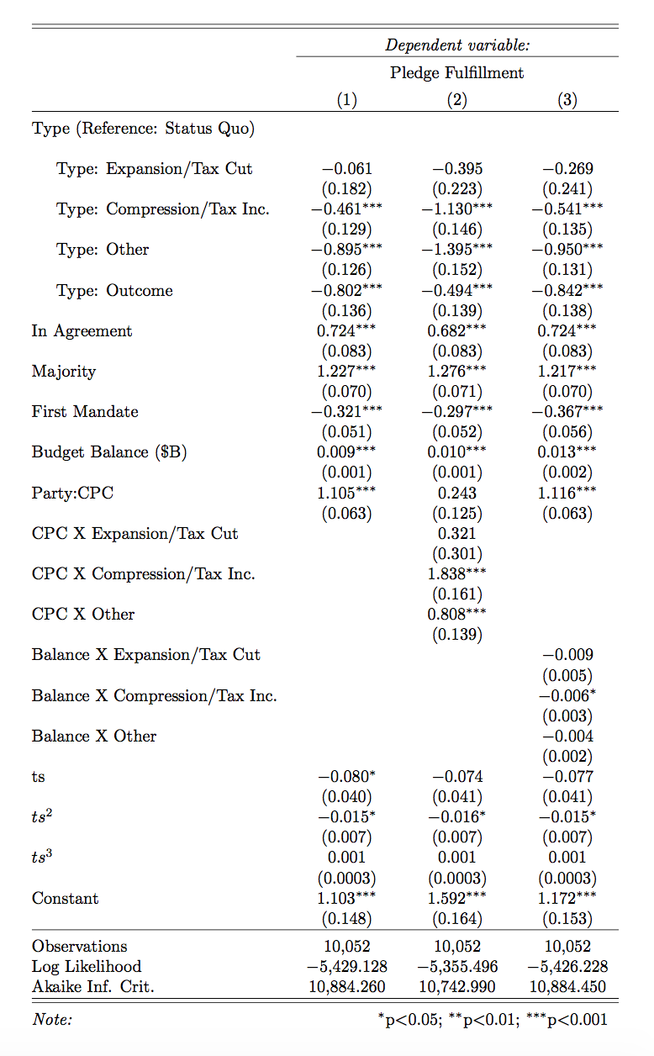

Table A2 – Determinants of Party Pledge Fulfillment in Canada 1993-2015 Excluding Time (binary logit regression coefficients with confidence intervals in parentheses)
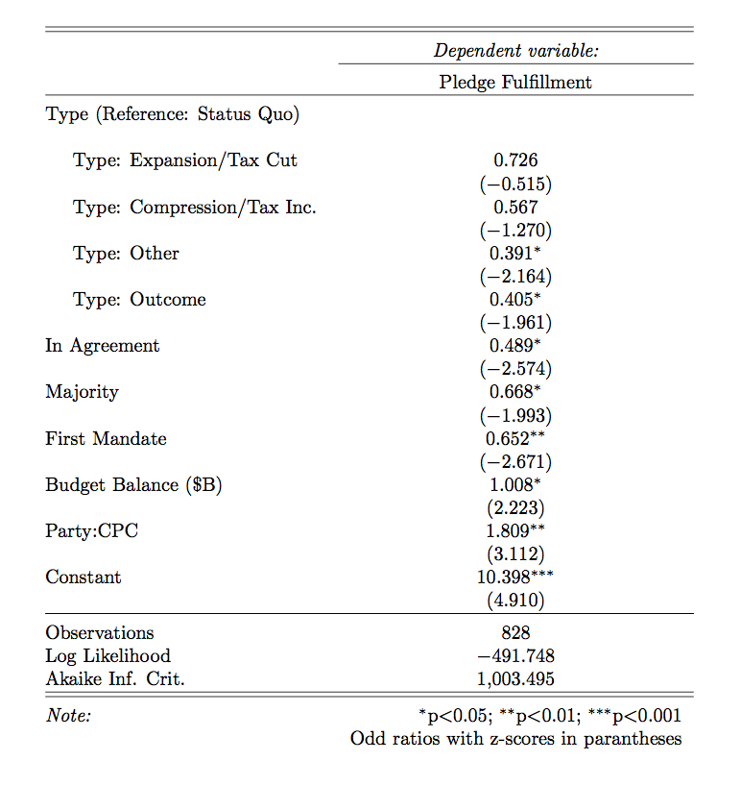

Table A3 – Determinants of Party Pledge Fulfillment in Canada 1993-2015 Using Budget Balance Expressed in % of GDP (binary logit regression coefficients
with confidence intervals in parentheses)
