Appendix Tables and Figures

Figure A1 – Age Distribution By Mode and Population Distribution

  
Figure 1 displays density plots for the age distribution of each mode and for the Canadian population. The black dotted line shows the unweighted phone data and black solid line the distribution of the weighted phone data. The rug plot indicates the mean for each distribution. Source for the Canadian population: Statistics Canada, 2011 Census.

Figure A2



Figure A3 Party Dynamics



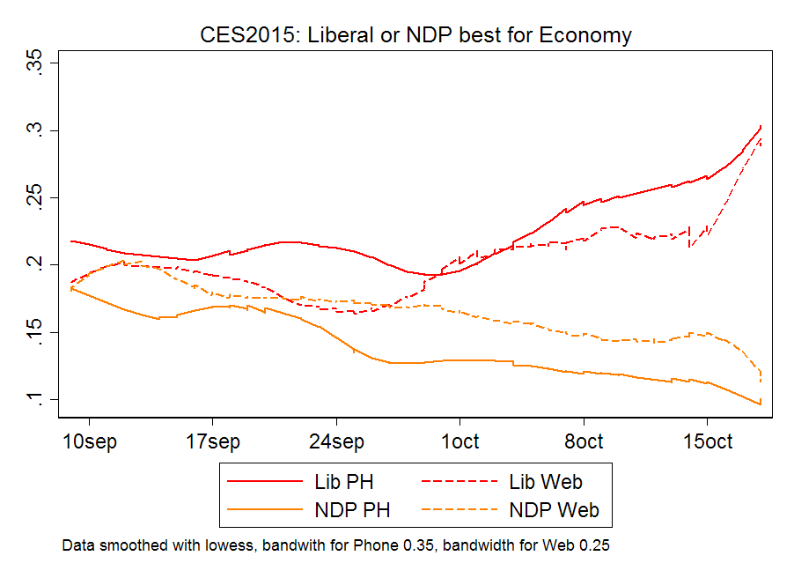

Figure A4 – Attitude Change over the Campaign, by Survey Mode

Table A1 – Benchmarks Sources

Macintosh HD:Users:charlesbreton1:Dropbox:CES - Mode Comparison:Tables:tablea1.pdf

Table A2 – Comparing Modes with Benchmarks (Full Results)

Macintosh HD:Users:charlesbreton1:Dropbox:CES - Mode Comparison:Tables:tablea2.pdf

The table shows point estimates for each sample and when they are combined as well as their corresponding 95% confidence interval and the actual value used as a benchmark.