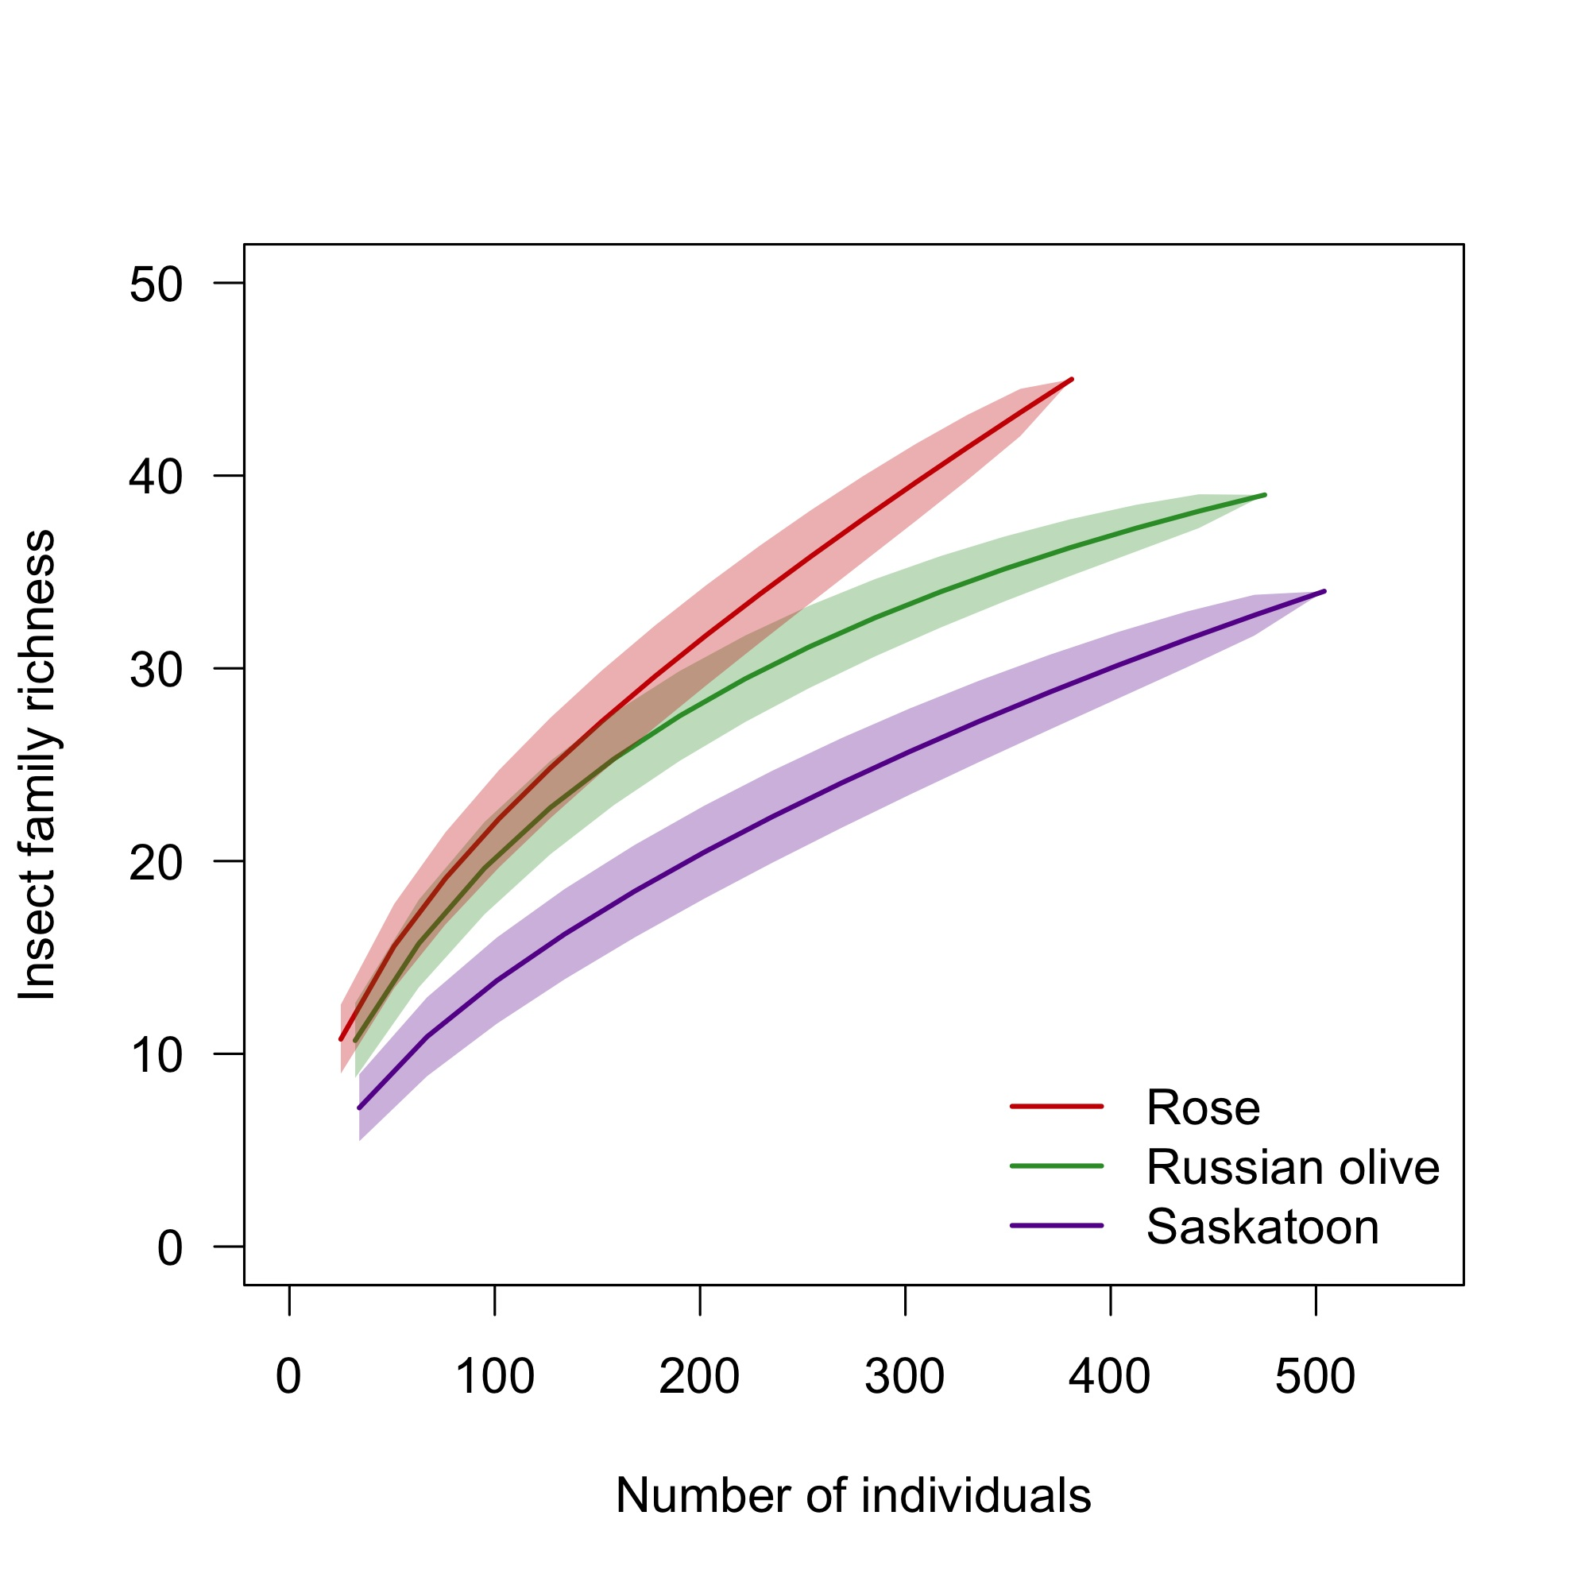
Fig. S3. Rarefied sample-based species accumulation curves, showing mean insect family richness. Shaded areas show ± 1 standard deviation.

