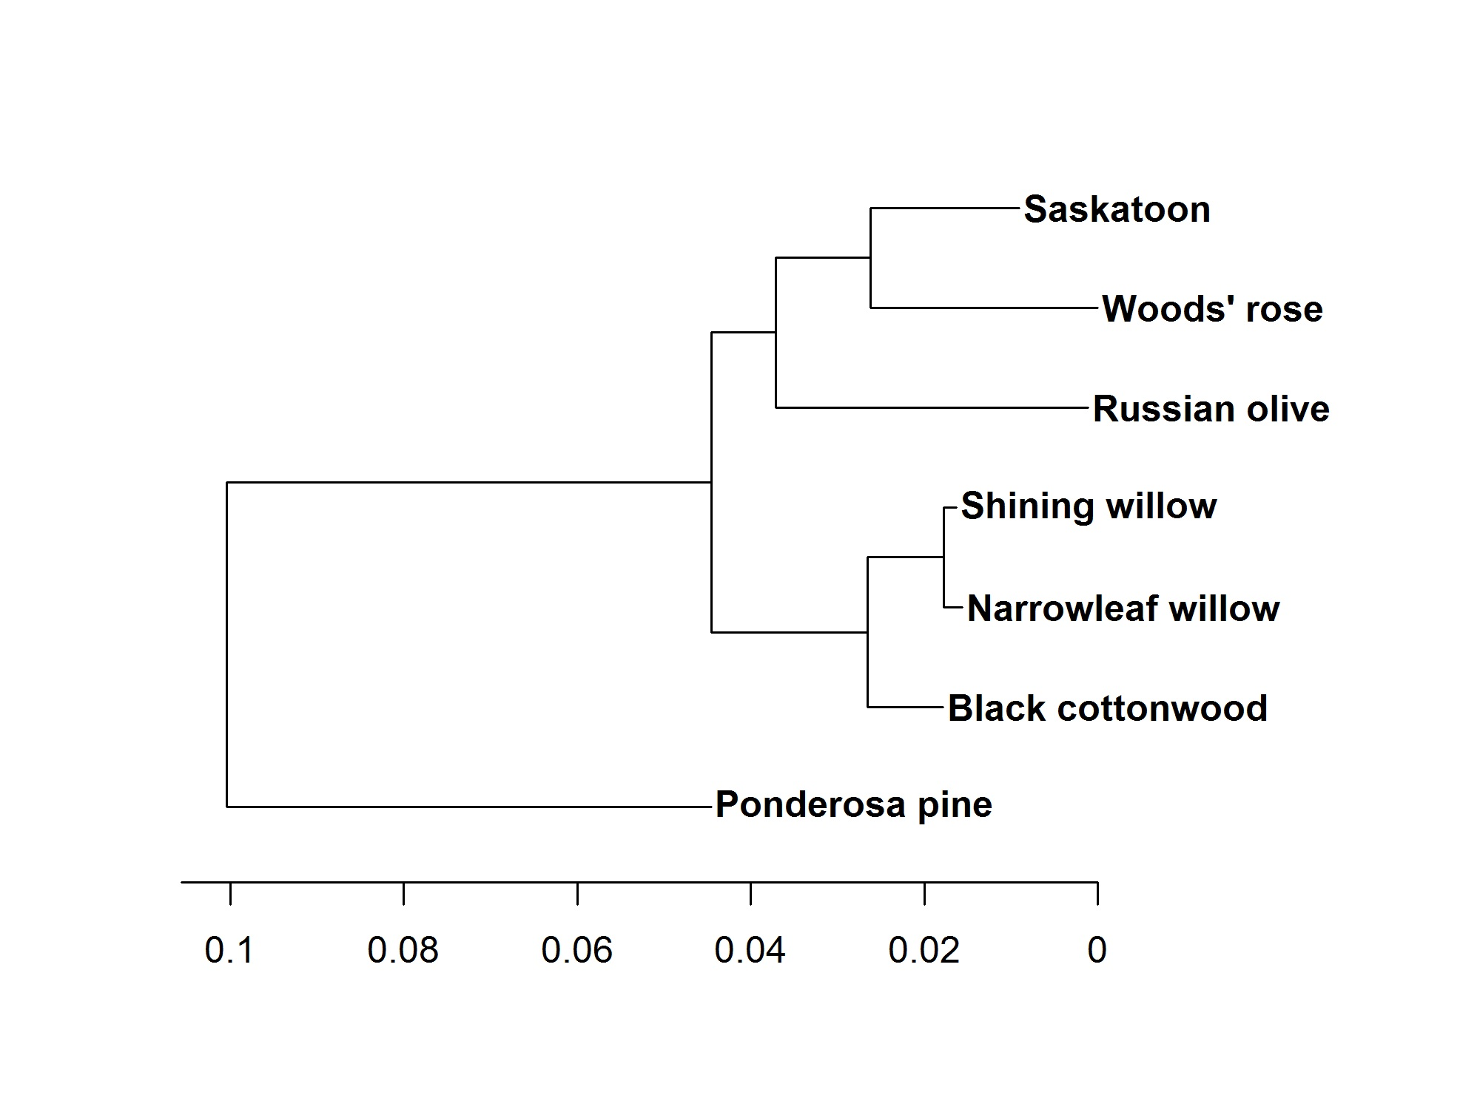
Fig. S1. Phylogenetic comparison between Russian olive and several species it co-occurs with in southern British Columbia. Comparisons are based on the large subunit of the ribulose-bisphosphate carboxylase gene (rbcL) nucleotide sequences of Russian olive, Woods’ rose, Saskatoon, shining willow (Salix lucida Muhlenberg; Salicaceae), narrowleaf willow (Salix exigua Nuttall), black cottonwood (Populus trichocarpa Torrey and Gray; Salicaceae), and ponderosa pine (Pinus ponderosa Douglas ex Lawson; Pinaceae).

