Online Appendix

S1. Why was profitability in the U.S. domestic airline sector typically low? Some historical context

In the 1920s, government subsidies for commercial airmail were designed to foster the development of a network of air services. Although the subsidies might have been expected to boost profits, they stimulated competitive bidding for the airmail contracts and this actually drove down profits.[1] 1938 saw the beginning of four decades of regulation, part of the rationale being that without it “destructive competition might well characterize the industry.”[2] The restriction on merger, combined with a favorable approach to smaller carriers, inhibited further concentration and the four-firm concentration ratio actually fell from 80 percent in 1934 to 71 percent in 1954. The evidence for this period accords with the standard economic model, which would predict profits lower than they would have been absent the fall in the concentration ratio that had resulted from regulatory restraints.

Richard Vietor recounts further profit-depressing developments during the period of regulation. A glut of aircraft and pilots after World War II led to new entrants who circumvented regulatory restrictions and added to competition. Then, in 1947, the reequipment cycle (accompanied by fresh debt) coincided with recession and resulted in negative margins. Profits suffered, as they did yet again in the late 1960s and early 1970s, when growth rates fell at the same time that inflation and interest rates rose, fuel prices rose by more than 200 percent, and load factors declined.

Deregulation in 1978 was followed by a fall in airline profits: the average rate of return on equity in 1978-87 was calculated as just 8 percent of its level in 1970-77.[3] This was associated with competition from and among a wave of new entrants. Of eighteen such entrants between 1979 and 1985, all but two failed to survive the fierce competition; most were bankrupt by 1987.[4] Attrition by mergers also proceeded apace in the new regime, with twenty-four of 1978’s trunk and local airlines merging into eight majors by 1989.[5]

S2. Detailed data appendix to accompany Table 1 in the main paper: More information about the derivation of profit data for GE activities in the aviation industry

<http://www.ge.com/investor-relations/shareholder-services/personal-investing/annual-reports> Some of the data were hand collected from annual reports and 10k filings. The segmental profit data for GE are on somewhat different bases in different years and in different segments. Over time, GE’s allocation of activities to segments and description of segments are subject to change. As between segments, aircraft engine profits are before interest and taxation and certain exceptional and other items, while the finance segment is post-interest and post-tax. Also, adjustments are made from GAAP for internal purposes of performance measurement. They do not, therefore, correspond in definition precisely with the net profit data for the airlines.

*GE’s profit from aviation engines/supplies*. 2011–2017: GE Annual Reports, 2011, 2013, 2014, 2015, 2016, 2017, segmental data for “aviation”; 2007–2010: GE Annual Report, 2010, segmental data for “aviation industrial”; 2004–2006: GE Annual Report, 2006, segmental data for “infrastructure aviation”; 2003: GE Annual Report, 2005, segmental data for “aviation”; 2000–2002: GE Annual Report, 2002, segmental data for “aircraft engines.”

*GECAS Profit (2000–2017)*. 2016, 2017 reported in MD&A for 10k for 2016 and 2017; 2014, 2015: 2013 level plus change in GECAS earnings reported in MD&A of 10k, 2014, 2015, respectively; 2011–2013: GE Annual Report, 2013, segmental data for “GECAS”; 2008–2010: GE Annual Report, 2010, segmental data for “GECAS”; 2005–2007: GE Annual Report, 2007, segmental data for “airline financial services”; 2004: GE Annual Report, 2006, segmental data for “airline financial services”; 2003: GE Annual Report, 2005, segmental data for “airline financial services”; 2000–2002: GE Annual Report, 2002, segmental data for “commercial finance: aviation services.”

*GE’s profit from Airline Leasing (1990-99)*. In contrast with the years from 2000, separate data were not provided in these earlier years for the entity later named GECAS, GECapital Aviation Services. The first mention of “GECAS” in annual reports seems to come in 1999; but its separate earnings were not reported in that year. GE’s earnings from aircraft leasing had therefore to be estimated indirectly from various mentions of this activity in the annual disclosures.

Much of the information comes from the notes to the accounts. Internet searches yielded full reports including such notes for 1993, 1997, 1998, and 1999. Comparative data reported in these reports for previous years made possible a complete series for operating profits for aircraft engines and for GE Capital Services (GECS), the segment that offered aircraft finance (mainly leasing), among many other activities. GECS operated toward thirty different businesses. Aircraft leasing was one component of just one of these GECS businesses. It was included alongside substantial other leasing activities: in 1999, a million cars and trucks, 350,000 trailers, one of the world’s largest stock of sea containers, 190,000 railcars,... In 1999 there were 900 aircraft.

In Table 1 of the main paper, we therefore had to estimate earnings from aircraft leasing by calculating the share of aircraft leasing in total leasing and the share of leasing in the published earnings of GECS. Data were not available for every year to estimate the share of aircraft leasing in total leasing and the share of leasing in GECS earnings, which could then be combined into the share of GECS earnings attributable to aircraft leasing. However, in the years for which this latter share was estimated from the accounting data, it varied little (from 5 percent), so this estimate was interpolated in years where data were missing.

There are two chief reasons why the resulting data for the period from 1991 to 1999 are imperfect and should not be interpreted too precisely. First, the estimation method implicitly assumes that the share of earnings attributable to aircraft leasing reflects corresponding shares of lease revenue and leased assets. Second, as the source data were not prepared by GE for such longer-term comparisons, there will be discontinuities. In the annual reports, GE data showed results for continuing operations—with like-for-like comparisons between adjacent years. But GE was buying and selling businesses throughout the period, so data for like-for-like comparisons over nine years are not available. And retrospective figures for a year’s earnings reported in a later year sometimes differ materially from the contemporaneous disclosure because the population of businesses within GECS has changed in the meantime. Also, some definitions of financial variables seem to change between years; for example, some loans to airlines seem to be combined with lease activities in some years.

S3. More information about the Altman Z-scores reported in Table 2 of the main paper

Table 2 in the main paper uses a combination of data from companies’ annual financial statements to indicate financial viability for individual U.S. airlines, and for their median, for the period from 1982 to 2008 (except for 1992 to 1996, which none of the studies analyzed). The Altman Z-scores are estimated by discriminant analysis of companies’ financial statement data, as at the end of each year. The model estimated is:

Z = a1X1 + a2X2 + a3X3 + a4X4 + a5X5

where

X1 = net working capital to total assets

X2 = retained earnings to total assets

X3 = operating profit to total assets

X4 = market value of equity to book value of debt

X5 = operating revenues to total assets

A variant of the model, used by Gritta et al., omits X5.[6]

Because they are drawn from slightly different sources with minor differences in the estimated model, the Z-scores reported in Table 2 of the main paper are not strictly comparable across all years, only within subsets from the same source. However, the central conclusions are likely to survive such discontinuities.

S4. Was the airlines’ financial distress to be expected given external market developments?

The evidence of section 3 in the main paper could be consistent with efficient economic natural selection if the adverse finances of the airlines were temporary fluctuations, which were expected soon to reverse. Then it might be in the debtors’ long-term interest to stay in business, if the losses would be recouped when normal conditions returned. Section 3 suggested that this possibility looks remote, since the losses accumulated in this period were so great.

Nevertheless, it is a possibility that the years following the millennium suffered unusually damaging levels for the short-run exogenous influences on profitability; and that, given past relationships (up to 2000) between profits and the external, macroeconomic drivers of profit, reported profits were as expected for the economic conditions of the period from 2000 to 2008. In that case, profits would have been “normal” given the economic circumstances; no other explanation would be needed. And continuing in business, though unprofitable in the short term, might have been in the interests of airlines’ stockholders.

In this appendix we explore this possibility systematically with regression analysis, relating airline profits to the level of demand in the markets supplied by the airlines and to prices in the oil market from which the airlines buy significant supplies. Both of these markets are known to be volatile; we investigate the possibility that the exceptionally poor financial performance of the airlines between 2000 and 2008 was the result simply of transitory and predictable adverse movements in those two markets that might be expected to reverse, so that exit from the industry might not be warranted on a long-term view.

Our analysis addresses the question of whether the collapse in airline profitability in the new century was to be expected given the movements in the usual drivers of airline profits: Was this new, lower level of profitability to be expected anyway given the cyclical movement of demand and the fluctuations in input prices? If profits turn out to be systematically lower than normal relationships would lead us to expect, we would have more confidence that the dominance of GE was a factor in the increased survival rates of airlines despite acute financial distress. So the analysis reports modeling exercises to estimate what “normal” profitability would have been, given the traditional explanatory variables, and compares that with actual values to identify the unexpected component.

The null hypothesis is then: Airline profits from 2001 were no different from expectations generated by an advance robust econometric model incorporating the demand and cost variables that drove profit fluctuations in the past.

We have adopted an autoregressive distributed lag (ARDL) modeling framework to estimate the above-mentioned hypothesis, as this is an advanced econometric framework that can capture the information embedded in the lags of the dependent and independent variables. The ARDL framework is well suited to situations where the variables under consideration exhibit non-stationary behavior. Fuel prices exhibited such behavior during our estimation window, while the post-2000 years—which included several shocks, caused by a boom period and two recessions—amplified the situation. ARDL models can handle cointegration with inherent robustness to misspecification of integration orders of relevant variables. Our framework uses the bounds test as a way of statistically detecting the presence of cointegration. The advantage of the procedure is that it uses the conditional error correction model, CECM (ARDL) as a platform. Thus, in estimating the CECM (ARDL), one can simultaneously test for cointegration and estimate the equilibrating relationship. Last, if cointegration does exist, one can estimate and conduct inference on the speed of convergence to equilibrium.

The literature has identified real GDP as a powerful explanatory variable on the demand side when forecasting airline profit, reflecting the likely demand for business and leisure travel.[7] On the cost side, oil prices are recognized as a strong influence: they have fluctuated between 13 percent and 33 percent of airline costs during the period, with obvious consequences for profit margins if all the costs cannot be passed onto customers.[8]

Specification 1 relates the U.S. airlines’ aggregate net profit to demand represented by real GDP and to fuel prices. A dummy variable is introduced for years when exogenous shocks (e.g., war, infection) might have been expected to disturb the normal relationship between GDP and demand for air travel.

Specification 1:

Yt = ά+ ß1Yt-1+ ß2Yt-2 + ß3Yt-3 + ß4Yt-4 + λ1 X1t + λ2 X1t-1+ λ3 X1t-2 +λ4 X1t-3 +μ X2t + δ1 Dt +δ2 Dt -1 +δ3 Dt-2 +δ4 Dt-3 + δ5 Dt-4 +ε t (1)

where

Yt is the net industry income in $ millions (NetIncMils), i.e., aggregate actual net income of the population of major and national airlines (with annual revenue > $ 100 million), while Yt-1, Yt-2, Yt-3, Yt-4 are the first, second, third, and fourth lags of Yt;

ά is the intercept (CONST);

X1t is the real GDP in 2005 dollar terms (RealGDP2005Bill) with X1t-1, X1t-2, X1t-3, X1t-4 being the first, second, third, and fourth lags of X1t, respectively;

X2t is the fuel price (Brent2011), with 2011 being the base year;

Dt is a dummy variable (ExShock) that accommodates exogenous shocks. This takes the value of 1 in 1990 and 1991 (Gulf War), with Dt-1, Dt-2, Dt-3, Dt-4 representing the first, second, third, and fourth lagged effects of Dt, respectively; and

ε is the error term.

First we test for stationarity of the dependent and independent variables using the Phillips-Perron test. The results show that the variables Real GDP (RealGDP2005Bill) and Net income (NetIncMils) are stationary at levels I(0) while the fuel price is stationary at the first difference I(1). Hence, the ARDL would be the most appropriate econometric specification to investigate the behavior of Netincome in the airline industry given our data set.

We proceed to run the ARDL model for data for 1948 to 2000, and the results are shown below.



Data source: The aggregate net income was sourced from the A4A (Airlines for America) website (<http://airlines.org>). These are aggregate data for national and major carriers whose annual revenue is greater than $100 million. Oil price data were sourced from the BP website (http://www.bp.com), and the U.S. real GDP data were from the U.S. Bureau of Statistics website (<http://www.bls.gov>). Major airlines are defined as those with over $1 billion in annual operating revenue, and national airlines are those with between $100 million and $1 billion in annual operating revenue.

We see that the second lag of the netincome, the third lag of the realGDP, and the first and third lag of the exogenous shock have a positive influence on the current level of netincome, while the current level, the second lag, and the fourth lag of the exogenous shock have a negative influence. The optimal lag levels were chosen based on the Akaike Information Criteria (AIC) and the model demonstrated an adjusted R squared of 87 percent indicating a good fit.

We then conducted a bounds test, which yielded the following output.



The bounds test showed evidence of a long-run relationship; i.e., the F statistic > cutoff level of 3.2 shows a cointegrating relationship. Hence we conducted a conditional error correction model to estimate the long-run adjustments. The results are given below.



We see a significant negative coefficient of -0.7, indicating that the investigated relationship demonstrates a long-run adjustment of 70 percent toward its natural equilibrium. Finally, we make an out-of-sample estimate for 2000 to 2008 (based on the ARDL model that we develop using data from 1948 to 2000) and compare our forecasted results with the actuals. Please find the graphical illustration below.



Thus we see that even based on this robust specification, except for 2003, 2006, and 2007, the actual net income for the U.S. airline industry was well below the forecasted level. It could be argued that the post-2000 years were volatile, such that a forecast based on the quiet period leading up to 2000 might be unreliable. To take account of this, we also run rolling one-year forecasts for 2000 to 2008, updated based on the actual previous year’s results. As shown below, the broad picture remains unchanged.



We also experimented with a second specification. Specification 2 adopted an alternative approach to measuring demand for airline services. Instead of using an economy-wide measure of demand (GDP) adjusted with dummies for specific shocks, we used actual consumption of airline services, measured by revenue passenger miles (RPMs). Harumi Ito and Darrin Lee review the case for such measures and recognize that the measure results from the interaction of both demand and supply but conclude that such variables “should provide a good proxy for actual demand.”[9]

For both specifications the results suggest that the years following the millennium saw a much weaker financial performance for these airlines than would have been expected on the basis of the previous relationship between the profit margin and its demand and cost drivers. This reinforces the evidence that the years from 2000 to 2008 were special and our case for analyzing the role of GE in overseeing a reduction in the (historically weak) level of profits in the airline industry. These results further emphasize our claim that the exceptionally poor financial performance of the airlines between 2000 and 2008 was not simply the result of transitory and predictable adverse movements in the level of demand in the markets supplied by the airlines and the prices in the oil markets over the past five decades, which might be expected to reverse.

S5. Profitability and share price performance of airlines heavily dependent on GE, 2000–2008

The profits data for airlines reported in Table 1 of the main paper are aggregates for the whole industry. In relation to our thesis it would be desirable to explore company-level links between airlines and GE support. Systematic detailed information on this is not in the public domain. But Table S5 below provides some perspective on company outcomes relative to their dependence on GE. It reports for 2000 to 2008 the average profit margin (net income/revenue) for four major airlines that we know—because of court proceedings in the case of US Airways, the CEO’s comments in relation to Continental, and media reports for United and Delta—were heavily dependent on GE financing when distressed. The table S5 below shows that, consistent with our thesis, in almost every year the average margin of the dependent airlines was worse than that for the industry as a whole.

|  |  |  |
| --- | --- | --- |
| Table S5  The average margin (%) of four dependent airlines and of  the airline industry as a whole | | |
| Year | 4 dependent airlines | Airline industry |
| 2000 | 4.1 | 2.1 |
| 2001 | -8.5 | -8.7 |
| 2002 | -16.5 | -14.0 |
| 2003 | -7.9 | -2.2 |
| 2004 | -16.1 | -9.4 |
| 2005 | -15.4 | -24.1 |
| 2006 | -8.5 | 12.6 |
| 2007 | 3.8 | 4.6 |
| 2008 | -27.8 | -16.7 |

The airline industry data is from Table 1 of the main paper. The data for the four dependent airlines were collected from respective 10k returns. Where data were unavailable for a particular company-year, the average was calculated for just the airlines with data.

Figure S5 depicts the buy-and-hold share returns for the four airlines, minus the buy-and-hold returns on the S&P 500. It shows that (i) over the period from 2000 to 2008, all four GE-assisted airlines underperformed the index; (ii) there are discontinuities in the share price graphs for United Airlines, Delta, and US Airways—media reports show that these discontinuities correspond to points when existing shareholders lost all their money after the companies emerged from bankruptcy protection and new shares were issued to creditors[10] − and (iii) United Airlines, Delta, and US Airways underperformed the market even after the new shares were issued.

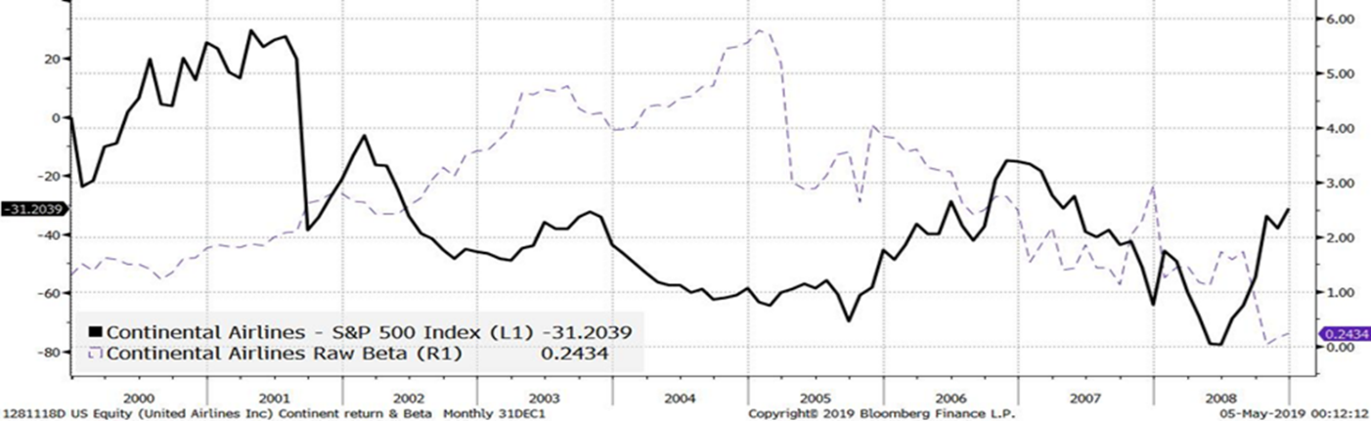Figure S5

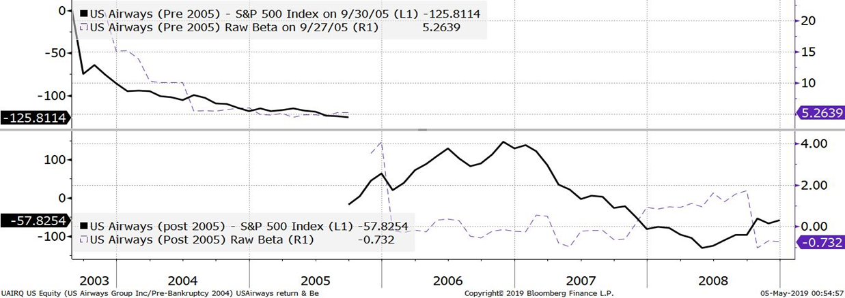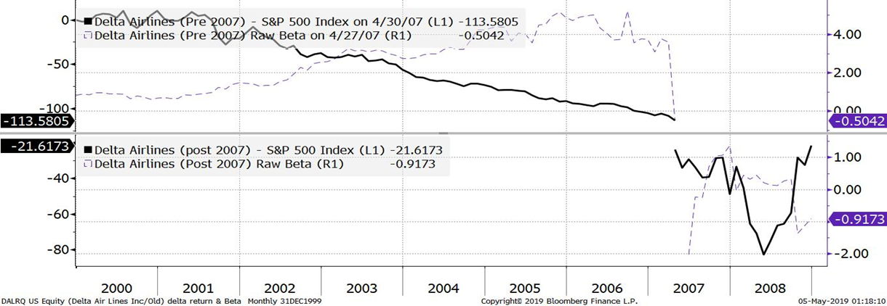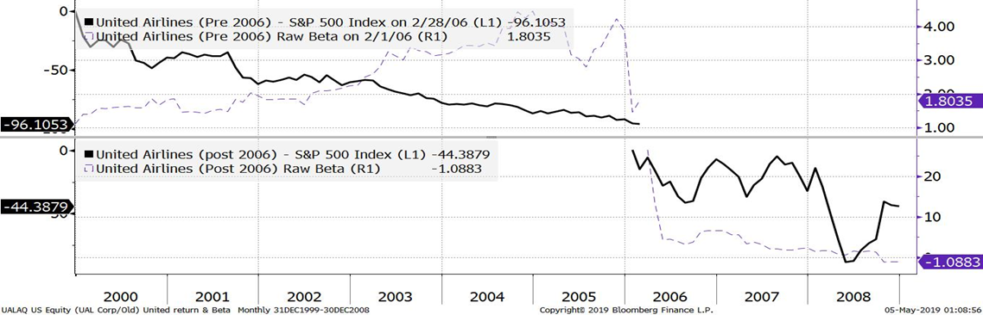

S6. Might the reported earnings of airlines have been deliberately managed downward in order to avoid tax?

A reviewer raised the interesting question of whether the reported earnings of the airlines had been managed downward to avoid tax and wondered whether analysis of nonfinancial performance measures, such as that proposed by Michael Schefczyk, might inform this issue.[11] Schefczyk proposed nonfinancial measures in order to circumvent problems in comparing financial measures for airlines based in jurisdictions operating under different tax and accounting rules. We are fortunate that this is not a major problem in our study, which is confined to U.S. airlines. In relation to the more general question of tax avoidance motives leading to distortions in reported profits, the losses that the airlines reported in this period (Table 1 in the main paper) were so great that they could have reported much smaller losses without risking liability for any tax.

We do report some physical measures and these are consistent with the financial metrics: Figure 4 in the main paper shows that capacity utilization (reflected in the comparison of enplanements and capacity) changed adversely (for the airlines, not the passengers) in the “GE dependence” period and favorably (for the airlines, not the passengers) in the subsequent period of market concentration.

We also show that in more recent years tax considerations did not deter the airlines from reporting high profits. And performance-related pay for airline executives, driven by financial metrics, may have encouraged over- rather than underreporting of profit.

S7. The role of government, government legislation, lobbying activities

The historical origins of §1110 are in the nineteenth-century railroad industry.[12] In 1957, Congress extended similar cover to aircraft and aircraft equipment financing by adding section 116(5) to the 1933 Act.[13] Section 116(5) morphed into §1110 in the current (1978) Bankruptcy Code. Because of various court cases that exposed ambiguities in §1110, Congress has amended §1110 (in 1994, 2000, and 2005) to maintain the spirit and intention of §1110.[14] While it certainly cannot be said that GE was a prime mover behind the creation of §1110 in 1978, it did play a role, albeit indirect, in achieving the 2000 amendment with Boeing.[15]

Section §1110 has afforded special treatment to lenders who targeted transportation industries, to encourage the financing necessary to capitalize industries deemed important to the public and the economy, at lower-than-usual interest rates.[16] “Whether or not there was an initial need for these provisions, . . . the industry claims it would simply cease financing of the relevant equipment if the protections were removed.”[17]

Airlines spend a fair amount of money on lobbying activities (see OpenSecrets.org, which tabulates data from the Senate Office of Public Records), but it is less clear that the lobbying is always effective. There is no evidence that US Airways and UAL spent more on lobbying when they were in Chapter 11 or emerging from it, but Delta’s lobbying expenditure increased by 150 percent in the year it exited from Chapter 11. The lobbying expenditure of GE on the airlines and air transport sector appears to be inconsequential. In 2008, GE spent $18.66 million in total on lobbying; 96 percent of this was for miscellaneous manufacturing and distribution and only 0.16 percent was spent on air transport.

There are instances where the government has helped the sector. For example, the Senate passed an amendment in 2005 to give financially troubled airlines, like Delta, twenty years to stretch out payments to their underfunded pension plans.[18] But there are also numerous instances when lobbying has not resulted in assistance. Invariably, individual airlines lobby against other airlines. When the government panel denied UAL’s 2002 request for loan aid, UAL enlisted the support of the House speaker, but Continental and American lobbied against UAL.[19]

1. Richard H. K. Vietor, “Contrived Competition: Airline Regulation and Deregulation,” *Business History Review* 64, no. 1 (1990): 61–108; See also Elizabeth Bailey, David Graham, and Daniel Kaplan, *Deregulating the Airlines* (Cambridge, MA, 1985).
2. Bailey, Graham, and Kaplan, *Deregulating*.
3. Alfred Kahn, “Airline Deregulation – A Mixed Bag, But a Clear Success Nevertheless,” *Transportation Law Journal* 16 (1988): 248–49.
4. Vietor, “Contrived Competition.”
5. Adam Pilarski, *Why Can’t We Make Money in Aviation?* (Burlington, VT, 2007), 26.
6. Richard Gritta, Bahram Adrangi, Brian Adams, and Nina Tatyanina, “An Update on Airline Financial Condition and Insolvency Prospects Using the Altman ‘Z’ Score Model,” *Journal of the Transportation Research Forum* 47, no. 2 (2008): 133–38.
7. See Vitaly S. Guzhva and Notis Pagiavlas, “US Commercial Airline Performance after September 11, 2001: Decomposing the Effect of the Terrorist Attack from Macroeconomic Influences,” *Journal of Air Transport Management* 10, no. 5 (2004): 327–32; Dennis J. Fixler and Bruce T. Grimm, “Reliability of GDP and Related NIPA Estimates,” *Survey of Current Business* 82 (Jan. 2002): 9–27; Benoît Cheze, Pascal Gastineau , and Julien Chevallier, “Forecasting World and Regional Aviation Jet Fuel Demands to the Mid-Term (2025),” *Energy Policy* 39, no. 9 (2011): 5147–58.
8. Pilarski, *Why Can’t We Make*.
9. Harumi Ito and Darrin Lee “Assessing the impact of the September 11 terrorist attacks on U.S. airline demand”, *Journal of Economics and Business*, 57 (2005): 75-95.

   The output results of the econometric model have not been presented because of space constraints and are available upon request.
10. Susan Carey, “United Airlines Gets Clearance to Exit Bankruptcy Protection,” *Wall Street Journal*, 21 Jan. 2006; Thomas G. Donlan, “Delta Returns to Trading with Strong Balance Sheet,” *Wall Street Journal*, 13 May 2007; “US Airways Is Cleared to Leave Bankruptcy,” *Wall Street Journal*, 17 Sept. 2005.
11. Michael Schefczyk, “Operational Performance of Airlines: An Extension of Traditional Measurement Paradigms,” *Strategic Management Journal* 14, no. 4 (1993): 301–17.
12. Gregory P. Ripple, “Special Protection in the Air[Line Industry]: The Historical Development of Section 1110 of the Bankruptcy Code,” *Notre Dame Law Review* 78, no. 1 (2002): 281–306.
13. Louis B. Goldman, Michael J. Album, and Mark S. Ward, “Repossessing the Spirit of St. Louis: Expanding the Protection of Sections 1110 and 1168 of the Bankruptcy Code,” *Business Lawyer* 41, no. 1 (1985): 29–55; Wilbur F. Foster and Risa M. Rosenberg, “Aircraft Lessors Entitled to Adequate Protection during the § 1110 60-Day Period,” *American Bankruptcy Institute Journal* 29, no. 1 (2010).
14. Ripple, “Special Protection.”
15. S. Fier, “Capitol Hill Will Heat Up before It Cools Down,” *Equipment Leasing Today* 12, no. 6 (2000).
16. Goldman, Album, and Ward, “Repossessing.”
17. H.R. Rep. No. 95-595, at 239 (1978).
18. Marilyn Geewax, “Pensions: Senate OKs Special Help for Airlines,” *Atlanta Journal*, 17 Nov. 2005.
19. Edmund L. Andrews and Edward Wong, “U.S. Panel Rejects Plea for Loan Aid by United Airlines,” *New York Times*, 5 Dec. 2002.