Supplementary material for Bulletin of Entomological Research

A comparison of the biology of Frankliniella intonsa and Megalurothrips usitatus on cowpea pods under natural regimes through an age-stage, two-sex lifetable approach
Liang-De Tang^{1#}, Ling-Hang Guo^{2#}, Zhen Shen¹, Yong-Ming Chen¹, Lian-Sheng Zang^{1*}
¹ National Key Laboratory of Green Pesticide, Guizhou University, Guiyang 550025, China
² School of Plant Protection, Hainan University, Haikou, 570228, China

# These authors contributed equally to this work.
*Correspondence author: lsz0415@163.com

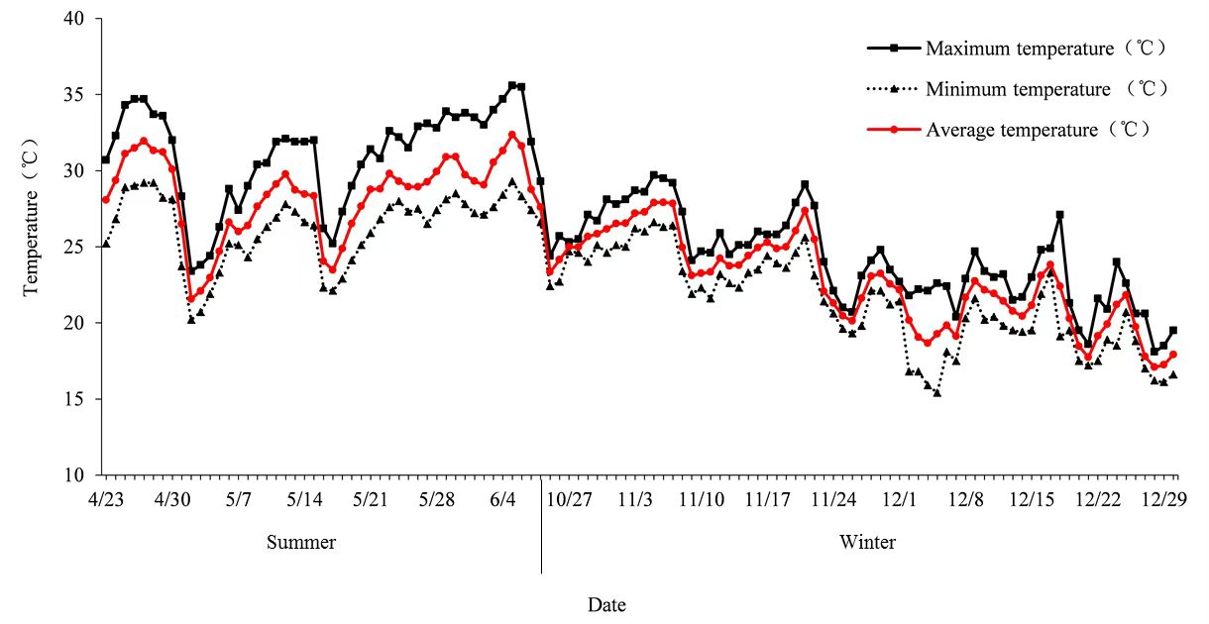
Fig. S1. The environmental temperature was recorded in summer (average temperature: 28.4 °C) and winter (average temperature: 22.7 °C) during the experiment in Dafeng Town, Chengmai County, Hainan Province, China. Note: Summer and winter here means most of the time is in this interval.

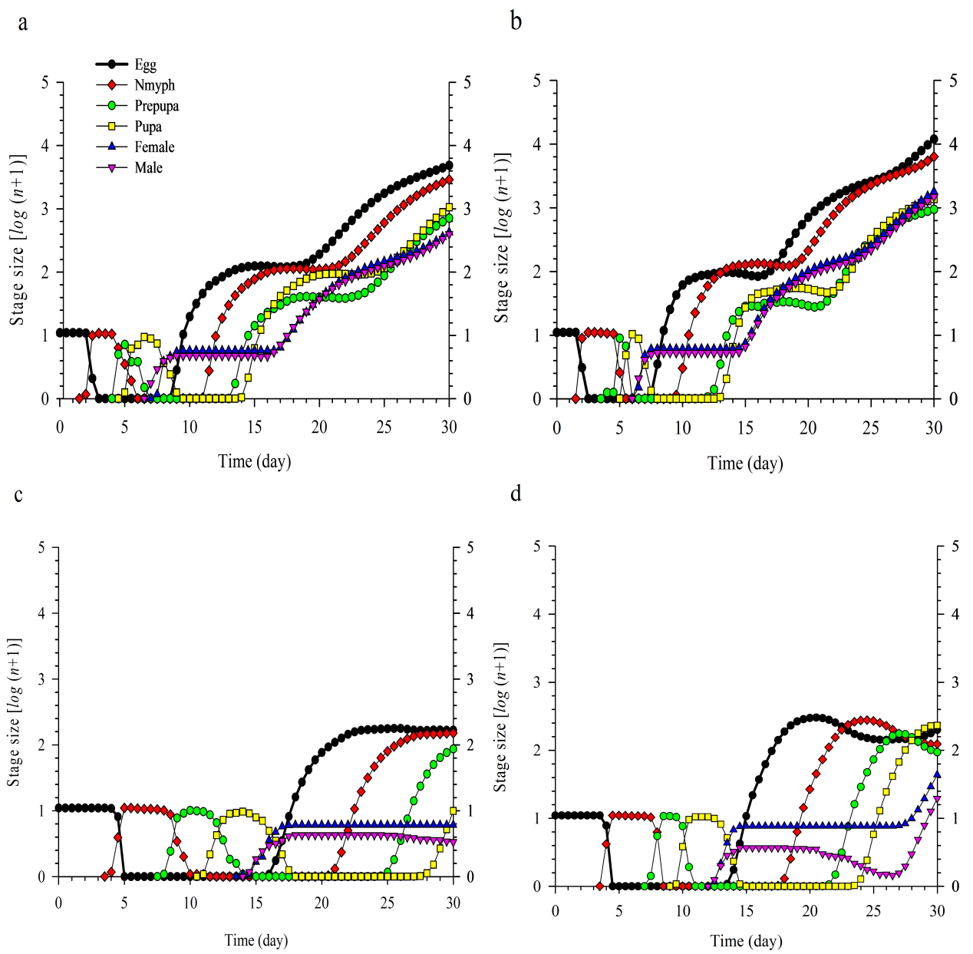
Fig. S2. Population projection of M. usitatus and F. intonsa on cowpea: (a) summer × M. usitatus, (b) summer × F. intonsa, (c) winter × M. usitatus and (d) winter × F. intonsa

