Supplementary Files
Monitoring mosquito richness in understudied area:
can environmental DNA metabarcoding be a complementary approach
to adult trapping ?

Rafael Gutierrez Lopez, Bastian Egeter, Christophe Paupy, Nil Rahola, Boris Makanga, Davy Jiolle, Vincent Bourret, Martim Melo, Claire Loiseau

Table S1. Names and number of sequences of the species known to be present on São Tomé included in the reference database.

Mosquito species | Sequence origin | Number of sequences
Anopheles coustani | This study | 1
Lutzia tigripes | This study | 1
Uranotaenia connali | This study | 3
Uranotaenia micromelas | This study | 3
Uranotaenia balfouri | GenBank/BOLD | 3
Uranotaenia bilineata | GenBank | 1
Aedes nigricephalus | This study | 2
Culex cambournaci | This study | 2
Culex decens | This study | 2
Aedes tarsalis | GenBank/BOLD | 3
Culex annulioris | GenBank/BOLD | 12
Culex thalassius | GenBank/BOLD | 3
Eretmapodites chrysogaster | GenBank/BOLD | 2
Toxorhynchites brevipalpis | GenBank | 1

Table S2. Taxonomic assignment before OTUs filtering (see excel file Table S2).
Table S3. Taxonomic assignment after OTUs filtering (see excel file Table S3).
Figure S1. Alpha rarefaction plots showing the number of OTUs obtained with a rarefied number of sequences in each sample. The plots (A) and (B) were generated using the OTU table before and after the OTU filtering respectively. The vertical axis displays the number of OTUs observed at different subsampling depths.
(A)
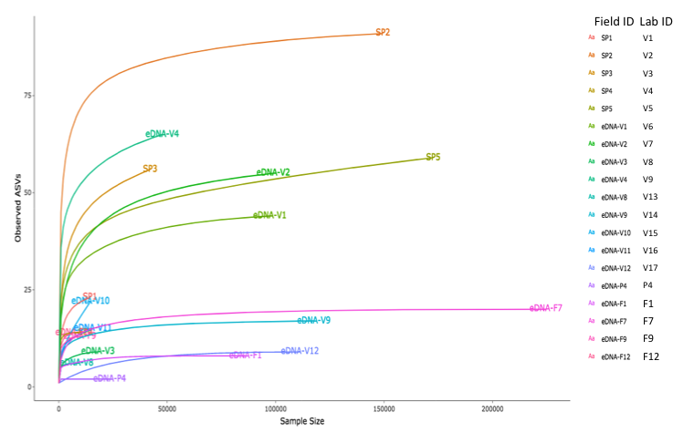
(B)

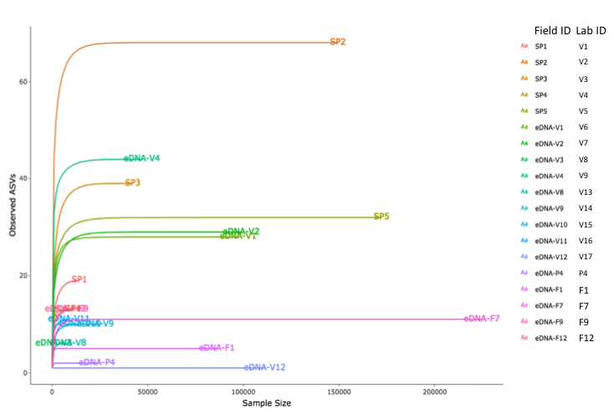
Figure S2.
Results of the BLAST in NCBI for all the OTUs assigned to Eretmapodites intermedius.

OTU 41
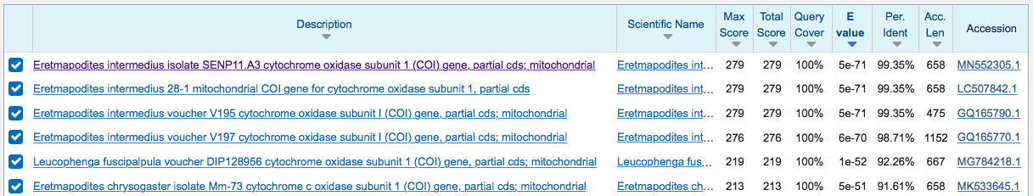
OTU 195
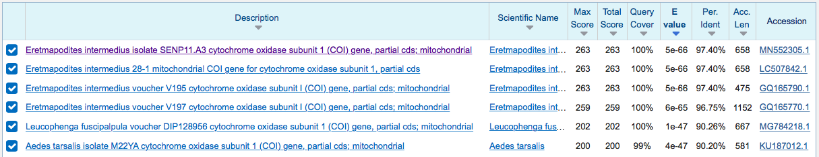
OTU 228
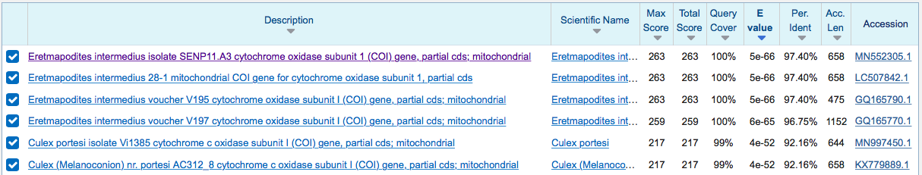
OTU 238
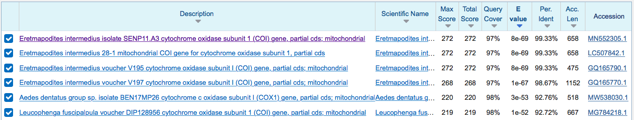
OTU 247
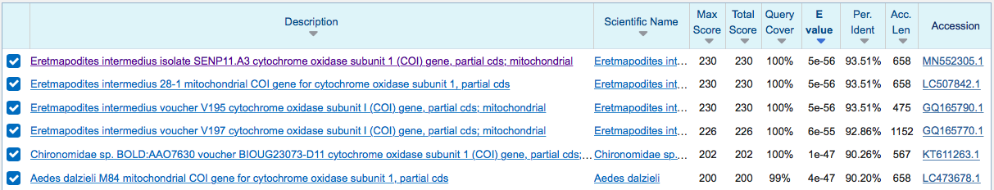
OTU 258
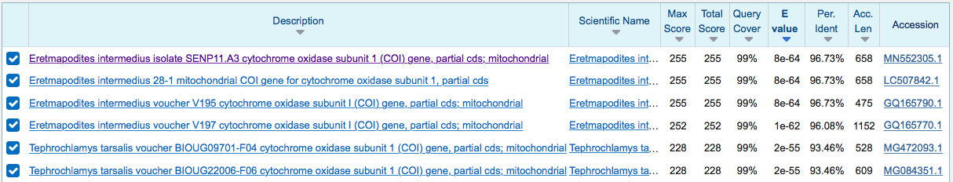
OTU 448
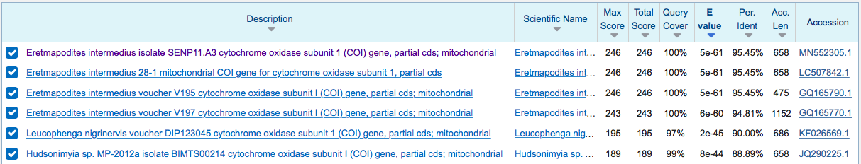
OTU 522
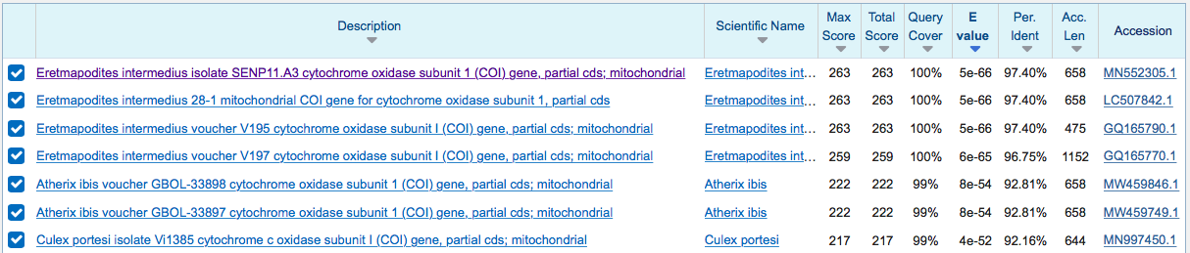
OTU 616
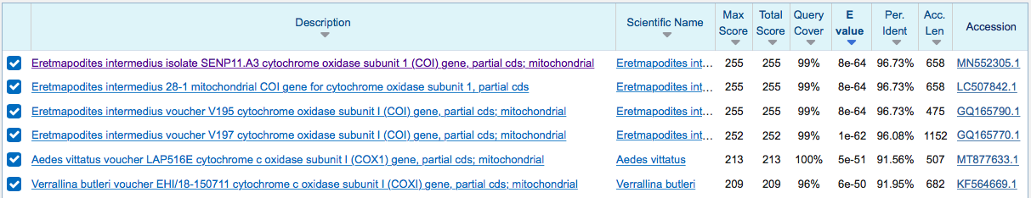
OTU 630
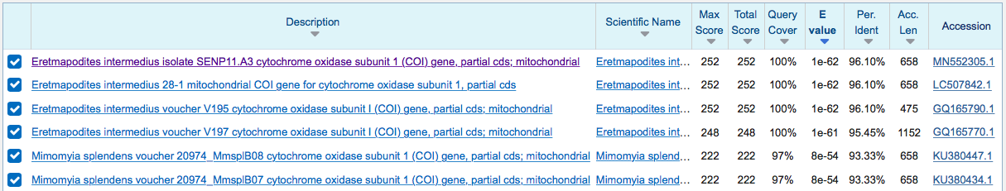
OTU 631
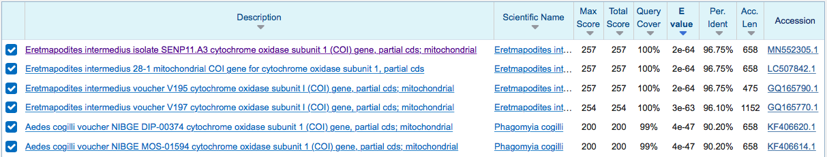
OTU 632
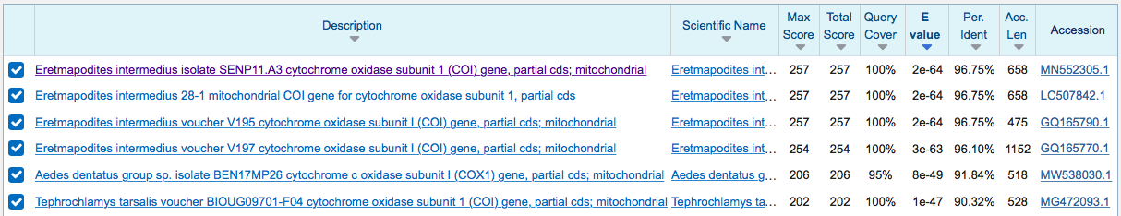
OTU 637
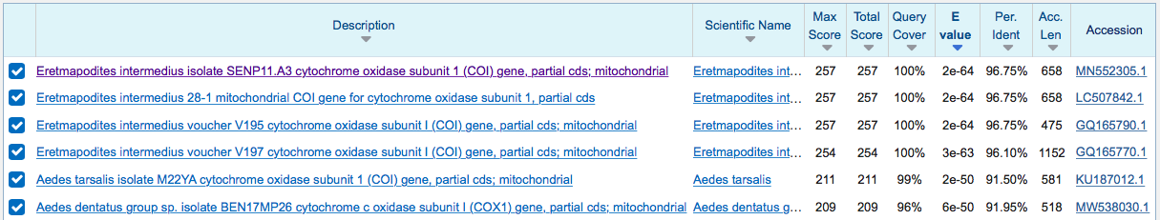
OTU 647
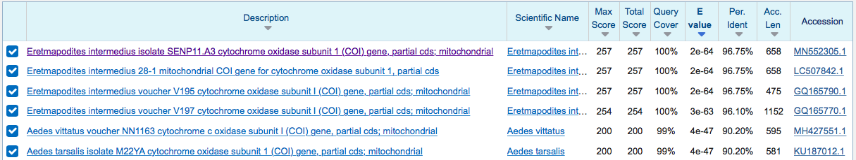

OTU 651
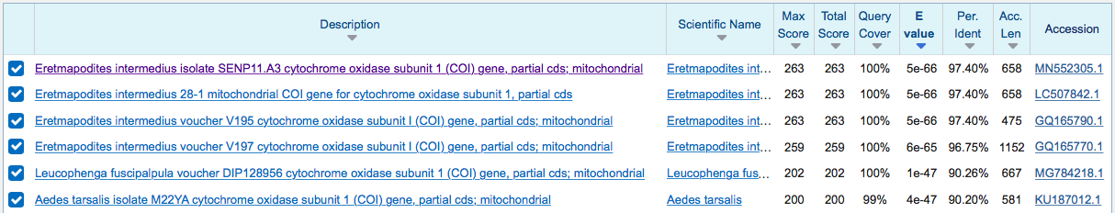
OTU 653
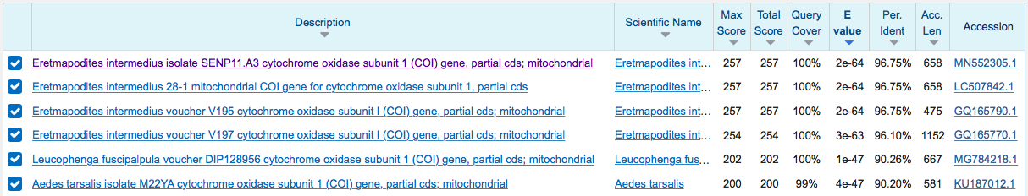

Figure S3.
Top left: Percentages of mosquito species per genus are given for the main genera Aedes, Culex and Anopheles. Other genera are represented in white and listed here (in decreasing percentage order): Uranotaenia, Wyeomyia, Tripteroides, Verrallina, Toxorhynchites, Coquillettidia, Armigeres, Topomyia, Psorophora , Eretmapodites, Mimomyia , Heizmannia , Sabethes, Orthopodomyia, Culiseta, Haemagogus , Mansonia, Deinocerites, Trichoprosopon, Malaya, Hodgesia , Limatus, Ficalbia , Bironella, Lutzia , Aedeomyia , Runchomyia, Onirion , Chagasia , Zeugnomyia , Isostomyia , Johnbelkinia, Shannoniana, Udaya , Opifex , Maorigoeldia, Galindomyia. Data were retrieved from http://www.mosquitocatalog.org; accessed on 26 February 2020.
Top right and bottom: Percentages of sequences per mosquito genus for 18S rRNA, COI and 28S rRNA genes. Data were recovered from NCBI https://www.ncbi.nlm.nih.gov; accessed on 26 February 2020).

