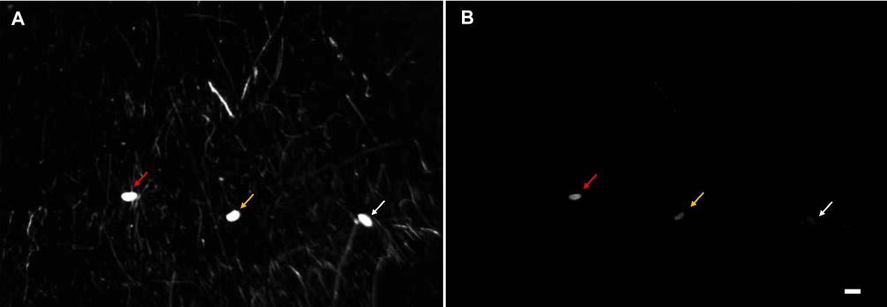
Figure S1 Nucleic acid distribution in pupae after immersion dsRNA (A) white light; (B) UV light. Red, yellow and white arrows indicate dsCP+TO + RNATransMate + dye, dsCP+TO + dye and ddH₂O without dye treatments, respectively. Bar represents 1 mm length.

