Supplementary DATA
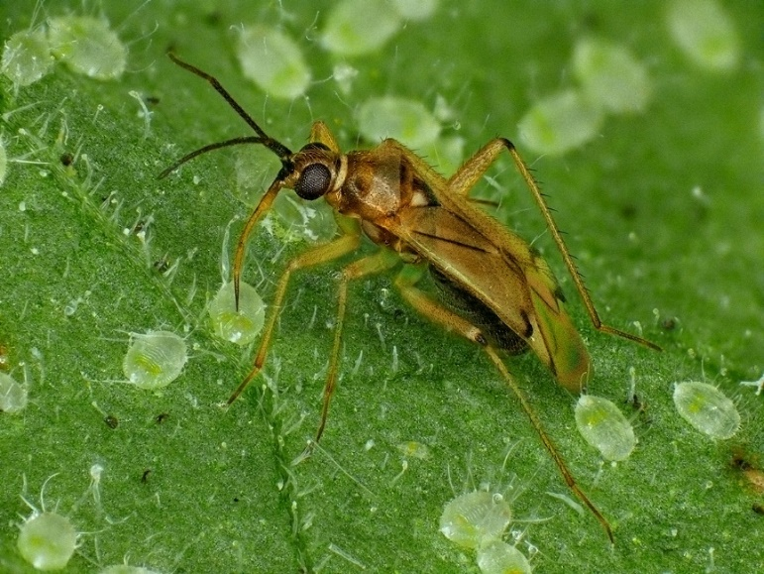
Supplementary file. Figure 1 Nesidiocoris volucer feeding on T. vaporariorum nymphs on a tobacco plant, photo taken by A. Franck CIRAD, UMR PVBMT.

