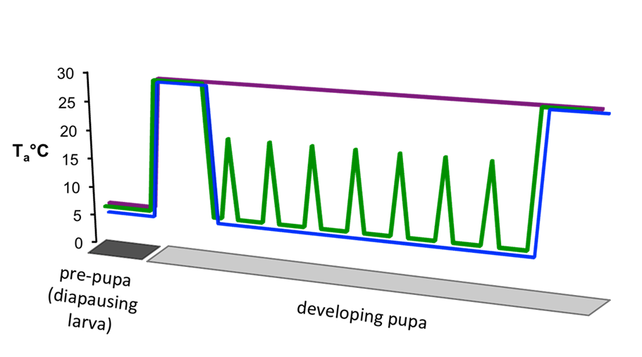
Supplementary figure 1. Thermal regimes applied during red-eye pupa development. The fluctuation thermal regime (FTR) shown in green, static thermal regime (STR) shown in blue, and control temperatures in purple.

Supplementary figure 2. Stages of metamorphosis at -10°C for 1-4 days, y-axis reports percent dead. Post-diapause quiescent (PDQ) pre pupa had individuals surviving at all time points. The red-eye pupa and emergence ready (ER) stage did not survive any time points at -10°C.

Supplementary table 1. Developmental stages included in each experiment. Columns denote developmental stage and (X) indicates that stage was included in the experiment (rows).
 | Pre-pupa | Larval-pupal molt | Pink-eye pupa | Red-eye pupa | Emergence ready
supercooling point | x | x | x | x | x
post-cold survival | x |  |  | x | x
CTmin |  |  |  | x
chilling recovery |  |  |  | x
emergence |  |  |  | x

Supplementary table 2. Temperature treatments applied during development for each experiment. Columns denote the temperature regime, and rows denote the experiment.
 | Control | FTR | STR | -5°C | -10°C
post-cold survival |  |  |  | x | x
CTmin | x | x | x
chilling recovery | x | x | x
emergence | x | x | x

Supplementary table 3. GLM pairwise comparisons of treatment effects on chilling recovery.
contrast estimate | SE | df | z.ratio | p.value
X1,control - X3,control -0.32093023 0.04117120 Inf -7.795 <.0001
X1,control - X24,control -0.60000000 0.04117120 Inf -14.573 <.0001
X1,control - X1,FTR 0.13425926 0.04107579 Inf 3.269 0.0299
X1,control - X3,FTR -0.18667097 0.05815745 Inf -3.210 0.0360
X1,control - X24,FTR -0.46574074 0.05815745 Inf -8.008 <.0001
X1,control - X1,STR 0.09624413 0.04122017 Inf 2.335 0.3209
X1,control - X3,STR -0.22468610 0.05825951 Inf -3.857 0.0037
X1,control - X24,STR -0.50375587 0.05825951 Inf -8.647 <.0001
X3,control - X24,control -0.27906977 0.04117120 Inf -6.778 <.0001
X3,control - X1,FTR 0.45518949 0.05815745 Inf 7.827 <.0001
X3,control - X3,FTR 0.13425926 0.04107579 Inf 3.269 0.0299
X3,control - X24,FTR -0.14481051 0.05815745 Inf -2.490 0.2366
X3,control - X1,STR 0.41717436 0.05825951 Inf 7.161 <.0001
X3,control - X3,STR 0.09624413 0.04122017 Inf 2.335 0.3209
X3,control - X24,STR -0.18282564 0.05825951 Inf -3.138 0.0448
X24,control - X1,FTR 0.73425926 0.05815745 Inf 12.625 <.0001
X24,control - X3,FTR 0.41332903 0.05815745 Inf 7.107 <.0001
X24,control - X24,FTR 0.13425926 0.04107579 Inf 3.269 0.0299
X24,control - X1,STR 0.69624413 0.05825951 Inf 11.951 <.0001
X24,control - X3,STR 0.37531390 0.05825951 Inf 6.442 <.0001
X24,control - X24,STR 0.09624413 0.04122017 Inf 2.335 0.3209
X1,FTR - X3,FTR -0.32093023 0.04117120 Inf -7.795 <.0001
X1,FTR - X24,FTR -0.60000000 0.04117120 Inf -14.573 <.0001
X1,FTR - X1,STR -0.03801513 0.04122017 Inf -0.922 0.9918
X1,FTR - X3,STR -0.35894536 0.05825951 Inf -6.161 <.0001
X1,FTR - X24,STR -0.63801513 0.05825951 Inf -10.951 <.0001
X3,FTR - X24,FTR -0.27906977 0.04117120 Inf -6.778 <.0001
X3,FTR - X1,STR 0.28291510 0.05825951 Inf 4.856 <.0001
X3,FTR - X3,STR -0.03801513 0.04122017 Inf -0.922 0.9918
X3,FTR - X24,STR -0.31708490 0.05825951 Inf -5.443 <.0001
X24,FTR - X1,STR 0.56198487 0.05825951 Inf 9.646 <.0001
X24,FTR - X3,STR 0.24105464 0.05825951 Inf 4.138 0.0012
X24,FTR - X24,STR -0.03801513 0.04122017 Inf -0.922 0.9918
X1,STR - X3,STR -0.32093023 0.04117120 Inf -7.795 <.0001
X1,STR - X24,STR -0.60000000 0.04117120 Inf -14.573 <.0001
X3,STR - X24,STR -0.27906977 0.04117120 Inf -6.778 <.0001

treatment | N | Subset means
 |  | 1 | 2 | 3
CON | 196 | 22.12
STR | 77 |  | 24.64
FTR | 164 |  |  | 25.84
Sig. |  | 1.000 | 1.000 | .966
Supplementary table 4. Mean days to emergence with respect to temperature treatment applied during the red-eye stage. Means for groups in homogeneous subsets are displayed. The error term is Mean Square(Error) = 4.421. Table uses Harmonic Mean Sample Size = 123.001 at alpha 0.05.

