Where in the world could Helicoverpa punctigera (Lepidoptera: Noctuidae) invade?

Ruan C. de M. Oliveira^{1,2}, Myron P. Zalucki³, Patrik L. Pastori¹ and Darren J. Kriticos ^{3,4}

¹Programa de Pós-graduação em Agronomia/Fitotecnia, Universidade Federal do Ceará – UFC, Av. Mister Hull, 2977, 60356-001, Fortaleza, CE, Brazil
² IN Soluções Biológicas LTDA, R. Padre Guerra SN, Bloco 310, Pici, 60440-605, Fortaleza, CE, Brazil
³ School of Biological Science, The University of Queensland, St Lucia, QLD 4072, Australia
⁴ CSIRO Health & Biosecurity, P.O. Box 1700, Canberra, A.C.T. 2601, Australia

Supplementary Material

List of Figures in the Supplementary Online Material
Fig. A: Annual Growth Index (GI_{A}) for Helicoverpa punctigera projected using CLIMEX, taking into account irrigation patterns and diapause, under CS GCM running the A1B scenario for a) Current and d) 2100 future scenario, Point locations indicate the natural occurrence.

Fig. B: Cold stress index for Helicoverpa punctigera projected using CLIMEX, taking into account irrigation patterns and diapause, under CS GCM running the A1B scenario for a) Current and d) 2100 future scenario, Point locations indicate the natural occurrence.

Fig. C: Dry stress index for Helicoverpa punctigera projected using CLIMEX, taking into account irrigation patterns and diapause, under CS GCM running the A1B scenario for a) Current and d) 2100 future scenario, Point locations indicate the natural occurrence.
.
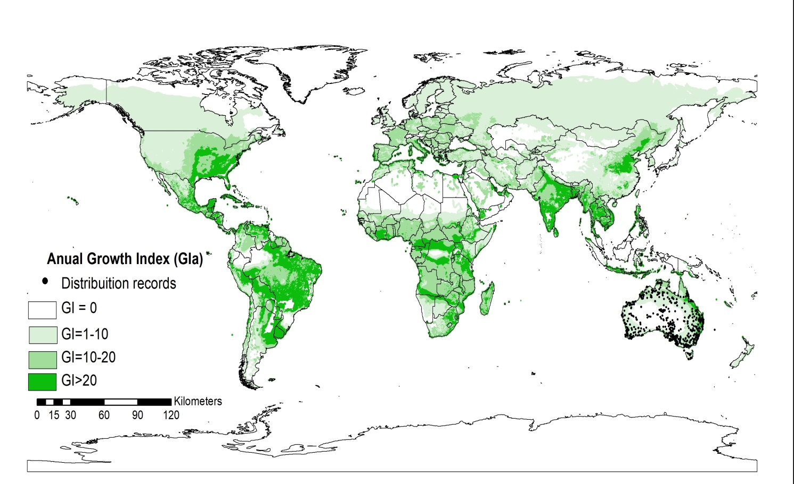
A.

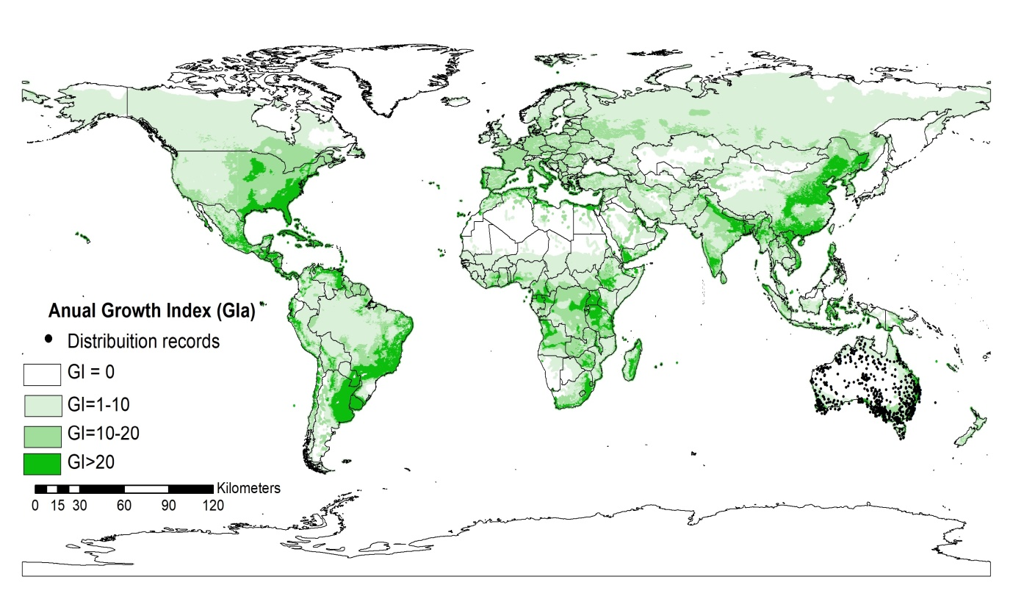
B.
Fig. A: Annual Growth Index (GI_{A}) for Helicoverpa punctigera projected using CLIMEX, taking into account irrigation patterns and diapause, under CS GCM running the A1B scenario for a) Current and d) 2100 future scenario, Point locations indicate the natural occurrence.
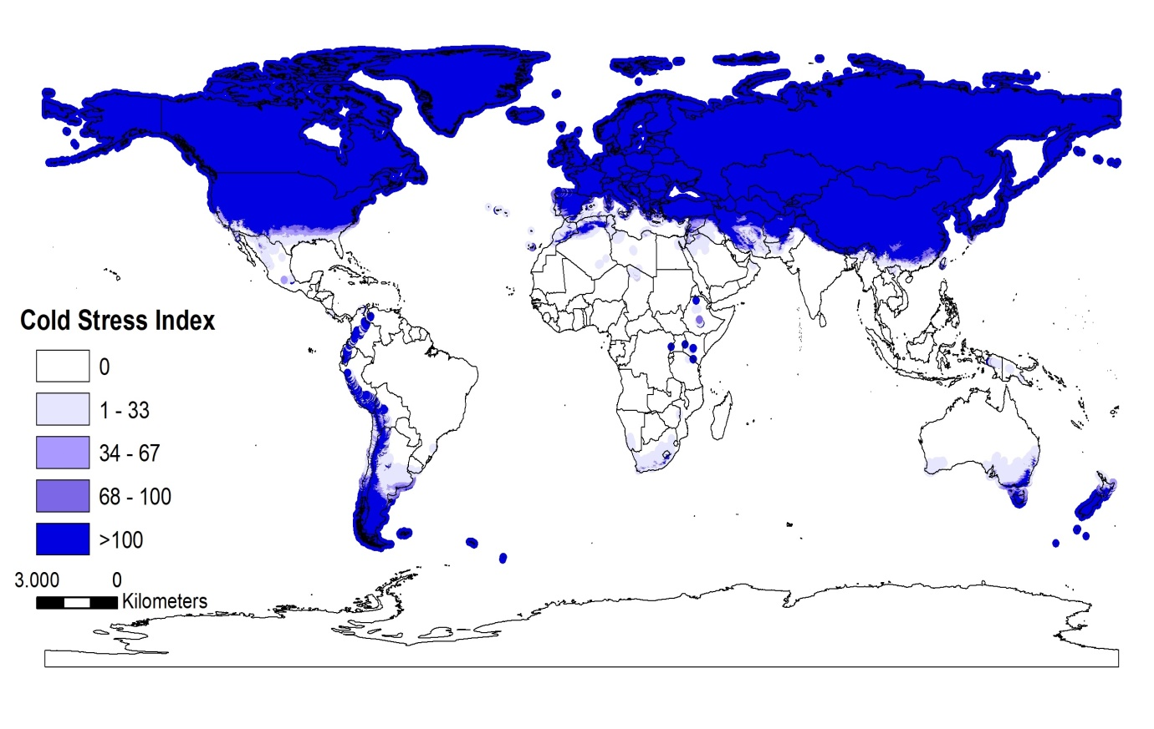
A.

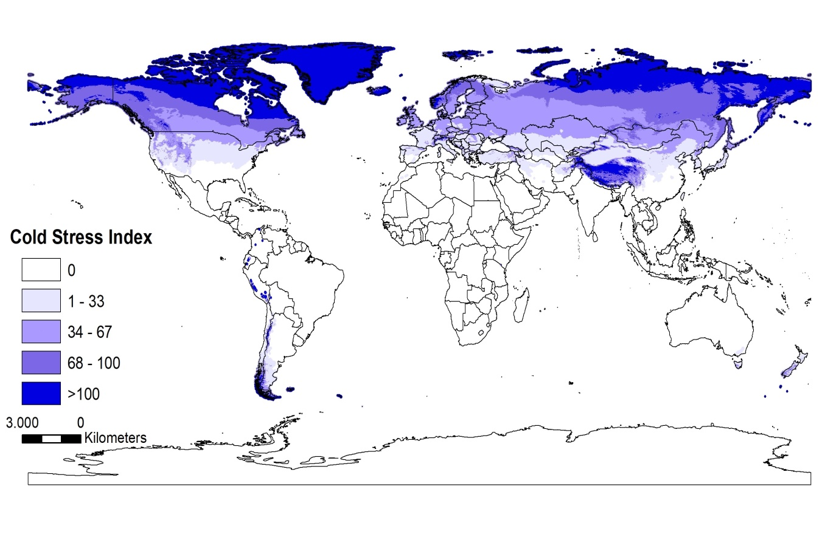
B.
Fig. B: Cold stress index for Helicoverpa punctigera projected using CLIMEX, taking into account irrigation patterns and diapause, under CS GCM running the A1B scenario for a) Current and d) 2100 future scenario, Point locations indicate the natural occurrence.
MetData: CM10_1975H_V1.1
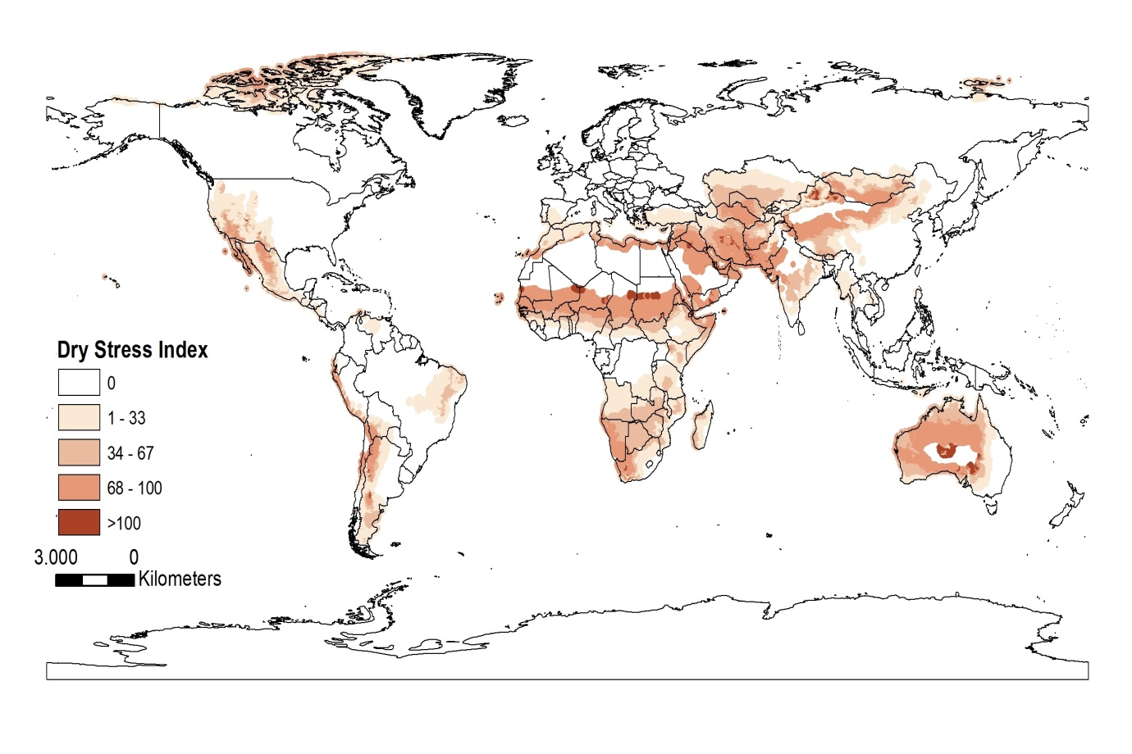
A.
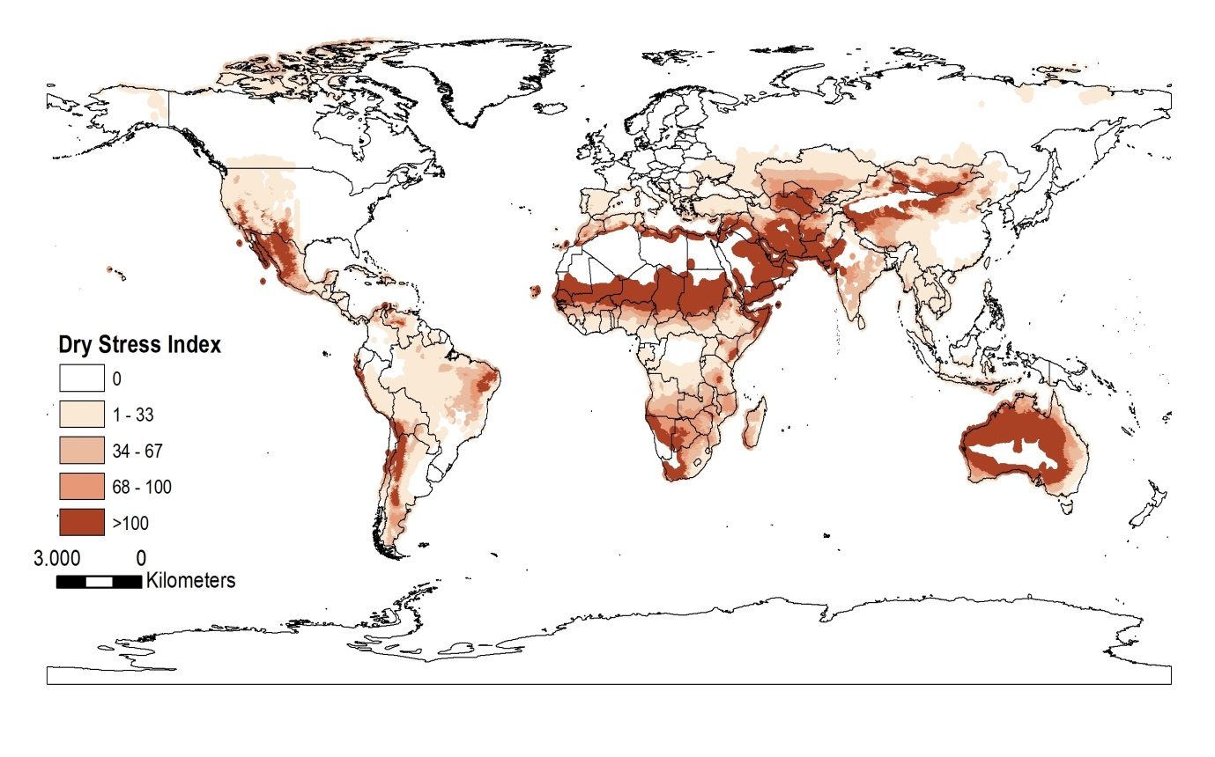
B.
Fig. C: Dry stress index for Helicoverpa punctigera projected using CLIMEX, taking into account irrigation patterns and diapause, under CS GCM running the A1B scenario for a) Current and d) 2100 future scenario, Point locations indicate the natural occurrence.

