Supplementary material

Fig. S1. Dynamic expression of sex pheromone communication-related genes SlitDes5 and SlitDes11 in the adult female sex pheromone gland (PG) and SlitOR6, SlitOR11, SlitOR13, SlitOR16, SlitPBP1, SlitPBP2, SlitPBP3 in the male antennae (MA). The different lowercase letters mean significance between tissues (p < 0.05, ANOVA, LSD). ♀, Female adult; ♂, Male adult; PG, sex pheromone gland; An, antenna. Horizontal axis: the PG or An from virgin female or male moths at 5 - 7 h of the scotophase at different ages (0 to 5-day-old); Vertical axis: the normalized expression of target gene was calculated by Q-gene software.
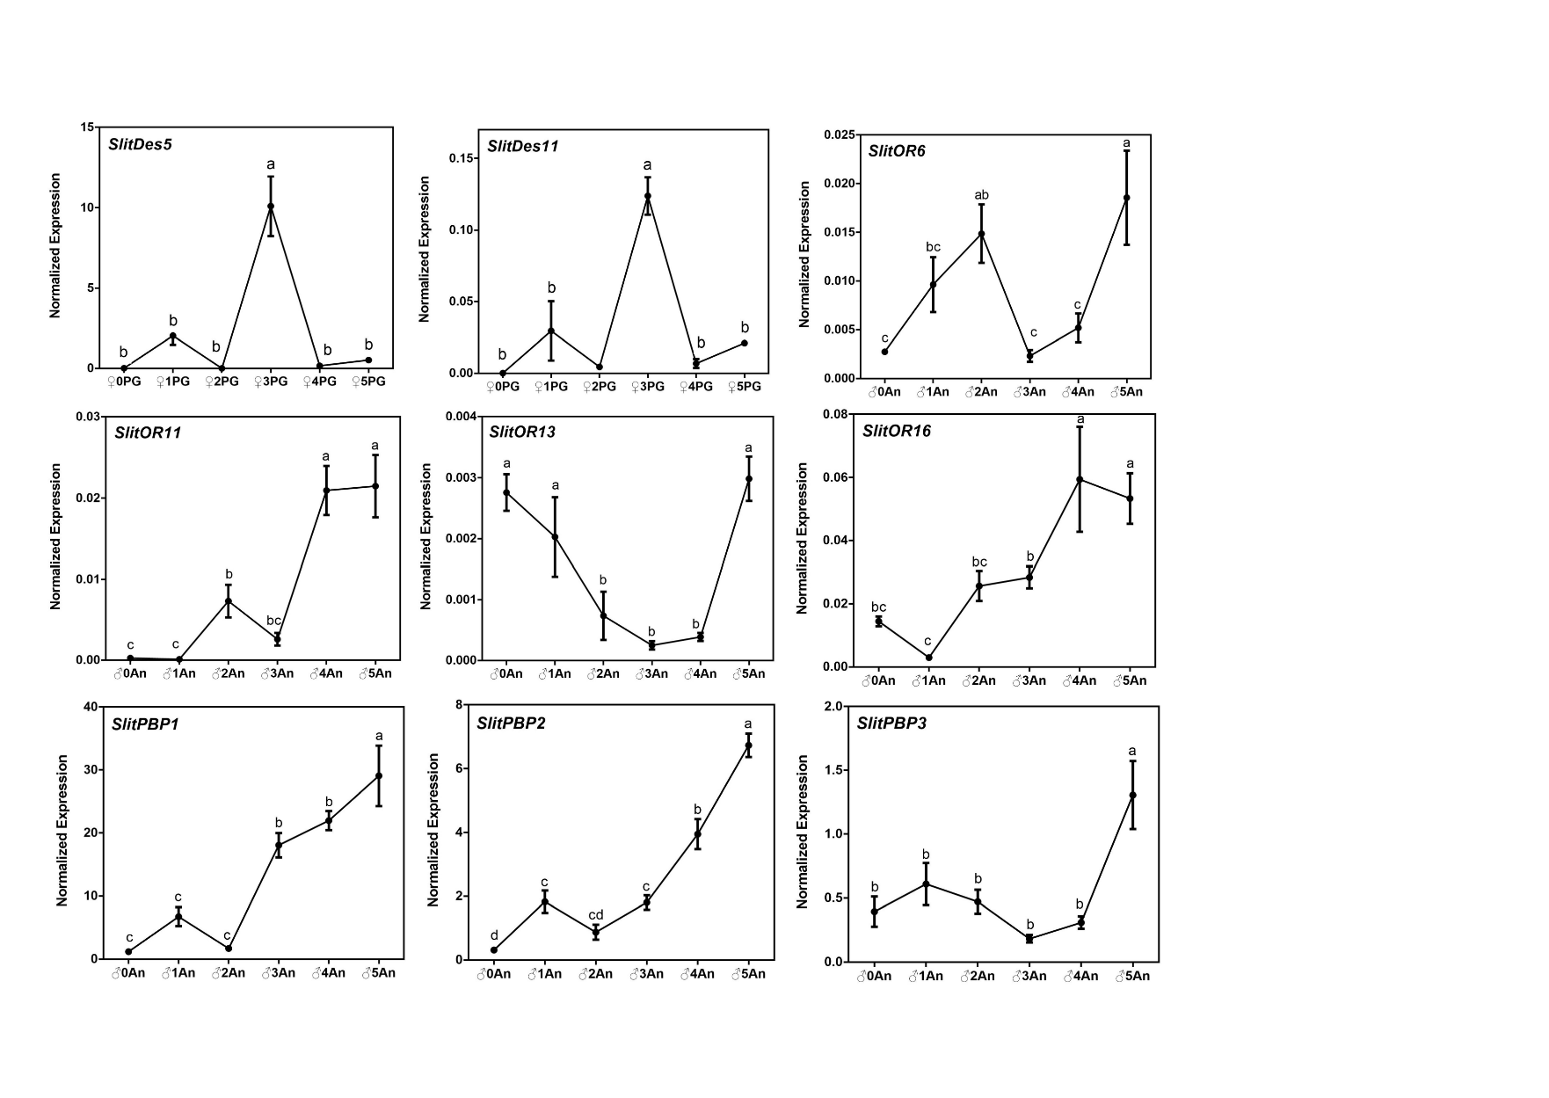

Fig. S2. Daily expression of sex pheromone communication-related genes SlitDes5 and SlitDes11 in the adult female sex pheromone gland (PG) and SlitOR6, SlitOR11, SlitOR13, SlitOR16, SlitPBP1, SlitPBP2, SlitPBP3 in the male antennae (MA). The different lowercase letters mean significance between tissues (p < 0.05, ANOVA, LSD). P, photophase; S, scotophase. Horizontal axis: the different points of samples were collected; Vertical axis: the normalized expression of target gene was calculated by Q-gene software.

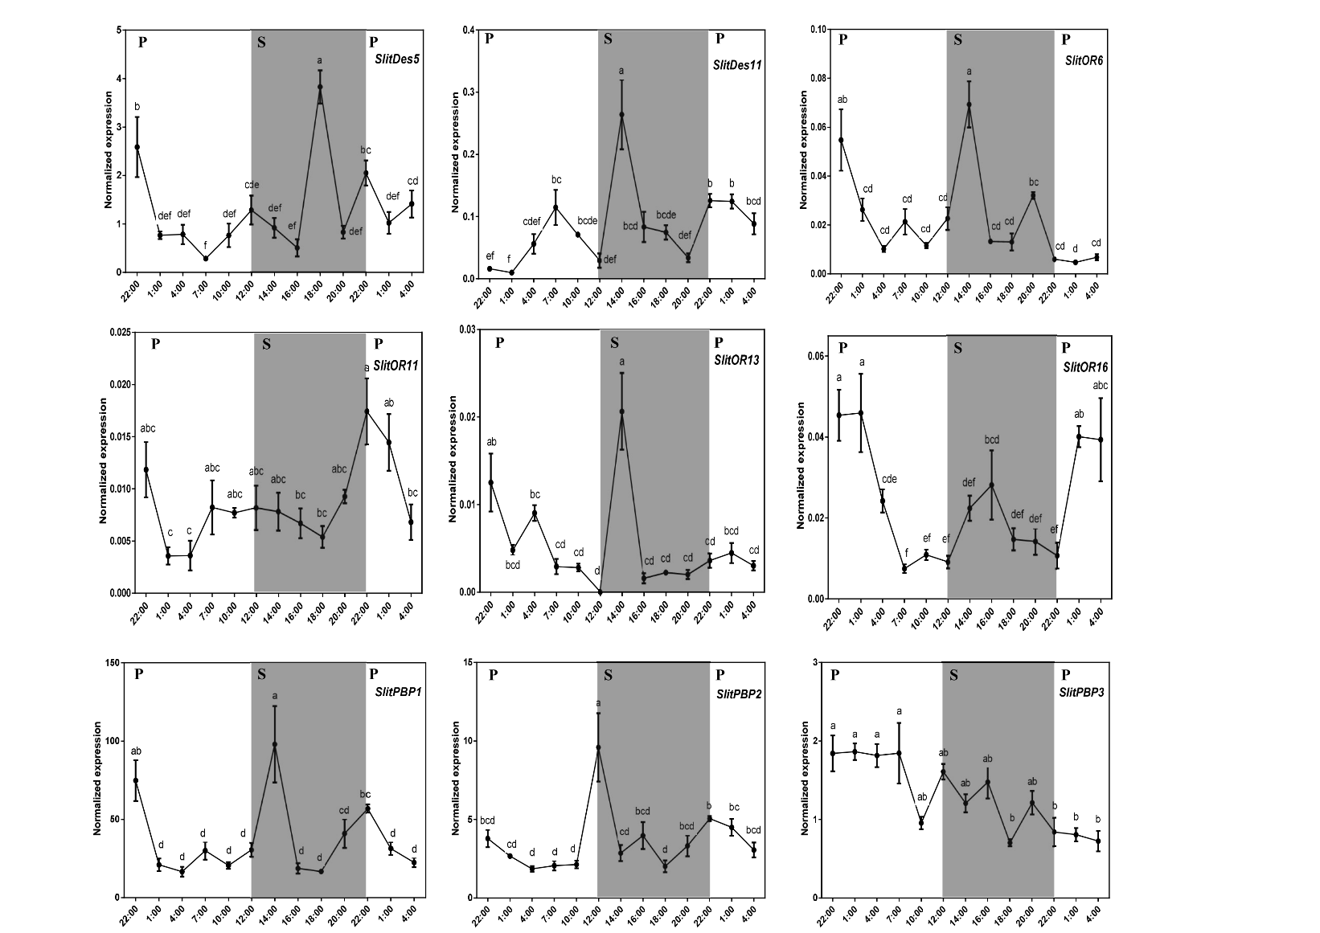

Table S1. Circadian clock genes of S. litura and other insects used for constructing phylogenetic trees.

Gene name | GenBank ID
SlitPer | This study
MbraPer | AAS49924.1
SexiPer | AEJ38224.1
AfalPer | AAC72313.1
MsexPer | ABW39272.1
BmorPer | ABF21088.1
DplePer | AAO48719.1
SfruPer | ABW39304.1
GbimPer | BAG48878.1
BgerPer | AAN02439.2
SlitTim1 | This study
AperTim1 | AAF66996.1
BmorTim1 | NP_001037622.1
SexiTim1 | AEJ38225.1
DpleTim1 | XP_032510676.1
TcasTim1 | AOR83338.1
PameTim1 | AAM77468.1
GbimTim1 | BAJ16356.1
AaegTim1 | AAY40757.1
SgreTim1 | ADX97416.1
DmelTim1 | AAC46920.1
ScraTim1 | BAB85471.1
SlitTim2 | This study
DmelTim2 | NP_524341.3
TcasTim2 | XP_008201051.1
DpleTim2 | XP_032512746.1
DmulTim2 | ATL75375.1
CmarTim2 | AFS34626.1
SlitClK | This study
DpleClK | XP_032526871.1
AperClK | AAR14936.1
DmelClK | AAD10630.1
CbowClK | APP94023.1
MsepClK | ARB18436.1
SexiClK | AEJ38222.1
TcasClK | NP_001106937.1
SlitCyc | This study
SnonCyc | ABC18168.2
DmelCyc | NP_524168.2
BmorCyc | NP_001036982.1
DpleCyc | AAR13012.1
AperCyc | AAR14937.1
AaegCyc | AEX32872.1
GbimCyc | BAN28450.1
LlonCyc | ABI21880.1
SlitCry1 | This study
HarmCry1 | ADN94464.1
MbraCry1 | AAY23345.1
AperCry1 | AAK11644.1
DpleCry1 | AAX58599.1
BmorCry1 | NP_001182628.1
SexiCry1 | ADY17887.1
SlitCry2 | This study
BmorCry2 | NP_001182627.1
AperCry2 | ABO38435.1
DpleCry2 | ABA62409.1
SlitVri | This study
SfruVri | AJB84657.1
ObruVri | KOB79426.1
AperVri | AAS92609.1
DpleVri | AAT86041.1
DmelVri | NP_001285624.1
ApisVri | ARM65427.1

Table S2. Primers used for qRT-PCR.

Primer name | Forward (5'-3') | Reverse (5'-3')
SlitGAPDH | TATCAAGCAGAAGGTCAAGG | CGAAGATGGAAGAGTGGTT
SlitEF | AATCGGTGGTATTGGTACG | TTGACTTCAGTGGTGATGTT
SlitPer | GAATGCGTTGAATCGGGTGTCG | TCCCTGGCTGAAGGTGGAGTGTT
SlitTim1 | ATTGGTCGGATCTTATCGAGTAT | TGTATCTGGCTTGCTCTGTGCTG
SlitTim2 | AAAGCAGTGGCGGAGATGACG | TCAGCTCGATTCGTTTCTGTTGC
SlitClK | AATCAACAGTCCTCAAGTCT | CCTCCAATGCCTCCAATA
SlitCyc | TCCTCCTACGACATATACAAG | GACGCATTCTGGTTGAAG
SlitCry1 | GTCCAGTCGGCCAGGTAGATTT | AGCCAGACGCTGCTGCATTTGT
SlitCry2 | CCCTAACCGATGACCACGACG | CCGACCAAATGAAGCCACCC
SlitVri | AGACCGCTGAACAGTATG | TTATGTGCTGAAGGGAGAG
SlitPBP1 | GTGAGTGTAATCCACGAATG | TGACCTCTTCCATGATGAC
SlitPBP2 | TGCTATCCTCTGCCTCT | TGTCCACTATCTGCTTCG
SlitPPB3 | ACGAGCGTGATGATGAC | AGGACCTCACTCACAATG
SlitOR6 | TCATTCTATTACTGATGGTGTTC | GCACTTGTTACTGTTAATCCT
SlitOR11 | CTGTCTGTTCAATCTGATACC | TACCATCCACTGAGAGTTG
SlitOR13 | CAGCAGTTGATTCAGTTGT | TGGACACCGACAGTAATC
SlitOR16 | GGATATGTCGTTGCTTGTATT | AATGCCTCGTTCTAATTCAC
SlitDes5 | TGCTGCGGTACATTATGA | AAGGTTGCTATGGACACA
SlitDes11 | GAAGCATCCAGACCTCAA | GGCATCAGCAGTAGATAGTA

