Supplementary Material

Table S1. Geographic characteristics of the three Greek populations whose pupae were subjected to prolonged chilling for producing ‘prolonged chilling’ adults. Freshly collected pupae remained at 25 ± 1^{ο}C for 2-3 months and then transferred to 3 ± 1 ^{ο}C for approximately 18 consecutive months (551 days). Then, pupae transferred back to 25 ± 1^{ο}C for adult emergence. Number of emerged adults per sex for each population are given. Pupae that did not give adults were dead. We used 484, 472 and 1,600 pupae from Kamari (Thessaly), Dafni (Macedonia) and Kallipefki (Thessaly) populations, respectively.
Location (Region) | Latitude / Longitude | Altitude (a.s.l) | Host fruit | Pupae collection date | Adult emergence
 |  |  |  |  | males/ females (n) | Total (%)
Kamari (Thessaly) | 39°34' 47'' N /22°55' 40'' E | 100m | wild cherries | 11th June, 2007 | 33 / 32 | 13.4%
Kallipefki (Thessaly) | 39°58' 0'' N /22°27' 37'' E | 1,054m | sweet cherries | 19th July, 2007 | 17 / 11 | 1.8%
Dafni (Macedonia) | 40°17' 06''N/ 21°08' 55'' E | 1,040m | sweet cherries | 16th July, 2007 | 21 / 9 | 6.4%

Table S2. Geographic characteristics of the three Greek populations from where pupae were used, and pupae collection date. Data for Mikra and Kernitsa have been previously published (Moraiti et al., 2012a).
Location (Region) | Latitude | Longitude | Altitude (a.s.l) | Pupae collection date
Mikra (Macedonia) | 40°31' 02'' N | 22°58' 0'' E | 4m | 15th June, 2007
Kamari (Thessaly) | 39°34' 47'' N | 22°55' 40'' E | 100m | 11th June, 2007
Kernitsa (Peloponnesus) | 38°02' 0'' N | 22°06' 0'' E | 731m | 20th June, 2007

Table S3. Pearson correlation products for the three body size traits (thorax length, thorax width, head width) of the Rhagoletis cerasi adults used in the Experiment 1 and the Experiment 2.
Experiment |  | Thorax width | Head width
Exp. 1 | Thorax length | (r=0.734, P<0.001) | (r=0.673, P<0.001)
(N=578) | Thorax width |  | (r=0.756, P<0.001)
Exp. 2 | Thorax length | (r=0.686, P<0.001) | (r=0.631, P<0.001)
(N=243) | Thorax width |  | (r=0.780, P<0.001)
Table S4. Results of the linear regression analysis for the effects of type of dormancy, population and sex on body size of Rhagoletis cerasi adults from Mikra (Macedonia), Kamari (Thessaly) and Kernitsa (Peloponnesus). Body size refers to the first principal component (PC1_Exp1). Data for adults from Mikra and Kernitsa have been previously published (Moraiti et al., 2012a).
Factor | Wald χ² (df) | P | B (95%CI)
Type of dormancy (ref: 2-year) | 357.744 (1) | <0.001 | -0.818 (-0.961, -0.676)
Population (ref: Kernista) | 24.363 (2) | <0.001
Mikra |  | 0.321 | 0.088 (-0.086, 0.263)
Kamari |  | 0.259 | -0.100 (-0.275, 0.074)
Sex (ref: male) | 532.235 (1) | <0.001 | 1.481 (1.279, 1.683)
Type of dormancy * Sex | 8.706 (1) | 0.003 | -0.303 (-0.504, -0.102)
Population * Sex | 6.150 (2) | 0.046
Mikra * females |  | 0.300 | -0.130 (-0.376, 0.116)
Kamari * females |  | 0.014 | -0.311 (-0.558, -0.064)
Table S5. Pairwise comparisons for the interaction between a) type of dormancy and sex, and b) type of dormancy and sex. Bonferroni correction was used to adjust for multiple comparisons. Body size refers to the composite index of the principal component analysis (PCA) of the three adult body traits (thorax length, thorax width, and head width) regressed to the first principal component which represent the overall body size and accounted for the 82.18% of the total variability. The body size was used as the dependent variable. Data for adults from Mikra and Kernitsa have been previously published (Moraiti et al., 2012a).
A. Population and Sex
Population | Sex | Mikra |  | Kamari |  | Kernitsa
 |  | Females | Males | Females | Males | Females | Males
Mikra | Females | -
 | Males | <0.001 | -
Kamari | Females | <0.001 | <0.001 | -
 | Males | <0.001 | 0.496 | <0.001 | -
Kernitsa | Females | 1.000 | <0.001 | <0.001 | <0.001 | -
 | Males | <0.001 | 1.000 | <0.001 | 1.000 | <0.001 | -
B. Type of dormancy and sex
Type of dormancy | Sex | 1-year |  | 2-year
 |  | Female | Male | Female | Male
1-year | Female | -
 | Male | <0.001 | -
2-year | Female | <0.001 | <0.001 | -
 | Male | 0.020 | <0.001 | <0.001 | -

Table S6. Adult longevity for Rhagoletis cerasi males and females emerged from pupae with annual diapause (1-year), and pupae with prolonged dormancy (2-year). Pupae obtained from field-infested cherries from Mikra (Macedonia, Greece), Kamari (Thessaly, Greece) and Kernitsa (Peloponnesus, Greece). Data for adults from Mikra and Kernitsa have been previously published (Moraiti et al., 2012a).
Population |  | Longevity (days)
 | N | (mean ± SE)
 |  | Males | Females
1-year
Mikra | 50 | 64.4 ± 3.0 | 63.6 ± 3.0
Kamari | 50 | 60.2 ± 3.2 | 58.7 ± 3.1
Kernitsa | 50 | 55.0 ± 3.1 | 57.7 ± 2.7
2-year
Mikra | 50 | 58.7 ± 3.6 | 51.2 ± 4.2
Kamari | 47 | 59.3 ± 4.2 | 47.7 ± 4.5
Kernitsa | 49 | 59.8 ± 4.1 | 48.0 ± 3.6

Table S7. Average longevity (mean ± SE) of Rhagoletis cerasi adults emerged from a) pupae with annual diapause (1-year), b) pupae with prolonged dormancy (2-year), and c) pupae that were exposed to cold for approximately 18 consecutive months (prolonged chilling). Pupae were obtained from Kamari population (Thessaly, Greece).

Type of dormancy | N | Longevity (days)
 |  | Males | Females
1-year | 50 | 60.24 ± 3.2 | 58.74 ± 3.1
2-year | 47 | 59.27 ± 4.2 | 47.72 ± 4.5
prolonged chilling | 26 | 49.04 ± 3.9 | 41.77 ± 4.4

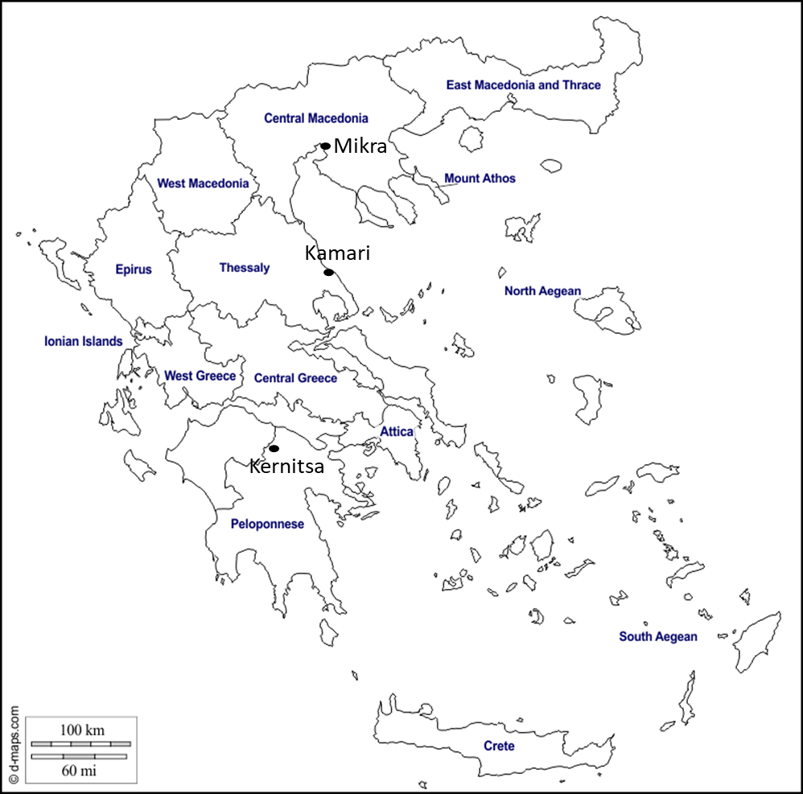

Figure S1. Map with the three Greek areas where Rhagoletis cerasi populations were obtained. Pupae were collected from infested sweet or wild cherries of abandoned trees located at Mikra, Kernitsa and Kamari. Mikra is a former municipality in the Thessaloniki regional unit in Macedonia region. Kamari is a coastal village in the Magnesia regional unit in Thessaly region. Kernitsa is a village in the Achaia regional unit of Peloponnese Region.
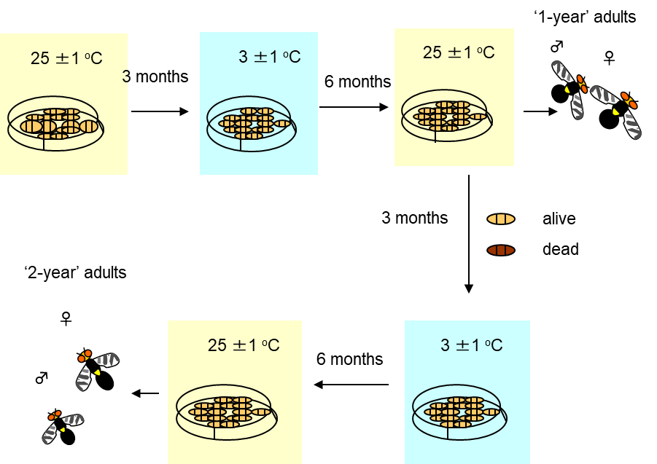
Figure S2. Experimental procedure following for emerging ‘1-year’ and ‘2-year’ adults. Cohorts of approximately 400 pupae from Mikra, Kamari, and Kernitsa were maintained at 25 ± 1^{ο}C for approximately 3 months, and then transferred to 3 ± 1^{ο}C for 6 months. At the end of the chilling period, pupae were transferred back to 25 ± 1^{ο}C for 3 months to promote pupae following annual dormancy to give adults (‘1-year’ adults). The percentage of pupae that produced “1-year” adults was estimated at 43.3%, 27.5% and 14.4% for Mikra, Kamari, and Kernitsa populations, respectively. fter adult emergence ceased, empty puparia were removed and the remaining pupae were divided (based on morphological features) into dead or alive (still in dormancy). The percentage of pupae that enter prolonged dormancy was 41.5%, 46.5% and 74% for Mikra, Kamari and Kernitsa populations, respectively. Pupae with prolonged dormancy were placed at 3 ± 1^{ο}C for an additional period of 6 months, and then transferred back to 25 ± 1^{ο}C until adult emergence was completed (‘2-year’ adults). Upon emergence, the number of males and females was recorded. Emergence rates were estimated at 70-80% for all three populations. Pupae that did not produce adults record as dead after remaining three months at 25 ± 1^{ο}C. The experimental design for Mikra and Kernitsa population has been previously published for Mikra and Kernitsa population (Moraiti et al., 2012a).

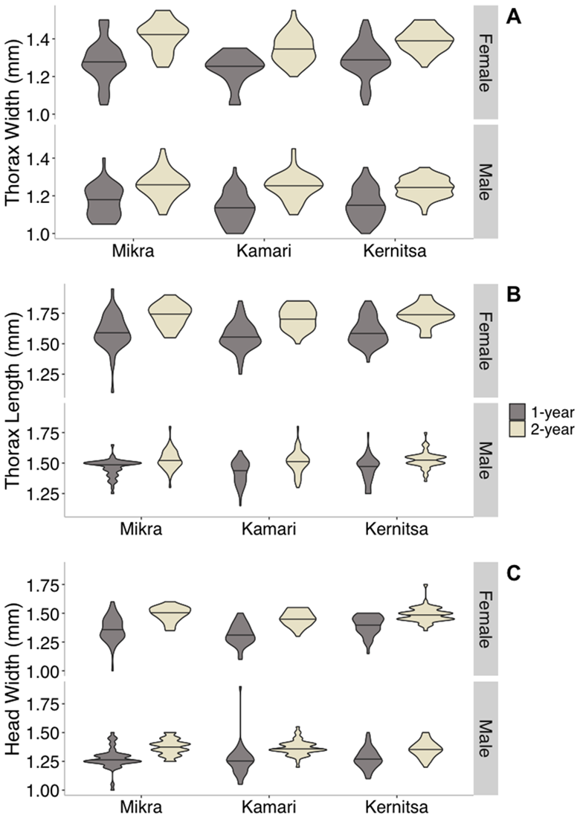
Figure S3. Violin plots of body size traits (A: thorax width, B: thorax length, C: head width) of Rhagoletis cerasi males and females emerged from a) pupae with annual diapause (1-year), and b) pupae with prolonged dormancy (2-year). Pupae obtained from field-infested cherries from Mikra (Macedonia), Kamari (Thessaly) and Kernitsa (Peloponnesus). For 1-year adults: N= 50 males and 50 females for each population. For 2-year adults: N= 50, 47 and 49 individuals per sex from Mikra, Kamari and Kernitsa population, respectively. Data for adults from Mikra and Kernitsa have been previously published (Moraiti et al., 2012a).

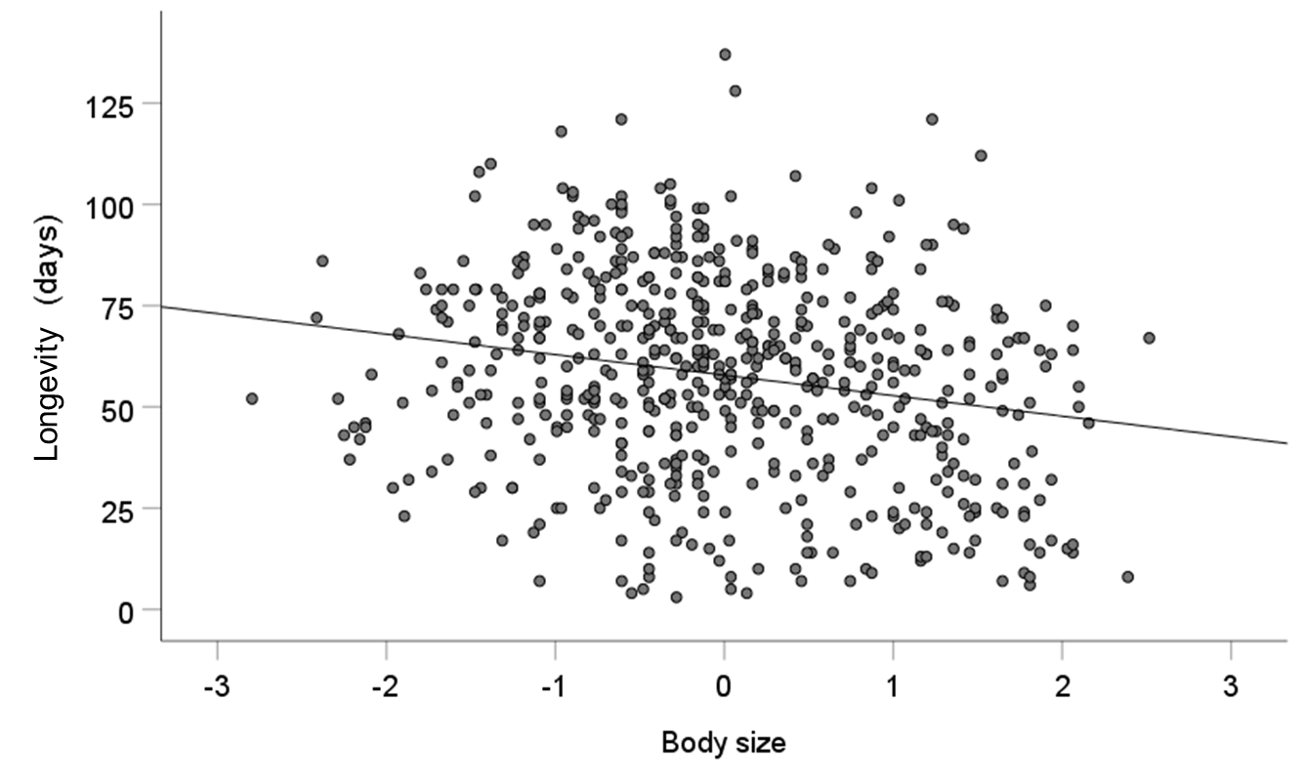

Figure S4. Scatter plot depicting the relationship between adult longevity (days) and body size (Pearson correlation analysis, r= -0.203, N=578, P<0.001). Adults emerged from pupae with annual diapause (1-year), and pupae with prolonged dormancy (2-year). Pupae obtained from field-infested cherries from Mikra (Macedonia, Greece), Kamari (Thessaly, Greece) and Kernitsa (Peloponnesus, Greece). Body size refers to the composite index of the principal component analysis (PCA) of the three adult body traits (thorax length, thorax width, and head width) regressed to the first principal component, which represent the overall body size and accounted for the 82.18% of the total variability.

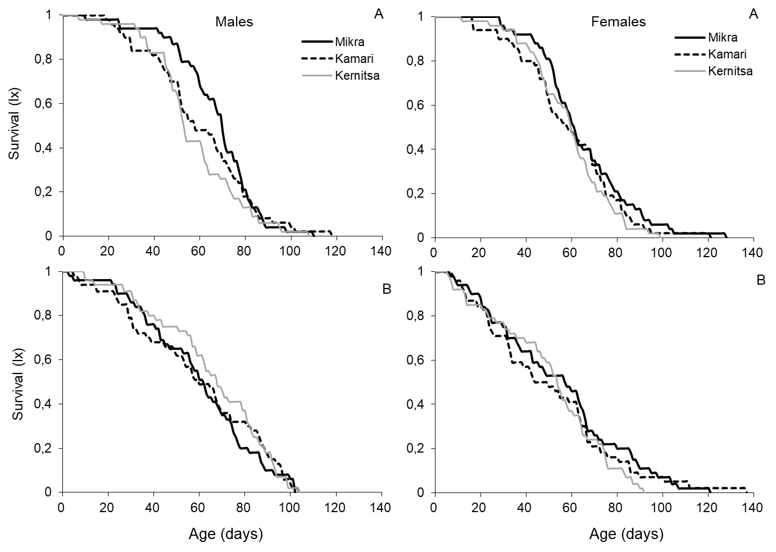

Figure S5. Age specific survival for Rhagoletis cerasi adults emerged from A) pupae with annual diapause (1-year) and B) prolonged dormancy (2-year). Pupae obtained from field-infested cherries from Mikra (Macedonia, Greece), Kamari (Thessaly, Greece) and Kernitsa (Peloponnesus, Greece). For 1-year adults: N= 50 males and 50 females for each population. For 2-year adults: N= 50, 47 and 49 individuals per sex from Mikra, Kamari and Kernitsa population, respectively. Data for adults from Mikra and Kernitsa have been previously published (Moraiti et al., 2012a).

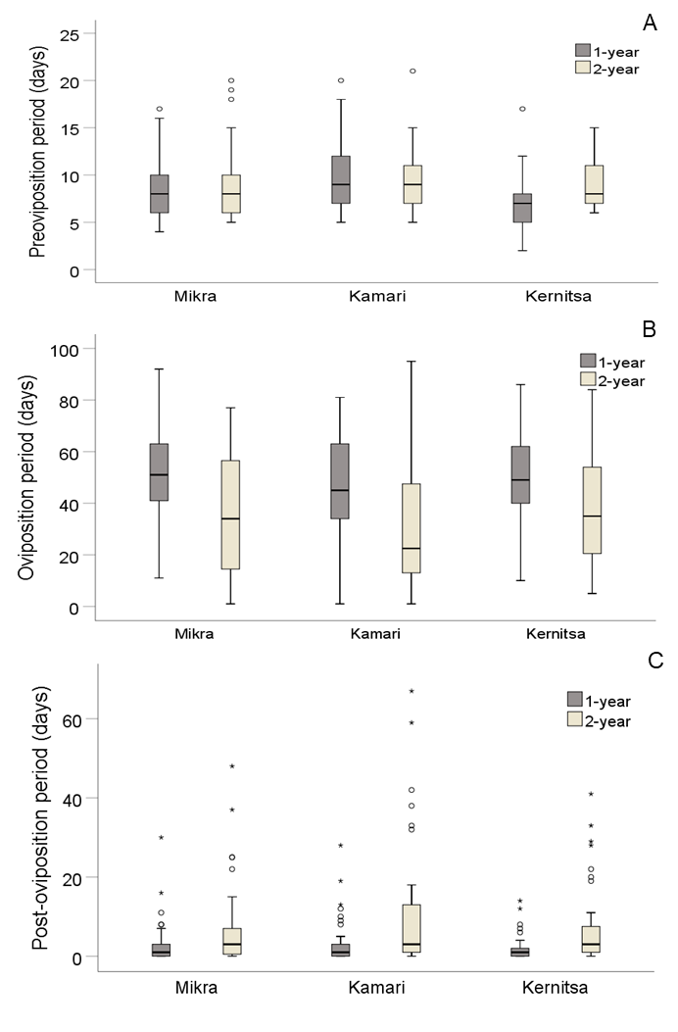
Figure S6. Box plots showing the duration of A: pre-oviposition period, B: oviposition period, and C: post-oviposition period of Rhagoletis cerasi females emerged from pupae with annual diapause (1-year) and prolonged dormancy (2-year). Pupae obtained from field-infested cherries from Mikra (Macedonia), Kamari (Thessaly) and Kernitsa (Peloponnesus). For 1-year females: N= 50, 50 and 43 females from Mikra, Kamari and Kernitsa population, respectively. For 2-year females: N= 48, 44 and 43 females from Mikra, Kamari and Kernitsa population, respectively. Data for females from Mikra and Kernitsa have been previously published (Moraiti et al., 2012a).

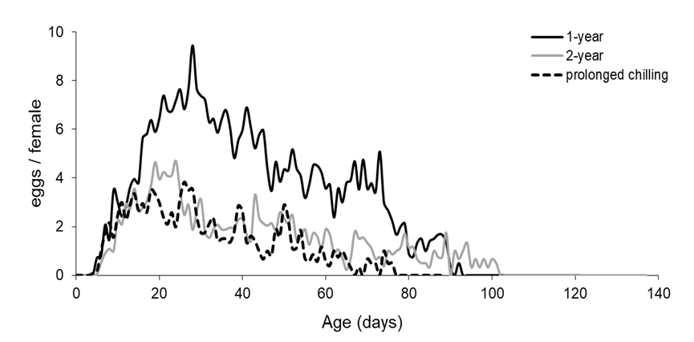
Figure S7. Age specific oviposition of Rhagoletis cerasi females emerged from pupae a) with annual diapause (1-year), b) prolonged dormancy (2-year), and c) pupae that were exposed to cold for approximately 18 consecutive months (prolonged chilling). Pupae were obtained from Kamari (Thessaly). N= 50, 44 and 25 for the 1-year, 2-year and prolonged chilling females, respectively.

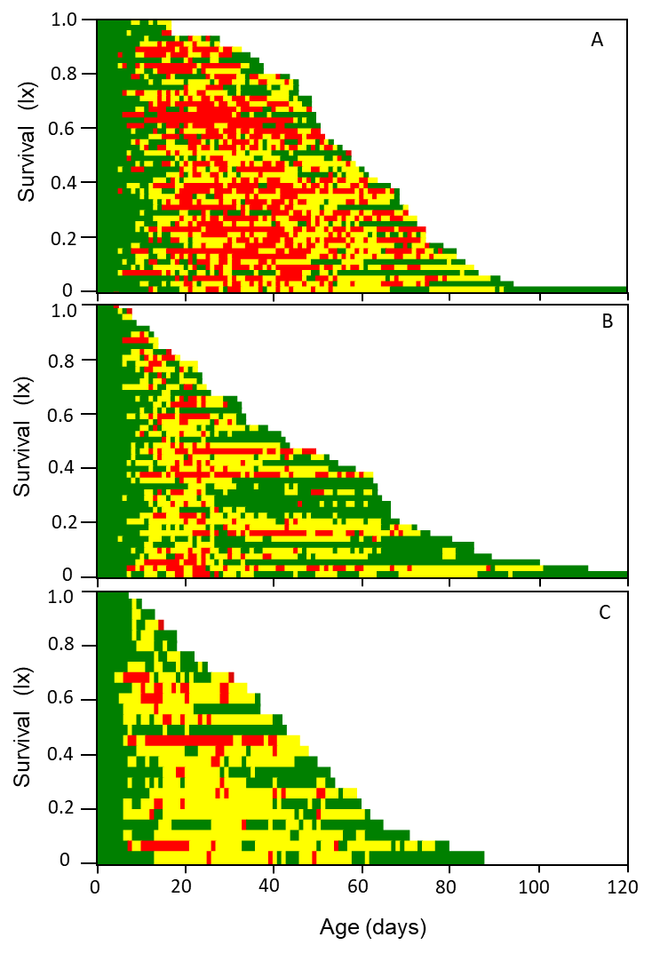
Figure S8. Even-history diagrams of Rhagoletis cerasi females emerged from A) pupae with annual diapause (1-year, n=50), B) pupae with prolonged dormancy (2-year, n=47), and C) pupae that were exposed to cold for 18 consecutive months (prolonged chilling, n=26). Pupae were obtained from Kamari population (Thessaly, Greece). Green = 0 eggs/day; yellow = 1–5 eggs/day; red = 5 eggs/day. n= the number of individuals tested in each treatment. N= 50, 44 and 25 females for 1-year, 2-year and prolonged chilling group, respectively.

