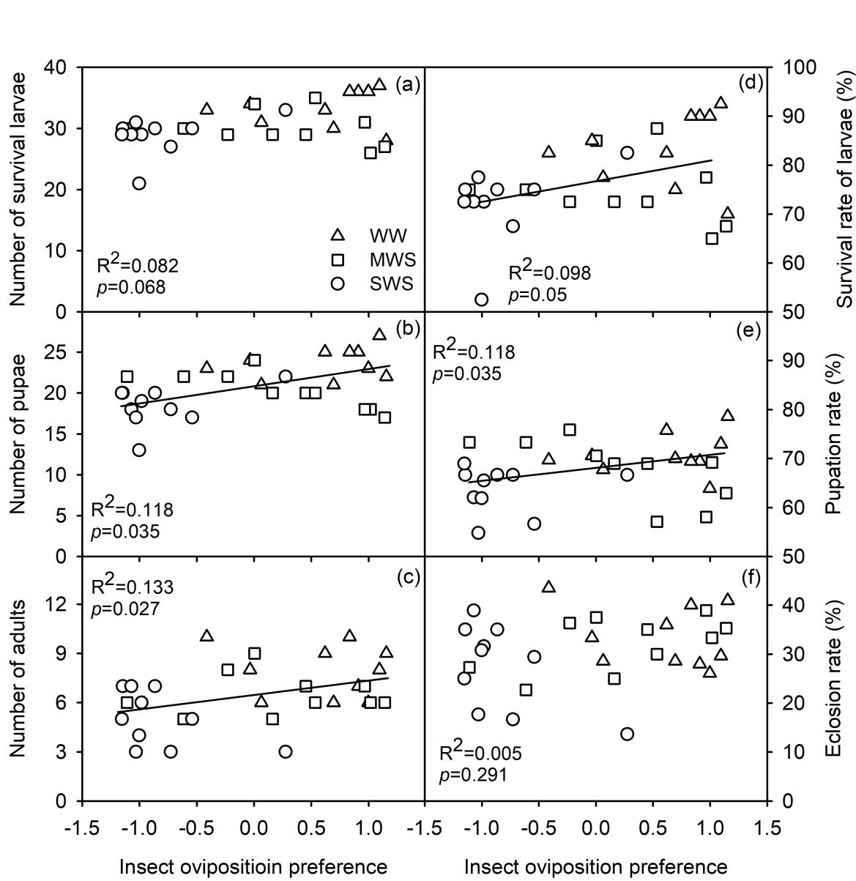
Figure S3 Relationships between female oviposition preference (number of eggs) and the number of survival larvae (a), pupae (b, y=1.49x+20.77), adults (c, y=0.83x+6.47), survival rate of larvae (d, y=4.04x+76.92), pupal rate (e, y=1.4x+67.44), and erosion rate (f). Female oviposition preference was estimated in a cage experiment, and standardized within trials by subtracting the mean number of eggs within each experimental trial from the individual measure, and dividing this difference by the standard deviation of the trial. Negative oviposition preference values correspond to that a plant was less preferred compared to other plants and positive values correspond to that a plant was more preferred.

