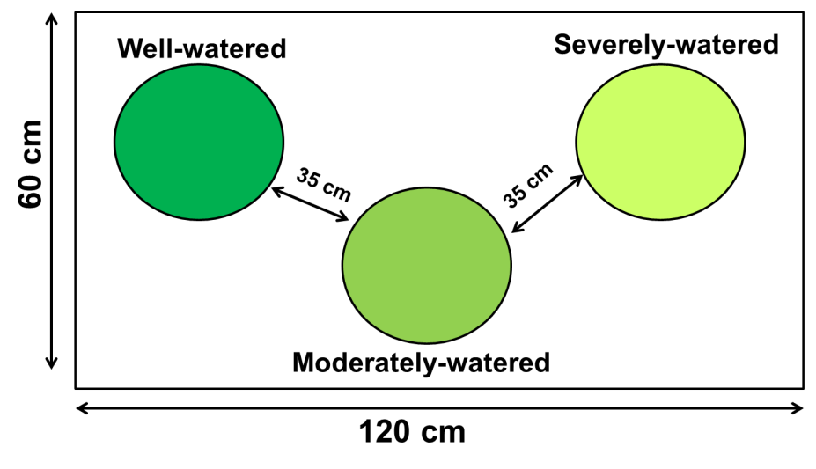
Figure S1 Schematic arrangement of the three pots (well-watered plants, moderately-watered plants, and severely-watered plants) in each cage.

