**Supplementary Materials for**

**Biological traits of the predatory mirid *Macrolophus praeclarus,* a candidate biocontrol agent for the Neotropical region**

Meritxell Pérez-Hedo1, Carolina Gallego1, Amy Roda2, Barry Kostyk3, Mónica Triana3, Fernando Alférez3, Philip A. Stansly3†, Jawwad Qureshi3, Alberto Urbaneja1

1Instituto Valenciano de Investigaciones Agrarias (IVIA). Centro de Protección Vegetal y Biotecnología. Unidad de Entomología. Carretera CV-315, Km 10'7 - 46113 Moncada, Spain

2United States Department of Agriculture, Animal Plant Health Inspection Service, Plant Protection and Quarantine, Science and Technology, Miami, Florida, 33158 United States of America

3University of Florida, Department of Entomology and Nematology, Southwest Florida Research and Education Center, Immokalee, Florida 34142, United States of America

Author for correspondence:

*Meritxell Pérez-Hedo*

Email: [mperezh@ivia.es](mailto:mperezh@ivia.es)

**This PDF file includes:**

Supplementary materials

Supplementary Figure 1 - 2

Supplementary Table 1

**Supplementary Materials**

**DNA extraction, PCR and sequencing of barcode fragment**

Total genomic DNA was extracted from *M. praeclarus* individuals from the SWFREC colony and from *M. pygmaeus* and *N. tenuis* from commercial strains (MIRICAL and NESIBUG, Koppert BS., Águilas, Murcia. Spain) for amplification of mitochondrial gene fragment using the salting-out method (Sunnucks & Hales, 1996) adapted from (Monzó et al., 2010). The amplification and sequencing of 758 bp fragment of the Cytochrome Oxidase Subunit I (COI) were performed using LCOI490 (GGTCAACAAATCATAAAGATATTGG) and HCOI2198 (TAAACTTCAGGGTGACCAAAAAATCA) standard primers (Folmer, Black, Hoeh, Lutz, & Vrijenhoek, 1994). All the PCRs were performed in 20-μL reaction mixtures with 1U of DNA polymerase (1U/ul, Biotools), PCR Master Mix (1X Reaction Buffer, 1.5 μM of MgCl2, 250 μM of each dNTPs and 0.25 μM of each primer), 1 μl of genomic DNA and RNase-free water, in a thermal cycler (Eppendorf Mastercycler).

PCR reactions were comprised of the following steps: initial denaturation at 95ºC for 2 min; 40 successive cycles of denaturation at 94ºC for 1 min, touchdown protocol with an annealing temperature of 54–45°C in the first six cycles and 45 °C in the following 34 cycles for 1 min, elongation at 72ºC for 90 s. and final extension at 72ºC for 10 min. The PCR products were purified using the QIAquick PCR Purification Kit (QUIAGEN) and PCR fragments were sequenced by the Sanger-sequencing method performed by capillary electrophoresis using a 3130XL Genetic Analyzer (Applied Biosystems, Carlsbad - California, USA), at the Sequencing Service of the IBMCP-CSIC (Valencia, Spain).

**Sequence data and phylogenetic analysis**

Nucleotides of the three mirid species sequenced, *M. praeclarus*, *M. pygmaeus* and *N. tenuis*, were analyzed and trimmed using Sequencer DNA Sequence Analysis Software (Gene Codes Corporation). High quality reads obtained in each studied accessions were assembled into consensus sequences and deposited in NCBI GenBank public sequence database under the accession numbers MT154517 for *M. praeclarus*,MT151780 for *M. pygmaeus* and MT151782 for *N. tenuis.* The phylogenetic analysis of *M. praeclarus* was carried out using COI barcode sequences obtained in this study along with those retrieved from GenBank database. The sequences selected from the database were: *M. pygmaeus* HQ845337.1, *Macrolophus melanotoma* (Costa) KJ467499.1, *Macrolophus rubi* (Woodroffe) KM022470.1, *N. tenuis* KY274652.1 and *Dicyphus sp.* (Reuter) KY274585.1. Each sequence obtained was compared against the GenBank database using the BLASTn tool. This search made it possible to compare the similarity between the sequences obtained and those stored in the database for *M. pygmaeus* and *N. tenuis*, in addition to ruling out errors due to contamination. Multiple alignments of consensus sequences and closest sequences were done using Clustal Omega Software (Sievers & Higgins, 2018).

A phylogenetic COI-based tree was built using MEGA X Software (Molecular Evolutionary Genetics Analysis) (Kumar et al., 2018), taking the Neighbor-Joining method as a parameter (Nei & Saitou, 1987). Estimation of the confidence of the branches was performed by bootstrapping with 10,000 replications (Felsenstein, 1985). The evolutionary distances were computed using the Kimura 2-parameter method (Kimura, 1980). The rate variation among sites was modeled with a gamma distribution (shape parameter = 1).

**Molecular characterization**

The *M. praeclarus* sequences were similar to the rest of Miridae with percentages of identity over 90% and with *Macrolophus* sp. with 96% of identity to COI barcode fragment. The phylogenetic tree for *M. praeclarus* showed 2 distinct branches (Fig. S1). The first branch was separated into two clusters. The first cluster involved the four *Macrolophus* species in which *M. praeclarus* was included; however, this species was found to be more evolutionarily distant from *M. rubi*, *M. pygmaeus* and *M. melanotoma* with a bootstrap value of 65%. The second cluster was comprised of only *N. tenuis*. The second principal branch contained the *Dicyphus* sp. The COI sequences of all groups showed an average divergence of more than 10% (Table S1). The species *Dicyphus* sp.with a 0.31 interspecific value was not as closely related to *M. praeclarus* as *M. melanotoma* and *M. pygmaeus* were with 0.25 interspecific values. However, it is important to highlight that among the group of *Macrolophus* species studied, *M. praeclarus* was the least genetically related to the rest of the group, suggesting a higher polymorphism in the COI region of *M. praeclarus* compared with other *Macrolophus* species.

*Macrolophus* group was well phylogenetically separated from *N. tenuis*, and specially from *Dicyphus* sp. which displayed a remarkable divergence in the phylogenetic tree classification among of the all the COI barcode fragments studied. *Dicyphus* sp. behaved as a separate group from the other taxa even though they all belong to the same tribe classification, being these results in line with those obtained in previous works (Cassis & Schuh, 2012; Cassis et al., 2006). The phylogenetic tree suggested that *M. praeclarus* does not share the same evolutionary history as other *Macrolophus* species, since *M. praeclarus* was displayed to be more evolutionarily distant from *M. rubi*, *M. pygmaeus* and *M. melanotoma* with a bootstrap value of 65%. This evolutionary distance could be explained by the mirids’ different geographical distribution and consequently its evolutionary separation. *Macrolophus praeclarus* is a species reported only in the Nearctic region, where as the other three *Macrolophus* species used in this study are Palearctic species (Martinez-Cascales et al., 2006). Further studies are needed to ascertain the evolutionary point of differentiation between these two groups of mirids. In addition, exploring the evolutionary origin *of M. praeclarus* from other American regions and how it coincides with the origin of target pests, such as *T. absoluta,* could help determine the likely integration of the mirid into a management strategy.

**References**

**Cassis, G., & Schuh, R.T.** (2012) Systematics, biodiversity, biogeography, and host associations of the Miridae (Insecta: Hemiptera: Heteroptera: Cimicomorpha). Annual Review of Entomology **57**, 377–404. https://doi.org/10.1146/annurev-ento-121510-133533

**Cassis, G., Martínez-Cascales, J.I., & Sánchez, J.A.** (2006) Description of a new species of *Dicyphus* Fieber (Insecta: Heteroptera: Miridae) from Portugal based on morphological and molecular data. Insect Systematics & Evolution **37**, 281–300. https://doi.org/10.1163/187631206788838572

**Felsenstein, J.** (1985) Confidence limits on phylogenies: an approach using the bootstrap. Evolution **39**, 783–791. https://doi.org/10.1111/j.1558-5646.1985.tb00420.x

**Folmer, O., Black, M., Hoeh, W., Lutz, R., & Vrijenhoek, R.** (1994) DNA primers for amplification of mitochondrial cytochrome c oxidase subunit I from diverse metazoan invertebrates. Molecular Marine Biology and Biotechnology **3**, 294–299.

**Kimura, M.** (1980) A simple method for estimating evolutionary rates of base substitutions through comparative studies of nucleotide sequences. *Journal of* Molecular Evolution **16**, 111–120. https://doi.org/10.1007/BF01731581

**Kumar, S., Stecher, G., Li, M., Knyaz, C., & Tamura, K.** (2018) MEGA X: molecular evolutionary genetics analysis across computing platforms. Molecular Biology and Evolution **35**, 1547–1549. https://doi.org/10.1093/molbev/msy096

**Martínez-Cascales, J.I., Cenis, J.L., Cassis, G., & Sánchez, J.A.** (2006) Species identity of *Macrolophus melanotoma* (Costa 1853) and *Macrolophus pygmaeus* (Rambur 1839) (Insecta : Heteroptera : Miridae) based on morphological and molecular data and bionomic implications. Insect Systematics & Evolution **37**, 385–404. https://doi.org/Doi 10.1163/187631206788831470

**Monzó, C., Sabater-Muñoz, B., Urbaneja, A., & Castañera, P.** (2010) Tracking medfly predation by the wolf spider, *Pardosa cribata* Simon, in citrus orchards using PCR-based gut-content analysis. Bulletin of Entomological Research **100**, 145–152. https://doi.org/Doi 10.1017/S0007485309006920

**Nei, M., & Saitou, N.** (1987) The neighbor-joining method: a new method for reconstructing phylogenetic trees. Molecular Biology and Evolution **4**, 406–425. https://doi.org/10.1093/oxfordjournals.molbev.a040454

**Sievers, F., & Higgins, D.G.** (2018) Clustal Omega for making accurate alignments of many protein sequences. Protein Science **27**, 135–145. https://doi.org/10.1002/pro.3290

**Sunnucks, P., & Hales, D.F.** (1996) Numerous transposed sequences of mitochondrial cytochrome oxidase I-II in aphids of the genus *Sitobion* (Hemiptera: Aphididae). Molecular Biology and Evolution **13**, 510–524. https://doi.org/10.1093/oxfordjournals.molbev.a025612

**Table S1.** Estimates of evolutionary divergence over sequence pairs between groups COI barcoding -The number of base substitutions per site from averaging over all sequence pairs between groups are shown. Note the interspecific divergence values between the different species compared to *M. praeclarus* for the mtCOI marker.

|  |  |  |  |  |  |  |
| --- | --- | --- | --- | --- | --- | --- |
|  | **1** | **2** | **3** | **4** | **5** | **6** |
| **1 *Nesidiocoris tenuis*** |  |  |  |  |  |  |
| **2 *Macrolophus praeclarus*** | 0.295 |  |  |  |  |  |
| **3 *Macrolophus pygmaeus*** | 0.270 | 0.257 |  |  |  |  |
| **4 *Macrolophus melanotoma*** | 0.301 | 0.254 | 0.193 |  |  |  |
| **5 *Macrolophus rubi*** | 0.280 | 0.260 | 0.133 | 0.180 |  |  |
| **6 *Dicyphus* sp.** | 0.310 | 0.300 | 0.311 | 0.311 | 0.324 |  |

**Figure S1**. Evolutionary relationships of *Macrolophus praeclarus* to cytochrome oxidase subunit 1 (COI) gene. Phylogenetic clusterings show the evolutionary relationships between *M. praeclarus* and some of the family miridae species. The evolutionary tree compared 8 nucleotide sequences among the COI sequences obtained in this study and the publicly available sequences. The phylogenetic tree was inferred using the Neighbor-Joining method. The optimal tree with the sum of branch length = 0.74636764 is shown. There were a total of 582 positions in the final dataset.

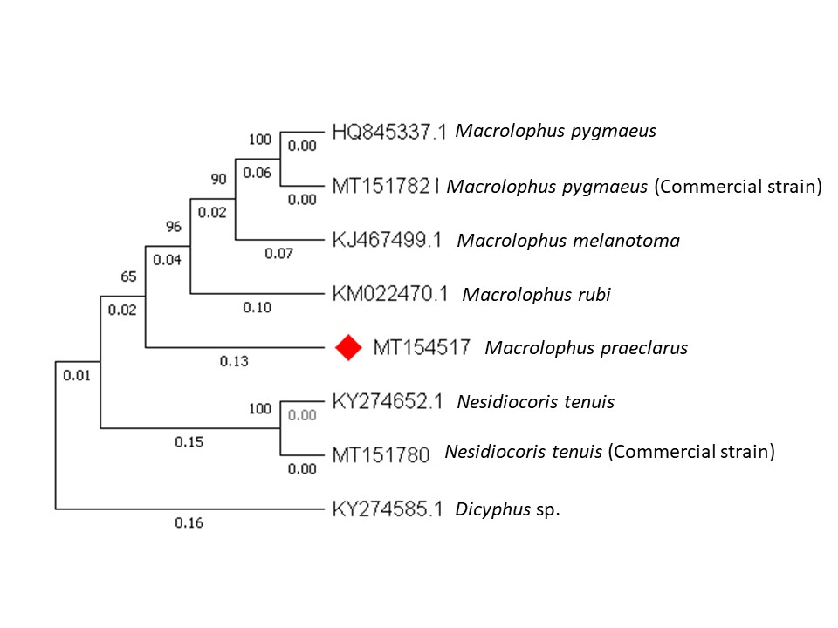

**Figure S2.** Influence of the temperature (º C) in the immature survival of *Macrolophus praeclarus* when reared on *Ephestia kuehniella* eggs on detached tomato stems and leaflets. The curve shows the probability of *M. praeclarus* survival estimated from logistic regression. Binary data (1=adulthood reached, 0= adulthood not reached) are shown in bubbles, and the size of the bubble (and the number above) represent the number of observations.

