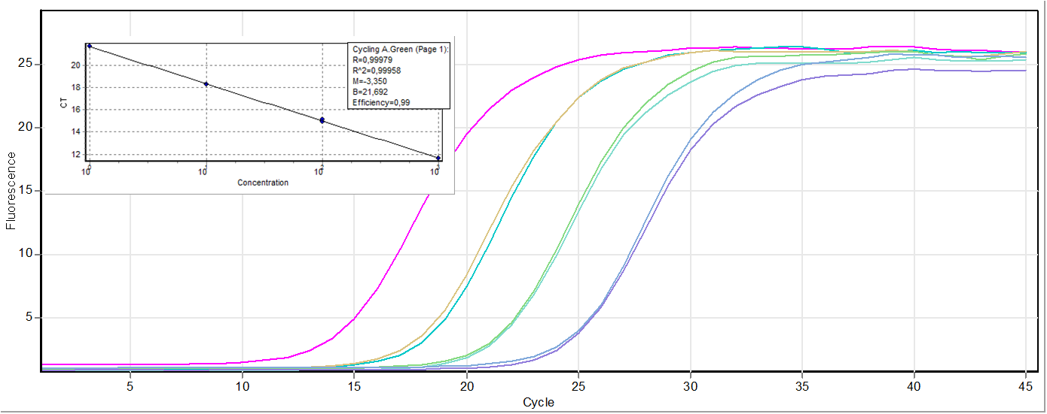
Supplementary Figure 2. Protocol using as template serial dilutions of DWV-B cDNA, obtained from the RNA extracted from sample 22 using the Lp primers for DWV-B, (pure, 1:10, 1:100, and 1:1000). Dynamic range curve for calculating real-time PCR assay sensitivity, presented in a graphic format of increase in fluorescence (delta Rn) plotted against number of cycles.

