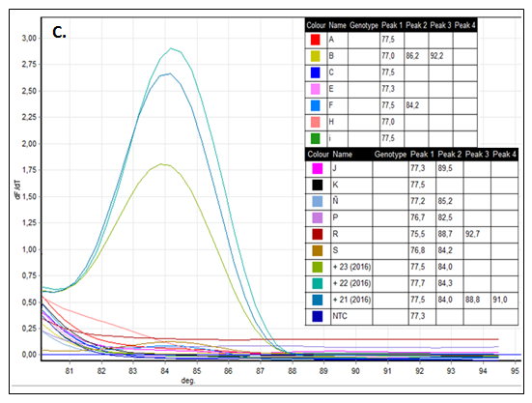
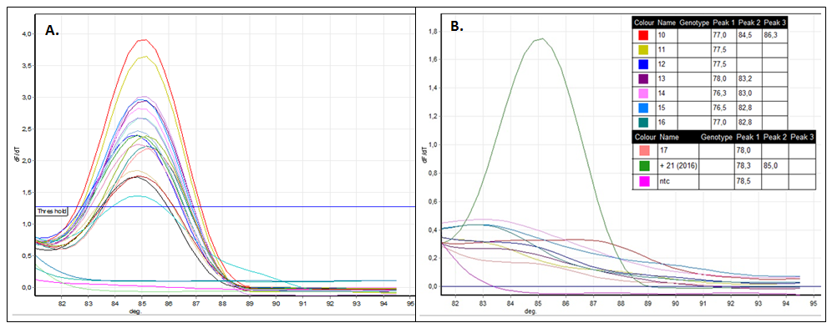

Supplementary Figure 1. A. Melt analysis for checking the specific amplification of DWV-B Lp PCR products of samples from 2016. B. Melt analysis for checking the specific amplification of DWV-B Lp PCR products of samples from 2017 using sample 21 from 2016 as positive control. C. Melt analysis for checking the specific amplification of DWV-B Lp PCR products of samples from 2017 using samples 21, 22 and 23 from 2016 as positive controls. In the vertical axis is represented the rate of change in relative fluorescence units (RFU) with time (T) (-d (RFU) / dT) versus temperature (° C) in the horizontal axis. This rate is marked as a peak at the specific dissociation temperature of 84, 5°C.

