Supplementary Information

The potential geographical distribution and phenology of Bemisia tabaci Middle East/Asia Minor 1, considering irrigation and glasshouse production

Kriticos, D.J.,^{1,2,3} De Barro, P.J.⁴, Yonow, T.³, Ota, N.¹ and Sutherst, R.W.^{2†}

¹CSIRO, GPO Box 1700, Canberra, 2601, Australia
²University of Queensland, Brisbane, QLD 4072, Australia
³InSTePP, University of Minnesota, St. Paul, MN 55108 USA
⁴CSIRO, GPO Box 2583 Brisbane QLD 4001 Australia
†Deceased
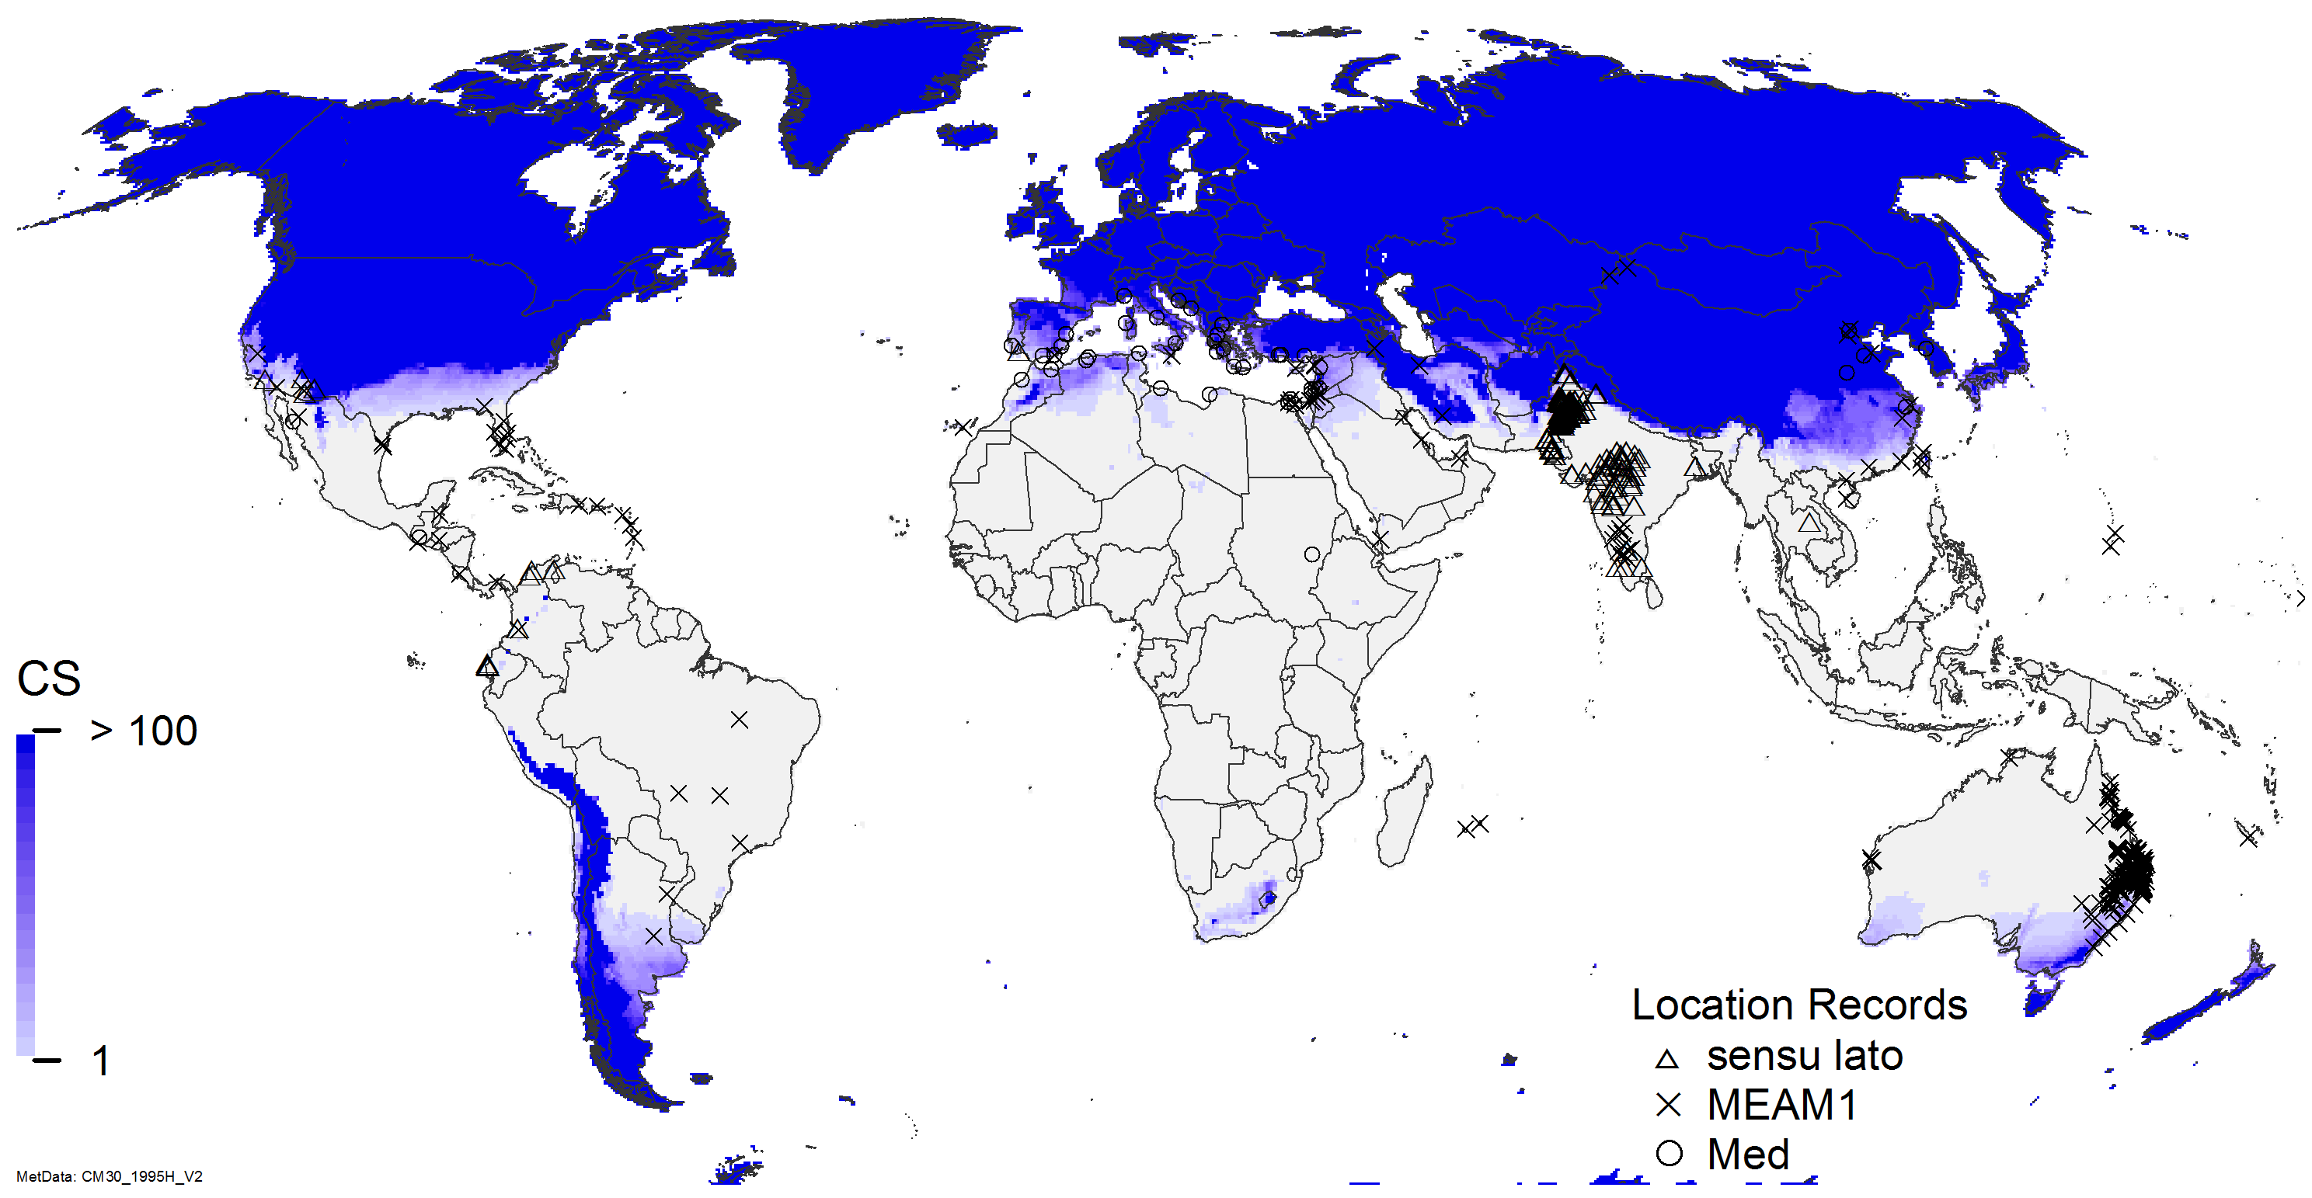
Fig S1 – Cold Stress for Bemisia tabaci MEAM1 modelled using CLIMEX with the CliMond 1975H climate dataset.
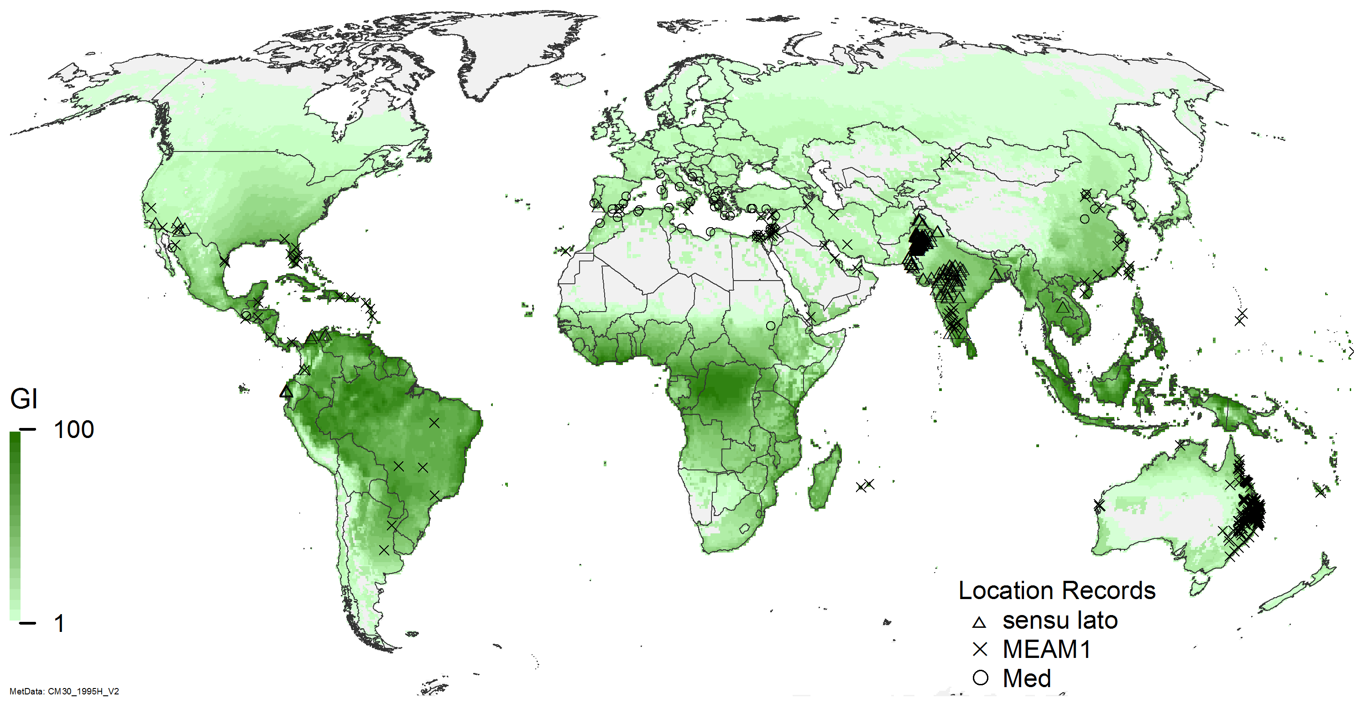
Fig S2 Annual Growth Index (GI_{A}) modelled using CLIMEX with the CliMond 1995H climate dataset under composite irrigation conditions.

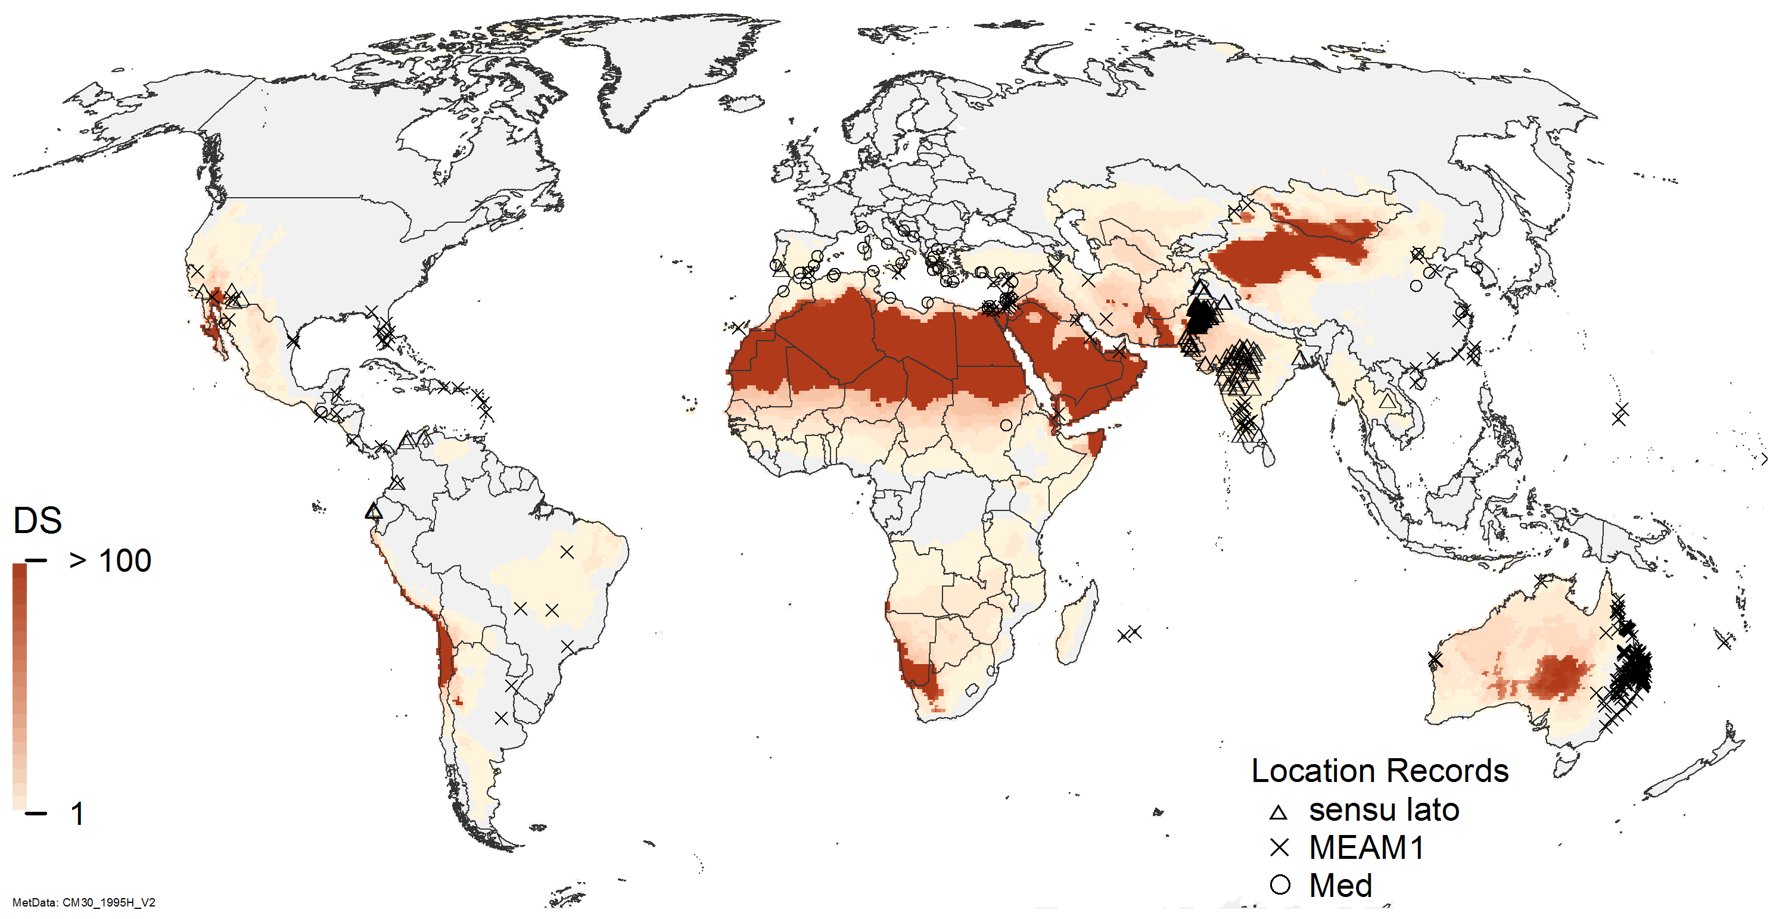
Fig S3 Dry Stress for Bemisia tabaci MEAM1 modelled using CLIMEX with the CliMond 1975H climate dataset under composite irrigation conditions.
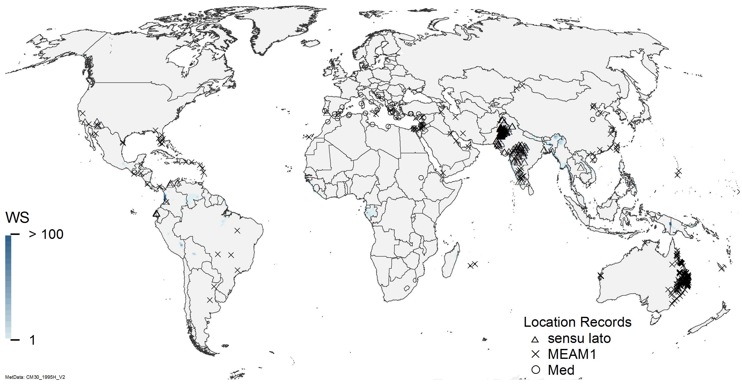
Fig S4 Wet Stress for Bemisia tabaci MEAM1 modelled using CLIMEX with the CliMond 1975H climate dataset under composite irrigation conditions.
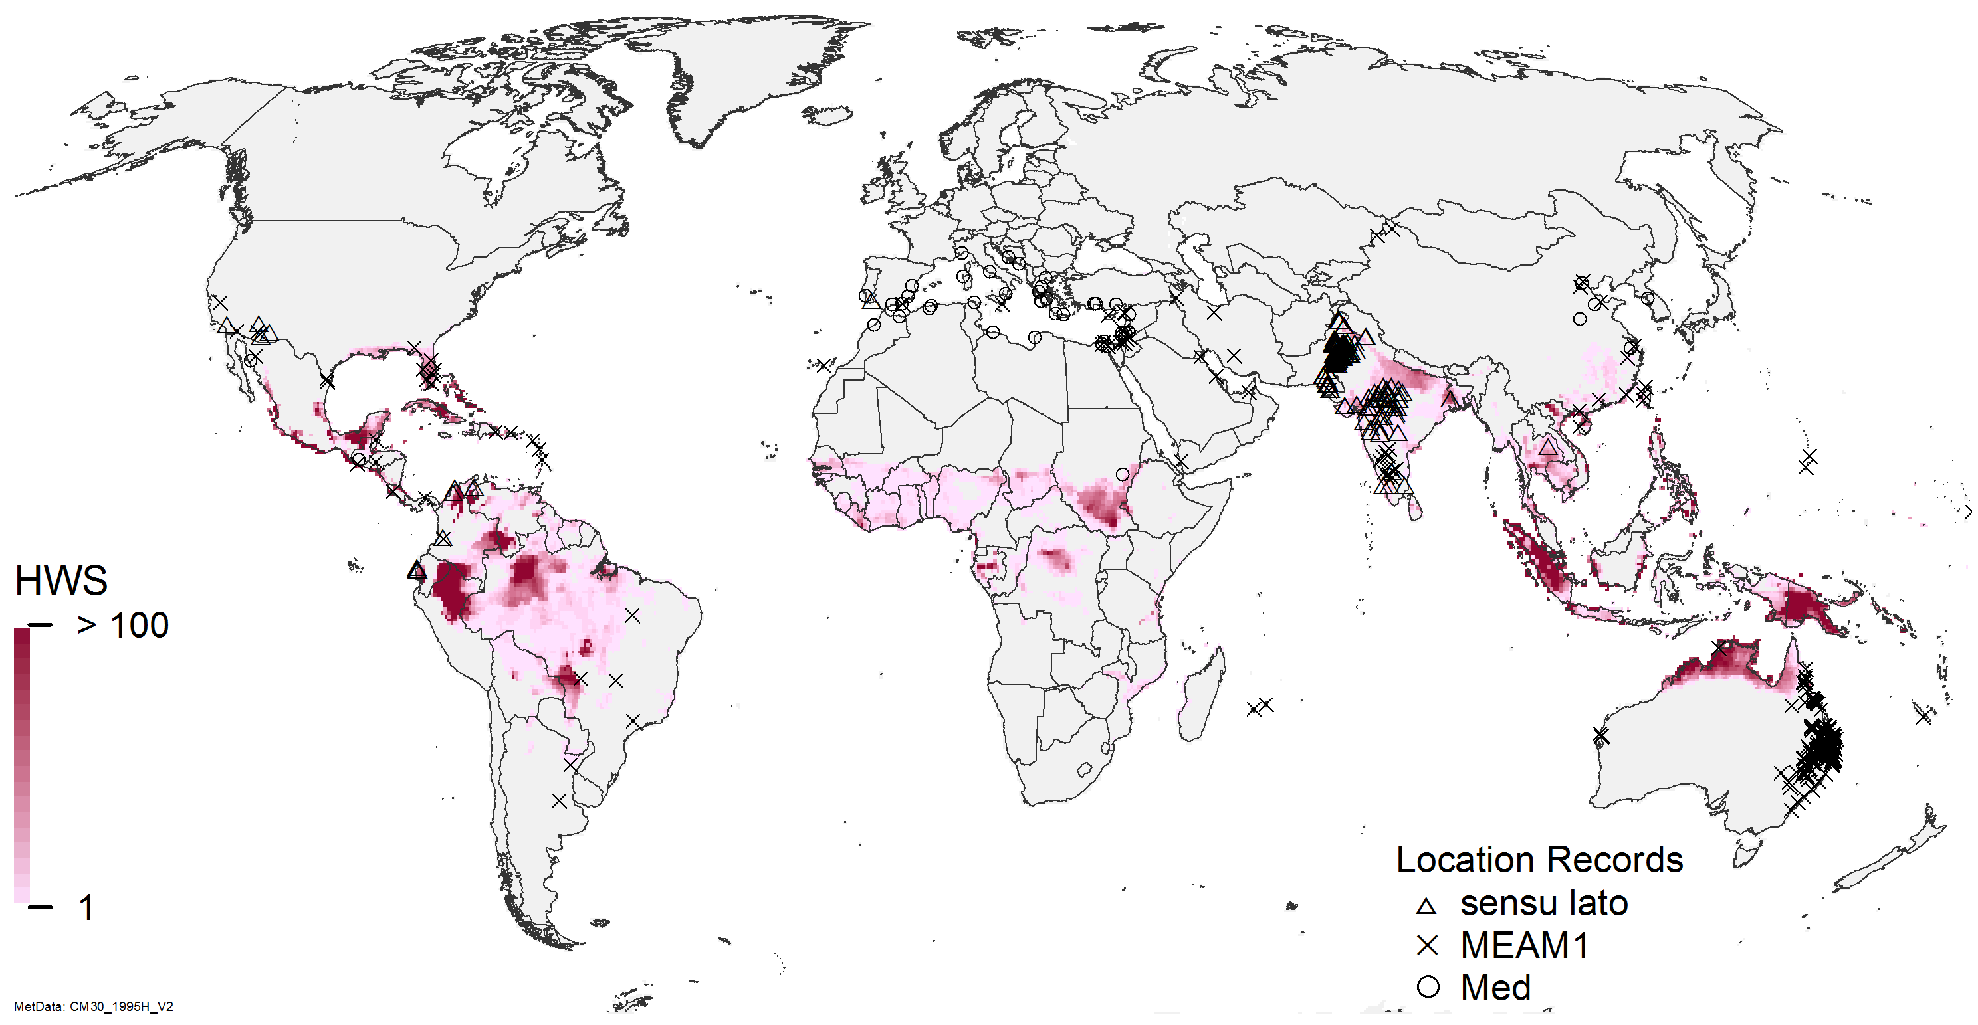
Fig S5 Hot-Wet Stress for Bemisia tabaci MEAM1 modelled using CLIMEX with the CliMond 1975H climate dataset under composite irrigation conditions.

