SUPPLEMENTARY MATERIAL

Dominant symbiotic bacteria associated with wild medfly populations reveal a bacteriocin-like killing phenotype: a ‘cold-case’ study.

Silvia Ciolfi and Laura Marri*
Department of Life Sciences, via A. Moro 2, University of Siena, Siena-53100, Italy

*Author for correspondence (e-mail: laura.marri@unisi.it)

Fig. S1. Estimated mean (± SD) of inhibition zones (R) showed by Klebsiella strains in the Agar overlay method against Escherichia coli ATCC 23739, Salmonella typhimurium ATCC 23853, and Enterobacter cloacae ATCC 13047.

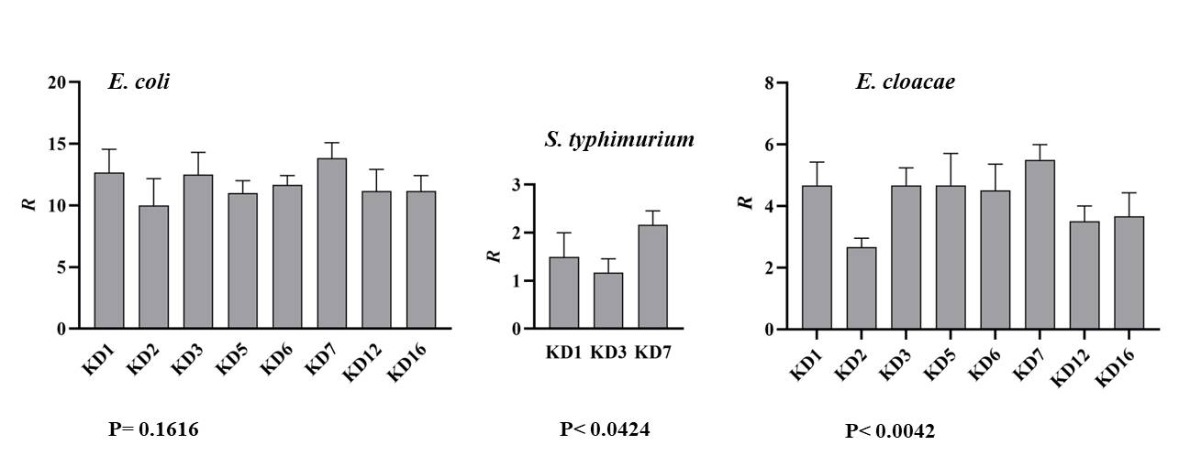

Fig. S2. Distribution of nucleotide site differences among sequences derived from PCR KlebD amplicons. Single-base substitutions (bold character) are indicated above the alignment.

618
KD5 601-TGTCACTGATGTTGCCCATCAGACCATCAAGGAGATGGAGGCGTTCGCTCAAATGGTCGC
KD6 601-TGTCACTGATGTTGCCCGTCAGACCATCAAGGAGATGGAGGCGTTCGCTCAAATGGTCGC
KD7 601-TGTCACTGATGTTGCCCATCAGACCATCAAGGAGATGGAGGCGTTCGCTCAAATGGTCGC
KD12 601-TGTCACTGATGTTGCCCATCAGACCATCAAGGAGATGGAGGCGTTCGCTCAAATGGTCGC
***************** ******************************************
706
KD5 661-TCAGAACGAGGCCCGTAAAAAAGGCAGAGAAAGAGGCCAGAAGGCAGAAGAGGCTTATCA
KD6 661-TCAGAACGAGGCCCGTAAAAAAGGCAGAGAAAGAGGCCAGAAGGCAGAAGAGGCTTATCA
KD7 661-TCAGAACGAGGCCCGTAAAAAAGGCAGAGAAAGAGGCCAGAAGGCAGAAGAGGCTTATCA
KD12 661-TCAGAACGAGGCCCGTAAAAAAGGCAGAGAAAGAGGCCAGAAGGCCGAAGAGGCTTATCA
********************************************* **************

KD5 721-AGCCGCTCTGCGGGCGGAAGAGGAAGCCCGGCGTCAGCAGGCTGAAATCGAGCGGAAACT
KD6 721-AGCCGCTCTGCGGGCGGAAGAGGAAGCCCGGCGTCAGCAGGCTGAAATCGAGCGGAAACT
KD7 721-AGCCGCTCTGCGGGCGGAAGAGGAAGCCCGGCGTCAGCAGGCTGAAATCGAGCGGAAACT
KD12 721-AGCCGCTCTGCGGGCGGAAGAGGAAGCCCGGCGTCAGCAGGCTGAAATCGAGCGGAAACT
************************************************************

KD5 781-GAAGGAAGCCAGAGAACGTGAGGCCGCAGCAAAAGCAAAAGCCCTGGCGGACAAAGCGGG
KD6 781-GAAGGAAGCCAGAGAACGTGAGGCCGCAGCAAAAGCAAAAGCCCTGGCGGACAAAGCGGG
KD7 781-GAAGGAAGCCAGAGAACGTGAGGCCGCAGCAAAAGCAAAAGCCCTGGCGGACAAAGCGGG
KD12 781-GAAGGAAGCCAGAGAACGTGAGGCCGCAGCAAAAGCAAAAGCCCTGGCGGACAAAGCGGG
************************************************************

KD5 841-CGCGGAGAAAGCAGAAGCAGACAGGAGAGCTCTGTTCACGAAGGCCGGTATACAGGACAC
KD6 841-CGCGGAGAAAGCAGAAGCAGACAGGAGAGCTCTGTTCACGAAGGCCGGTATACAGGACAC
KD7 841-CGCGGAGAAAGCAGAAGCAGACAGGAGAGCTCTGTTCACGAAGGCCGGTATACAGGACAC
KD12 841-CGCGGAGAAAGCAGAAGCAGACAGGAGAGCTCTGTTCACGAAGGCCGGTATACAGGACAC
************************************************************
920
KD5 901-ACCGGTTTACACAACGGAATTGGTGAAAGCGGCAAACGCGACGCTGTCTGCGGGAAGCTC
KD6 901-ACCGGTTTACACAACGGAAATGGTGAAAGCGGCAAACGCGACGCTGTCTGCGGGAAGCTC
KD7 901-ACCGGTTTACACAACGGAAATGGTGAAAGCGGCAAACGCGACGCTGTCTGCGGGAAGCTC
KD12 901-ACCGGTTTACACAACGGAAATGGTGAAAGCGGCAAACGCGACGCTGTCTGCGGGAAGCTC
******************* ****************************************
965
KD5 961-ACTGATGCTGAGCCGGGCGCCAGGGATGATACAGCTCTCGGCGTCGGGTGTGGGGACACT
KD6 961-ACTGATGCTGAGCCGGGCGCCAGGGATGATACAGCTCTCGGCGTCGGGTGTGGGGACACT
KD7 961-ACTGATGCTGAGCCGGGCGCCAGGGATGATACAGCTCTCGGCGTCGGGTGTGGGGACACT
KD12 961-ACTGGTGCTGAGCCGGGCGCCAGGGATGATACAGCTCTCGGCGTCGGGTGTGGGGACACT
**** *******************************************************

